­Clem Daria-Ștefana

Grupa 134

Proiect – Baze de date

Gestiunea unei școli

1. Descrierea modelului real, a utilității acestuia și a regulilor de funcționare.

Acest proiect are ca temă gestiunea unei școli. Astfel, elevii școlii sunt înscriși în clase, care fac parte dintr-o încadrare. La fiecară clasă sunt anumite materii și anumiți profesori care predau. Profesorii pot preda mai multe materii (de exemplu, un profesor poate preda fizică și chimie sau limba română și limba latină). Elevii primesc note la materiile de la clasă. De asemenea, elevii au posibilitatea de a lua bursă în timpul anului școlar. Aceasta poate fi de 3 tipuri: bursă de merit, de performanță și socială.

În funcție de bugetul alocat școlii, bursele se acordă elevilor după anumite criterii. Bursa de merit este oferită elevilor care au rezultate bune la ore sau care strâng un anumit punctaj la proiectele organizate de școală. Rezultatele de la ore se calculează în funcție de importanța notelor luate de elevi (examen, teză, test, etc). Bursa de performanță este acordată elevilor care obțin premii la olimpiadele naționale și nu sunt corigenți la nicio materie (media ≥ 5). În final, bursa socială este destinată celor care suferă de o condiție medicală sau a căror părinți au veniturile jumătate din salariul minim pe economie.

Elevii școlii care se încadrează să ia una sau mai multe burse pot primi banii cash, de la contabilitate, sau într-un cont care aparține unei bănci ori un cont local al școlii. O bancă poate avea mai multe conturi deschise. Aceștia pot partipa în timpul anului la olimpiade (acestea se actualizează anual, în funcție de programa stabilită) și pot realiza proiecte.

2. Prezentarea constrângerilor (restricții, reguli) impuse asupra modelului.

*Elev*

* Este înscris într-o singură clasă
* Obține mai multe note la materiile care i se predau la clasă
* Are deschis zero sau mai multe conturi
* Poate participa la mai multe olimpiade
* Poate obține zero sau mai multe burse
* Poate participa la zero sau mai multe proiecte

*Clasă*

* Are mai mulți profesori
* Are mai multe materii care se predau elevilor

*Profesor*

* Poate preda la una sau mai multe clase
* Poate preda una sau mai multe materii

*Materie*

* Este predată uneia sau mai multor clase de elevi
* Este predată de unul sau mai mulți profesori
* Sunt obținute una sau mai multe note

*Notă*

* Este specifică unei singure materii
* Este specifică unui singur student
* Este luată la un singur tip de examinare

*Tip_notă*

* La un tip de notare se pot obține mai multe note

*Olimpiadă*

* Pot participa zero sau mai mulți elevi

*Proiect*

* Pot participa zero sau mai mulți elevi

*Cont*

* Este specific unui singur student
* În cazul în care elevii au deschis un cont la o bancă acesta va deveni metoda unică de plată lunară a bursei
* Aparține unei singure bănci sau este local, aparținând al școlii

*Bursa*

* O bursă poate fi acordată niciunuia sau mai multor studenți
* Aceasta poate fi de 3 tipuri

*Bancă*

* Poate avea zero sau mai multe conturi deschise

3. Descrierea entităților, incluzând precizarea cheii primare.

|  |  |  |
| --- | --- | --- |
| **Entitate** | **Cheie primară** | **Observații** |
| **Elev** | Nr_matricol | Informații generale despre elevi |
| **Clasă** | Id_clasă | Informații generale despre clase |
| **Profesor** | Cod_profesor | Informații generale despre profesori |
| **Materie** | Id_materie | Informații generale despre materiile care pot fi studiate de elevi |
| **Notă** | Id_notă | Informații despre notele și data primirii lor de către elev |
| **Tip_notare** | Nume | Informații generale despre tipuri de notare posibile |
| **Olimpiadă** | Cod_olimpiadă | Informații despre olimpiade și etapele acesteia |
| **Proiect** | Id_proiect | Informații generale despre proiecte |
| **Cont** | Cont_bancar | Informații necesare pentru trimiterea sume de bani primită de student ca bursă |
| **Bancă** | Id_bancă | Informații generale despre bancă |
| **Bursă** | Id_bursă | Informații generale despre bursa |
| **Bursă_merit** | Id _bursă | Informații specifice despre bursa de merit, subentitate a entității bursă |
| **Bursă_performanță** | Id_bursă | Informații specifice despre bursa de merit, subentitate a entității bursă |
| **Bursă_socială** | Id_bursă | Informații specifice despre bursa de merit, subentitate a entității bursă |

4. Descrierea relațiilor, incluzând precizarea cardinalității acestora.

|  |  |  |
| --- | --- | --- |
| **Relație** | **Cardinalitate** | **Observații** |
| **Predă** | Profesor – (clasă, materie)  Many – to – many (M(1) – M(1))  Clasă – (profesor, materie)  Many-to-many (M(1) – M(1))  Materie – (profesor, clasă)  Many – to – many (M(1) – M(1)) | Un profesor poate preda la mai multe clase mai multe materii. |
| **Are înscris** | Clasă – elev  One – to – many (1 – M(1)) | O clasă are înscriși mai mulți elevi |
| **Obține** | Elev – notă  One – to – many (1 – M(1)) | Un student obține mai multe note |
| **Înregistrează** | Materie – notă  One – to – many (1 – M(1)) | La o materie se obțin mai multe note |
| **Consemnează** | Tip_notare – notă  One – to – many (1 – M(0)) | La o anumită metodă de notare se pot obține mai multe note |
| **Participă** | Elev – Olimpiadă  Many – to – many (M(0) – M(0)) | Un elev poate participa la o olimpiadă, iar la o olimpiadă pot participa mai mulți elevi |
| **Realizează** | Elev – Proiect  Many – to – many (M(0) – M(0)) | Un elev poate realiza mai multe proiecte, iar la un proiect pot lucra mai mulți elevi |
| **Deține** | Elev – Cont  One – to – Many (1 – M(0)) | Un elev poate avea un cont pentru primirea banilor |
| **Este obținută** | Bursă – Elev  One – to – many (1(0) – M(1)) | Un elev poate câștiga o singură bursă |
| **Aparține** | Bancă – Cont  One – to – many (1 – M(0)) | Un cont poate aparține de o singură bancă |

5. Descrierea atributelor, incluzând tipul de date și eventuale constrângeri, valori implicite, valori posibile ale atributelor.

Entitate: ELEV

|  |  |  |  |
| --- | --- | --- | --- |
| **Atribut** | **Tip de date** | **Valori posibile** | **Observații, obligatoriu/opțional** |
| ***Nr_matricol*** | Number(5, 0) | [10000, 99999] | Not null |
| ***Id_clasă*** | Number(3, 0) | [0, 499] | Id-ul clasei la care e repartizat elevul, not null |
| ***Id_bursă*** | Number(2, 0) | [0, 99] | Id-ul tipului de bursă luat, null |
| ***Nume*** | Varchar2(20) |  | not null |
| ***Prenume*** | Varchar(20) |  | not null |
| ***Data_nașterii*** | Date |  | not null |
| ***Venit_părinți*** | Number(5, 0) | [500, 99999] | Venitul însumat al părinților, not null |
| ***Condiție_medicală*** | Number(1, 0) | [0, 1] | Condiția medicală a elevului, poate fi 0 –sanatos, 1 – are o afecțiune medicală, not null |

Entitate: CLASĂ

|  |  |  |  |
| --- | --- | --- | --- |
| **Atribut** | **Tip**  **Dimensiune/Precizie** | **Valori posibile și default** | **Observații, obligatoriu/opțional** |
| ***Id_clasă*** | Number(3, 0) | [0, 499] | Not null |
| ***An*** | Number(2, 0) | [0, 12] | Anul de studiu pentru care este repartizată clasa, not null |
| ***Literă*** | Char(1) | [A, Z] | A câta clasă din anul de învățământ este, not null |

Entitate: PROFESOR

|  |  |  |  |
| --- | --- | --- | --- |
| **Atribut** | **Tip**  **Dimensiune/Precizie** | **Valori posibile și default** | **Observații, obligatoriu/opțional** |
| ***Cod_profesor*** | Number (4, 0) | [0, 9999] | Not null |
| ***Nume*** | Varchar2 (20) |  | Not null |
| ***Prenume*** | Varchar2 (20) |  | Not null |
| ***Salariu*** | Number (4, 0) | [2000, 6000] | Not null |
| ***Nr_telefon*** | Varchar2 (10) |  | Not null |
| ***Data_angajării*** | Date |  | Not null |

Entitate: MATERIE

|  |  |  |  |
| --- | --- | --- | --- |
| **Atribut** | **Tip**  **Dimensiune/Precizie** | **Valori posibile și default** | **Observații, obligatoriu/opțional** |
| ***Id_materie*** | Number(2, 0) | [0, 99] | Not null |
| ***Denumire*** | Varchar2 (20) | [Matematică, Fizică, etc] | Numele materiei, not null |

Entitate: NOTĂ

|  |  |  |  |
| --- | --- | --- | --- |
| **Atribut** | **Tip**  **Dimensiune/Precizie** | **Valori posibile și default** | **Observații, obligatoriu/opțional** |
| ***Id_notă*** | Number (6, 0) | [0, 999999] | Not null |
| ***Nume*** | Varchar2 (25) | [examen, teza, test, etc] | Numele tipului de notare la care a fost obținut calificativul , not null |
| ***Nr_matricol*** | Number (5, 0) | [10000, 99999] | Not null |
| ***Id_materie*** | Number (2, 0) | [0, 99] | Not null |
| ***Data_notării*** | Date |  | Data când a fost primită nota, not null |
| ***Calificativ*** | Number (2, 1) | [1, 10] | Nota propriu-zisă, not null |

Entitate: TIP_NOTĂ

|  |  |  |  |
| --- | --- | --- | --- |
| **Atribut** | **Tip Dimensiune/Precizie** | **Valori posibile și default** | **Observații. Obigatoriu/opțional** |
| ***Nume*** | Varchar2 (25) | [examen, teza, test, etc] | Not null |
| ***Importanță*** | Number (1, 0) | [0, 6] | Importanța tipului de evaluare pentru media elevului, not null |

Entitate: OLIMPIADĂ

|  |  |  |  |
| --- | --- | --- | --- |
| **Atribut** | **Tip**  **Dimensiune/Precizie** | **Valori posibile și default** | **Observații, obligatoriu/opțional** |
| ***Cod_olimpiadă*** | Number(5, 0) | [10000, 99999] | Not null |
| ***Disciplină*** | Varchar2 (30) | [Matematică, Limba și literatura română, etc] | Domeniul destinat, not null |

Entitate: PROIECT

|  |  |  |  |
| --- | --- | --- | --- |
| **Atribut** | **Tip**  **Dimensiune/Precizie** | **Valori posibile și default** | **Observații, obligatoriu/opțional** |
| ***Id_proiect*** | Number (4, 0) | [0, 9999] | Not null |
| ***Nume*** | Varchar2 (25) |  | Denumirea proiectului, not null |
| ***Nr_punctaj*** | Number (3, 1) | [0, 100] | Punctajul pe care un elev le primește la finalizarea unui proiect, not null |

Entitate: CONT

|  |  |  |  |
| --- | --- | --- | --- |
| **Atribut** | **Tip**  **Dimensiune/Precizie** | **Valori posibile și default** | **Observații, obligatoriu/opțional** |
| ***Cont_bancar*** | Varchar2 (24) |  | Numărul de cont în care se vor livra banii, not null |
| ***Nr_matricol*** | Number (5, 0) | [10000, 99999] | Numărul matricol al elevului care deține cardul, not null |
| ***Id_bancă*** | Varchar2 (20) | [BT, BCR, etc] | Banca la care este deschis cardul, null |

Entitate: BANCĂ

|  |  |  |  |
| --- | --- | --- | --- |
| **Atribut** | **Tip**  **Dimensiune/Precizie** | **Valori posibile și default** | **Observații, obligatoriu/opțional** |
| ***Id_bancă*** | Varchar2 (20) | [BT, BCR, etc] | Not null |
| ***nume*** | Varchar2 (35) | [Banca Transilvania, Banca Comerciala Romana, etc.] | Not null |
| ***adresă*** | Varchar2 (40) | Calea Unirii, etc. | Adresa la care are sediu banca, null |

Entitate: BURSĂ

|  |  |  |  |
| --- | --- | --- | --- |
| **Atribut** | **Tip**  **Dimensiune/Precizie** | **Valori posibile și default** | **Observații, obligatoriu/opțional** |
| ***Id_bursă*** | Number (2, 0) | [0, 99] | Not null |
| ***Sumă*** | Number (3, 0) | [50, 900] | Suma de banii care intră în posesia elevilor, not null |

Entitate: BURSĂ_SOCIALĂ

|  |  |  |  |
| --- | --- | --- | --- |
| **Atribut** | **Tip**  **Dimensiune/Precizie** | **Valori posibile și default** | **Observații, obligatoriu/opțional** |
| ***Id_social*** | Number (2, 0) | [0, 99] | Not null |
| ***Categorie*** | Varchar2 (10) | [medical, venit] | Motivul pentru care se acordă bursă, not null |

Entitate: BURSĂ_MERIT

|  |  |  |  |
| --- | --- | --- | --- |
| **Atribut** | **Tip**  **Dimensiune/Precizie** | **Valori posibile și default** | **Observații, obligatoriu/opțional** |
| ***Id_merit*** | Number (2, 0) | [0, 99] | Not null |
| ***Medie_minimă*** | Number (2, 1) | [1, 10] | Media minimă pentru care se poate acorda bursă, not null |
| ***Punctaj_minim*** | Number (2, 0) | [0, 99] | Punctajul minim primit la proiecte pentru care se poate acorda bursă, not null |

Entitate: BURSĂ_PERFORMANȚĂ

|  |  |  |  |
| --- | --- | --- | --- |
| **Atribut** | **Tip**  **Dimensiune/Precizie** | **Valori posibile și default** | **Observații, obligatoriu/opțional** |
| ***Id_performanta*** | Number (2, 0) | [0, 99] | Not null |
| ***Loc_minim*** | Number (1, 0) | [1, 6] | Locul minim pe care se poate clasa un elev la o olimpiadă națională pentru a lua bursă, not null |

6. Realizarea diagramei entitate-relație corespunzătoare descrierii de la punctele 3-5.

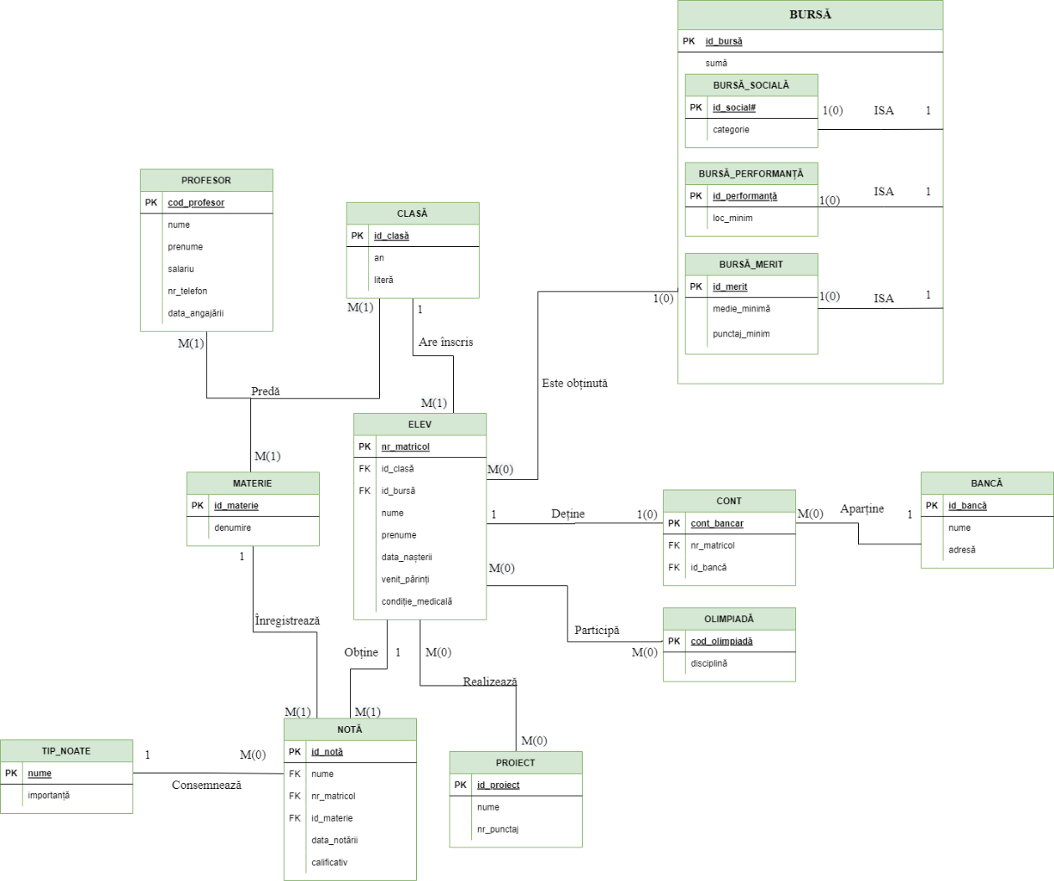

7. Realizarea diagramei conceptuale corespunzătoare diagramei entitate-relație proiectate la punctul 6. Diagrama conceptuală obținută trebuie să conțină minimum 6 tabele (fără considerarea subentităților), dintre care cel puțin un tabel asociativ.

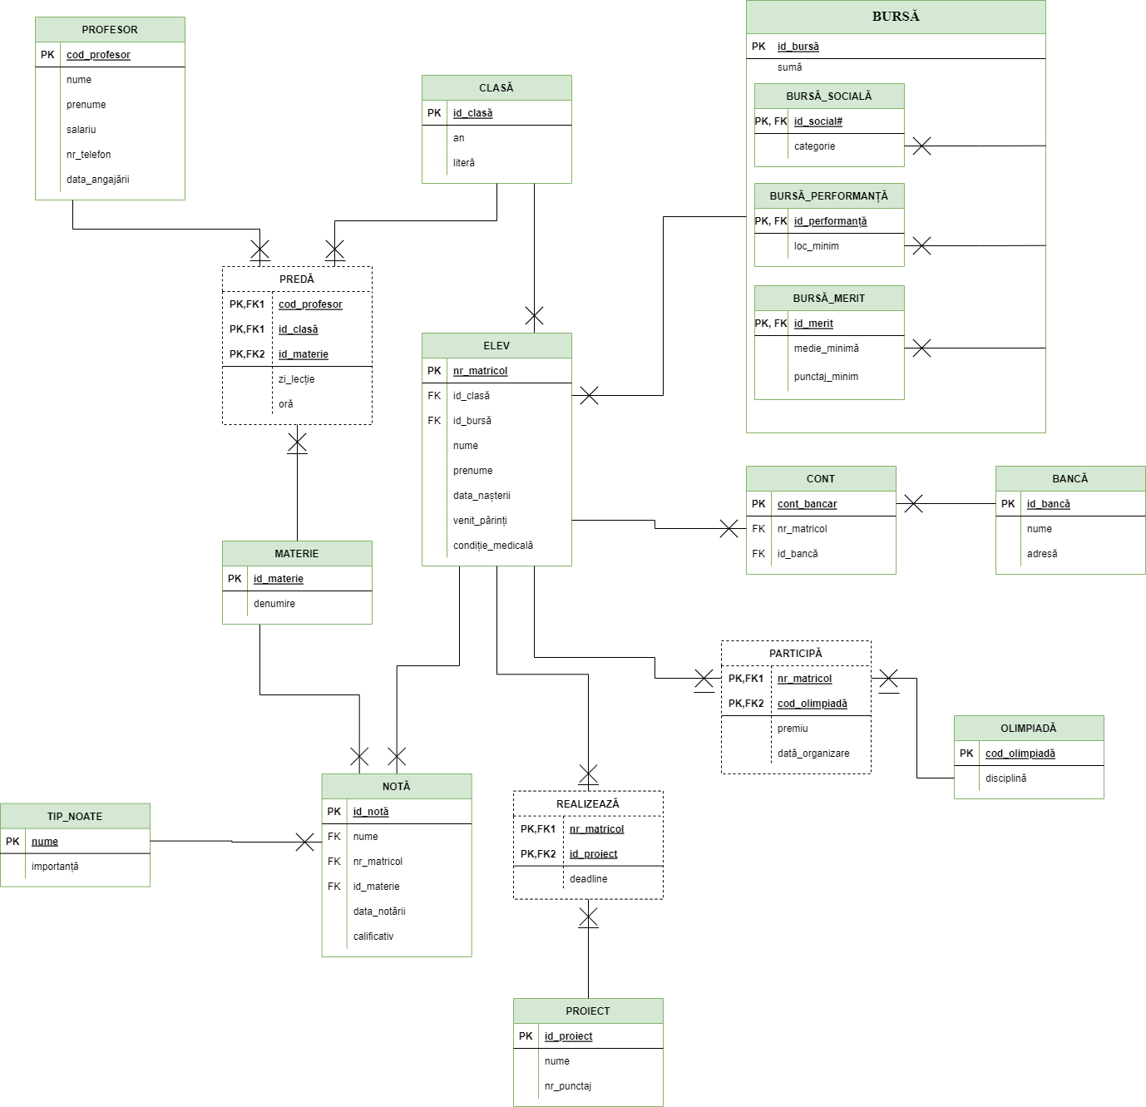

8. Enumerarea schemelor relaționale corespunzătoare diagramei conceptuale proiectate la punctul 7.

ELEV (nr_matricol #, id_clasă, id_bursă, nume, prenume, data_nașterii, venit_părinți, condiție_medicală)

CONT (cont_bancar #, nr_matricol, id_bancă)

BANCĂ (id_bancă #, nume, adresă)

CLASĂ (id_clasă #, an, literă)

PROFESOR (cod_profesor #, nume, prenume, salariu, nr_telefon, data_angajării)

PREDĂ (cod_profesor #, id_materie #, id_clasă #, zi_lecție, oră)

MATERIE (id_materie #, denumire)

NOTĂ (id_notă #, nume, nr_matricol, id_materie, data_notării, calificativ)

TIP_NOTARE (nume #, importanță)

REALIZEAZĂ (nr_matricol #, id_proiect #, deadline)

PROIECT (id_proiect #, nume, nr_punctaj)

PARTICIPĂ (nr_matricol #, cod_olimpiadă #, dată_organizare)

OLIMPIADĂ (cod_olimpiadă #, disciplină)

BURSĂ (id_bursă #, sumă)

BURSĂ_MERIT (id_merit #, medie_minimă, punctaj_minim)

BURSĂ_PERFORMANȚĂ (id_performanță #, loc_minim)

BURSĂ_SOCIALĂ (id_socială #, categorie)

9. Realizarea normalizarii pâna la forma normala 3 (FN1-FN3).

**NON FN1**

|  |  |
| --- | --- |
| **Id_clasă** | **Nume** |
| 101 | 10 C |
| 203 | 4 B |

**FN1**

|  |  |  |
| --- | --- | --- |
| **Id_clasă** | **An** | **Literă** |
| 101 | 10 | C |
| 203 | 4 | B |

O relaţie este în FN1 dacă domeniile pe care sunt definite atributele relaţiei sunt constituite numai din valori atomice. Aducerea relaţiilor în FN1 presupune eliminarea atributelor compuse şi a celor repetitive. În acest caz, coloana nume oferă informații atât despre anul de învățământ, cât și despre litera clasei. Pentru ca tabelul să fie în FN1, coloana nume se împarte în 2 coloane diferite: an (anul de învățământ) și literă (litera clasei).

**NON FN2**

|  |  |  |  |  |
| --- | --- | --- | --- | --- |
| **Id_materie** | **Denumire** | **Id_notă** | **Data_notarii** | **calificativ** |
| 10 | Fizica | 101 | 10-03-2020 | 8 |
| 10 | Fizica | 107 | 19-03-2020 | 9 |
| 11 | Chimie | 190 | 20-04-2020 | 8 |

**FN2**

|  |  |
| --- | --- |
| **#Id_materie** | **Denumire** |
| 10 | Fizica |
| 10 | Fizica |
| 11 | Chimie |

|  |  |  |  |
| --- | --- | --- | --- |
| **#Id_notă** | **#Id_materie** | **Data_notarii** | **calificativ** |
| 101 | 10 | 10-03-2020 | 8 |
| 107 | 10 | 19-03-2020 | 9 |
| 190 | 11 | 20-04-2020 | 8 |

O relaţie se află în a doua formă normală FN2 dacă se află în forma normală FN1 şi fiecare atribut care nu este cheie este dependent de întreaga cheie primară. Se observă că în primul tabel avem o cheie primară compusă (id_materie, id_notă). Atributul calificativ depinde doar de cheia id_notă, creându-se astfel o semidependență (nu depinde de ambele chei primare). De asemenea, atributul denumire depinde de cheia id_materie (analog cu exemplul anterior). Se obțin două tabele: primul va înregistra atributele id_materie și denumire, iar al doilea va conține id_notă, id_materie, data_notării, calificativ.  
**NON FN3**

|  |  |  |  |  |  |  |  |
| --- | --- | --- | --- | --- | --- | --- | --- |
| **Nr_matricol** | **Nume** | **Prenume** | **Data_nașterii** | **Venit_părinți** | **Condiție_medicală** | **Cont_bancar** | **Bancă** |
| 10111 | Marchitan | Nadia | 15-04-2002 | 6700 | 0 | RO329... | BT |

**FN3**

|  |  |  |
| --- | --- | --- |
| **Cont_bancar** | **Nr_matricol** | **Bancă** |
| R0329... | 10111 | BT |

|  |  |  |  |  |  |
| --- | --- | --- | --- | --- | --- |
| **Nr_matricol** | **Nume** | **Prenume** | **Data_nașterii** | **Venit_părinți** | **Condiție_medicală** |
| 10111 | Marchitan | Nadia | 15-04-2002 | 6700 | 0 |

O relaţie este în forma normală trei (FN3) dacă se găseşte în FN2 şi fiecare atribut care nu este cheie (nu participă la o cheie) depinde direct de cheia primară. În tabelul NON FN3 se poate observa că numele băncii nu depinde în mod direct de cheia primară (nr_matricol), ea depinzând de contul bancar. Astfel, pentru a converti tabela la FN3 împărțim tabela în 2: prima care va înregistra date despre cont (cont_bancar, bancă, nr_matricol) și a doua care va conține date despre elev.

10. Crearea unei secvențe ce va fi utilizată în inserarea înregistrărilor în tabele (punctul 11).

**create sequence generare_cod_olimpiada**

**Start with 10000**

**Increment by 1;**

11.Crearea tabelelor în SQL și inserarea de date coerente în fiecare dintre acestea (minimum 5 înregistrări în fiecare tabel neasociativ; minimum 10 înregistrări în tabelele asociative).

create table MATERIE (

id_materie number(2, 0) not null primary key,

denumire varchar2(20) not null

);

insert into MATERIE values (1, 'matematica');

insert into MATERIE values (2, 'chimie');

insert into MATERIE values (3, 'fizica');

insert into MATERIE values (4, 'sport');

insert into MATERIE values (5, 'informatica');

insert into MATERIE values (6, 'biologie');

insert into MATERIE values (7, 'psihologie');

insert into MATERIE values (8, 'limba romana');

insert into MATERIE values (9, 'limba franceza');

insert into MATERIE values (10, 'educatie civica');

insert into MATERIE values (11, 'muzica');

insert into MATERIE values (12, 'desen');

insert into MATERIE values (13, 'limba engleza');

insert into MATERIE values (14, 'TIC');

insert into MATERIE values (15, 'istorie');

insert into MATERIE values (16, 'geografie');

insert into MATERIE values (17, 'filozofie');

insert into MATERIE values (18, 'limba spaniola');

insert into MATERIE values (19, 'educatie tehnologica');

insert into MATERIE values (20, 'Optional PopCulture');

create table PROFESOR (

cod_profesor number(4, 0) not null primary key,

nume varchar2(20) not null,

prenume varchar2(20) not null,

salariu number(4, 0) not null,

nr_telefon varchar2(10) not null,

data_angajarii date not null

);

insert into PROFESOR values (200, 'dima', 'cezar', 3179, '0782446817', '25-03-2003');

insert into PROFESOR values (138, 'apostol', 'daria', 4800, '0797783548', '24-04-2008');

insert into PROFESOR values (5, 'amoraritei', 'cezar', 4567, '0717474711', '01-11-1984');

insert into PROFESOR values (161, 'penescu', 'cezar', 3413, '0711761768', '10-06-1998');

insert into PROFESOR values (124, 'apostol', 'cezar', 5681, '0769904924', '19-09-2007');

insert into PROFESOR values (22, 'scutaru', 'amalia', 4313, '0736818377', '15-02-1982');

insert into PROFESOR values (194, 'cojocaru', 'delia', 3482, '0734043134', '07-04-1994');

insert into PROFESOR values (48, 'scutaru', 'stefan', 3068, '0731248667', '11-08-2012');

insert into PROFESOR values (117, 'popovici', 'matei', 6193, '0761888769', '28-02-1998');

insert into PROFESOR values (191, 'apetrei', 'calin', 5112, '0759779287', '06-08-1980');

insert into PROFESOR values (23, 'amoraritei', 'delia', 4396, '0780343570', '17-03-2018');

insert into PROFESOR values (118, 'onciuleanu', 'calin', 3131, '0715530331', '08-01-2015');

insert into PROFESOR values (137, 'cuzic', 'cezar', 4166, '0736351626', '18-08-1993');

insert into PROFESOR values (90, 'alexa', 'elias', 4939, '0714248130', '04-06-2018');

insert into PROFESOR values (61, 'apetrei', 'daria', 6181, '0752436786', '15-07-2015');

insert into PROFESOR values (173, 'popovici', 'stefana', 4691, '0738737343', '01-03-2017');

insert into PROFESOR values (129, 'amoraritei', 'robert', 5647, '0762800380', '27-11-2008');

insert into PROFESOR values (199, 'amoraritei', 'daria', 6121, '0760141077', '02-07-1995');

insert into PROFESOR values (27, 'popescu', 'delia', 4337, '0740240855', '21-03-2012');

insert into PROFESOR values (152, 'popescu', 'valentin', 5252, '0763332056', '04-12-1985');

insert into PROFESOR values (136, 'cuzic', 'elias', 5716, '0774357097', '07-08-2019');

insert into PROFESOR values (128, 'amoraritei', 'matei', 3673, '0751863354', '02-02-1987');

insert into PROFESOR values (164, 'alexa', 'valentin', 5449, '0760084349', '16-02-2010');

create table CLASA (

id_clasa number(3, 0) not null primary key,

an number(2, 0) not null,

litera char(1) not null

);

insert into CLASA values (80, 12, 'A');

insert into CLASA values (81, 12, 'B');

insert into CLASA values (82, 12, 'C');

insert into CLASA values (83, 12, 'D');

insert into CLASA values (100, 10, 'A');

insert into CLASA values (101, 10, 'B');

insert into CLASA values (102, 10, 'C');

insert into CLASA values (103, 10, 'D');

insert into CLASA values (104, 11, 'A');

insert into CLASA values (105, 11, 'B');

insert into CLASA values (106, 11, 'C');

insert into CLASA values (107, 11, 'D');

insert into CLASA values (210, 9, 'A');

insert into CLASA values (211, 9, 'B');

insert into CLASA values (212, 9, 'C');

insert into CLASA values (213, 9, 'D');

insert into CLASA values (206, 8, 'A');

insert into CLASA values (207, 8, 'B');

insert into CLASA values (208, 8, 'C');

insert into CLASA values (209, 8, 'D');

insert into CLASA values (467, 3, 'A');

insert into CLASA values (468, 3, 'B');

insert into CLASA values (469, 3, 'C');

insert into CLASA values (470, 3, 'D');

insert into CLASA values (300, 2, 'A');

insert into CLASA values (301, 2, 'B');

insert into CLASA values (302, 2, 'C');

insert into CLASA values (303, 2, 'D');

insert into CLASA values (405, 0, 'A');

insert into CLASA values (406, 0, 'B');

insert into CLASA values (407, 0, 'C');

insert into CLASA values (408, 0, 'D');

insert into CLASA values (327, 1, 'A');

insert into CLASA values (328, 1, 'B');

insert into CLASA values (329, 1, 'C');

insert into CLASA values (330, 1, 'D');

insert into CLASA values (560, 4, 'A');

insert into CLASA values (561, 4, 'B');

insert into CLASA values (562, 4, 'C');

insert into CLASA values (563, 4, 'D');

insert into CLASA values (565, 5, 'A');

insert into CLASA values (566, 5, 'B');

insert into CLASA values (567, 5, 'C');

insert into CLASA values (568, 5, 'D');

insert into CLASA values (580, 6, 'A');

insert into CLASA values (581, 6, 'B');

insert into CLASA values (582, 6, 'C');

insert into CLASA values (583, 6, 'D');

insert into CLASA values (901, 7, 'A');

insert into CLASA values (902, 7, 'B');

insert into CLASA values (903, 7, 'C');

insert into CLASA values (904, 7, 'D');

create table ELEV (

nr_matricol number(5, 0) not null primary key,

id_clasa number(3, 0) not null,

id_bursa number(2, 0),

nume varchar2(20) not null,

prenume varchar2(20) not null,

data_nasterii date not null,

venit_parinti number(5, 0) not null,

conditie_medicala number(1, 0) not null,

foreign key(id_clasa) references CLASA(id_clasa),

foreign key(id_bursa) references BURSA(id_bursa)

);

insert into ELEV(nr_matricol, id_clasa, id_bursa, nume, prenume, data_nasterii, venit_parinti, conditie_medicala)

values (84753, 565, 72, 'pinzaru', 'claudia', '21-12-2011', 21140, 0);

insert into ELEV(nr_matricol, id_clasa, id_bursa, nume, prenume, data_nasterii, venit_parinti, conditie_medicala)

values (68559, 208, 10, 'birleanu', 'matei', '14-12-2008', 93395, 0);

insert into ELEV(nr_matricol, id_clasa, id_bursa, nume, prenume, data_nasterii, venit_parinti, conditie_medicala)

values (82323, 565, 57, 'berbecariu', 'irina', '29-07-2011', 50193, 0);

insert into ELEV(nr_matricol, id_clasa, id_bursa, nume, prenume, data_nasterii, venit_parinti, conditie_medicala)

values (51001, 406, 11, 'onciuleanu', 'andrei', '29-03-2016', 34350, 0);

insert into ELEV(nr_matricol, id_clasa, id_bursa, nume, prenume, data_nasterii, venit_parinti, conditie_medicala)

values (75503, 206, 56, 'boamba', 'stefana', '15-08-2008', 9245, 1);

insert into ELEV(nr_matricol, id_clasa, id_bursa, nume, prenume, data_nasterii, venit_parinti, conditie_medicala)

values (91860, 105, 70, 'meran', 'andreea', '05-04-2005', 15562, 0);

insert into ELEV(nr_matricol, id_clasa, id_bursa, nume, prenume, data_nasterii, venit_parinti, conditie_medicala)

values (26880, 581, 74, 'apostol', 'alexandru', '16-07-2010', 8367, 0);

insert into ELEV(nr_matricol, id_clasa, id_bursa, nume, prenume, data_nasterii, venit_parinti, conditie_medicala)

values (29056, 107, 10, 'boca', 'denis', '23-11-2005', 28143, 0);

insert into ELEV(nr_matricol, id_clasa, id_bursa, nume, prenume, data_nasterii, venit_parinti, conditie_medicala)

values (96444, 904, 83, 'stratu', 'denis', '15-08-2009', 81516, 0);

insert into ELEV(nr_matricol, id_clasa, id_bursa, nume, prenume, data_nasterii, venit_parinti, conditie_medicala)

values (79329, 565, 14, 'radu', 'teodor', '23-04-2011', 81248, 1);

insert into ELEV(nr_matricol, id_clasa, id_bursa, nume, prenume, data_nasterii, venit_parinti, conditie_medicala)

values (86076, 82, 70, 'jitareanu', 'matei', '18-11-2004', 71240, 0);

insert into ELEV(nr_matricol, id_clasa, id_bursa, nume, prenume, data_nasterii, venit_parinti, conditie_medicala)

values (70844, 582, 81, 'ursaciuc', 'valentina', '26-02-2010', 79813, 1);

insert into ELEV(nr_matricol, id_clasa, id_bursa, nume, prenume, data_nasterii, venit_parinti, conditie_medicala)

values (24372, 469, 12, 'scutaru', 'claudia', '05-03-2013', 54934, 1);

insert into ELEV(nr_matricol, id_clasa, id_bursa, nume, prenume, data_nasterii, venit_parinti, conditie_medicala)

values (64827, 106, 71, 'alexa', 'narcisa', '25-10-2005', 82845, 1);

insert into ELEV(nr_matricol, id_clasa, id_bursa, nume, prenume, data_nasterii, venit_parinti, conditie_medicala)

values (37363, 206, 13, 'ursaciuc', 'denis', '11-09-2008', 13476, 0);

insert into ELEV(nr_matricol, id_clasa, id_bursa, nume, prenume, data_nasterii, venit_parinti, conditie_medicala)

values (94748, 107, 74, 'mocanu', 'matei', '22-03-2005', 47514, 0);

insert into ELEV(nr_matricol, id_clasa, id_bursa, nume, prenume, data_nasterii, venit_parinti, conditie_medicala)

values (76040, 103, 56, 'popescu', 'daria', '01-08-2006', 81567, 1);

insert into ELEV(nr_matricol, id_clasa, id_bursa, nume, prenume, data_nasterii, venit_parinti, conditie_medicala)

values (92152, 329, 71, 'mindrescu', 'ionela', '01-04-2015', 9403, 1);

insert into ELEV(nr_matricol, id_clasa, id_bursa, nume, prenume, data_nasterii, venit_parinti, conditie_medicala)

values (76010, 100, 83, 'onciuleanu', 'bianca', '01-11-2006', 5090, 0);

insert into ELEV(nr_matricol, id_clasa, id_bursa, nume, prenume, data_nasterii, venit_parinti, conditie_medicala)

values (54140, 567, 11, 'dima', 'adrian', '25-07-2011', 23831, 0);

insert into ELEV(nr_matricol, id_clasa, id_bursa, nume, prenume, data_nasterii, venit_parinti, conditie_medicala)

values (80441, 102, 12, 'apostol', 'constantin', '17-11-2006', 59087, 0);

insert into ELEV(nr_matricol, id_clasa, id_bursa, nume, prenume, data_nasterii, venit_parinti, conditie_medicala)

values (87296, 904, 71, 'boamba', 'andrei', '16-09-2009', 24657, 0);

insert into ELEV(nr_matricol, id_clasa, nume, prenume, data_nasterii, venit_parinti, conditie_medicala)

values (22259, 406, 'cujba', 'miruna', '22-07-2016', 58934, 0);

insert into ELEV(nr_matricol, id_clasa, id_bursa, nume, prenume, data_nasterii, venit_parinti, conditie_medicala)

values (96820, 562, 10, 'tibulca', 'vasile', '15-08-2012', 31928, 1);

insert into ELEV(nr_matricol, id_clasa, id_bursa, nume, prenume, data_nasterii, venit_parinti, conditie_medicala)

values (52645, 407, 82, 'ursaciuc', 'constantin', '01-08-2016', 67114, 1);

insert into ELEV(nr_matricol, id_clasa, id_bursa, nume, prenume, data_nasterii, venit_parinti, conditie_medicala)

values (38923, 904, 10, 'boamba', 'daria', '07-05-2009', 81830, 0);

insert into ELEV(nr_matricol, id_clasa, id_bursa, nume, prenume, data_nasterii, venit_parinti, conditie_medicala)

values (68815, 563, 70, 'boca', 'constantin', '29-01-2012', 78509, 1);

insert into ELEV(nr_matricol, id_clasa, id_bursa, nume, prenume, data_nasterii, venit_parinti, conditie_medicala)

values (28349, 213, 12, 'alexa', 'andreea', '11-10-2007', 34271, 0);

insert into ELEV(nr_matricol, id_clasa, id_bursa, nume, prenume, data_nasterii, venit_parinti, conditie_medicala)

values (96433, 327, 12, 'basarab', 'eduard', '13-01-2015', 57721, 0);

insert into ELEV(nr_matricol, id_clasa, id_bursa, nume, prenume, data_nasterii, venit_parinti, conditie_medicala)

values (42545, 212, 13, 'cujba', 'irina', '27-12-2007', 93687, 1);

insert into ELEV(nr_matricol, id_clasa, id_bursa, nume, prenume, data_nasterii, venit_parinti, conditie_medicala)

values (32529, 566, 73, 'apetrei', 'antonia', '16-10-2011', 52561, 0);

insert into ELEV(nr_matricol, id_clasa, id_bursa, nume, prenume, data_nasterii, venit_parinti, conditie_medicala)

values (92092, 408, 14, 'onciuleanu', 'antonia', '17-05-2016', 48859, 0);

insert into ELEV(nr_matricol, id_clasa, id_bursa, nume, prenume, data_nasterii, venit_parinti, conditie_medicala)

values (34698, 566, 10, 'popescu', 'isabela', '23-01-2011', 84109, 0);

insert into ELEV(nr_matricol, id_clasa, id_bursa, nume, prenume, data_nasterii, venit_parinti, conditie_medicala)

values (27639, 210, 71, 'basarab', 'bianca', '03-12-2007', 48427, 0);

insert into ELEV(nr_matricol, id_clasa, id_bursa, nume, prenume, data_nasterii, venit_parinti, conditie_medicala)

values (68754, 902, 70, 'budeanu', 'vasile', '08-07-2009', 51124, 1);

insert into ELEV(nr_matricol, id_clasa, id_bursa, nume, prenume, data_nasterii, venit_parinti, conditie_medicala)

values (86863, 102, 81, 'cuzic', 'ionela', '11-06-2006', 29117, 0);

insert into ELEV(nr_matricol, id_clasa, id_bursa, nume, prenume, data_nasterii, venit_parinti, conditie_medicala)

values (83253, 406, 57, 'cojocaru', 'valentin', '17-05-2016', 34534, 0);

insert into ELEV(nr_matricol, id_clasa, id_bursa, nume, prenume, data_nasterii, venit_parinti, conditie_medicala)

values (76878, 563, 57, 'pinzaru', 'robert', '01-01-2012', 42879, 0);

insert into ELEV(nr_matricol, id_clasa, id_bursa, nume, prenume, data_nasterii, venit_parinti, conditie_medicala)

values (44926, 107, 12, 'berbecariu', 'ionela', '04-07-2005', 92036, 0);

insert into ELEV(nr_matricol, id_clasa, id_bursa, nume, prenume, data_nasterii, venit_parinti, conditie_medicala)

values (20632, 100, 11, 'boca', 'miruna', '06-02-2006', 86761, 0);

insert into ELEV(nr_matricol, id_clasa, id_bursa, nume, prenume, data_nasterii, venit_parinti, conditie_medicala)

values (10724, 582, 80, 'minecan', 'vasile', '18-01-2010', 52126, 0);

insert into ELEV(nr_matricol, id_clasa, nume, prenume, data_nasterii, venit_parinti, conditie_medicala)

values (62155, 105, 'minecan', 'irina', '07-01-2005', 83006, 0);

insert into ELEV(nr_matricol, id_clasa, id_bursa, nume, prenume, data_nasterii, venit_parinti, conditie_medicala)

values (91508, 208, 82, 'cojocaru', 'adrian', '19-04-2008', 1503, 1);

insert into ELEV(nr_matricol, id_clasa, id_bursa, nume, prenume, data_nasterii, venit_parinti, conditie_medicala)

values (41026, 566, 83, 'pinzaru', 'viviana', '29-10-2011', 10295, 1);

insert into ELEV(nr_matricol, id_clasa, id_bursa, nume, prenume, data_nasterii, venit_parinti, conditie_medicala)

values (23340, 104, 10, 'tibulca', 'valentin', '22-06-2005', 12211, 1);

insert into ELEV(nr_matricol, id_clasa, nume, prenume, data_nasterii, venit_parinti, conditie_medicala)

values (34835, 407, 'mocanu', 'bianca', '03-07-2016', 1323, 1);

insert into ELEV(nr_matricol, id_clasa, id_bursa, nume, prenume, data_nasterii, venit_parinti, conditie_medicala)

values (18071, 406, 74, 'penescu', 'sorin', '01-10-2016', 6111, 1);

insert into ELEV(nr_matricol, id_clasa, id_bursa, nume, prenume, data_nasterii, venit_parinti, conditie_medicala)

values (27592, 568, 73, 'scutaru', 'ionela', '15-02-2011', 27546, 1);

insert into ELEV(nr_matricol, id_clasa, id_bursa, nume, prenume, data_nasterii, venit_parinti, conditie_medicala)

values (43700, 563, 13, 'berbecariu', 'daria', '13-07-2012', 28864, 0);

insert into ELEV(nr_matricol, id_clasa, id_bursa, nume, prenume, data_nasterii, venit_parinti, conditie_medicala)

values (59547, 209, 74, 'stratu', 'mihai', '01-10-2008', 40105, 0);

insert into ELEV(nr_matricol, id_clasa, id_bursa, nume, prenume, data_nasterii, venit_parinti, conditie_medicala)

values (62599, 100, 70, 'berbecariu', 'ioana', '12-03-2006', 38916, 0);

insert into ELEV(nr_matricol, id_clasa, id_bursa, nume, prenume, data_nasterii, venit_parinti, conditie_medicala)

values (50404, 562, 56, 'cujba', 'dan', '16-09-2012', 6555, 0);

insert into ELEV(nr_matricol, id_clasa, id_bursa, nume, prenume, data_nasterii, venit_parinti, conditie_medicala)

values (18428, 405, 83, 'boca', 'matei', '07-08-2016', 10764, 0);

insert into ELEV(nr_matricol, id_clasa, nume, prenume, data_nasterii, venit_parinti, conditie_medicala)

values (56266, 80, 'mocanu', 'constantin', '04-05-2004', 96381, 1);

insert into ELEV(nr_matricol, id_clasa, id_bursa, nume, prenume, data_nasterii, venit_parinti, conditie_medicala)

values (12918, 583, 11, 'brinzac', 'mihaela', '10-02-2010', 57208, 0);

insert into ELEV(nr_matricol, id_clasa, id_bursa, nume, prenume, data_nasterii, venit_parinti, conditie_medicala)

values (96225, 567, 56, 'lungu', 'vasile', '10-05-2011', 94392, 0);

insert into ELEV(nr_matricol, id_clasa, id_bursa, nume, prenume, data_nasterii, venit_parinti, conditie_medicala)

values (74896, 83, 83, 'alexa', 'cosmin', '04-04-2004', 43837, 1);

insert into ELEV(nr_matricol, id_clasa, id_bursa, nume, prenume, data_nasterii, venit_parinti, conditie_medicala)

values (32993, 208, 13, 'cuzic', 'vasile', '05-10-2008', 13521, 1);

insert into ELEV(nr_matricol, id_clasa, id_bursa, nume, prenume, data_nasterii, venit_parinti, conditie_medicala)

values (33193, 104, 13, 'basarab', 'viviana', '11-07-2005', 85315, 0);

insert into ELEV(nr_matricol, id_clasa, id_bursa, nume, prenume, data_nasterii, venit_parinti, conditie_medicala)

values (71442, 903, 80, 'cujba', 'sorin', '19-10-2009', 59179, 0);

insert into ELEV(nr_matricol, id_clasa, id_bursa, nume, prenume, data_nasterii, venit_parinti, conditie_medicala)

values (50088, 210, 81, 'boamba', 'ionela', '07-02-2007', 79285, 0);

insert into ELEV(nr_matricol, id_clasa, id_bursa, nume, prenume, data_nasterii, venit_parinti, conditie_medicala)

values (46117, 207, 82, 'brinzac', 'irina', '15-09-2008', 14825, 1);

insert into ELEV(nr_matricol, id_clasa, id_bursa, nume, prenume, data_nasterii, venit_parinti, conditie_medicala)

values (83409, 211, 81, 'dima', 'dan', '25-05-2007', 16609, 1);

insert into ELEV(nr_matricol, id_clasa, id_bursa, nume, prenume, data_nasterii, venit_parinti, conditie_medicala)

values (53141, 583, 74, 'apostol', 'valentin', '13-10-2010', 70666, 1);

insert into ELEV(nr_matricol, id_clasa, id_bursa, nume, prenume, data_nasterii, venit_parinti, conditie_medicala)

values (89636, 330, 10, 'apostol', 'eduard', '19-12-2015', 16377, 1);

insert into ELEV(nr_matricol, id_clasa, id_bursa, nume, prenume, data_nasterii, venit_parinti, conditie_medicala)

values (61529, 300, 10, 'popovici', 'narcisa', '21-11-2014', 50049, 0);

insert into ELEV(nr_matricol, id_clasa, id_bursa, nume, prenume, data_nasterii, venit_parinti, conditie_medicala)

values (78503, 405, 14, 'onciuleanu', 'gabriela', '22-03-2016', 57973, 1);

insert into ELEV(nr_matricol, id_clasa, id_bursa, nume, prenume, data_nasterii, venit_parinti, conditie_medicala)

values (38732, 210, 14, 'onciuleanu', 'mihai', '06-08-2007', 10901, 0);

insert into ELEV(nr_matricol, id_clasa, nume, prenume, data_nasterii, venit_parinti, conditie_medicala)

values (56992, 100, 'clem', 'roland', '01-02-2006', 93052, 0);

insert into ELEV(nr_matricol, id_clasa, id_bursa, nume, prenume, data_nasterii, venit_parinti, conditie_medicala)

values (19081, 207, 71, 'maftei', 'vlad', '28-04-2008', 7156, 1);

insert into ELEV(nr_matricol, id_clasa, id_bursa, nume, prenume, data_nasterii, venit_parinti, conditie_medicala)

values (56592, 328, 57, 'jitareanu', 'irina', '12-06-2015', 21457, 0);

insert into ELEV(nr_matricol, id_clasa, id_bursa, nume, prenume, data_nasterii, venit_parinti, conditie_medicala)

values (42496, 211, 82, 'bistriceanu', 'cosmin', '13-08-2007', 86702, 1);

insert into ELEV(nr_matricol, id_clasa, id_bursa, nume, prenume, data_nasterii, venit_parinti, conditie_medicala)

values (57624, 560, 13, 'basarab', 'constantin', '21-09-2012', 15697, 1);

insert into ELEV(nr_matricol, id_clasa, id_bursa, nume, prenume, data_nasterii, venit_parinti, conditie_medicala)

values (11921, 211, 13, 'stefanoaia', 'cosmin', '15-02-2007', 87366, 1);

insert into ELEV(nr_matricol, id_clasa, id_bursa, nume, prenume, data_nasterii, venit_parinti, conditie_medicala)

values (65749, 83, 71, 'mindrescu', 'narcisa', '23-03-2004', 72473, 1);

insert into ELEV(nr_matricol, id_clasa, id_bursa, nume, prenume, data_nasterii, venit_parinti, conditie_medicala)

values (34754, 210, 73, 'meran', 'mihaela', '17-05-2007', 53392, 1);

insert into ELEV(nr_matricol, id_clasa, id_bursa, nume, prenume, data_nasterii, venit_parinti, conditie_medicala)

values (47791, 583, 81, 'boamba', 'valentina', '13-05-2010', 34099, 0);

insert into ELEV(nr_matricol, id_clasa, id_bursa, nume, prenume, data_nasterii, venit_parinti, conditie_medicala)

values (90522, 105, 56, 'cujba', 'valentina', '29-01-2005', 29652, 0);

insert into ELEV(nr_matricol, id_clasa, id_bursa, nume, prenume, data_nasterii, venit_parinti, conditie_medicala)

values (25531, 210, 74, 'ursaciuc', 'gabriela', '01-08-2007', 81731, 1);

insert into ELEV(nr_matricol, id_clasa, id_bursa, nume, prenume, data_nasterii, venit_parinti, conditie_medicala)

values (93405, 904, 56, 'jitareanu', 'dan', '23-12-2009', 76985, 0);

insert into ELEV(nr_matricol, id_clasa, id_bursa, nume, prenume, data_nasterii, venit_parinti, conditie_medicala)

values (47700, 904, 56, 'boca', 'sorin', '01-09-2009', 49921, 0);

insert into ELEV(nr_matricol, id_clasa, id_bursa, nume, prenume, data_nasterii, venit_parinti, conditie_medicala)

values (14071, 213, 13, 'pinzaru', 'miruna', '01-03-2007', 86294, 0);

insert into ELEV(nr_matricol, id_clasa, id_bursa, nume, prenume, data_nasterii, venit_parinti, conditie_medicala)

values (30562, 106, 74, 'radu', 'constantin', '16-04-2005', 83356, 0);

insert into ELEV(nr_matricol, id_clasa, id_bursa, nume, prenume, data_nasterii, venit_parinti, conditie_medicala)

values (68919, 581, 56, 'amoraritei', 'viviana', '10-04-2010', 86339, 0);

insert into ELEV(nr_matricol, id_clasa, id_bursa, nume, prenume, data_nasterii, venit_parinti, conditie_medicala)

values (28871, 208, 57, 'lungu', 'miruna', '28-09-2008', 11985, 0);

insert into ELEV(nr_matricol, id_clasa, id_bursa, nume, prenume, data_nasterii, venit_parinti, conditie_medicala)

values (74618, 211, 11, 'jitareanu', 'denis', '27-06-2007', 43302, 1);

insert into ELEV(nr_matricol, id_clasa, id_bursa, nume, prenume, data_nasterii, venit_parinti, conditie_medicala)

values (60640, 213, 56, 'mindrescu', 'isabela', '29-02-2007', 70861, 0);

insert into ELEV(nr_matricol, id_clasa, id_bursa, nume, prenume, data_nasterii, venit_parinti, conditie_medicala)

values (62879, 407, 70, 'budeanu', 'cosmin', '01-01-2016', 31788, 0);

insert into ELEV(nr_matricol, id_clasa, id_bursa, nume, prenume, data_nasterii, venit_parinti, conditie_medicala)

values (88042, 209, 74, 'apetrei', 'alexandru', '09-02-2008', 51972, 0);

insert into ELEV(nr_matricol, id_clasa, id_bursa, nume, prenume, data_nasterii, venit_parinti, conditie_medicala)

values (51136, 566, 71, 'dima', 'antonia', '22-04-2011', 8992, 0);

insert into ELEV(nr_matricol, id_clasa, id_bursa, nume, prenume, data_nasterii, venit_parinti, conditie_medicala)

values (19950, 561, 71, 'maftei', 'andrei', '22-06-2012', 27370, 0);

insert into ELEV(nr_matricol, id_clasa, id_bursa, nume, prenume, data_nasterii, venit_parinti, conditie_medicala)

values (97600, 101, 10, 'tibulca', 'narcisa', '28-06-2006', 70069, 1);

insert into ELEV(nr_matricol, id_clasa, id_bursa, nume, prenume, data_nasterii, venit_parinti, conditie_medicala)

values (73076, 562, 56, 'mindrescu', 'andreea', '18-07-2012', 46719, 0);

insert into ELEV(nr_matricol, id_clasa, id_bursa, nume, prenume, data_nasterii, venit_parinti, conditie_medicala)

values (87819, 408, 72, 'scutaru', 'mihaela', '08-02-2016', 53578, 0);

insert into ELEV(nr_matricol, id_clasa, id_bursa, nume, prenume, data_nasterii, venit_parinti, conditie_medicala)

values (22438, 104, 12, 'brinzac', 'narcisa', '23-04-2005', 36394, 0);

insert into ELEV(nr_matricol, id_clasa, id_bursa, nume, prenume, data_nasterii, venit_parinti, conditie_medicala)

values (48660, 329, 13, 'meran', 'vasile', '15-12-2015', 65436, 0);

insert into ELEV(nr_matricol, id_clasa, id_bursa, nume, prenume, data_nasterii, venit_parinti, conditie_medicala)

values (50343, 902, 12, 'scutaru', 'robert', '17-01-2009', 79454, 1);

insert into ELEV(nr_matricol, id_clasa, id_bursa, nume, prenume, data_nasterii, venit_parinti, conditie_medicala)

values (60053, 102, 83, 'boca', 'vasile', '04-05-2006', 41620, 1);

insert into ELEV(nr_matricol, id_clasa, id_bursa, nume, prenume, data_nasterii, venit_parinti, conditie_medicala)

values (55839, 103, 56, 'tibulca', 'andreea', '07-03-2006', 12510, 0);

insert into ELEV(nr_matricol, id_clasa, id_bursa, nume, prenume, data_nasterii, venit_parinti, conditie_medicala)

values (31643, 211, 56, 'munteanu', 'vasile', '12-08-2007', 27000, 1);

insert into ELEV(nr_matricol, id_clasa, id_bursa, nume, prenume, data_nasterii, venit_parinti, conditie_medicala)

values (10851, 902, 56, 'cuzic', 'valentin', '25-06-2009', 30006, 0);

insert into ELEV(nr_matricol, id_clasa, id_bursa, nume, prenume, data_nasterii, venit_parinti, conditie_medicala)

values (47221, 902, 10, 'popescu', 'denis', '14-02-2009', 12758, 1);

insert into ELEV(nr_matricol, id_clasa, id_bursa, nume, prenume, data_nasterii, venit_parinti, conditie_medicala)

values (58021, 212, 14, 'apetrei', 'viviana', '24-03-2007', 35876, 1);

insert into ELEV(nr_matricol, id_clasa, id_bursa, nume, prenume, data_nasterii, venit_parinti, conditie_medicala)

values (70746, 302, 73, 'birleanu', 'dan', '06-08-2014', 42424, 1);

insert into ELEV(nr_matricol, id_clasa, id_bursa, nume, prenume, data_nasterii, venit_parinti, conditie_medicala)

values (65572, 303, 81, 'cuzic', 'cosmin', '24-02-2014', 11425, 0);

insert into ELEV(nr_matricol, id_clasa, id_bursa, nume, prenume, data_nasterii, venit_parinti, conditie_medicala)

values (43241, 329, 57, 'cujba', 'andreea', '13-02-2015', 41773, 0);

insert into ELEV(nr_matricol, id_clasa, id_bursa, nume, prenume, data_nasterii, venit_parinti, conditie_medicala)

values (18140, 562, 10, 'mindrescu', 'denis', '09-09-2012', 89376, 0);

insert into ELEV(nr_matricol, id_clasa, id_bursa, nume, prenume, data_nasterii, venit_parinti, conditie_medicala)

values (35746, 213, 70, 'popovici', 'mihaela', '23-07-2007', 63865, 0);

insert into ELEV(nr_matricol, id_clasa, id_bursa, nume, prenume, data_nasterii, venit_parinti, conditie_medicala)

values (74002, 100, 80, 'meran', 'ioana', '20-09-2006', 43900, 0);

insert into ELEV(nr_matricol, id_clasa, nume, prenume, data_nasterii, venit_parinti, conditie_medicala)

values (19527, 300, 'cojocaru', 'valentina', '06-01-2014', 67533, 1);

insert into ELEV(nr_matricol, id_clasa, id_bursa, nume, prenume, data_nasterii, venit_parinti, conditie_medicala)

values (49626, 901, 12, 'cojocaru', 'viviana', '01-11-2009', 74727, 1);

insert into ELEV(nr_matricol, id_clasa, id_bursa, nume, prenume, data_nasterii, venit_parinti, conditie_medicala)

values (80436, 100, 10, 'scutaru', 'daria', '24-01-2006', 62862, 0);

insert into ELEV(nr_matricol, id_clasa, id_bursa, nume, prenume, data_nasterii, venit_parinti, conditie_medicala)

values (68934, 101, 11, 'clem', 'cosmin', '07-04-2006', 59948, 1);

insert into ELEV(nr_matricol, id_clasa, id_bursa, nume, prenume, data_nasterii, venit_parinti, conditie_medicala)

values (62768, 100, 14, 'munteanu', 'andreea', '17-06-2006', 19497, 1);

insert into ELEV(nr_matricol, id_clasa, id_bursa, nume, prenume, data_nasterii, venit_parinti, conditie_medicala)

values (16246, 903, 70, 'basarab', 'teodor', '05-05-2009', 11873, 1);

insert into ELEV(nr_matricol, id_clasa, id_bursa, nume, prenume, data_nasterii, venit_parinti, conditie_medicala)

values (33594, 568, 72, 'brinzac', 'bianca', '02-03-2011', 31613, 0);

insert into ELEV(nr_matricol, id_clasa, id_bursa, nume, prenume, data_nasterii, venit_parinti, conditie_medicala)

values (35941, 565, 10, 'dima', 'constantin', '02-10-2011', 24115, 1);

insert into ELEV(nr_matricol, id_clasa, id_bursa, nume, prenume, data_nasterii, venit_parinti, conditie_medicala)

values (51850, 901, 73, 'cuzic', 'miruna', '11-12-2009', 72071, 0);

insert into ELEV(nr_matricol, id_clasa, id_bursa, nume, prenume, data_nasterii, venit_parinti, conditie_medicala)

values (32114, 303, 13, 'radu', 'andrei', '20-05-2014', 64871, 1);

insert into ELEV(nr_matricol, id_clasa, id_bursa, nume, prenume, data_nasterii, venit_parinti, conditie_medicala)

values (43582, 207, 70, 'apetrei', 'gabriela', '18-10-2008', 97489, 0);

insert into ELEV(nr_matricol, id_clasa, id_bursa, nume, prenume, data_nasterii, venit_parinti, conditie_medicala)

values (50328, 212, 82, 'minecan', 'dan', '28-02-2007', 63560, 0);

insert into ELEV(nr_matricol, id_clasa, id_bursa, nume, prenume, data_nasterii, venit_parinti, conditie_medicala)

values (74919, 82, 70, 'ursaciuc', 'adrian', '06-09-2004', 69176, 1);

insert into ELEV(nr_matricol, id_clasa, id_bursa, nume, prenume, data_nasterii, venit_parinti, conditie_medicala)

values (77523, 300, 14, 'popovici', 'dan', '04-12-2014', 30642, 0);

insert into ELEV(nr_matricol, id_clasa, id_bursa, nume, prenume, data_nasterii, venit_parinti, conditie_medicala)

values (96507, 563, 10, 'apostol', 'narcisa', '11-08-2012', 39865, 1);

insert into ELEV(nr_matricol, id_clasa, id_bursa, nume, prenume, data_nasterii, venit_parinti, conditie_medicala)

values (13841, 103, 56, 'minecan', 'denis', '27-12-2006', 20402, 1);

insert into ELEV(nr_matricol, id_clasa, id_bursa, nume, prenume, data_nasterii, venit_parinti, conditie_medicala)

values (57659, 583, 13, 'lungu', 'dan', '06-11-2010', 10544, 0);

insert into ELEV(nr_matricol, id_clasa, id_bursa, nume, prenume, data_nasterii, venit_parinti, conditie_medicala)

values (52026, 328, 71, 'stratu', 'miruna', '21-10-2015', 68889, 0);

insert into ELEV(nr_matricol, id_clasa, id_bursa, nume, prenume, data_nasterii, venit_parinti, conditie_medicala)

values (21259, 582, 80, 'maftei', 'ioana', '10-09-2010', 56839, 0);

insert into ELEV(nr_matricol, id_clasa, id_bursa, nume, prenume, data_nasterii, venit_parinti, conditie_medicala)

values (48445, 408, 10, 'maftei', 'adrian', '27-12-2016', 83459, 0);

insert into ELEV(nr_matricol, id_clasa, nume, prenume, data_nasterii, venit_parinti, conditie_medicala)

values (37064, 583, 'tibulca', 'alexandru', '07-07-2010', 12412, 0);

insert into ELEV(nr_matricol, id_clasa, id_bursa, nume, prenume, data_nasterii, venit_parinti, conditie_medicala)

values (44230, 566, 57, 'stratu', 'viviana', '19-05-2011', 31175, 0);

insert into ELEV(nr_matricol, id_clasa, id_bursa, nume, prenume, data_nasterii, venit_parinti, conditie_medicala)

values (18418, 209, 83, 'birleanu', 'teodor', '04-07-2008', 6899, 0);

insert into ELEV(nr_matricol, id_clasa, id_bursa, nume, prenume, data_nasterii, venit_parinti, conditie_medicala)

values (69131, 901, 80, 'stefanoaia', 'stefana', '02-05-2009', 31738, 0);

insert into ELEV(nr_matricol, id_clasa, id_bursa, nume, prenume, data_nasterii, venit_parinti, conditie_medicala)

values (36613, 102, 10, 'clem', 'miruna', '25-07-2006', 46812, 0);

insert into ELEV(nr_matricol, id_clasa, id_bursa, nume, prenume, data_nasterii, venit_parinti, conditie_medicala)

values (79654, 904, 82, 'stefanoaia', 'miruna', '13-09-2009', 69657, 0);

insert into ELEV(nr_matricol, id_clasa, id_bursa, nume, prenume, data_nasterii, venit_parinti, conditie_medicala)

values (75937, 107, 82, 'apetrei', 'miruna', '27-07-2005', 10080, 1);

insert into ELEV(nr_matricol, id_clasa, nume, prenume, data_nasterii, venit_parinti, conditie_medicala)

values (12310, 563, 'maftei', 'mihaela', '25-04-2012', 97318, 1);

insert into ELEV(nr_matricol, id_clasa, id_bursa, nume, prenume, data_nasterii, venit_parinti, conditie_medicala)

values (59946, 565, 10, 'popescu', 'mihai', '05-05-2011', 61619, 1);

insert into ELEV(nr_matricol, id_clasa, id_bursa, nume, prenume, data_nasterii, venit_parinti, conditie_medicala)

values (37068, 468, 80, 'stefanoaia', 'teodor', '07-08-2013', 5355, 0);

insert into ELEV(nr_matricol, id_clasa, id_bursa, nume, prenume, data_nasterii, venit_parinti, conditie_medicala)

values (93311, 104, 74, 'cozorici', 'vasile', '11-01-2005', 75595, 0);

insert into ELEV(nr_matricol, id_clasa, id_bursa, nume, prenume, data_nasterii, venit_parinti, conditie_medicala)

values (69484, 328, 74, 'lungu', 'claudia', '04-11-2015', 21220, 1);

insert into ELEV(nr_matricol, id_clasa, id_bursa, nume, prenume, data_nasterii, venit_parinti, conditie_medicala)

values (65663, 470, 73, 'mocanu', 'ionela', '14-02-2013', 65508, 1);

insert into ELEV(nr_matricol, id_clasa, id_bursa, nume, prenume, data_nasterii, venit_parinti, conditie_medicala)

values (44668, 212, 10, 'lungu', 'teodor', '14-11-2007', 94806, 0);

insert into ELEV(nr_matricol, id_clasa, id_bursa, nume, prenume, data_nasterii, venit_parinti, conditie_medicala)

values (92362, 330, 71, 'meran', 'constantin', '05-04-2015', 60766, 0);

insert into ELEV(nr_matricol, id_clasa, id_bursa, nume, prenume, data_nasterii, venit_parinti, conditie_medicala)

values (48514, 106, 56, 'minecan', 'teodor', '15-12-2005', 56606, 1);

insert into ELEV(nr_matricol, id_clasa, id_bursa, nume, prenume, data_nasterii, venit_parinti, conditie_medicala)

values (21499, 469, 11, 'amoraritei', 'antonia', '19-08-2013', 1024, 1);

insert into ELEV(nr_matricol, id_clasa, id_bursa, nume, prenume, data_nasterii, venit_parinti, conditie_medicala)

values (19024, 561, 81, 'onciuleanu', 'petruta', '11-04-2012', 16921, 0);

insert into ELEV(nr_matricol, id_clasa, id_bursa, nume, prenume, data_nasterii, venit_parinti, conditie_medicala)

values (53849, 903, 80, 'brinzac', 'matei', '17-07-2009', 66063, 0);

insert into ELEV(nr_matricol, id_clasa, id_bursa, nume, prenume, data_nasterii, venit_parinti, conditie_medicala)

values (13483, 567, 83, 'popescu', 'mihaela', '29-06-2011', 65037, 1);

insert into ELEV(nr_matricol, id_clasa, id_bursa, nume, prenume, data_nasterii, venit_parinti, conditie_medicala)

values (39894, 563, 70, 'cozorici', 'sorin', '01-01-2012', 73329, 1);

insert into ELEV(nr_matricol, id_clasa, id_bursa, nume, prenume, data_nasterii, venit_parinti, conditie_medicala)

values (93563, 102, 83, 'boca', 'antonia', '20-07-2006', 41812, 1);

insert into ELEV(nr_matricol, id_clasa, id_bursa, nume, prenume, data_nasterii, venit_parinti, conditie_medicala)

values (64500, 302, 10, 'onciuleanu', 'denis', '20-09-2014', 60715, 1);

insert into ELEV(nr_matricol, id_clasa, id_bursa, nume, prenume, data_nasterii, venit_parinti, conditie_medicala)

values (85915, 567, 10, 'apostol', 'adrian', '01-03-2011', 64095, 1);

insert into ELEV(nr_matricol, id_clasa, id_bursa, nume, prenume, data_nasterii, venit_parinti, conditie_medicala)

values (29203, 562, 74, 'cojocaru', 'gabriela', '13-07-2012', 73390, 1);

insert into ELEV(nr_matricol, id_clasa, id_bursa, nume, prenume, data_nasterii, venit_parinti, conditie_medicala)

values (49485, 902, 57, 'mindrescu', 'stefana', '03-05-2009', 67308, 0);

insert into ELEV(nr_matricol, id_clasa, id_bursa, nume, prenume, data_nasterii, venit_parinti, conditie_medicala)

values (27284, 207, 70, 'radu', 'eduard', '09-10-2008', 27980, 1);

insert into ELEV(nr_matricol, id_clasa, id_bursa, nume, prenume, data_nasterii, venit_parinti, conditie_medicala)

values (71488, 562, 70, 'ursaciuc', 'andrei', '26-07-2012', 94251, 0);

insert into ELEV(nr_matricol, id_clasa, id_bursa, nume, prenume, data_nasterii, venit_parinti, conditie_medicala)

values (93017, 405, 83, 'dima', 'andrei', '16-09-2016', 34653, 0);

insert into ELEV(nr_matricol, id_clasa, id_bursa, nume, prenume, data_nasterii, venit_parinti, conditie_medicala)

values (46134, 101, 12, 'pinzaru', 'vlad', '25-11-2006', 59800, 1);

insert into ELEV(nr_matricol, id_clasa, id_bursa, nume, prenume, data_nasterii, venit_parinti, conditie_medicala)

values (53820, 301, 83, 'popescu', 'alexandru', '05-02-2014', 70621, 1);

insert into ELEV(nr_matricol, id_clasa, id_bursa, nume, prenume, data_nasterii, venit_parinti, conditie_medicala)

values (24807, 408, 81, 'stefanoaia', 'daria', '04-01-2016', 18850, 0);

insert into ELEV(nr_matricol, id_clasa, id_bursa, nume, prenume, data_nasterii, venit_parinti, conditie_medicala)

values (28147, 206, 12, 'apostol', 'matei', '26-11-2008', 74455, 0);

insert into ELEV(nr_matricol, id_clasa, id_bursa, nume, prenume, data_nasterii, venit_parinti, conditie_medicala)

values (23302, 207, 70, 'berbecariu', 'denis', '18-06-2008', 63866, 0);

insert into ELEV(nr_matricol, id_clasa, id_bursa, nume, prenume, data_nasterii, venit_parinti, conditie_medicala)

values (29375, 583, 12, 'jitareanu', 'vasile', '17-06-2010', 22209, 0);

insert into ELEV(nr_matricol, id_clasa, id_bursa, nume, prenume, data_nasterii, venit_parinti, conditie_medicala)

values (27410, 83, 11, 'cozorici', 'robert', '21-09-2004', 41066, 0);

insert into ELEV(nr_matricol, id_clasa, id_bursa, nume, prenume, data_nasterii, venit_parinti, conditie_medicala)

values (34006, 583, 56, 'minecan', 'roland', '25-11-2010', 20999, 0);

insert into ELEV(nr_matricol, id_clasa, id_bursa, nume, prenume, data_nasterii, venit_parinti, conditie_medicala)

values (35031, 904, 70, 'budeanu', 'dan', '04-10-2009', 83534, 1);

insert into ELEV(nr_matricol, id_clasa, id_bursa, nume, prenume, data_nasterii, venit_parinti, conditie_medicala)

values (28313, 80, 13, 'lungu', 'miruna', '17-06-2004', 15221, 1);

insert into ELEV(nr_matricol, id_clasa, id_bursa, nume, prenume, data_nasterii, venit_parinti, conditie_medicala)

values (37724, 107, 13, 'bistriceanu', 'matei', '04-02-2005', 33533, 1);

insert into ELEV(nr_matricol, id_clasa, id_bursa, nume, prenume, data_nasterii, venit_parinti, conditie_medicala)

values (13134, 562, 10, 'boca', 'andreea', '12-11-2012', 32062, 1);

insert into ELEV(nr_matricol, id_clasa, id_bursa, nume, prenume, data_nasterii, venit_parinti, conditie_medicala)

values (99281, 901, 74, 'boamba', 'gabriela', '06-08-2009', 32086, 0);

insert into ELEV(nr_matricol, id_clasa, id_bursa, nume, prenume, data_nasterii, venit_parinti, conditie_medicala)

values (34123, 206, 72, 'amoraritei', 'vlad', '11-07-2008', 46861, 1);

insert into ELEV(nr_matricol, id_clasa, id_bursa, nume, prenume, data_nasterii, venit_parinti, conditie_medicala)

values (43924, 303, 11, 'meran', 'narcisa', '10-12-2014', 46222, 0);

insert into ELEV(nr_matricol, id_clasa, id_bursa, nume, prenume, data_nasterii, venit_parinti, conditie_medicala)

values (44843, 210, 13, 'cuzic', 'andrei', '11-10-2007', 25036, 1);

insert into ELEV(nr_matricol, id_clasa, id_bursa, nume, prenume, data_nasterii, venit_parinti, conditie_medicala)

values (51360, 567, 80, 'apetrei', 'mihaela', '10-11-2011', 20732, 0);

insert into ELEV(nr_matricol, id_clasa, id_bursa, nume, prenume, data_nasterii, venit_parinti, conditie_medicala)

values (55082, 470, 13, 'cojocaru', 'constantin', '07-07-2013', 50471, 1);

insert into ELEV(nr_matricol, id_clasa, id_bursa, nume, prenume, data_nasterii, venit_parinti, conditie_medicala)

values (10478, 102, 14, 'penescu', 'stefana', '13-12-2006', 12907, 0);

insert into ELEV(nr_matricol, id_clasa, id_bursa, nume, prenume, data_nasterii, venit_parinti, conditie_medicala)

values (98527, 468, 72, 'mindrescu', 'petruta', '26-07-2013', 79903, 1);

insert into ELEV(nr_matricol, id_clasa, id_bursa, nume, prenume, data_nasterii, venit_parinti, conditie_medicala)

values (57082, 566, 11, 'pinzaru', 'irina', '22-02-2011', 99716, 1);

insert into ELEV(nr_matricol, id_clasa, id_bursa, nume, prenume, data_nasterii, venit_parinti, conditie_medicala)

values (41827, 207, 82, 'clem', 'andreea', '19-06-2008', 38662, 0);

insert into ELEV(nr_matricol, id_clasa, id_bursa, nume, prenume, data_nasterii, venit_parinti, conditie_medicala)

values (18974, 467, 81, 'penescu', 'petruta', '20-09-2013', 20291, 0);

insert into ELEV(nr_matricol, id_clasa, id_bursa, nume, prenume, data_nasterii, venit_parinti, conditie_medicala)

values (79905, 209, 82, 'boamba', 'sorin', '14-09-2008', 52046, 0);

insert into ELEV(nr_matricol, id_clasa, id_bursa, nume, prenume, data_nasterii, venit_parinti, conditie_medicala)

values (65016, 566, 14, 'popovici', 'valentin', '08-02-2011', 98161, 0);

insert into ELEV(nr_matricol, id_clasa, id_bursa, nume, prenume, data_nasterii, venit_parinti, conditie_medicala)

values (16576, 211, 83, 'onciuleanu', 'adrian', '12-03-2007', 54253, 0);

insert into ELEV(nr_matricol, id_clasa, id_bursa, nume, prenume, data_nasterii, venit_parinti, conditie_medicala)

values (88151, 330, 74, 'jitareanu', 'roland', '01-10-2015', 60951, 0);

insert into ELEV(nr_matricol, id_clasa, id_bursa, nume, prenume, data_nasterii, venit_parinti, conditie_medicala)

values (74287, 470, 80, 'scutaru', 'valentin', '13-01-2013', 35101, 1);

insert into ELEV(nr_matricol, id_clasa, id_bursa, nume, prenume, data_nasterii, venit_parinti, conditie_medicala)

values (47413, 105, 74, 'mindrescu', 'ioana', '20-03-2005', 75058, 1);

insert into ELEV(nr_matricol, id_clasa, id_bursa, nume, prenume, data_nasterii, venit_parinti, conditie_medicala)

values (80664, 208, 13, 'cujba', 'adrian', '07-11-2008', 55165, 1);

insert into ELEV(nr_matricol, id_clasa, id_bursa, nume, prenume, data_nasterii, venit_parinti, conditie_medicala)

values (38325, 328, 12, 'birleanu', 'miruna', '28-05-2015', 98858, 0);

insert into ELEV(nr_matricol, id_clasa, id_bursa, nume, prenume, data_nasterii, venit_parinti, conditie_medicala)

values (95282, 303, 12, 'amoraritei', 'claudia', '11-12-2014', 16833, 1);

insert into ELEV(nr_matricol, id_clasa, id_bursa, nume, prenume, data_nasterii, venit_parinti, conditie_medicala)

values (46288, 567, 72, 'berbecariu', 'miruna', '01-12-2011', 87543, 0);

insert into ELEV(nr_matricol, id_clasa, id_bursa, nume, prenume, data_nasterii, venit_parinti, conditie_medicala)

values (68183, 107, 73, 'scutaru', 'andreea', '24-05-2005', 89541, 0);

insert into ELEV(nr_matricol, id_clasa, id_bursa, nume, prenume, data_nasterii, venit_parinti, conditie_medicala)

values (39027, 213, 71, 'jitareanu', 'constantin', '15-01-2007', 69353, 1);

insert into ELEV(nr_matricol, id_clasa, id_bursa, nume, prenume, data_nasterii, venit_parinti, conditie_medicala)

values (85050, 903, 57, 'apostol', 'viviana', '09-10-2009', 60662, 0);

insert into ELEV(nr_matricol, id_clasa, id_bursa, nume, prenume, data_nasterii, venit_parinti, conditie_medicala)

values (82470, 580, 73, 'munteanu', 'cosmin', '20-09-2010', 36909, 1);

insert into ELEV(nr_matricol, id_clasa, id_bursa, nume, prenume, data_nasterii, venit_parinti, conditie_medicala)

values (49431, 327, 11, 'basarab', 'denis', '29-08-2015', 22518, 0);

insert into ELEV(nr_matricol, id_clasa, id_bursa, nume, prenume, data_nasterii, venit_parinti, conditie_medicala)

values (69139, 82, 80, 'stratu', 'petruta', '15-04-2004', 95164, 1);

insert into ELEV(nr_matricol, id_clasa, id_bursa, nume, prenume, data_nasterii, venit_parinti, conditie_medicala)

values (47852, 302, 72, 'minecan', 'miruna', '13-11-2014', 21985, 1);

insert into ELEV(nr_matricol, id_clasa, id_bursa, nume, prenume, data_nasterii, venit_parinti, conditie_medicala)

values (11451, 562, 71, 'apostol', 'dan', '22-07-2012', 74803, 0);

insert into ELEV(nr_matricol, id_clasa, nume, prenume, data_nasterii, venit_parinti, conditie_medicala)

values (27738, 580, 'radu', 'bianca', '18-05-2010', 57526, 0);

insert into ELEV(nr_matricol, id_clasa, id_bursa, nume, prenume, data_nasterii, venit_parinti, conditie_medicala)

values (33509, 103, 83, 'stratu', 'alexandru', '01-05-2006', 37463, 1);

insert into ELEV(nr_matricol, id_clasa, id_bursa, nume, prenume, data_nasterii, venit_parinti, conditie_medicala)

values (72133, 566, 72, 'jitareanu', 'cosmin', '05-10-2011', 72909, 0);

insert into ELEV(nr_matricol, id_clasa, id_bursa, nume, prenume, data_nasterii, venit_parinti, conditie_medicala)

values (45942, 327, 80, 'berbecariu', 'mihai', '20-05-2015', 67204, 1);

insert into ELEV(nr_matricol, id_clasa, id_bursa, nume, prenume, data_nasterii, venit_parinti, conditie_medicala)

values (36047, 329, 72, 'mindrescu', 'alexandru', '06-07-2015', 95941, 1);

insert into ELEV(nr_matricol, id_clasa, id_bursa, nume, prenume, data_nasterii, venit_parinti, conditie_medicala)

values (55561, 561, 82, 'popovici', 'miruna', '04-06-2012', 11332, 0);

insert into ELEV(nr_matricol, id_clasa, id_bursa, nume, prenume, data_nasterii, venit_parinti, conditie_medicala)

values (98152, 300, 83, 'apetrei', 'valentina', '01-11-2014', 75247, 0);

insert into ELEV(nr_matricol, id_clasa, id_bursa, nume, prenume, data_nasterii, venit_parinti, conditie_medicala)

values (42407, 80, 82, 'dima', 'miruna', '01-06-2004', 56929, 0);

insert into ELEV(nr_matricol, id_clasa, nume, prenume, data_nasterii, venit_parinti, conditie_medicala)

values (43488, 208, 'mocanu', 'miruna', '25-03-2008', 80524, 0);

insert into ELEV(nr_matricol, id_clasa, id_bursa, nume, prenume, data_nasterii, venit_parinti, conditie_medicala)

values (74775, 901, 70, 'cojocaru', 'eduard', '09-02-2009', 69914, 1);

insert into ELEV(nr_matricol, id_clasa, id_bursa, nume, prenume, data_nasterii, venit_parinti, conditie_medicala)

values (83301, 83, 11, 'basarab', 'sorin', '22-04-2004', 62261, 0);

insert into ELEV(nr_matricol, id_clasa, id_bursa, nume, prenume, data_nasterii, venit_parinti, conditie_medicala)

values (80462, 80, 12, 'dima', 'irina', '07-02-2004', 9494, 0);

insert into ELEV(nr_matricol, id_clasa, id_bursa, nume, prenume, data_nasterii, venit_parinti, conditie_medicala)

values (97936, 106, 13, 'bistriceanu', 'sorin', '04-01-2005', 27484, 0);

insert into ELEV(nr_matricol, id_clasa, id_bursa, nume, prenume, data_nasterii, venit_parinti, conditie_medicala)

values (26067, 560, 73, 'ursaciuc', 'dan', '16-12-2012', 8584, 0);

insert into ELEV(nr_matricol, id_clasa, id_bursa, nume, prenume, data_nasterii, venit_parinti, conditie_medicala)

values (10406, 467, 14, 'onciuleanu', 'isabela', '16-07-2013', 24375, 1);

insert into ELEV(nr_matricol, id_clasa, id_bursa, nume, prenume, data_nasterii, venit_parinti, conditie_medicala)

values (60304, 83, 80, 'bistriceanu', 'stefana', '04-03-2004', 35092, 0);

insert into ELEV(nr_matricol, id_clasa, id_bursa, nume, prenume, data_nasterii, venit_parinti, conditie_medicala)

values (47264, 327, 10, 'cuzic', 'viviana', '29-12-2015', 67133, 1);

insert into ELEV(nr_matricol, id_clasa, id_bursa, nume, prenume, data_nasterii, venit_parinti, conditie_medicala)

values (36477, 328, 10, 'birleanu', 'cosmin', '15-06-2015', 29529, 1);

insert into ELEV(nr_matricol, id_clasa, nume, prenume, data_nasterii, venit_parinti, conditie_medicala)

values (35920, 469, 'cuzic', 'narcisa', '23-08-2013', 84771, 1);

insert into ELEV(nr_matricol, id_clasa, id_bursa, nume, prenume, data_nasterii, venit_parinti, conditie_medicala)

values (68294, 470, 57, 'cozorici', 'miruna', '14-12-2013', 97186, 1);

insert into ELEV(nr_matricol, id_clasa, id_bursa, nume, prenume, data_nasterii, venit_parinti, conditie_medicala)

values (44835, 102, 57, 'apostol', 'valentina', '01-05-2006', 85849, 1);

insert into ELEV(nr_matricol, id_clasa, id_bursa, nume, prenume, data_nasterii, venit_parinti, conditie_medicala)

values (69065, 83, 70, 'boca', 'irina', '01-12-2004', 16890, 0);

insert into ELEV(nr_matricol, id_clasa, id_bursa, nume, prenume, data_nasterii, venit_parinti, conditie_medicala)

values (38500, 103, 82, 'lungu', 'valentin', '27-08-2006', 87308, 0);

insert into ELEV(nr_matricol, id_clasa, id_bursa, nume, prenume, data_nasterii, venit_parinti, conditie_medicala)

values (60814, 206, 56, 'meran', 'gabriela', '04-03-2008', 29954, 0);

insert into ELEV(nr_matricol, id_clasa, id_bursa, nume, prenume, data_nasterii, venit_parinti, conditie_medicala)

values (35090, 560, 10, 'penescu', 'gabriela', '14-08-2012', 2796, 0);

insert into ELEV(nr_matricol, id_clasa, id_bursa, nume, prenume, data_nasterii, venit_parinti, conditie_medicala)

values (96888, 100, 80, 'pinzaru', 'daria', '10-09-2006', 76275, 1);

insert into ELEV(nr_matricol, id_clasa, id_bursa, nume, prenume, data_nasterii, venit_parinti, conditie_medicala)

values (21483, 468, 83, 'mocanu', 'dan', '02-04-2013', 87648, 1);

insert into ELEV(nr_matricol, id_clasa, id_bursa, nume, prenume, data_nasterii, venit_parinti, conditie_medicala)

values (62770, 102, 57, 'cuzic', 'petruta', '17-12-2006', 59052, 1);

insert into ELEV(nr_matricol, id_clasa, id_bursa, nume, prenume, data_nasterii, venit_parinti, conditie_medicala)

values (50680, 562, 70, 'dima', 'viviana', '29-08-2012', 41238, 1);

insert into ELEV(nr_matricol, id_clasa, id_bursa, nume, prenume, data_nasterii, venit_parinti, conditie_medicala)

values (35939, 468, 57, 'stefanoaia', 'mihai', '20-07-2013', 42776, 0);

insert into ELEV(nr_matricol, id_clasa, id_bursa, nume, prenume, data_nasterii, venit_parinti, conditie_medicala)

values (84573, 583, 13, 'popovici', 'alexandru', '19-06-2010', 71758, 0);

insert into ELEV(nr_matricol, id_clasa, id_bursa, nume, prenume, data_nasterii, venit_parinti, conditie_medicala)

values (25160, 210, 81, 'clem', 'miruna', '25-02-2007', 78879, 1);

insert into ELEV(nr_matricol, id_clasa, nume, prenume, data_nasterii, venit_parinti, conditie_medicala)

values (83692, 104, 'apetrei', 'eduard', '28-06-2005', 86727, 1);

insert into ELEV(nr_matricol, id_clasa, id_bursa, nume, prenume, data_nasterii, venit_parinti, conditie_medicala)

values (99021, 567, 11, 'ursaciuc', 'ioana', '04-09-2011', 50902, 0);

insert into ELEV(nr_matricol, id_clasa, id_bursa, nume, prenume, data_nasterii, venit_parinti, conditie_medicala)

values (90249, 408, 13, 'dima', 'robert', '09-05-2016', 44256, 0);

insert into ELEV(nr_matricol, id_clasa, nume, prenume, data_nasterii, venit_parinti, conditie_medicala)

values (36904, 470, 'brinzac', 'claudia', '06-08-2013', 48654, 1);

insert into ELEV(nr_matricol, id_clasa, id_bursa, nume, prenume, data_nasterii, venit_parinti, conditie_medicala)

values (14948, 330, 72, 'cozorici', 'eduard', '27-02-2015', 65686, 0);

insert into ELEV(nr_matricol, id_clasa, id_bursa, nume, prenume, data_nasterii, venit_parinti, conditie_medicala)

values (11799, 106, 71, 'mindrescu', 'cosmin', '28-06-2005', 19116, 1);

insert into ELEV(nr_matricol, id_clasa, id_bursa, nume, prenume, data_nasterii, venit_parinti, conditie_medicala)

values (96041, 211, 13, 'cozorici', 'stefana', '01-10-2007', 6145, 0);

insert into ELEV(nr_matricol, id_clasa, id_bursa, nume, prenume, data_nasterii, venit_parinti, conditie_medicala)

values (76140, 302, 11, 'berbecariu', 'teodor', '26-04-2014', 29883, 0);

insert into ELEV(nr_matricol, id_clasa, id_bursa, nume, prenume, data_nasterii, venit_parinti, conditie_medicala)

values (97175, 567, 82, 'stefanoaia', 'narcisa', '09-08-2011', 86116, 0);

insert into ELEV(nr_matricol, id_clasa, id_bursa, nume, prenume, data_nasterii, venit_parinti, conditie_medicala)

values (32803, 83, 81, 'cujba', 'antonia', '13-09-2004', 22665, 1);

insert into ELEV(nr_matricol, id_clasa, id_bursa, nume, prenume, data_nasterii, venit_parinti, conditie_medicala)

values (72494, 82, 57, 'lungu', 'valentina', '07-10-2004', 50488, 1);

insert into ELEV(nr_matricol, id_clasa, id_bursa, nume, prenume, data_nasterii, venit_parinti, conditie_medicala)

values (70808, 560, 72, 'penescu', 'teodor', '14-04-2012', 12973, 1);

insert into ELEV(nr_matricol, id_clasa, id_bursa, nume, prenume, data_nasterii, venit_parinti, conditie_medicala)

values (95801, 901, 81, 'amoraritei', 'adrian', '03-05-2009', 77126, 1);

insert into ELEV(nr_matricol, id_clasa, id_bursa, nume, prenume, data_nasterii, venit_parinti, conditie_medicala)

values (57072, 301, 70, 'apostol', 'andreea', '01-04-2014', 76815, 0);

insert into ELEV(nr_matricol, id_clasa, id_bursa, nume, prenume, data_nasterii, venit_parinti, conditie_medicala)

values (57849, 213, 72, 'bistriceanu', 'roland', '20-04-2007', 7059, 1);

insert into ELEV(nr_matricol, id_clasa, id_bursa, nume, prenume, data_nasterii, venit_parinti, conditie_medicala)

values (98256, 563, 72, 'alexa', 'petruta', '21-03-2012', 30736, 0);

insert into ELEV(nr_matricol, id_clasa, id_bursa, nume, prenume, data_nasterii, venit_parinti, conditie_medicala)

values (18208, 106, 14, 'dima', 'alexandru', '10-07-2005', 55174, 1);

insert into ELEV(nr_matricol, id_clasa, id_bursa, nume, prenume, data_nasterii, venit_parinti, conditie_medicala)

values (12071, 209, 71, 'jitareanu', 'adrian', '01-02-2008', 54950, 0);

insert into ELEV(nr_matricol, id_clasa, id_bursa, nume, prenume, data_nasterii, venit_parinti, conditie_medicala)

values (25591, 560, 81, 'mindrescu', 'bianca', '25-09-2012', 63279, 0);

insert into ELEV(nr_matricol, id_clasa, id_bursa, nume, prenume, data_nasterii, venit_parinti, conditie_medicala)

values (31170, 209, 56, 'meran', 'alexandru', '18-11-2008', 39348, 0);

insert into ELEV(nr_matricol, id_clasa, id_bursa, nume, prenume, data_nasterii, venit_parinti, conditie_medicala)

values (92212, 207, 11, 'apetrei', 'valentin', '22-11-2008', 33105, 1);

insert into ELEV(nr_matricol, id_clasa, id_bursa, nume, prenume, data_nasterii, venit_parinti, conditie_medicala)

values (26071, 407, 10, 'boca', 'alexandru', '10-01-2016', 86163, 1);

insert into ELEV(nr_matricol, id_clasa, id_bursa, nume, prenume, data_nasterii, venit_parinti, conditie_medicala)

values (67746, 301, 83, 'budeanu', 'stefana', '09-07-2014', 78977, 1);

insert into ELEV(nr_matricol, id_clasa, id_bursa, nume, prenume, data_nasterii, venit_parinti, conditie_medicala)

values (63384, 904, 11, 'clem', 'robert', '02-06-2009', 43058, 0);

insert into ELEV(nr_matricol, id_clasa, id_bursa, nume, prenume, data_nasterii, venit_parinti, conditie_medicala)

values (78095, 901, 81, 'cojocaru', 'vlad', '01-06-2009', 78162, 1);

insert into ELEV(nr_matricol, id_clasa, id_bursa, nume, prenume, data_nasterii, venit_parinti, conditie_medicala)

values (93466, 208, 81, 'onciuleanu', 'narcisa', '08-04-2008', 50315, 0);

insert into ELEV(nr_matricol, id_clasa, id_bursa, nume, prenume, data_nasterii, venit_parinti, conditie_medicala)

values (97259, 330, 82, 'tibulca', 'miruna', '11-02-2015', 83424, 0);

insert into ELEV(nr_matricol, id_clasa, id_bursa, nume, prenume, data_nasterii, venit_parinti, conditie_medicala)

values (78349, 470, 56, 'bistriceanu', 'valentin', '04-04-2013', 61134, 1);

insert into ELEV(nr_matricol, id_clasa, id_bursa, nume, prenume, data_nasterii, venit_parinti, conditie_medicala)

values (85502, 470, 10, 'apostol', 'irina', '18-01-2013', 72747, 0);

insert into ELEV(nr_matricol, id_clasa, id_bursa, nume, prenume, data_nasterii, venit_parinti, conditie_medicala)

values (70721, 467, 11, 'meran', 'andrei', '18-08-2013', 23557, 1);

insert into ELEV(nr_matricol, id_clasa, id_bursa, nume, prenume, data_nasterii, venit_parinti, conditie_medicala)

values (78019, 903, 81, 'scutaru', 'irina', '17-01-2009', 96436, 0);

insert into ELEV(nr_matricol, id_clasa, id_bursa, nume, prenume, data_nasterii, venit_parinti, conditie_medicala)

values (17113, 407, 57, 'cozorici', 'adrian', '02-11-2016', 82909, 0);

insert into ELEV(nr_matricol, id_clasa, id_bursa, nume, prenume, data_nasterii, venit_parinti, conditie_medicala)

values (90147, 104, 81, 'tibulca', 'stefana', '10-07-2005', 74209, 1);

insert into ELEV(nr_matricol, id_clasa, id_bursa, nume, prenume, data_nasterii, venit_parinti, conditie_medicala)

values (77866, 82, 13, 'pinzaru', 'andrei', '08-01-2004', 74580, 0);

insert into ELEV(nr_matricol, id_clasa, id_bursa, nume, prenume, data_nasterii, venit_parinti, conditie_medicala)

values (95377, 212, 12, 'clem', 'claudia', '11-11-2007', 62747, 1);

insert into ELEV(nr_matricol, id_clasa, id_bursa, nume, prenume, data_nasterii, venit_parinti, conditie_medicala)

values (36208, 211, 73, 'popovici', 'cosmin', '01-09-2007', 33127, 0);

insert into ELEV(nr_matricol, id_clasa, id_bursa, nume, prenume, data_nasterii, venit_parinti, conditie_medicala)

values (60653, 212, 13, 'basarab', 'dan', '23-08-2007', 60237, 0);

insert into ELEV(nr_matricol, id_clasa, nume, prenume, data_nasterii, venit_parinti, conditie_medicala)

values (85080, 560, 'scutaru', 'vasile', '14-02-2012', 80663, 1);

insert into ELEV(nr_matricol, id_clasa, id_bursa, nume, prenume, data_nasterii, venit_parinti, conditie_medicala)

values (15868, 82, 11, 'jitareanu', 'daria', '25-03-2004', 84943, 0);

insert into ELEV(nr_matricol, id_clasa, nume, prenume, data_nasterii, venit_parinti, conditie_medicala)

values (34760, 302, 'radu', 'daria', '24-04-2014', 54351, 1);

insert into ELEV(nr_matricol, id_clasa, id_bursa, nume, prenume, data_nasterii, venit_parinti, conditie_medicala)

values (16740, 467, 10, 'boamba', 'alexandru', '05-03-2013', 70687, 1);

insert into ELEV(nr_matricol, id_clasa, id_bursa, nume, prenume, data_nasterii, venit_parinti, conditie_medicala)

values (54855, 901, 72, 'pinzaru', 'antonia', '24-05-2009', 75269, 0);

insert into ELEV(nr_matricol, id_clasa, id_bursa, nume, prenume, data_nasterii, venit_parinti, conditie_medicala)

values (22208, 327, 74, 'alexa', 'vasile', '22-04-2015', 52543, 1);

insert into ELEV(nr_matricol, id_clasa, id_bursa, nume, prenume, data_nasterii, venit_parinti, conditie_medicala)

values (21313, 301, 11, 'bistriceanu', 'vasile', '26-06-2014', 25361, 1);

insert into ELEV(nr_matricol, id_clasa, id_bursa, nume, prenume, data_nasterii, venit_parinti, conditie_medicala)

values (19178, 581, 70, 'basarab', 'valentina', '07-08-2010', 63804, 0);

insert into ELEV(nr_matricol, id_clasa, id_bursa, nume, prenume, data_nasterii, venit_parinti, conditie_medicala)

values (65535, 212, 73, 'pinzaru', 'andreea', '19-08-2007', 40316, 1);

insert into ELEV(nr_matricol, id_clasa, id_bursa, nume, prenume, data_nasterii, venit_parinti, conditie_medicala)

values (10751, 562, 81, 'meran', 'adrian', '28-06-2012', 5271, 1);

insert into ELEV(nr_matricol, id_clasa, id_bursa, nume, prenume, data_nasterii, venit_parinti, conditie_medicala)

values (86540, 406, 56, 'tibulca', 'constantin', '20-10-2016', 98897, 1);

insert into ELEV(nr_matricol, id_clasa, id_bursa, nume, prenume, data_nasterii, venit_parinti, conditie_medicala)

values (76326, 104, 72, 'radu', 'alexandru', '06-01-2005', 82975, 1);

insert into ELEV(nr_matricol, id_clasa, id_bursa, nume, prenume, data_nasterii, venit_parinti, conditie_medicala)

values (56957, 213, 12, 'birleanu', 'adrian', '26-09-2007', 92138, 1);

insert into ELEV(nr_matricol, id_clasa, id_bursa, nume, prenume, data_nasterii, venit_parinti, conditie_medicala)

values (43366, 302, 12, 'apostol', 'gabriela', '11-02-2014', 6420, 1);

insert into ELEV(nr_matricol, id_clasa, id_bursa, nume, prenume, data_nasterii, venit_parinti, conditie_medicala)

values (82314, 903, 74, 'minecan', 'ioana', '19-06-2009', 74766, 0);

insert into ELEV(nr_matricol, id_clasa, id_bursa, nume, prenume, data_nasterii, venit_parinti, conditie_medicala)

values (89124, 469, 82, 'minecan', 'isabela', '19-10-2013', 67191, 1);

insert into ELEV(nr_matricol, id_clasa, id_bursa, nume, prenume, data_nasterii, venit_parinti, conditie_medicala)

values (36024, 580, 73, 'lungu', 'bianca', '16-06-2010', 6372, 1);

insert into ELEV(nr_matricol, id_clasa, id_bursa, nume, prenume, data_nasterii, venit_parinti, conditie_medicala)

values (24758, 567, 70, 'ursaciuc', 'viviana', '04-04-2011', 46445, 0);

insert into ELEV(nr_matricol, id_clasa, id_bursa, nume, prenume, data_nasterii, venit_parinti, conditie_medicala)

values (13915, 582, 83, 'radu', 'denis', '22-04-2010', 48723, 0);

insert into ELEV(nr_matricol, id_clasa, id_bursa, nume, prenume, data_nasterii, venit_parinti, conditie_medicala)

values (26683, 213, 73, 'meran', 'denis', '11-07-2007', 35256, 1);

insert into ELEV(nr_matricol, id_clasa, nume, prenume, data_nasterii, venit_parinti, conditie_medicala)

values (98711, 208, 'cujba', 'miruna', '12-11-2008', 75438, 0);

insert into ELEV(nr_matricol, id_clasa, id_bursa, nume, prenume, data_nasterii, venit_parinti, conditie_medicala)

values (81565, 901, 74, 'dima', 'miruna', '27-06-2009', 26901, 0);

insert into ELEV(nr_matricol, id_clasa, id_bursa, nume, prenume, data_nasterii, venit_parinti, conditie_medicala)

values (51586, 583, 72, 'dima', 'valentin', '17-09-2010', 77886, 0);

insert into ELEV(nr_matricol, id_clasa, id_bursa, nume, prenume, data_nasterii, venit_parinti, conditie_medicala)

values (50025, 100, 73, 'boamba', 'adrian', '01-05-2006', 59609, 1);

insert into ELEV(nr_matricol, id_clasa, id_bursa, nume, prenume, data_nasterii, venit_parinti, conditie_medicala)

values (41810, 327, 82, 'apetrei', 'constantin', '02-05-2015', 54402, 0);

insert into ELEV(nr_matricol, id_clasa, id_bursa, nume, prenume, data_nasterii, venit_parinti, conditie_medicala)

values (92127, 83, 71, 'cozorici', 'antonia', '05-09-2004', 27585, 0);

insert into ELEV(nr_matricol, id_clasa, id_bursa, nume, prenume, data_nasterii, venit_parinti, conditie_medicala)

values (78915, 212, 57, 'jitareanu', 'claudia', '04-12-2007', 91120, 1);

insert into ELEV(nr_matricol, id_clasa, id_bursa, nume, prenume, data_nasterii, venit_parinti, conditie_medicala)

values (93371, 904, 71, 'amoraritei', 'petruta', '02-10-2009', 5999, 1);

insert into ELEV(nr_matricol, id_clasa, id_bursa, nume, prenume, data_nasterii, venit_parinti, conditie_medicala)

values (92243, 302, 13, 'penescu', 'eduard', '03-12-2014', 10144, 1);

insert into ELEV(nr_matricol, id_clasa, id_bursa, nume, prenume, data_nasterii, venit_parinti, conditie_medicala)

values (12057, 212, 74, 'tibulca', 'roland', '20-08-2007', 65263, 1);

insert into ELEV(nr_matricol, id_clasa, id_bursa, nume, prenume, data_nasterii, venit_parinti, conditie_medicala)

values (15743, 327, 13, 'apostol', 'vasile', '29-06-2015', 41389, 0);

insert into ELEV(nr_matricol, id_clasa, nume, prenume, data_nasterii, venit_parinti, conditie_medicala)

values (97190, 102, 'cozorici', 'valentin', '24-08-2006', 37320, 0);

insert into ELEV(nr_matricol, id_clasa, id_bursa, nume, prenume, data_nasterii, venit_parinti, conditie_medicala)

values (69299, 580, 14, 'penescu', 'adrian', '01-08-2010', 46102, 0);

insert into ELEV(nr_matricol, id_clasa, id_bursa, nume, prenume, data_nasterii, venit_parinti, conditie_medicala)

values (64106, 303, 80, 'cujba', 'mihaela', '07-09-2014', 10315, 0);

insert into ELEV(nr_matricol, id_clasa, id_bursa, nume, prenume, data_nasterii, venit_parinti, conditie_medicala)

values (30852, 302, 82, 'popovici', 'andrei', '15-12-2014', 20331, 1);

insert into ELEV(nr_matricol, id_clasa, id_bursa, nume, prenume, data_nasterii, venit_parinti, conditie_medicala)

values (23655, 213, 74, 'brinzac', 'miruna', '26-07-2007', 37995, 0);

insert into ELEV(nr_matricol, id_clasa, id_bursa, nume, prenume, data_nasterii, venit_parinti, conditie_medicala)

values (55046, 83, 83, 'stefanoaia', 'valentina', '25-06-2004', 34743, 0);

insert into ELEV(nr_matricol, id_clasa, nume, prenume, data_nasterii, venit_parinti, conditie_medicala)

values (20469, 301, 'amoraritei', 'dan', '23-10-2014', 22194, 0);

insert into ELEV(nr_matricol, id_clasa, id_bursa, nume, prenume, data_nasterii, venit_parinti, conditie_medicala)

values (30324, 581, 12, 'radu', 'roland', '04-10-2010', 38301, 1);

insert into ELEV(nr_matricol, id_clasa, id_bursa, nume, prenume, data_nasterii, venit_parinti, conditie_medicala)

values (48261, 568, 13, 'popescu', 'stefana', '01-06-2011', 78457, 1);

insert into ELEV(nr_matricol, id_clasa, id_bursa, nume, prenume, data_nasterii, venit_parinti, conditie_medicala)

values (50868, 568, 83, 'radu', 'viviana', '15-04-2011', 50625, 1);

insert into ELEV(nr_matricol, id_clasa, nume, prenume, data_nasterii, venit_parinti, conditie_medicala)

values (83780, 300, 'jitareanu', 'miruna', '25-07-2014', 88530, 1);

insert into ELEV(nr_matricol, id_clasa, id_bursa, nume, prenume, data_nasterii, venit_parinti, conditie_medicala)

values (89612, 405, 71, 'radu', 'miruna', '13-07-2016', 79497, 0);

insert into ELEV(nr_matricol, id_clasa, id_bursa, nume, prenume, data_nasterii, venit_parinti, conditie_medicala)

values (48308, 302, 74, 'dima', 'valentina', '29-03-2014', 19798, 0);

insert into ELEV(nr_matricol, id_clasa, id_bursa, nume, prenume, data_nasterii, venit_parinti, conditie_medicala)

values (60692, 565, 70, 'cozorici', 'teodor', '11-08-2011', 24821, 1);

insert into ELEV(nr_matricol, id_clasa, id_bursa, nume, prenume, data_nasterii, venit_parinti, conditie_medicala)

values (70734, 82, 82, 'mindrescu', 'andrei', '24-02-2004', 4091, 1);

insert into ELEV(nr_matricol, id_clasa, id_bursa, nume, prenume, data_nasterii, venit_parinti, conditie_medicala)

values (87886, 107, 57, 'bistriceanu', 'narcisa', '11-04-2005', 53658, 0);

insert into ELEV(nr_matricol, id_clasa, id_bursa, nume, prenume, data_nasterii, venit_parinti, conditie_medicala)

values (84963, 213, 56, 'popovici', 'roland', '17-04-2007', 30991, 0);

insert into ELEV(nr_matricol, id_clasa, id_bursa, nume, prenume, data_nasterii, venit_parinti, conditie_medicala)

values (44118, 83, 81, 'ursaciuc', 'robert', '05-02-2004', 68233, 0);

insert into ELEV(nr_matricol, id_clasa, id_bursa, nume, prenume, data_nasterii, venit_parinti, conditie_medicala)

values (13044, 100, 73, 'alexa', 'sorin', '10-12-2006', 64553, 1);

insert into ELEV(nr_matricol, id_clasa, id_bursa, nume, prenume, data_nasterii, venit_parinti, conditie_medicala)

values (48881, 107, 12, 'apetrei', 'andrei', '05-04-2005', 71641, 0);

insert into ELEV(nr_matricol, id_clasa, id_bursa, nume, prenume, data_nasterii, venit_parinti, conditie_medicala)

values (86676, 561, 71, 'scutaru', 'valentina', '12-11-2012', 84374, 1);

insert into ELEV(nr_matricol, id_clasa, id_bursa, nume, prenume, data_nasterii, venit_parinti, conditie_medicala)

values (39158, 100, 13, 'munteanu', 'narcisa', '29-04-2006', 70958, 1);

insert into ELEV(nr_matricol, id_clasa, id_bursa, nume, prenume, data_nasterii, venit_parinti, conditie_medicala)

values (15023, 210, 14, 'budeanu', 'sorin', '22-12-2007', 47956, 0);

insert into ELEV(nr_matricol, id_clasa, id_bursa, nume, prenume, data_nasterii, venit_parinti, conditie_medicala)

values (98716, 583, 70, 'stratu', 'narcisa', '01-09-2010', 50449, 1);

insert into ELEV(nr_matricol, id_clasa, id_bursa, nume, prenume, data_nasterii, venit_parinti, conditie_medicala)

values (79291, 302, 83, 'onciuleanu', 'teodor', '17-12-2014', 80618, 0);

insert into ELEV(nr_matricol, id_clasa, id_bursa, nume, prenume, data_nasterii, venit_parinti, conditie_medicala)

values (58955, 329, 83, 'cozorici', 'andreea', '19-03-2015', 43940, 0);

insert into ELEV(nr_matricol, id_clasa, id_bursa, nume, prenume, data_nasterii, venit_parinti, conditie_medicala)

values (13126, 568, 12, 'apostol', 'ioana', '14-10-2011', 29209, 1);

insert into ELEV(nr_matricol, id_clasa, nume, prenume, data_nasterii, venit_parinti, conditie_medicala)

values (65141, 101, 'onciuleanu', 'constantin', '13-10-2006', 10234, 1);

insert into ELEV(nr_matricol, id_clasa, id_bursa, nume, prenume, data_nasterii, venit_parinti, conditie_medicala)

values (18763, 328, 71, 'birleanu', 'mihai', '02-10-2015', 7423, 1);

insert into ELEV(nr_matricol, id_clasa, id_bursa, nume, prenume, data_nasterii, venit_parinti, conditie_medicala)

values (28337, 567, 12, 'alexa', 'constantin', '16-09-2011', 38821, 1);

insert into ELEV(nr_matricol, id_clasa, id_bursa, nume, prenume, data_nasterii, venit_parinti, conditie_medicala)

values (75643, 566, 56, 'meran', 'eduard', '29-12-2011', 54580, 1);

insert into ELEV(nr_matricol, id_clasa, id_bursa, nume, prenume, data_nasterii, venit_parinti, conditie_medicala)

values (13081, 582, 72, 'cuzic', 'gabriela', '10-06-2010', 92612, 1);

insert into ELEV(nr_matricol, id_clasa, id_bursa, nume, prenume, data_nasterii, venit_parinti, conditie_medicala)

values (87754, 301, 10, 'cuzic', 'alexandru', '24-06-2014', 41579, 0);

insert into ELEV(nr_matricol, id_clasa, id_bursa, nume, prenume, data_nasterii, venit_parinti, conditie_medicala)

values (13818, 469, 80, 'bistriceanu', 'miruna', '03-09-2013', 53288, 1);

insert into ELEV(nr_matricol, id_clasa, id_bursa, nume, prenume, data_nasterii, venit_parinti, conditie_medicala)

values (22837, 209, 81, 'radu', 'narcisa', '04-07-2008', 25899, 0);

insert into ELEV(nr_matricol, id_clasa, id_bursa, nume, prenume, data_nasterii, venit_parinti, conditie_medicala)

values (21492, 568, 70, 'alexa', 'adrian', '27-07-2011', 58102, 0);

insert into ELEV(nr_matricol, id_clasa, id_bursa, nume, prenume, data_nasterii, venit_parinti, conditie_medicala)

values (36581, 100, 12, 'minecan', 'miruna', '17-11-2006', 97443, 0);

insert into ELEV(nr_matricol, id_clasa, id_bursa, nume, prenume, data_nasterii, venit_parinti, conditie_medicala)

values (81061, 100, 82, 'scutaru', 'eduard', '29-10-2006', 26030, 0);

insert into ELEV(nr_matricol, id_clasa, id_bursa, nume, prenume, data_nasterii, venit_parinti, conditie_medicala)

values (18728, 300, 11, 'mindrescu', 'daria', '21-02-2014', 8218, 0);

insert into ELEV(nr_matricol, id_clasa, id_bursa, nume, prenume, data_nasterii, venit_parinti, conditie_medicala)

values (61132, 560, 56, 'bistriceanu', 'isabela', '21-03-2012', 37882, 1);

insert into ELEV(nr_matricol, id_clasa, id_bursa, nume, prenume, data_nasterii, venit_parinti, conditie_medicala)

values (58870, 103, 83, 'mindrescu', 'valentin', '21-06-2006', 48415, 0);

insert into ELEV(nr_matricol, id_clasa, id_bursa, nume, prenume, data_nasterii, venit_parinti, conditie_medicala)

values (90937, 562, 71, 'pinzaru', 'mihai', '14-05-2012', 13637, 1);

insert into ELEV(nr_matricol, id_clasa, id_bursa, nume, prenume, data_nasterii, venit_parinti, conditie_medicala)

values (97604, 567, 13, 'apetrei', 'bianca', '02-01-2011', 72013, 1);

insert into ELEV(nr_matricol, id_clasa, id_bursa, nume, prenume, data_nasterii, venit_parinti, conditie_medicala)

values (90479, 561, 80, 'popovici', 'robert', '28-12-2012', 63163, 0);

insert into ELEV(nr_matricol, id_clasa, id_bursa, nume, prenume, data_nasterii, venit_parinti, conditie_medicala)

values (88104, 407, 74, 'clem', 'daria', '28-02-2016', 31457, 1);

insert into ELEV(nr_matricol, id_clasa, id_bursa, nume, prenume, data_nasterii, venit_parinti, conditie_medicala)

values (15065, 82, 10, 'munteanu', 'mihai', '14-12-2004', 5805, 1);

insert into ELEV(nr_matricol, id_clasa, id_bursa, nume, prenume, data_nasterii, venit_parinti, conditie_medicala)

values (53078, 469, 74, 'basarab', 'vasile', '24-11-2013', 31014, 1);

insert into ELEV(nr_matricol, id_clasa, id_bursa, nume, prenume, data_nasterii, venit_parinti, conditie_medicala)

values (80901, 565, 11, 'clem', 'mihai', '27-01-2011', 17135, 1);

insert into ELEV(nr_matricol, id_clasa, id_bursa, nume, prenume, data_nasterii, venit_parinti, conditie_medicala)

values (24097, 405, 10, 'clem', 'stefana', '06-11-2016', 26392, 0);

insert into ELEV(nr_matricol, id_clasa, id_bursa, nume, prenume, data_nasterii, venit_parinti, conditie_medicala)

values (69281, 302, 12, 'penescu', 'daria', '01-06-2014', 11718, 0);

insert into ELEV(nr_matricol, id_clasa, id_bursa, nume, prenume, data_nasterii, venit_parinti, conditie_medicala)

values (52042, 562, 82, 'birleanu', 'miruna', '16-08-2012', 90373, 1);

insert into ELEV(nr_matricol, id_clasa, nume, prenume, data_nasterii, venit_parinti, conditie_medicala)

values (99113, 583, 'amoraritei', 'roland', '20-08-2010', 88099, 1);

insert into ELEV(nr_matricol, id_clasa, id_bursa, nume, prenume, data_nasterii, venit_parinti, conditie_medicala)

values (54668, 562, 80, 'boca', 'eduard', '15-01-2012', 8587, 1);

insert into ELEV(nr_matricol, id_clasa, id_bursa, nume, prenume, data_nasterii, venit_parinti, conditie_medicala)

values (58047, 106, 74, 'berbecariu', 'mihaela', '23-08-2005', 90125, 0);

insert into ELEV(nr_matricol, id_clasa, id_bursa, nume, prenume, data_nasterii, venit_parinti, conditie_medicala)

values (42254, 581, 83, 'lungu', 'matei', '06-08-2010', 85664, 0);

insert into ELEV(nr_matricol, id_clasa, id_bursa, nume, prenume, data_nasterii, venit_parinti, conditie_medicala)

values (39462, 300, 14, 'budeanu', 'petruta', '09-09-2014', 84258, 0);

insert into ELEV(nr_matricol, id_clasa, id_bursa, nume, prenume, data_nasterii, venit_parinti, conditie_medicala)

values (96002, 903, 13, 'basarab', 'stefana', '24-01-2009', 36077, 0);

insert into ELEV(nr_matricol, id_clasa, id_bursa, nume, prenume, data_nasterii, venit_parinti, conditie_medicala)

values (31475, 904, 81, 'cujba', 'mihai', '18-09-2009', 18042, 1);

insert into ELEV(nr_matricol, id_clasa, id_bursa, nume, prenume, data_nasterii, venit_parinti, conditie_medicala)

values (77943, 583, 56, 'munteanu', 'sorin', '29-12-2010', 98581, 1);

insert into ELEV(nr_matricol, id_clasa, id_bursa, nume, prenume, data_nasterii, venit_parinti, conditie_medicala)

values (25984, 105, 71, 'budeanu', 'miruna', '16-11-2005', 39213, 0);

insert into ELEV(nr_matricol, id_clasa, id_bursa, nume, prenume, data_nasterii, venit_parinti, conditie_medicala)

values (54634, 208, 70, 'penescu', 'vlad', '26-01-2008', 40204, 0);

insert into ELEV(nr_matricol, id_clasa, id_bursa, nume, prenume, data_nasterii, venit_parinti, conditie_medicala)

values (99707, 211, 57, 'stefanoaia', 'miruna', '13-06-2007', 94976, 1);

insert into ELEV(nr_matricol, id_clasa, id_bursa, nume, prenume, data_nasterii, venit_parinti, conditie_medicala)

values (81066, 329, 56, 'minecan', 'narcisa', '13-06-2015', 74770, 1);

insert into ELEV(nr_matricol, id_clasa, nume, prenume, data_nasterii, venit_parinti, conditie_medicala)

values (79691, 83, 'maftei', 'andreea', '20-08-2004', 14273, 0);

insert into ELEV(nr_matricol, id_clasa, id_bursa, nume, prenume, data_nasterii, venit_parinti, conditie_medicala)

values (87361, 566, 72, 'onciuleanu', 'miruna', '05-04-2011', 12441, 0);

insert into ELEV(nr_matricol, id_clasa, id_bursa, nume, prenume, data_nasterii, venit_parinti, conditie_medicala)

values (60879, 211, 10, 'clem', 'petruta', '08-11-2007', 8534, 0);

insert into ELEV(nr_matricol, id_clasa, id_bursa, nume, prenume, data_nasterii, venit_parinti, conditie_medicala)

values (15409, 301, 13, 'birleanu', 'constantin', '03-11-2014', 68664, 1);

insert into ELEV(nr_matricol, id_clasa, id_bursa, nume, prenume, data_nasterii, venit_parinti, conditie_medicala)

values (29636, 300, 14, 'ursaciuc', 'sorin', '14-05-2014', 71471, 1);

insert into ELEV(nr_matricol, id_clasa, id_bursa, nume, prenume, data_nasterii, venit_parinti, conditie_medicala)

values (88521, 565, 83, 'cujba', 'alexandru', '18-02-2011', 55259, 0);

insert into ELEV(nr_matricol, id_clasa, id_bursa, nume, prenume, data_nasterii, venit_parinti, conditie_medicala)

values (35211, 106, 13, 'munteanu', 'mihaela', '04-05-2005', 62143, 0);

insert into ELEV(nr_matricol, id_clasa, id_bursa, nume, prenume, data_nasterii, venit_parinti, conditie_medicala)

values (79118, 300, 12, 'cojocaru', 'dan', '02-06-2014', 44767, 1);

insert into ELEV(nr_matricol, id_clasa, id_bursa, nume, prenume, data_nasterii, venit_parinti, conditie_medicala)

values (94467, 407, 80, 'cozorici', 'dan', '13-01-2016', 49045, 0);

insert into ELEV(nr_matricol, id_clasa, id_bursa, nume, prenume, data_nasterii, venit_parinti, conditie_medicala)

values (57183, 212, 74, 'minecan', 'sorin', '06-11-2007', 22276, 0);

insert into ELEV(nr_matricol, id_clasa, id_bursa, nume, prenume, data_nasterii, venit_parinti, conditie_medicala)

values (46878, 901, 56, 'clem', 'narcisa', '13-06-2009', 24564, 1);

insert into ELEV(nr_matricol, id_clasa, id_bursa, nume, prenume, data_nasterii, venit_parinti, conditie_medicala)

values (90610, 301, 10, 'popovici', 'mihai', '12-07-2014', 73181, 1);

insert into ELEV(nr_matricol, id_clasa, id_bursa, nume, prenume, data_nasterii, venit_parinti, conditie_medicala)

values (38719, 107, 80, 'onciuleanu', 'roland', '28-04-2005', 17979, 0);

insert into ELEV(nr_matricol, id_clasa, id_bursa, nume, prenume, data_nasterii, venit_parinti, conditie_medicala)

values (91543, 300, 11, 'boca', 'bianca', '01-05-2014', 55279, 0);

insert into ELEV(nr_matricol, id_clasa, id_bursa, nume, prenume, data_nasterii, venit_parinti, conditie_medicala)

values (43399, 100, 80, 'popovici', 'eduard', '02-07-2006', 34503, 0);

insert into ELEV(nr_matricol, id_clasa, id_bursa, nume, prenume, data_nasterii, venit_parinti, conditie_medicala)

values (61449, 467, 71, 'munteanu', 'irina', '11-12-2013', 22641, 1);

insert into ELEV(nr_matricol, id_clasa, id_bursa, nume, prenume, data_nasterii, venit_parinti, conditie_medicala)

values (85932, 301, 81, 'berbecariu', 'andreea', '28-09-2014', 58253, 0);

insert into ELEV(nr_matricol, id_clasa, id_bursa, nume, prenume, data_nasterii, venit_parinti, conditie_medicala)

values (28930, 567, 10, 'stefanoaia', 'alexandru', '29-11-2011', 31623, 0);

insert into ELEV(nr_matricol, id_clasa, id_bursa, nume, prenume, data_nasterii, venit_parinti, conditie_medicala)

values (46605, 469, 82, 'jitareanu', 'antonia', '12-05-2013', 7675, 1);

insert into ELEV(nr_matricol, id_clasa, id_bursa, nume, prenume, data_nasterii, venit_parinti, conditie_medicala)

values (61238, 468, 71, 'lungu', 'stefana', '02-08-2013', 22925, 1);

insert into ELEV(nr_matricol, id_clasa, id_bursa, nume, prenume, data_nasterii, venit_parinti, conditie_medicala)

values (73252, 328, 72, 'scutaru', 'alexandru', '01-02-2015', 54797, 1);

insert into ELEV(nr_matricol, id_clasa, id_bursa, nume, prenume, data_nasterii, venit_parinti, conditie_medicala)

values (85316, 83, 74, 'popescu', 'narcisa', '20-01-2004', 75232, 1);

insert into ELEV(nr_matricol, id_clasa, id_bursa, nume, prenume, data_nasterii, venit_parinti, conditie_medicala)

values (82159, 106, 74, 'popovici', 'adrian', '24-08-2005', 1694, 1);

insert into ELEV(nr_matricol, id_clasa, id_bursa, nume, prenume, data_nasterii, venit_parinti, conditie_medicala)

values (86609, 405, 72, 'boca', 'andrei', '09-04-2016', 13525, 1);

insert into ELEV(nr_matricol, id_clasa, id_bursa, nume, prenume, data_nasterii, venit_parinti, conditie_medicala)

values (48037, 80, 80, 'boamba', 'andreea', '02-01-2004', 82209, 0);

insert into ELEV(nr_matricol, id_clasa, id_bursa, nume, prenume, data_nasterii, venit_parinti, conditie_medicala)

values (64075, 105, 71, 'apostol', 'bianca', '12-12-2005', 48969, 0);

insert into ELEV(nr_matricol, id_clasa, id_bursa, nume, prenume, data_nasterii, venit_parinti, conditie_medicala)

values (46301, 467, 56, 'apostol', 'cosmin', '05-04-2013', 69726, 0);

insert into ELEV(nr_matricol, id_clasa, id_bursa, nume, prenume, data_nasterii, venit_parinti, conditie_medicala)

values (30912, 470, 57, 'mocanu', 'mihaela', '04-09-2013', 86859, 1);

insert into ELEV(nr_matricol, id_clasa, id_bursa, nume, prenume, data_nasterii, venit_parinti, conditie_medicala)

values (24216, 207, 56, 'clem', 'denis', '13-11-2008', 68670, 1);

insert into ELEV(nr_matricol, id_clasa, id_bursa, nume, prenume, data_nasterii, venit_parinti, conditie_medicala)

values (17228, 330, 56, 'boamba', 'miruna', '09-02-2015', 86906, 1);

insert into ELEV(nr_matricol, id_clasa, nume, prenume, data_nasterii, venit_parinti, conditie_medicala)

values (71903, 469, 'onciuleanu', 'claudia', '13-04-2013', 60671, 1);

insert into ELEV(nr_matricol, id_clasa, id_bursa, nume, prenume, data_nasterii, venit_parinti, conditie_medicala)

values (38339, 83, 74, 'bistriceanu', 'miruna', '01-12-2004', 46827, 1);

insert into ELEV(nr_matricol, id_clasa, id_bursa, nume, prenume, data_nasterii, venit_parinti, conditie_medicala)

values (50593, 560, 56, 'radu', 'isabela', '27-04-2012', 52206, 0);

insert into ELEV(nr_matricol, id_clasa, id_bursa, nume, prenume, data_nasterii, venit_parinti, conditie_medicala)

values (24150, 901, 83, 'minecan', 'daria', '19-07-2009', 88295, 1);

insert into ELEV(nr_matricol, id_clasa, id_bursa, nume, prenume, data_nasterii, venit_parinti, conditie_medicala)

values (80869, 470, 83, 'stefanoaia', 'matei', '22-03-2013', 1046, 1);

insert into ELEV(nr_matricol, id_clasa, id_bursa, nume, prenume, data_nasterii, venit_parinti, conditie_medicala)

values (90613, 210, 13, 'amoraritei', 'irina', '04-04-2007', 32803, 1);

insert into ELEV(nr_matricol, id_clasa, id_bursa, nume, prenume, data_nasterii, venit_parinti, conditie_medicala)

values (76830, 212, 80, 'penescu', 'roland', '12-05-2007', 68734, 1);

insert into ELEV(nr_matricol, id_clasa, id_bursa, nume, prenume, data_nasterii, venit_parinti, conditie_medicala)

values (46582, 208, 12, 'berbecariu', 'roland', '16-10-2008', 2933, 0);

insert into ELEV(nr_matricol, id_clasa, id_bursa, nume, prenume, data_nasterii, venit_parinti, conditie_medicala)

values (81017, 561, 56, 'cojocaru', 'antonia', '22-10-2012', 70201, 0);

insert into ELEV(nr_matricol, id_clasa, id_bursa, nume, prenume, data_nasterii, venit_parinti, conditie_medicala)

values (39727, 210, 80, 'tibulca', 'sorin', '12-07-2007', 17992, 0);

insert into ELEV(nr_matricol, id_clasa, id_bursa, nume, prenume, data_nasterii, venit_parinti, conditie_medicala)

values (34284, 562, 74, 'munteanu', 'dan', '29-01-2012', 94687, 1);

insert into ELEV(nr_matricol, id_clasa, id_bursa, nume, prenume, data_nasterii, venit_parinti, conditie_medicala)

values (95887, 105, 82, 'ursaciuc', 'andreea', '29-01-2005', 24312, 1);

insert into ELEV(nr_matricol, id_clasa, id_bursa, nume, prenume, data_nasterii, venit_parinti, conditie_medicala)

values (62358, 582, 72, 'tibulca', 'gabriela', '14-11-2010', 2922, 1);

insert into ELEV(nr_matricol, id_clasa, id_bursa, nume, prenume, data_nasterii, venit_parinti, conditie_medicala)

values (39900, 581, 11, 'alexa', 'andrei', '21-01-2010', 10265, 0);

insert into ELEV(nr_matricol, id_clasa, id_bursa, nume, prenume, data_nasterii, venit_parinti, conditie_medicala)

values (70154, 207, 10, 'budeanu', 'ionela', '01-04-2008', 25066, 0);

insert into ELEV(nr_matricol, id_clasa, id_bursa, nume, prenume, data_nasterii, venit_parinti, conditie_medicala)

values (59804, 330, 73, 'munteanu', 'vlad', '28-06-2015', 41148, 1);

insert into ELEV(nr_matricol, id_clasa, id_bursa, nume, prenume, data_nasterii, venit_parinti, conditie_medicala)

values (82926, 102, 83, 'ursaciuc', 'mihaela', '28-03-2006', 91498, 1);

insert into ELEV(nr_matricol, id_clasa, id_bursa, nume, prenume, data_nasterii, venit_parinti, conditie_medicala)

values (81253, 328, 81, 'berbecariu', 'alexandru', '27-02-2015', 89899, 0);

insert into ELEV(nr_matricol, id_clasa, id_bursa, nume, prenume, data_nasterii, venit_parinti, conditie_medicala)

values (25937, 470, 56, 'cuzic', 'daria', '23-06-2013', 74470, 0);

insert into ELEV(nr_matricol, id_clasa, id_bursa, nume, prenume, data_nasterii, venit_parinti, conditie_medicala)

values (95695, 468, 13, 'stratu', 'stefana', '15-01-2013', 34469, 0);

insert into ELEV(nr_matricol, id_clasa, id_bursa, nume, prenume, data_nasterii, venit_parinti, conditie_medicala)

values (20341, 470, 14, 'stefanoaia', 'isabela', '23-12-2013', 62152, 1);

insert into ELEV(nr_matricol, id_clasa, nume, prenume, data_nasterii, venit_parinti, conditie_medicala)

values (88787, 80, 'apetrei', 'ioana', '07-07-2004', 27208, 0);

insert into ELEV(nr_matricol, id_clasa, id_bursa, nume, prenume, data_nasterii, venit_parinti, conditie_medicala)

values (90232, 408, 10, 'popescu', 'constantin', '04-10-2016', 32430, 0);

insert into ELEV(nr_matricol, id_clasa, id_bursa, nume, prenume, data_nasterii, venit_parinti, conditie_medicala)

values (85638, 105, 12, 'meran', 'sorin', '17-06-2005', 78158, 0);

insert into ELEV(nr_matricol, id_clasa, id_bursa, nume, prenume, data_nasterii, venit_parinti, conditie_medicala)

values (10498, 102, 73, 'meran', 'viviana', '14-02-2006', 4542, 0);

insert into ELEV(nr_matricol, id_clasa, id_bursa, nume, prenume, data_nasterii, venit_parinti, conditie_medicala)

values (97679, 560, 70, 'penescu', 'isabela', '10-01-2012', 36494, 1);

insert into ELEV(nr_matricol, id_clasa, id_bursa, nume, prenume, data_nasterii, venit_parinti, conditie_medicala)

values (59017, 206, 12, 'minecan', 'adrian', '10-10-2008', 94158, 1);

insert into ELEV(nr_matricol, id_clasa, id_bursa, nume, prenume, data_nasterii, venit_parinti, conditie_medicala)

values (13864, 80, 71, 'popescu', 'vlad', '17-08-2004', 45198, 0);

insert into ELEV(nr_matricol, id_clasa, id_bursa, nume, prenume, data_nasterii, venit_parinti, conditie_medicala)

values (17021, 565, 73, 'boamba', 'valentin', '24-07-2011', 36903, 0);

insert into ELEV(nr_matricol, id_clasa, id_bursa, nume, prenume, data_nasterii, venit_parinti, conditie_medicala)

values (98765, 211, 74, 'jitareanu', 'andreea', '22-12-2007', 90241, 0);

insert into ELEV(nr_matricol, id_clasa, id_bursa, nume, prenume, data_nasterii, venit_parinti, conditie_medicala)

values (48741, 408, 82, 'boamba', 'bianca', '28-04-2016', 82579, 0);

insert into ELEV(nr_matricol, id_clasa, id_bursa, nume, prenume, data_nasterii, venit_parinti, conditie_medicala)

values (75662, 405, 11, 'apetrei', 'vlad', '20-10-2016', 19700, 0);

insert into ELEV(nr_matricol, id_clasa, id_bursa, nume, prenume, data_nasterii, venit_parinti, conditie_medicala)

values (15399, 103, 12, 'mindrescu', 'dan', '25-11-2006', 63516, 1);

insert into ELEV(nr_matricol, id_clasa, id_bursa, nume, prenume, data_nasterii, venit_parinti, conditie_medicala)

values (20920, 901, 57, 'amoraritei', 'denis', '21-12-2009', 20439, 0);

insert into ELEV(nr_matricol, id_clasa, id_bursa, nume, prenume, data_nasterii, venit_parinti, conditie_medicala)

values (87479, 103, 71, 'dima', 'isabela', '01-08-2006', 18326, 1);

insert into ELEV(nr_matricol, id_clasa, id_bursa, nume, prenume, data_nasterii, venit_parinti, conditie_medicala)

values (24678, 468, 56, 'minecan', 'mihaela', '19-01-2013', 50481, 0);

insert into ELEV(nr_matricol, id_clasa, id_bursa, nume, prenume, data_nasterii, venit_parinti, conditie_medicala)

values (91087, 300, 11, 'onciuleanu', 'viviana', '14-04-2014', 3691, 1);

insert into ELEV(nr_matricol, id_clasa, id_bursa, nume, prenume, data_nasterii, venit_parinti, conditie_medicala)

values (73548, 330, 11, 'bistriceanu', 'dan', '23-12-2015', 89859, 1);

insert into ELEV(nr_matricol, id_clasa, nume, prenume, data_nasterii, venit_parinti, conditie_medicala)

values (49164, 103, 'pinzaru', 'petruta', '18-05-2006', 85346, 0);

insert into ELEV(nr_matricol, id_clasa, nume, prenume, data_nasterii, venit_parinti, conditie_medicala)

values (56497, 467, 'apostol', 'daria', '23-12-2013', 86253, 0);

insert into ELEV(nr_matricol, id_clasa, id_bursa, nume, prenume, data_nasterii, venit_parinti, conditie_medicala)

values (56401, 104, 12, 'penescu', 'irina', '10-12-2005', 8774, 1);

insert into ELEV(nr_matricol, id_clasa, id_bursa, nume, prenume, data_nasterii, venit_parinti, conditie_medicala)

values (24465, 103, 83, 'penescu', 'matei', '11-02-2006', 25884, 1);

insert into ELEV(nr_matricol, id_clasa, id_bursa, nume, prenume, data_nasterii, venit_parinti, conditie_medicala)

values (35077, 405, 57, 'stefanoaia', 'petruta', '25-07-2016', 25529, 0);

insert into ELEV(nr_matricol, id_clasa, id_bursa, nume, prenume, data_nasterii, venit_parinti, conditie_medicala)

values (97141, 904, 13, 'cujba', 'vasile', '21-12-2009', 12128, 0);

insert into ELEV(nr_matricol, id_clasa, id_bursa, nume, prenume, data_nasterii, venit_parinti, conditie_medicala)

values (99029, 406, 71, 'penescu', 'ioana', '05-02-2016', 87267, 0);

insert into ELEV(nr_matricol, id_clasa, id_bursa, nume, prenume, data_nasterii, venit_parinti, conditie_medicala)

values (48861, 563, 13, 'lungu', 'vlad', '28-11-2012', 84097, 1);

insert into ELEV(nr_matricol, id_clasa, id_bursa, nume, prenume, data_nasterii, venit_parinti, conditie_medicala)

values (61987, 568, 11, 'maftei', 'viviana', '01-11-2011', 21857, 0);

insert into ELEV(nr_matricol, id_clasa, id_bursa, nume, prenume, data_nasterii, venit_parinti, conditie_medicala)

values (67460, 82, 57, 'jitareanu', 'valentina', '09-03-2004', 6749, 1);

insert into ELEV(nr_matricol, id_clasa, id_bursa, nume, prenume, data_nasterii, venit_parinti, conditie_medicala)

values (25452, 207, 71, 'stefanoaia', 'ioana', '17-02-2008', 76119, 1);

insert into ELEV(nr_matricol, id_clasa, id_bursa, nume, prenume, data_nasterii, venit_parinti, conditie_medicala)

values (40223, 209, 71, 'clem', 'alexandru', '26-12-2008', 37642, 0);

insert into ELEV(nr_matricol, id_clasa, nume, prenume, data_nasterii, venit_parinti, conditie_medicala)

values (73668, 903, 'boamba', 'vlad', '01-07-2009', 13206, 0);

insert into ELEV(nr_matricol, id_clasa, id_bursa, nume, prenume, data_nasterii, venit_parinti, conditie_medicala)

values (59818, 563, 71, 'radu', 'valentin', '28-03-2012', 61716, 0);

insert into ELEV(nr_matricol, id_clasa, id_bursa, nume, prenume, data_nasterii, venit_parinti, conditie_medicala)

values (82047, 583, 57, 'tibulca', 'ioana', '07-08-2010', 86549, 1);

insert into ELEV(nr_matricol, id_clasa, id_bursa, nume, prenume, data_nasterii, venit_parinti, conditie_medicala)

values (37738, 408, 80, 'stefanoaia', 'roland', '28-05-2016', 57425, 0);

insert into ELEV(nr_matricol, id_clasa, id_bursa, nume, prenume, data_nasterii, venit_parinti, conditie_medicala)

values (90754, 301, 83, 'cojocaru', 'roland', '01-01-2014', 75409, 1);

insert into ELEV(nr_matricol, id_clasa, id_bursa, nume, prenume, data_nasterii, venit_parinti, conditie_medicala)

values (97830, 211, 74, 'cujba', 'ionela', '12-06-2007', 82627, 1);

insert into ELEV(nr_matricol, id_clasa, id_bursa, nume, prenume, data_nasterii, venit_parinti, conditie_medicala)

values (22402, 81, 11, 'popovici', 'teodor', '16-04-2004', 64764, 0);

insert into ELEV(nr_matricol, id_clasa, nume, prenume, data_nasterii, venit_parinti, conditie_medicala)

values (54031, 106, 'scutaru', 'adrian', '15-01-2005', 45527, 0);

insert into ELEV(nr_matricol, id_clasa, id_bursa, nume, prenume, data_nasterii, venit_parinti, conditie_medicala)

values (92383, 901, 70, 'birleanu', 'andreea', '11-03-2009', 74032, 1);

insert into ELEV(nr_matricol, id_clasa, id_bursa, nume, prenume, data_nasterii, venit_parinti, conditie_medicala)

values (11660, 903, 56, 'cujba', 'robert', '02-08-2009', 53639, 1);

insert into ELEV(nr_matricol, id_clasa, id_bursa, nume, prenume, data_nasterii, venit_parinti, conditie_medicala)

values (99635, 102, 83, 'munteanu', 'ioana', '05-12-2006', 82518, 0);

insert into ELEV(nr_matricol, id_clasa, id_bursa, nume, prenume, data_nasterii, venit_parinti, conditie_medicala)

values (18599, 101, 83, 'apetrei', 'matei', '22-02-2006', 95073, 1);

insert into ELEV(nr_matricol, id_clasa, id_bursa, nume, prenume, data_nasterii, venit_parinti, conditie_medicala)

values (13872, 406, 74, 'apostol', 'roland', '27-09-2016', 71992, 1);

insert into ELEV(nr_matricol, id_clasa, id_bursa, nume, prenume, data_nasterii, venit_parinti, conditie_medicala)

values (49757, 207, 56, 'scutaru', 'constantin', '18-02-2008', 47082, 1);

insert into ELEV(nr_matricol, id_clasa, id_bursa, nume, prenume, data_nasterii, venit_parinti, conditie_medicala)

values (55893, 206, 81, 'brinzac', 'gabriela', '01-10-2008', 69732, 1);

insert into ELEV(nr_matricol, id_clasa, id_bursa, nume, prenume, data_nasterii, venit_parinti, conditie_medicala)

values (16011, 327, 80, 'cozorici', 'denis', '10-04-2015', 87550, 1);

insert into ELEV(nr_matricol, id_clasa, id_bursa, nume, prenume, data_nasterii, venit_parinti, conditie_medicala)

values (97410, 213, 70, 'maftei', 'gabriela', '06-08-2007', 96561, 0);

insert into ELEV(nr_matricol, id_clasa, id_bursa, nume, prenume, data_nasterii, venit_parinti, conditie_medicala)

values (68498, 563, 82, 'onciuleanu', 'irina', '14-12-2012', 77953, 1);

insert into ELEV(nr_matricol, id_clasa, id_bursa, nume, prenume, data_nasterii, venit_parinti, conditie_medicala)

values (19150, 327, 71, 'basarab', 'narcisa', '01-08-2015', 61647, 0);

insert into ELEV(nr_matricol, id_clasa, id_bursa, nume, prenume, data_nasterii, venit_parinti, conditie_medicala)

values (86036, 468, 80, 'popescu', 'eduard', '27-09-2013', 6141, 1);

insert into ELEV(nr_matricol, id_clasa, id_bursa, nume, prenume, data_nasterii, venit_parinti, conditie_medicala)

values (95802, 565, 83, 'dima', 'claudia', '08-11-2011', 47358, 0);

insert into ELEV(nr_matricol, id_clasa, id_bursa, nume, prenume, data_nasterii, venit_parinti, conditie_medicala)

values (16372, 302, 81, 'popovici', 'valentina', '11-08-2014', 66273, 1);

insert into ELEV(nr_matricol, id_clasa, id_bursa, nume, prenume, data_nasterii, venit_parinti, conditie_medicala)

values (62421, 104, 14, 'pinzaru', 'dan', '27-07-2005', 38528, 1);

insert into ELEV(nr_matricol, id_clasa, id_bursa, nume, prenume, data_nasterii, venit_parinti, conditie_medicala)

values (82200, 583, 80, 'munteanu', 'gabriela', '28-02-2010', 95597, 0);

insert into ELEV(nr_matricol, id_clasa, id_bursa, nume, prenume, data_nasterii, venit_parinti, conditie_medicala)

values (37289, 212, 12, 'munteanu', 'alexandru', '15-11-2007', 92740, 0);

insert into ELEV(nr_matricol, id_clasa, id_bursa, nume, prenume, data_nasterii, venit_parinti, conditie_medicala)

values (77170, 104, 57, 'pinzaru', 'stefana', '19-12-2005', 38491, 0);

insert into ELEV(nr_matricol, id_clasa, id_bursa, nume, prenume, data_nasterii, venit_parinti, conditie_medicala)

values (82881, 81, 12, 'minecan', 'robert', '15-02-2004', 19458, 1);

insert into ELEV(nr_matricol, id_clasa, id_bursa, nume, prenume, data_nasterii, venit_parinti, conditie_medicala)

values (51688, 408, 80, 'lungu', 'petruta', '21-01-2016', 42495, 0);

insert into ELEV(nr_matricol, id_clasa, id_bursa, nume, prenume, data_nasterii, venit_parinti, conditie_medicala)

values (46404, 209, 81, 'munteanu', 'andrei', '14-10-2008', 3296, 1);

insert into ELEV(nr_matricol, id_clasa, id_bursa, nume, prenume, data_nasterii, venit_parinti, conditie_medicala)

values (50139, 100, 14, 'apostol', 'sorin', '21-05-2006', 68535, 0);

insert into ELEV(nr_matricol, id_clasa, id_bursa, nume, prenume, data_nasterii, venit_parinti, conditie_medicala)

values (77554, 328, 56, 'lungu', 'andrei', '16-11-2015', 56555, 1);

insert into ELEV(nr_matricol, id_clasa, id_bursa, nume, prenume, data_nasterii, venit_parinti, conditie_medicala)

values (53557, 405, 13, 'clem', 'matei', '05-07-2016', 98864, 1);

insert into ELEV(nr_matricol, id_clasa, id_bursa, nume, prenume, data_nasterii, venit_parinti, conditie_medicala)

values (29629, 560, 83, 'stefanoaia', 'denis', '02-02-2012', 27074, 1);

insert into ELEV(nr_matricol, id_clasa, id_bursa, nume, prenume, data_nasterii, venit_parinti, conditie_medicala)

values (72669, 565, 82, 'stratu', 'antonia', '15-04-2011', 92003, 1);

insert into ELEV(nr_matricol, id_clasa, id_bursa, nume, prenume, data_nasterii, venit_parinti, conditie_medicala)

values (44608, 81, 82, 'mocanu', 'robert', '04-02-2004', 16273, 1);

insert into ELEV(nr_matricol, id_clasa, id_bursa, nume, prenume, data_nasterii, venit_parinti, conditie_medicala)

values (91642, 563, 72, 'meran', 'valentin', '21-03-2012', 88146, 1);

insert into ELEV(nr_matricol, id_clasa, id_bursa, nume, prenume, data_nasterii, venit_parinti, conditie_medicala)

values (43717, 302, 80, 'bistriceanu', 'viviana', '05-12-2014', 36648, 0);

insert into ELEV(nr_matricol, id_clasa, id_bursa, nume, prenume, data_nasterii, venit_parinti, conditie_medicala)

values (32683, 209, 70, 'birleanu', 'vasile', '23-05-2008', 96551, 0);

insert into ELEV(nr_matricol, id_clasa, id_bursa, nume, prenume, data_nasterii, venit_parinti, conditie_medicala)

values (63586, 469, 14, 'apetrei', 'petruta', '28-07-2013', 69297, 1);

insert into ELEV(nr_matricol, id_clasa, id_bursa, nume, prenume, data_nasterii, venit_parinti, conditie_medicala)

values (32523, 328, 71, 'mocanu', 'daria', '26-09-2015', 95623, 1);

insert into ELEV(nr_matricol, id_clasa, id_bursa, nume, prenume, data_nasterii, venit_parinti, conditie_medicala)

values (45618, 210, 11, 'pinzaru', 'alexandru', '26-10-2007', 85887, 0);

insert into ELEV(nr_matricol, id_clasa, nume, prenume, data_nasterii, venit_parinti, conditie_medicala)

values (90741, 406, 'meran', 'miruna', '15-06-2016', 31821, 1);

insert into ELEV(nr_matricol, id_clasa, id_bursa, nume, prenume, data_nasterii, venit_parinti, conditie_medicala)

values (77730, 83, 81, 'cujba', 'denis', '19-12-2004', 14621, 0);

insert into ELEV(nr_matricol, id_clasa, id_bursa, nume, prenume, data_nasterii, venit_parinti, conditie_medicala)

values (47397, 209, 73, 'berbecariu', 'miruna', '03-08-2008', 7999, 0);

insert into ELEV(nr_matricol, id_clasa, id_bursa, nume, prenume, data_nasterii, venit_parinti, conditie_medicala)

values (81752, 567, 81, 'meran', 'teodor', '05-03-2011', 7743, 1);

insert into ELEV(nr_matricol, id_clasa, id_bursa, nume, prenume, data_nasterii, venit_parinti, conditie_medicala)

values (38160, 581, 10, 'popescu', 'cosmin', '19-04-2010', 13917, 0);

insert into ELEV(nr_matricol, id_clasa, id_bursa, nume, prenume, data_nasterii, venit_parinti, conditie_medicala)

values (27776, 103, 80, 'mindrescu', 'viviana', '24-05-2006', 14483, 0);

insert into ELEV(nr_matricol, id_clasa, id_bursa, nume, prenume, data_nasterii, venit_parinti, conditie_medicala)

values (26007, 563, 74, 'penescu', 'denis', '13-06-2012', 67139, 1);

insert into ELEV(nr_matricol, id_clasa, id_bursa, nume, prenume, data_nasterii, venit_parinti, conditie_medicala)

values (16982, 105, 13, 'popovici', 'daria', '23-03-2005', 4117, 1);

insert into ELEV(nr_matricol, id_clasa, id_bursa, nume, prenume, data_nasterii, venit_parinti, conditie_medicala)

values (10171, 560, 11, 'alexa', 'valentina', '01-07-2012', 95517, 0);

insert into ELEV(nr_matricol, id_clasa, id_bursa, nume, prenume, data_nasterii, venit_parinti, conditie_medicala)

values (16157, 470, 83, 'radu', 'petruta', '14-01-2013', 4813, 0);

insert into ELEV(nr_matricol, id_clasa, id_bursa, nume, prenume, data_nasterii, venit_parinti, conditie_medicala)

values (24494, 208, 14, 'meran', 'isabela', '14-11-2008', 77167, 0);

insert into ELEV(nr_matricol, id_clasa, id_bursa, nume, prenume, data_nasterii, venit_parinti, conditie_medicala)

values (60943, 563, 70, 'dima', 'mihaela', '11-12-2012', 54777, 1);

insert into ELEV(nr_matricol, id_clasa, id_bursa, nume, prenume, data_nasterii, venit_parinti, conditie_medicala)

values (49470, 582, 82, 'popescu', 'bianca', '25-03-2010', 12044, 0);

insert into ELEV(nr_matricol, id_clasa, id_bursa, nume, prenume, data_nasterii, venit_parinti, conditie_medicala)

values (92603, 300, 80, 'mindrescu', 'mihaela', '05-04-2014', 56116, 0);

insert into ELEV(nr_matricol, id_clasa, id_bursa, nume, prenume, data_nasterii, venit_parinti, conditie_medicala)

values (84467, 468, 70, 'bistriceanu', 'daria', '20-11-2013', 39147, 1);

insert into ELEV(nr_matricol, id_clasa, id_bursa, nume, prenume, data_nasterii, venit_parinti, conditie_medicala)

values (67786, 902, 73, 'meran', 'claudia', '10-11-2009', 47608, 0);

insert into ELEV(nr_matricol, id_clasa, id_bursa, nume, prenume, data_nasterii, venit_parinti, conditie_medicala)

values (90063, 103, 73, 'lungu', 'ionela', '05-11-2006', 66808, 1);

insert into ELEV(nr_matricol, id_clasa, id_bursa, nume, prenume, data_nasterii, venit_parinti, conditie_medicala)

values (78276, 208, 70, 'cuzic', 'irina', '25-11-2008', 39032, 1);

insert into ELEV(nr_matricol, id_clasa, id_bursa, nume, prenume, data_nasterii, venit_parinti, conditie_medicala)

values (16638, 301, 56, 'budeanu', 'alexandru', '13-07-2014', 34538, 1);

insert into ELEV(nr_matricol, id_clasa, nume, prenume, data_nasterii, venit_parinti, conditie_medicala)

values (90006, 107, 'stefanoaia', 'andrei', '11-06-2005', 21182, 0);

insert into ELEV(nr_matricol, id_clasa, nume, prenume, data_nasterii, venit_parinti, conditie_medicala)

values (63399, 100, 'stratu', 'sorin', '10-11-2006', 81962, 0);

insert into ELEV(nr_matricol, id_clasa, id_bursa, nume, prenume, data_nasterii, venit_parinti, conditie_medicala)

values (14115, 405, 72, 'brinzac', 'constantin', '01-12-2016', 53988, 0);

insert into ELEV(nr_matricol, id_clasa, id_bursa, nume, prenume, data_nasterii, venit_parinti, conditie_medicala)

values (16442, 83, 70, 'amoraritei', 'cosmin', '11-05-2004', 70157, 0);

insert into ELEV(nr_matricol, id_clasa, id_bursa, nume, prenume, data_nasterii, venit_parinti, conditie_medicala)

values (76262, 104, 14, 'amoraritei', 'eduard', '22-06-2005', 75031, 0);

insert into ELEV(nr_matricol, id_clasa, id_bursa, nume, prenume, data_nasterii, venit_parinti, conditie_medicala)

values (79734, 470, 73, 'stratu', 'ioana', '01-11-2013', 4749, 1);

insert into ELEV(nr_matricol, id_clasa, id_bursa, nume, prenume, data_nasterii, venit_parinti, conditie_medicala)

values (43593, 406, 13, 'birleanu', 'isabela', '07-01-2016', 49133, 0);

insert into ELEV(nr_matricol, id_clasa, id_bursa, nume, prenume, data_nasterii, venit_parinti, conditie_medicala)

values (20573, 561, 82, 'alexa', 'teodor', '25-05-2012', 58425, 0);

insert into ELEV(nr_matricol, id_clasa, id_bursa, nume, prenume, data_nasterii, venit_parinti, conditie_medicala)

values (79817, 567, 83, 'meran', 'vlad', '03-09-2011', 66716, 0);

insert into ELEV(nr_matricol, id_clasa, id_bursa, nume, prenume, data_nasterii, venit_parinti, conditie_medicala)

values (61673, 83, 12, 'popescu', 'matei', '29-12-2004', 20766, 0);

insert into ELEV(nr_matricol, id_clasa, id_bursa, nume, prenume, data_nasterii, venit_parinti, conditie_medicala)

values (20906, 106, 14, 'cozorici', 'valentina', '19-02-2005', 12378, 1);

insert into ELEV(nr_matricol, id_clasa, id_bursa, nume, prenume, data_nasterii, venit_parinti, conditie_medicala)

values (72908, 328, 12, 'budeanu', 'robert', '11-10-2015', 22883, 0);

insert into ELEV(nr_matricol, id_clasa, id_bursa, nume, prenume, data_nasterii, venit_parinti, conditie_medicala)

values (10619, 406, 57, 'onciuleanu', 'robert', '24-04-2016', 50568, 0);

insert into ELEV(nr_matricol, id_clasa, id_bursa, nume, prenume, data_nasterii, venit_parinti, conditie_medicala)

values (99623, 100, 57, 'dima', 'daria', '05-06-2006', 72090, 1);

insert into ELEV(nr_matricol, id_clasa, id_bursa, nume, prenume, data_nasterii, venit_parinti, conditie_medicala)

values (31831, 206, 11, 'brinzac', 'eduard', '26-11-2008', 56255, 0);

insert into ELEV(nr_matricol, id_clasa, id_bursa, nume, prenume, data_nasterii, venit_parinti, conditie_medicala)

values (67203, 563, 13, 'stefanoaia', 'valentin', '18-08-2012', 69491, 1);

insert into ELEV(nr_matricol, id_clasa, id_bursa, nume, prenume, data_nasterii, venit_parinti, conditie_medicala)

values (33406, 83, 71, 'basarab', 'vlad', '17-09-2004', 68749, 0);

insert into ELEV(nr_matricol, id_clasa, id_bursa, nume, prenume, data_nasterii, venit_parinti, conditie_medicala)

values (52953, 206, 74, 'mocanu', 'andreea', '07-11-2008', 60890, 0);

insert into ELEV(nr_matricol, id_clasa, id_bursa, nume, prenume, data_nasterii, venit_parinti, conditie_medicala)

values (49163, 213, 12, 'cozorici', 'ioana', '02-05-2007', 75744, 1);

insert into ELEV(nr_matricol, id_clasa, id_bursa, nume, prenume, data_nasterii, venit_parinti, conditie_medicala)

values (32715, 405, 73, 'maftei', 'claudia', '11-08-2016', 7515, 0);

insert into ELEV(nr_matricol, id_clasa, id_bursa, nume, prenume, data_nasterii, venit_parinti, conditie_medicala)

values (82379, 327, 10, 'alexa', 'mihaela', '25-04-2015', 98059, 0);

insert into ELEV(nr_matricol, id_clasa, id_bursa, nume, prenume, data_nasterii, venit_parinti, conditie_medicala)

values (45555, 101, 56, 'amoraritei', 'mihaela', '08-02-2006', 33741, 0);

insert into ELEV(nr_matricol, id_clasa, id_bursa, nume, prenume, data_nasterii, venit_parinti, conditie_medicala)

values (31265, 329, 14, 'pinzaru', 'mihaela', '26-09-2015', 77210, 1);

insert into ELEV(nr_matricol, id_clasa, id_bursa, nume, prenume, data_nasterii, venit_parinti, conditie_medicala)

values (91969, 206, 72, 'alexa', 'mihai', '08-11-2008', 12514, 0);

insert into ELEV(nr_matricol, id_clasa, id_bursa, nume, prenume, data_nasterii, venit_parinti, conditie_medicala)

values (83162, 80, 72, 'clem', 'vlad', '09-06-2004', 30646, 1);

insert into ELEV(nr_matricol, id_clasa, id_bursa, nume, prenume, data_nasterii, venit_parinti, conditie_medicala)

values (33391, 82, 80, 'maftei', 'denis', '25-12-2004', 54306, 1);

insert into ELEV(nr_matricol, id_clasa, id_bursa, nume, prenume, data_nasterii, venit_parinti, conditie_medicala)

values (62666, 106, 11, 'budeanu', 'mihaela', '24-02-2005', 71863, 1);

insert into ELEV(nr_matricol, id_clasa, id_bursa, nume, prenume, data_nasterii, venit_parinti, conditie_medicala)

values (88848, 561, 56, 'lungu', 'mihaela', '17-10-2012', 16195, 0);

insert into ELEV(nr_matricol, id_clasa, id_bursa, nume, prenume, data_nasterii, venit_parinti, conditie_medicala)

values (42640, 106, 56, 'berbecariu', 'sorin', '16-12-2005', 97678, 1);

insert into ELEV(nr_matricol, id_clasa, id_bursa, nume, prenume, data_nasterii, venit_parinti, conditie_medicala)

values (70046, 470, 82, 'bistriceanu', 'ionela', '29-04-2013', 93657, 1);

insert into ELEV(nr_matricol, id_clasa, id_bursa, nume, prenume, data_nasterii, venit_parinti, conditie_medicala)

values (90351, 902, 80, 'basarab', 'matei', '05-02-2009', 58082, 1);

insert into ELEV(nr_matricol, id_clasa, id_bursa, nume, prenume, data_nasterii, venit_parinti, conditie_medicala)

values (31681, 583, 83, 'minecan', 'vlad', '02-08-2010', 57571, 1);

insert into ELEV(nr_matricol, id_clasa, id_bursa, nume, prenume, data_nasterii, venit_parinti, conditie_medicala)

values (99550, 82, 12, 'dima', 'ionela', '01-08-2004', 33248, 1);

insert into ELEV(nr_matricol, id_clasa, id_bursa, nume, prenume, data_nasterii, venit_parinti, conditie_medicala)

values (51117, 106, 80, 'basarab', 'adrian', '02-09-2005', 16581, 0);

insert into ELEV(nr_matricol, id_clasa, nume, prenume, data_nasterii, venit_parinti, conditie_medicala)

values (27337, 470, 'mindrescu', 'claudia', '28-10-2013', 79482, 1);

insert into ELEV(nr_matricol, id_clasa, id_bursa, nume, prenume, data_nasterii, venit_parinti, conditie_medicala)

values (63300, 100, 83, 'cojocaru', 'claudia', '23-10-2006', 37951, 0);

insert into ELEV(nr_matricol, id_clasa, id_bursa, nume, prenume, data_nasterii, venit_parinti, conditie_medicala)

values (46128, 903, 56, 'cozorici', 'miruna', '21-11-2009', 54975, 1);

insert into ELEV(nr_matricol, id_clasa, id_bursa, nume, prenume, data_nasterii, venit_parinti, conditie_medicala)

values (97730, 107, 71, 'minecan', 'petruta', '09-10-2005', 28333, 1);

insert into ELEV(nr_matricol, id_clasa, id_bursa, nume, prenume, data_nasterii, venit_parinti, conditie_medicala)

values (54620, 328, 57, 'cojocaru', 'andreea', '04-08-2015', 37548, 0);

insert into ELEV(nr_matricol, id_clasa, id_bursa, nume, prenume, data_nasterii, venit_parinti, conditie_medicala)

values (20083, 469, 57, 'apostol', 'claudia', '13-03-2013', 4735, 0);

insert into ELEV(nr_matricol, id_clasa, id_bursa, nume, prenume, data_nasterii, venit_parinti, conditie_medicala)

values (17765, 468, 13, 'berbecariu', 'vlad', '11-10-2013', 42220, 0);

insert into ELEV(nr_matricol, id_clasa, id_bursa, nume, prenume, data_nasterii, venit_parinti, conditie_medicala)

values (64907, 328, 56, 'lungu', 'denis', '10-06-2015', 47495, 0);

insert into ELEV(nr_matricol, id_clasa, id_bursa, nume, prenume, data_nasterii, venit_parinti, conditie_medicala)

values (19925, 101, 14, 'jitareanu', 'mihaela', '27-05-2006', 14091, 1);

insert into ELEV(nr_matricol, id_clasa, id_bursa, nume, prenume, data_nasterii, venit_parinti, conditie_medicala)

values (61233, 568, 82, 'popovici', 'vlad', '12-01-2011', 15075, 1);

insert into ELEV(nr_matricol, id_clasa, id_bursa, nume, prenume, data_nasterii, venit_parinti, conditie_medicala)

values (82060, 467, 10, 'dima', 'cosmin', '23-12-2013', 34746, 1);

insert into ELEV(nr_matricol, id_clasa, id_bursa, nume, prenume, data_nasterii, venit_parinti, conditie_medicala)

values (49612, 470, 14, 'radu', 'robert', '01-09-2013', 33381, 0);

insert into ELEV(nr_matricol, id_clasa, id_bursa, nume, prenume, data_nasterii, venit_parinti, conditie_medicala)

values (24141, 80, 12, 'amoraritei', 'isabela', '22-05-2004', 90675, 1);

insert into ELEV(nr_matricol, id_clasa, id_bursa, nume, prenume, data_nasterii, venit_parinti, conditie_medicala)

values (79747, 101, 10, 'brinzac', 'alexandru', '06-10-2006', 34270, 1);

insert into ELEV(nr_matricol, id_clasa, id_bursa, nume, prenume, data_nasterii, venit_parinti, conditie_medicala)

values (38274, 82, 14, 'bistriceanu', 'claudia', '23-10-2004', 16193, 1);

insert into ELEV(nr_matricol, id_clasa, id_bursa, nume, prenume, data_nasterii, venit_parinti, conditie_medicala)

values (80562, 102, 11, 'basarab', 'miruna', '20-05-2006', 22384, 0);

insert into ELEV(nr_matricol, id_clasa, id_bursa, nume, prenume, data_nasterii, venit_parinti, conditie_medicala)

values (34676, 301, 74, 'popovici', 'ionela', '14-11-2014', 27927, 0);

insert into ELEV(nr_matricol, id_clasa, id_bursa, nume, prenume, data_nasterii, venit_parinti, conditie_medicala)

values (51196, 80, 73, 'jitareanu', 'viviana', '06-05-2004', 98960, 0);

insert into ELEV(nr_matricol, id_clasa, id_bursa, nume, prenume, data_nasterii, venit_parinti, conditie_medicala)

values (55455, 329, 74, 'clem', 'bianca', '08-01-2015', 21804, 1);

insert into ELEV(nr_matricol, id_clasa, id_bursa, nume, prenume, data_nasterii, venit_parinti, conditie_medicala)

values (89224, 101, 10, 'brinzac', 'vasile', '07-03-2006', 66986, 0);

insert into ELEV(nr_matricol, id_clasa, id_bursa, nume, prenume, data_nasterii, venit_parinti, conditie_medicala)

values (60939, 904, 83, 'ursaciuc', 'daria', '21-02-2009', 5857, 0);

insert into ELEV(nr_matricol, id_clasa, id_bursa, nume, prenume, data_nasterii, venit_parinti, conditie_medicala)

values (60823, 566, 71, 'maftei', 'antonia', '28-09-2011', 38795, 0);

insert into ELEV(nr_matricol, id_clasa, id_bursa, nume, prenume, data_nasterii, venit_parinti, conditie_medicala)

values (36717, 103, 12, 'mocanu', 'vasile', '08-07-2006', 19204, 0);

insert into ELEV(nr_matricol, id_clasa, id_bursa, nume, prenume, data_nasterii, venit_parinti, conditie_medicala)

values (35753, 303, 13, 'scutaru', 'bianca', '29-04-2014', 97066, 1);

insert into ELEV(nr_matricol, id_clasa, id_bursa, nume, prenume, data_nasterii, venit_parinti, conditie_medicala)

values (75127, 303, 72, 'brinzac', 'daria', '08-12-2014', 52137, 1);

insert into ELEV(nr_matricol, id_clasa, id_bursa, nume, prenume, data_nasterii, venit_parinti, conditie_medicala)

values (49855, 329, 81, 'apetrei', 'daria', '27-02-2015', 21211, 1);

insert into ELEV(nr_matricol, id_clasa, id_bursa, nume, prenume, data_nasterii, venit_parinti, conditie_medicala)

values (31442, 208, 56, 'stratu', 'mihaela', '02-04-2008', 13773, 0);

insert into ELEV(nr_matricol, id_clasa, id_bursa, nume, prenume, data_nasterii, venit_parinti, conditie_medicala)

values (61173, 102, 71, 'amoraritei', 'constantin', '24-09-2006', 67796, 0);

insert into ELEV(nr_matricol, id_clasa, id_bursa, nume, prenume, data_nasterii, venit_parinti, conditie_medicala)

values (18350, 405, 82, 'budeanu', 'ioana', '05-03-2016', 7053, 0);

insert into ELEV(nr_matricol, id_clasa, id_bursa, nume, prenume, data_nasterii, venit_parinti, conditie_medicala)

values (93299, 211, 74, 'popescu', 'andreea', '01-01-2007', 78259, 1);

insert into ELEV(nr_matricol, id_clasa, id_bursa, nume, prenume, data_nasterii, venit_parinti, conditie_medicala)

values (68335, 562, 81, 'cujba', 'isabela', '15-08-2012', 37440, 1);

insert into ELEV(nr_matricol, id_clasa, id_bursa, nume, prenume, data_nasterii, venit_parinti, conditie_medicala)

values (28736, 81, 81, 'budeanu', 'constantin', '18-06-2004', 41287, 1);

insert into ELEV(nr_matricol, id_clasa, id_bursa, nume, prenume, data_nasterii, venit_parinti, conditie_medicala)

values (64657, 327, 72, 'meran', 'valentina', '01-08-2015', 83148, 0);

insert into ELEV(nr_matricol, id_clasa, nume, prenume, data_nasterii, venit_parinti, conditie_medicala)

values (80712, 467, 'berbecariu', 'robert', '03-01-2013', 64936, 0);

insert into ELEV(nr_matricol, id_clasa, id_bursa, nume, prenume, data_nasterii, venit_parinti, conditie_medicala)

values (23222, 82, 71, 'maftei', 'stefana', '22-12-2004', 97533, 0);

insert into ELEV(nr_matricol, id_clasa, id_bursa, nume, prenume, data_nasterii, venit_parinti, conditie_medicala)

values (85610, 301, 80, 'cozorici', 'gabriela', '22-12-2014', 19295, 0);

insert into ELEV(nr_matricol, id_clasa, id_bursa, nume, prenume, data_nasterii, venit_parinti, conditie_medicala)

values (98656, 329, 71, 'tibulca', 'bianca', '03-05-2015', 7554, 0);

insert into ELEV(nr_matricol, id_clasa, id_bursa, nume, prenume, data_nasterii, venit_parinti, conditie_medicala)

values (68646, 107, 11, 'ursaciuc', 'vasile', '03-10-2005', 49958, 1);

insert into ELEV(nr_matricol, id_clasa, id_bursa, nume, prenume, data_nasterii, venit_parinti, conditie_medicala)

values (13528, 301, 10, 'lungu', 'sorin', '16-07-2014', 18155, 1);

insert into ELEV(nr_matricol, id_clasa, id_bursa, nume, prenume, data_nasterii, venit_parinti, conditie_medicala)

values (89086, 212, 74, 'tibulca', 'isabela', '02-05-2007', 57642, 0);

insert into ELEV(nr_matricol, id_clasa, id_bursa, nume, prenume, data_nasterii, venit_parinti, conditie_medicala)

values (11576, 901, 74, 'apostol', 'mihai', '22-01-2009', 61927, 0);

insert into ELEV(nr_matricol, id_clasa, id_bursa, nume, prenume, data_nasterii, venit_parinti, conditie_medicala)

values (41363, 300, 13, 'popovici', 'ioana', '08-07-2014', 31483, 0);

insert into ELEV(nr_matricol, id_clasa, id_bursa, nume, prenume, data_nasterii, venit_parinti, conditie_medicala)

values (44962, 467, 14, 'maftei', 'narcisa', '17-08-2013', 89009, 1);

insert into ELEV(nr_matricol, id_clasa, id_bursa, nume, prenume, data_nasterii, venit_parinti, conditie_medicala)

values (66045, 83, 57, 'munteanu', 'ionela', '29-03-2004', 99329, 0);

insert into ELEV(nr_matricol, id_clasa, id_bursa, nume, prenume, data_nasterii, venit_parinti, conditie_medicala)

values (36864, 566, 82, 'minecan', 'mihai', '26-10-2011', 56664, 1);

insert into ELEV(nr_matricol, id_clasa, id_bursa, nume, prenume, data_nasterii, venit_parinti, conditie_medicala)

values (70575, 566, 80, 'radu', 'stefana', '19-05-2011', 33795, 0);

insert into ELEV(nr_matricol, id_clasa, id_bursa, nume, prenume, data_nasterii, venit_parinti, conditie_medicala)

values (83338, 406, 57, 'apetrei', 'irina', '01-06-2016', 30987, 1);

insert into ELEV(nr_matricol, id_clasa, id_bursa, nume, prenume, data_nasterii, venit_parinti, conditie_medicala)

values (23399, 210, 74, 'alexa', 'antonia', '21-05-2007', 51950, 0);

insert into ELEV(nr_matricol, id_clasa, id_bursa, nume, prenume, data_nasterii, venit_parinti, conditie_medicala)

values (17642, 302, 11, 'cojocaru', 'ionela', '27-06-2014', 27955, 1);

insert into ELEV(nr_matricol, id_clasa, id_bursa, nume, prenume, data_nasterii, venit_parinti, conditie_medicala)

values (52078, 581, 81, 'birleanu', 'gabriela', '14-09-2010', 45558, 0);

insert into ELEV(nr_matricol, id_clasa, id_bursa, nume, prenume, data_nasterii, venit_parinti, conditie_medicala)

values (56178, 213, 72, 'budeanu', 'mihai', '29-10-2007', 58894, 0);

insert into ELEV(nr_matricol, id_clasa, id_bursa, nume, prenume, data_nasterii, venit_parinti, conditie_medicala)

values (36870, 560, 82, 'stratu', 'valentin', '22-10-2012', 41915, 1);

insert into ELEV(nr_matricol, id_clasa, id_bursa, nume, prenume, data_nasterii, venit_parinti, conditie_medicala)

values (76530, 80, 73, 'basarab', 'andrei', '26-12-2004', 91923, 0);

insert into ELEV(nr_matricol, id_clasa, id_bursa, nume, prenume, data_nasterii, venit_parinti, conditie_medicala)

values (60853, 902, 13, 'stratu', 'claudia', '19-10-2009', 8368, 1);

insert into ELEV(nr_matricol, id_clasa, id_bursa, nume, prenume, data_nasterii, venit_parinti, conditie_medicala)

values (34167, 470, 83, 'amoraritei', 'teodor', '23-02-2013', 83177, 0);

insert into ELEV(nr_matricol, id_clasa, id_bursa, nume, prenume, data_nasterii, venit_parinti, conditie_medicala)

values (50171, 469, 10, 'dima', 'bianca', '20-05-2013', 68834, 0);

insert into ELEV(nr_matricol, id_clasa, id_bursa, nume, prenume, data_nasterii, venit_parinti, conditie_medicala)

values (72960, 904, 73, 'minecan', 'ionela', '05-01-2009', 98869, 1);

insert into ELEV(nr_matricol, id_clasa, id_bursa, nume, prenume, data_nasterii, venit_parinti, conditie_medicala)

values (99345, 207, 74, 'alexa', 'ionela', '01-05-2008', 35549, 1);

insert into ELEV(nr_matricol, id_clasa, nume, prenume, data_nasterii, venit_parinti, conditie_medicala)

values (94699, 208, 'bistriceanu', 'vlad', '25-09-2008', 83502, 1);

insert into ELEV(nr_matricol, id_clasa, id_bursa, nume, prenume, data_nasterii, venit_parinti, conditie_medicala)

values (65127, 107, 81, 'bistriceanu', 'ioana', '27-10-2005', 66606, 0);

insert into ELEV(nr_matricol, id_clasa, nume, prenume, data_nasterii, venit_parinti, conditie_medicala)

values (67296, 582, 'berbecariu', 'narcisa', '23-03-2010', 99356, 1);

insert into ELEV(nr_matricol, id_clasa, id_bursa, nume, prenume, data_nasterii, venit_parinti, conditie_medicala)

values (98357, 207, 13, 'bistriceanu', 'andrei', '13-07-2008', 55192, 1);

insert into ELEV(nr_matricol, id_clasa, id_bursa, nume, prenume, data_nasterii, venit_parinti, conditie_medicala)

values (11678, 405, 12, 'popovici', 'vasile', '26-05-2016', 32467, 0);

insert into ELEV(nr_matricol, id_clasa, id_bursa, nume, prenume, data_nasterii, venit_parinti, conditie_medicala)

values (77520, 302, 74, 'tibulca', 'eduard', '27-11-2014', 55058, 1);

insert into ELEV(nr_matricol, id_clasa, id_bursa, nume, prenume, data_nasterii, venit_parinti, conditie_medicala)

values (90097, 102, 80, 'bistriceanu', 'constantin', '26-08-2006', 4593, 1);

insert into ELEV(nr_matricol, id_clasa, id_bursa, nume, prenume, data_nasterii, venit_parinti, conditie_medicala)

values (61988, 563, 13, 'apetrei', 'teodor', '24-10-2012', 13894, 0);

insert into ELEV(nr_matricol, id_clasa, id_bursa, nume, prenume, data_nasterii, venit_parinti, conditie_medicala)

values (23215, 562, 73, 'berbecariu', 'gabriela', '22-09-2012', 76161, 1);

insert into ELEV(nr_matricol, id_clasa, id_bursa, nume, prenume, data_nasterii, venit_parinti, conditie_medicala)

values (45705, 407, 10, 'minecan', 'antonia', '22-10-2016', 46943, 1);

insert into ELEV(nr_matricol, id_clasa, id_bursa, nume, prenume, data_nasterii, venit_parinti, conditie_medicala)

values (94560, 582, 57, 'boamba', 'viviana', '11-12-2010', 18169, 1);

insert into ELEV(nr_matricol, id_clasa, id_bursa, nume, prenume, data_nasterii, venit_parinti, conditie_medicala)

values (30743, 904, 14, 'popovici', 'irina', '21-05-2009', 63986, 0);

insert into ELEV(nr_matricol, id_clasa, id_bursa, nume, prenume, data_nasterii, venit_parinti, conditie_medicala)

values (11419, 565, 57, 'mindrescu', 'miruna', '26-11-2011', 75034, 1);

insert into ELEV(nr_matricol, id_clasa, id_bursa, nume, prenume, data_nasterii, venit_parinti, conditie_medicala)

values (62744, 562, 83, 'budeanu', 'miruna', '04-05-2012', 72657, 1);

insert into ELEV(nr_matricol, id_clasa, id_bursa, nume, prenume, data_nasterii, venit_parinti, conditie_medicala)

values (39482, 470, 81, 'cozorici', 'cosmin', '26-12-2013', 97614, 0);

insert into ELEV(nr_matricol, id_clasa, nume, prenume, data_nasterii, venit_parinti, conditie_medicala)

values (58631, 561, 'budeanu', 'irina', '11-12-2012', 7870, 1);

insert into ELEV(nr_matricol, id_clasa, nume, prenume, data_nasterii, venit_parinti, conditie_medicala)

values (39192, 303, 'apetrei', 'isabela', '22-03-2014', 3011, 0);

insert into ELEV(nr_matricol, id_clasa, id_bursa, nume, prenume, data_nasterii, venit_parinti, conditie_medicala)

values (85393, 208, 74, 'penescu', 'cosmin', '02-12-2008', 35065, 1);

insert into ELEV(nr_matricol, id_clasa, id_bursa, nume, prenume, data_nasterii, venit_parinti, conditie_medicala)

values (18617, 568, 56, 'brinzac', 'andrei', '23-07-2011', 87303, 1);

insert into ELEV(nr_matricol, id_clasa, id_bursa, nume, prenume, data_nasterii, venit_parinti, conditie_medicala)

values (44729, 568, 83, 'minecan', 'viviana', '07-05-2011', 81802, 1);

insert into ELEV(nr_matricol, id_clasa, id_bursa, nume, prenume, data_nasterii, venit_parinti, conditie_medicala)

values (44833, 408, 70, 'ursaciuc', 'petruta', '29-10-2016', 7793, 0);

insert into ELEV(nr_matricol, id_clasa, id_bursa, nume, prenume, data_nasterii, venit_parinti, conditie_medicala)

values (32632, 213, 14, 'scutaru', 'isabela', '20-04-2007', 44823, 0);

insert into ELEV(nr_matricol, id_clasa, id_bursa, nume, prenume, data_nasterii, venit_parinti, conditie_medicala)

values (57975, 406, 73, 'popovici', 'isabela', '02-07-2016', 6458, 1);

insert into ELEV(nr_matricol, id_clasa, id_bursa, nume, prenume, data_nasterii, venit_parinti, conditie_medicala)

values (22592, 328, 12, 'apetrei', 'narcisa', '23-03-2015', 86794, 1);

insert into ELEV(nr_matricol, id_clasa, id_bursa, nume, prenume, data_nasterii, venit_parinti, conditie_medicala)

values (67849, 106, 74, 'brinzac', 'ionela', '24-07-2005', 38927, 1);

insert into ELEV(nr_matricol, id_clasa, id_bursa, nume, prenume, data_nasterii, venit_parinti, conditie_medicala)

values (67477, 566, 13, 'cojocaru', 'vasile', '25-03-2011', 56919, 1);

insert into ELEV(nr_matricol, id_clasa, id_bursa, nume, prenume, data_nasterii, venit_parinti, conditie_medicala)

values (99666, 329, 57, 'berbecariu', 'cosmin', '29-02-2015', 38491, 1);

insert into ELEV(nr_matricol, id_clasa, id_bursa, nume, prenume, data_nasterii, venit_parinti, conditie_medicala)

values (61905, 211, 74, 'cuzic', 'teodor', '12-09-2007', 51485, 1);

insert into ELEV(nr_matricol, id_clasa, id_bursa, nume, prenume, data_nasterii, venit_parinti, conditie_medicala)

values (19536, 211, 10, 'basarab', 'irina', '08-05-2007', 89519, 1);

insert into ELEV(nr_matricol, id_clasa, id_bursa, nume, prenume, data_nasterii, venit_parinti, conditie_medicala)

values (78329, 206, 72, 'budeanu', 'isabela', '18-03-2008', 22460, 1);

insert into ELEV(nr_matricol, id_clasa, id_bursa, nume, prenume, data_nasterii, venit_parinti, conditie_medicala)

values (95385, 408, 10, 'budeanu', 'vlad', '19-03-2016', 7395, 1);

insert into ELEV(nr_matricol, id_clasa, id_bursa, nume, prenume, data_nasterii, venit_parinti, conditie_medicala)

values (87506, 467, 74, 'jitareanu', 'robert', '14-10-2013', 18577, 1);

insert into ELEV(nr_matricol, id_clasa, id_bursa, nume, prenume, data_nasterii, venit_parinti, conditie_medicala)

values (10222, 213, 14, 'birleanu', 'ionela', '09-06-2007', 15129, 0);

insert into ELEV(nr_matricol, id_clasa, id_bursa, nume, prenume, data_nasterii, venit_parinti, conditie_medicala)

values (83193, 560, 82, 'jitareanu', 'ioana', '24-10-2012', 96123, 0);

insert into ELEV(nr_matricol, id_clasa, id_bursa, nume, prenume, data_nasterii, venit_parinti, conditie_medicala)

values (25868, 82, 72, 'budeanu', 'andrei', '15-04-2004', 55245, 1);

insert into ELEV(nr_matricol, id_clasa, id_bursa, nume, prenume, data_nasterii, venit_parinti, conditie_medicala)

values (39598, 581, 11, 'ursaciuc', 'miruna', '07-03-2010', 52067, 1);

insert into ELEV(nr_matricol, id_clasa, id_bursa, nume, prenume, data_nasterii, venit_parinti, conditie_medicala)

values (92025, 583, 80, 'clem', 'sorin', '12-10-2010', 52128, 0);

insert into ELEV(nr_matricol, id_clasa, id_bursa, nume, prenume, data_nasterii, venit_parinti, conditie_medicala)

values (30327, 561, 80, 'cuzic', 'valentina', '17-03-2012', 71592, 0);

insert into ELEV(nr_matricol, id_clasa, id_bursa, nume, prenume, data_nasterii, venit_parinti, conditie_medicala)

values (52029, 904, 74, 'pinzaru', 'ionela', '01-08-2009', 43178, 0);

insert into ELEV(nr_matricol, id_clasa, id_bursa, nume, prenume, data_nasterii, venit_parinti, conditie_medicala)

values (23626, 565, 82, 'stratu', 'vasile', '26-12-2011', 69566, 0);

insert into ELEV(nr_matricol, id_clasa, id_bursa, nume, prenume, data_nasterii, venit_parinti, conditie_medicala)

values (88198, 330, 12, 'mocanu', 'valentin', '17-11-2015', 45210, 1);

insert into ELEV(nr_matricol, id_clasa, id_bursa, nume, prenume, data_nasterii, venit_parinti, conditie_medicala)

values (62639, 561, 73, 'pinzaru', 'teodor', '13-01-2012', 48649, 0);

insert into ELEV(nr_matricol, id_clasa, nume, prenume, data_nasterii, venit_parinti, conditie_medicala)

values (37957, 327, 'minecan', 'alexandru', '21-04-2015', 24492, 0);

insert into ELEV(nr_matricol, id_clasa, id_bursa, nume, prenume, data_nasterii, venit_parinti, conditie_medicala)

values (78228, 80, 81, 'apetrei', 'dan', '04-03-2004', 14279, 0);

insert into ELEV(nr_matricol, id_clasa, id_bursa, nume, prenume, data_nasterii, venit_parinti, conditie_medicala)

values (83718, 560, 71, 'brinzac', 'denis', '14-06-2012', 45569, 0);

insert into ELEV(nr_matricol, id_clasa, nume, prenume, data_nasterii, venit_parinti, conditie_medicala)

values (41996, 567, 'cuzic', 'mihai', '11-12-2011', 76421, 1);

insert into ELEV(nr_matricol, id_clasa, id_bursa, nume, prenume, data_nasterii, venit_parinti, conditie_medicala)

values (47349, 213, 81, 'clem', 'constantin', '05-08-2007', 43164, 1);

insert into ELEV(nr_matricol, id_clasa, id_bursa, nume, prenume, data_nasterii, venit_parinti, conditie_medicala)

values (95853, 560, 10, 'brinzac', 'antonia', '05-07-2012', 98441, 0);

insert into ELEV(nr_matricol, id_clasa, id_bursa, nume, prenume, data_nasterii, venit_parinti, conditie_medicala)

values (47549, 213, 10, 'cujba', 'bianca', '01-07-2007', 96616, 1);

insert into ELEV(nr_matricol, id_clasa, id_bursa, nume, prenume, data_nasterii, venit_parinti, conditie_medicala)

values (31274, 583, 71, 'minecan', 'eduard', '16-04-2010', 70003, 0);

insert into ELEV(nr_matricol, id_clasa, id_bursa, nume, prenume, data_nasterii, venit_parinti, conditie_medicala)

values (35923, 904, 80, 'penescu', 'viviana', '08-03-2009', 90931, 0);

insert into ELEV(nr_matricol, id_clasa, id_bursa, nume, prenume, data_nasterii, venit_parinti, conditie_medicala)

values (16498, 107, 12, 'lungu', 'irina', '29-11-2005', 13526, 1);

insert into ELEV(nr_matricol, id_clasa, id_bursa, nume, prenume, data_nasterii, venit_parinti, conditie_medicala)

values (21545, 903, 12, 'amoraritei', 'andrei', '24-01-2009', 85812, 1);

insert into ELEV(nr_matricol, id_clasa, id_bursa, nume, prenume, data_nasterii, venit_parinti, conditie_medicala)

values (41976, 328, 72, 'scutaru', 'vlad', '08-02-2015', 11413, 1);

insert into ELEV(nr_matricol, id_clasa, nume, prenume, data_nasterii, venit_parinti, conditie_medicala)

values (50511, 561, 'cojocaru', 'matei', '25-07-2012', 21373, 1);

insert into ELEV(nr_matricol, id_clasa, id_bursa, nume, prenume, data_nasterii, venit_parinti, conditie_medicala)

values (21991, 81, 81, 'amoraritei', 'bianca', '15-05-2004', 87494, 1);

insert into ELEV(nr_matricol, id_clasa, id_bursa, nume, prenume, data_nasterii, venit_parinti, conditie_medicala)

values (62797, 563, 74, 'birleanu', 'alexandru', '09-09-2012', 43723, 0);

insert into ELEV(nr_matricol, id_clasa, id_bursa, nume, prenume, data_nasterii, venit_parinti, conditie_medicala)

values (49733, 329, 73, 'boamba', 'claudia', '21-06-2015', 41983, 1);

insert into ELEV(nr_matricol, id_clasa, id_bursa, nume, prenume, data_nasterii, venit_parinti, conditie_medicala)

values (99275, 469, 74, 'popescu', 'claudia', '07-11-2013', 62644, 0);

insert into ELEV(nr_matricol, id_clasa, id_bursa, nume, prenume, data_nasterii, venit_parinti, conditie_medicala)

values (16904, 568, 14, 'budeanu', 'bianca', '01-01-2011', 17618, 0);

insert into ELEV(nr_matricol, id_clasa, id_bursa, nume, prenume, data_nasterii, venit_parinti, conditie_medicala)

values (62210, 82, 74, 'alexa', 'ioana', '17-01-2004', 44158, 1);

insert into ELEV(nr_matricol, id_clasa, id_bursa, nume, prenume, data_nasterii, venit_parinti, conditie_medicala)

values (29639, 103, 81, 'cojocaru', 'robert', '19-12-2006', 76425, 1);

insert into ELEV(nr_matricol, id_clasa, id_bursa, nume, prenume, data_nasterii, venit_parinti, conditie_medicala)

values (18839, 582, 14, 'stratu', 'adrian', '17-12-2010', 6267, 0);

insert into ELEV(nr_matricol, id_clasa, id_bursa, nume, prenume, data_nasterii, venit_parinti, conditie_medicala)

values (19212, 405, 14, 'stratu', 'dan', '26-09-2016', 35628, 1);

insert into ELEV(nr_matricol, id_clasa, id_bursa, nume, prenume, data_nasterii, venit_parinti, conditie_medicala)

values (91728, 302, 74, 'stefanoaia', 'andreea', '25-08-2014', 10579, 1);

insert into ELEV(nr_matricol, id_clasa, id_bursa, nume, prenume, data_nasterii, venit_parinti, conditie_medicala)

values (97444, 80, 56, 'bistriceanu', 'mihaela', '04-07-2004', 92295, 1);

insert into ELEV(nr_matricol, id_clasa, id_bursa, nume, prenume, data_nasterii, venit_parinti, conditie_medicala)

values (10352, 903, 57, 'onciuleanu', 'cosmin', '14-06-2009', 86899, 1);

insert into ELEV(nr_matricol, id_clasa, id_bursa, nume, prenume, data_nasterii, venit_parinti, conditie_medicala)

values (77041, 210, 10, 'cojocaru', 'petruta', '12-10-2007', 29565, 0);

insert into ELEV(nr_matricol, id_clasa, id_bursa, nume, prenume, data_nasterii, venit_parinti, conditie_medicala)

values (12607, 327, 71, 'onciuleanu', 'ionela', '15-08-2015', 75693, 0);

insert into ELEV(nr_matricol, id_clasa, id_bursa, nume, prenume, data_nasterii, venit_parinti, conditie_medicala)

values (65816, 903, 57, 'alexa', 'stefana', '20-09-2009', 51536, 1);

insert into ELEV(nr_matricol, id_clasa, id_bursa, nume, prenume, data_nasterii, venit_parinti, conditie_medicala)

values (81845, 561, 14, 'minecan', 'andreea', '12-04-2012', 69839, 1);

insert into ELEV(nr_matricol, id_clasa, id_bursa, nume, prenume, data_nasterii, venit_parinti, conditie_medicala)

values (99308, 566, 11, 'dima', 'andreea', '09-06-2011', 72879, 0);

insert into ELEV(nr_matricol, id_clasa, id_bursa, nume, prenume, data_nasterii, venit_parinti, conditie_medicala)

values (80236, 107, 80, 'popescu', 'petruta', '09-10-2005', 7260, 0);

insert into ELEV(nr_matricol, id_clasa, id_bursa, nume, prenume, data_nasterii, venit_parinti, conditie_medicala)

values (35393, 209, 74, 'cuzic', 'mihaela', '26-10-2008', 31829, 0);

insert into ELEV(nr_matricol, id_clasa, id_bursa, nume, prenume, data_nasterii, venit_parinti, conditie_medicala)

values (81212, 302, 72, 'scutaru', 'stefana', '06-10-2014', 77957, 0);

insert into ELEV(nr_matricol, id_clasa, id_bursa, nume, prenume, data_nasterii, venit_parinti, conditie_medicala)

values (46935, 101, 71, 'munteanu', 'miruna', '12-11-2006', 58324, 1);

insert into ELEV(nr_matricol, id_clasa, id_bursa, nume, prenume, data_nasterii, venit_parinti, conditie_medicala)

values (64077, 101, 13, 'alexa', 'vlad', '21-02-2006', 21325, 1);

insert into ELEV(nr_matricol, id_clasa, nume, prenume, data_nasterii, venit_parinti, conditie_medicala)

values (75204, 560, 'birleanu', 'viviana', '07-12-2012', 14237, 1);

insert into ELEV(nr_matricol, id_clasa, id_bursa, nume, prenume, data_nasterii, venit_parinti, conditie_medicala)

values (68896, 329, 14, 'boca', 'mihai', '22-01-2015', 50047, 0);

insert into ELEV(nr_matricol, id_clasa, id_bursa, nume, prenume, data_nasterii, venit_parinti, conditie_medicala)

values (88703, 104, 56, 'brinzac', 'sorin', '17-06-2005', 24152, 0);

insert into ELEV(nr_matricol, id_clasa, id_bursa, nume, prenume, data_nasterii, venit_parinti, conditie_medicala)

values (94396, 583, 72, 'alexa', 'denis', '22-04-2010', 57229, 1);

insert into ELEV(nr_matricol, id_clasa, id_bursa, nume, prenume, data_nasterii, venit_parinti, conditie_medicala)

values (57131, 103, 83, 'alexa', 'alexandru', '26-04-2006', 84455, 0);

insert into ELEV(nr_matricol, id_clasa, id_bursa, nume, prenume, data_nasterii, venit_parinti, conditie_medicala)

values (63459, 302, 72, 'cujba', 'narcisa', '23-03-2014', 53424, 1);

insert into ELEV(nr_matricol, id_clasa, id_bursa, nume, prenume, data_nasterii, venit_parinti, conditie_medicala)

values (77977, 567, 73, 'apostol', 'petruta', '01-11-2011', 44948, 0);

insert into ELEV(nr_matricol, id_clasa, id_bursa, nume, prenume, data_nasterii, venit_parinti, conditie_medicala)

values (39445, 208, 71, 'apostol', 'vlad', '18-01-2008', 70320, 1);

insert into ELEV(nr_matricol, id_clasa, id_bursa, nume, prenume, data_nasterii, venit_parinti, conditie_medicala)

values (98612, 567, 11, 'mindrescu', 'eduard', '11-06-2011', 60995, 1);

insert into ELEV(nr_matricol, id_clasa, id_bursa, nume, prenume, data_nasterii, venit_parinti, conditie_medicala)

values (65646, 82, 81, 'onciuleanu', 'vlad', '18-10-2004', 80576, 0);

insert into ELEV(nr_matricol, id_clasa, id_bursa, nume, prenume, data_nasterii, venit_parinti, conditie_medicala)

values (50116, 81, 80, 'cuzic', 'bianca', '10-06-2004', 49790, 0);

insert into ELEV(nr_matricol, id_clasa, id_bursa, nume, prenume, data_nasterii, venit_parinti, conditie_medicala)

values (19176, 562, 74, 'tibulca', 'adrian', '10-07-2012', 78141, 1);

insert into ELEV(nr_matricol, id_clasa, id_bursa, nume, prenume, data_nasterii, venit_parinti, conditie_medicala)

values (17895, 902, 70, 'pinzaru', 'isabela', '01-08-2009', 74953, 1);

insert into ELEV(nr_matricol, id_clasa, id_bursa, nume, prenume, data_nasterii, venit_parinti, conditie_medicala)

values (36080, 80, 72, 'cozorici', 'isabela', '27-01-2004', 9989, 1);

insert into ELEV(nr_matricol, id_clasa, id_bursa, nume, prenume, data_nasterii, venit_parinti, conditie_medicala)

values (45200, 566, 82, 'clem', 'mihaela', '11-07-2011', 83877, 0);

insert into ELEV(nr_matricol, id_clasa, id_bursa, nume, prenume, data_nasterii, venit_parinti, conditie_medicala)

values (35929, 582, 57, 'mocanu', 'viviana', '23-06-2010', 81081, 0);

insert into ELEV(nr_matricol, id_clasa, id_bursa, nume, prenume, data_nasterii, venit_parinti, conditie_medicala)

values (76841, 407, 12, 'basarab', 'roland', '29-03-2016', 2458, 1);

insert into ELEV(nr_matricol, id_clasa, id_bursa, nume, prenume, data_nasterii, venit_parinti, conditie_medicala)

values (57206, 327, 57, 'birleanu', 'vlad', '21-04-2015', 64433, 0);

insert into ELEV(nr_matricol, id_clasa, id_bursa, nume, prenume, data_nasterii, venit_parinti, conditie_medicala)

values (21530, 209, 14, 'brinzac', 'cosmin', '25-01-2008', 44500, 1);

insert into ELEV(nr_matricol, id_clasa, id_bursa, nume, prenume, data_nasterii, venit_parinti, conditie_medicala)

values (70728, 407, 83, 'penescu', 'mihai', '01-08-2016', 15898, 0);

insert into ELEV(nr_matricol, id_clasa, id_bursa, nume, prenume, data_nasterii, venit_parinti, conditie_medicala)

values (59204, 406, 13, 'berbecariu', 'andrei', '27-06-2016', 94881, 1);

insert into ELEV(nr_matricol, id_clasa, id_bursa, nume, prenume, data_nasterii, venit_parinti, conditie_medicala)

values (88150, 903, 14, 'mocanu', 'petruta', '09-10-2009', 47585, 0);

insert into ELEV(nr_matricol, id_clasa, id_bursa, nume, prenume, data_nasterii, venit_parinti, conditie_medicala)

values (39931, 467, 10, 'berbecariu', 'vasile', '22-01-2013', 54822, 1);

insert into ELEV(nr_matricol, id_clasa, id_bursa, nume, prenume, data_nasterii, venit_parinti, conditie_medicala)

values (46742, 581, 13, 'apetrei', 'adrian', '01-02-2010', 28481, 1);

insert into ELEV(nr_matricol, id_clasa, id_bursa, nume, prenume, data_nasterii, venit_parinti, conditie_medicala)

values (22182, 208, 73, 'stefanoaia', 'adrian', '08-03-2008', 73513, 0);

insert into ELEV(nr_matricol, id_clasa, id_bursa, nume, prenume, data_nasterii, venit_parinti, conditie_medicala)

values (34443, 468, 81, 'radu', 'miruna', '29-03-2013', 21988, 1);

insert into ELEV(nr_matricol, id_clasa, id_bursa, nume, prenume, data_nasterii, venit_parinti, conditie_medicala)

values (39001, 301, 70, 'clem', 'irina', '25-01-2014', 67085, 1);

insert into ELEV(nr_matricol, id_clasa, id_bursa, nume, prenume, data_nasterii, venit_parinti, conditie_medicala)

values (22675, 328, 13, 'minecan', 'bianca', '25-02-2015', 74145, 0);

insert into ELEV(nr_matricol, id_clasa, id_bursa, nume, prenume, data_nasterii, venit_parinti, conditie_medicala)

values (81428, 468, 13, 'apetrei', 'denis', '27-10-2013', 9888, 0);

insert into ELEV(nr_matricol, id_clasa, id_bursa, nume, prenume, data_nasterii, venit_parinti, conditie_medicala)

values (23249, 582, 72, 'meran', 'matei', '26-03-2010', 25406, 0);

insert into ELEV(nr_matricol, id_clasa, id_bursa, nume, prenume, data_nasterii, venit_parinti, conditie_medicala)

values (65103, 206, 10, 'stefanoaia', 'claudia', '24-02-2008', 90275, 1);

insert into ELEV(nr_matricol, id_clasa, id_bursa, nume, prenume, data_nasterii, venit_parinti, conditie_medicala)

values (54852, 300, 10, 'apostol', 'ionela', '02-12-2014', 29427, 0);

insert into ELEV(nr_matricol, id_clasa, id_bursa, nume, prenume, data_nasterii, venit_parinti, conditie_medicala)

values (66431, 104, 70, 'scutaru', 'mihai', '18-06-2005', 97112, 1);

insert into ELEV(nr_matricol, id_clasa, id_bursa, nume, prenume, data_nasterii, venit_parinti, conditie_medicala)

values (56840, 467, 80, 'alexa', 'claudia', '05-12-2013', 48991, 1);

insert into ELEV(nr_matricol, id_clasa, id_bursa, nume, prenume, data_nasterii, venit_parinti, conditie_medicala)

values (71996, 406, 13, 'budeanu', 'matei', '10-05-2016', 49637, 0);

insert into ELEV(nr_matricol, id_clasa, nume, prenume, data_nasterii, venit_parinti, conditie_medicala)

values (98444, 103, 'cojocaru', 'denis', '02-12-2006', 5696, 0);

insert into ELEV(nr_matricol, id_clasa, id_bursa, nume, prenume, data_nasterii, venit_parinti, conditie_medicala)

values (51144, 328, 70, 'popescu', 'miruna', '27-08-2015', 56804, 0);

insert into ELEV(nr_matricol, id_clasa, id_bursa, nume, prenume, data_nasterii, venit_parinti, conditie_medicala)

values (33466, 300, 10, 'ursaciuc', 'cosmin', '07-07-2014', 45311, 1);

insert into ELEV(nr_matricol, id_clasa, nume, prenume, data_nasterii, venit_parinti, conditie_medicala)

values (93071, 469, 'maftei', 'valentina', '14-05-2013', 72526, 1);

insert into ELEV(nr_matricol, id_clasa, id_bursa, nume, prenume, data_nasterii, venit_parinti, conditie_medicala)

values (98313, 80, 83, 'popescu', 'valentina', '21-09-2004', 1253, 0);

insert into ELEV(nr_matricol, id_clasa, id_bursa, nume, prenume, data_nasterii, venit_parinti, conditie_medicala)

values (19274, 581, 82, 'stefanoaia', 'gabriela', '23-08-2010', 3764, 0);

insert into ELEV(nr_matricol, id_clasa, id_bursa, nume, prenume, data_nasterii, venit_parinti, conditie_medicala)

values (91463, 405, 11, 'stefanoaia', 'sorin', '24-04-2016', 43663, 0);

insert into ELEV(nr_matricol, id_clasa, id_bursa, nume, prenume, data_nasterii, venit_parinti, conditie_medicala)

values (52700, 82, 82, 'boamba', 'mihai', '25-02-2004', 38700, 0);

insert into ELEV(nr_matricol, id_clasa, id_bursa, nume, prenume, data_nasterii, venit_parinti, conditie_medicala)

values (69300, 902, 12, 'cojocaru', 'teodor', '15-02-2009', 97501, 1);

insert into ELEV(nr_matricol, id_clasa, id_bursa, nume, prenume, data_nasterii, venit_parinti, conditie_medicala)

values (12930, 901, 81, 'ursaciuc', 'bianca', '13-02-2009', 82127, 1);

insert into ELEV(nr_matricol, id_clasa, id_bursa, nume, prenume, data_nasterii, venit_parinti, conditie_medicala)

values (71447, 329, 72, 'clem', 'teodor', '26-09-2015', 66953, 1);

insert into ELEV(nr_matricol, id_clasa, id_bursa, nume, prenume, data_nasterii, venit_parinti, conditie_medicala)

values (70839, 206, 12, 'boca', 'miruna', '23-06-2008', 54365, 1);

insert into ELEV(nr_matricol, id_clasa, id_bursa, nume, prenume, data_nasterii, venit_parinti, conditie_medicala)

values (44638, 81, 83, 'radu', 'claudia', '26-02-2004', 2345, 1);

insert into ELEV(nr_matricol, id_clasa, nume, prenume, data_nasterii, venit_parinti, conditie_medicala)

values (32932, 107, 'boamba', 'miruna', '10-09-2005', 92389, 1);

insert into ELEV(nr_matricol, id_clasa, id_bursa, nume, prenume, data_nasterii, venit_parinti, conditie_medicala)

values (36123, 408, 12, 'popovici', 'bianca', '17-10-2016', 69341, 1);

insert into ELEV(nr_matricol, id_clasa, id_bursa, nume, prenume, data_nasterii, venit_parinti, conditie_medicala)

values (94765, 106, 57, 'radu', 'sorin', '08-09-2005', 2682, 1);

insert into ELEV(nr_matricol, id_clasa, id_bursa, nume, prenume, data_nasterii, venit_parinti, conditie_medicala)

values (87892, 300, 71, 'popovici', 'gabriela', '13-06-2014', 65496, 1);

insert into ELEV(nr_matricol, id_clasa, id_bursa, nume, prenume, data_nasterii, venit_parinti, conditie_medicala)

values (90430, 561, 80, 'munteanu', 'robert', '18-10-2012', 66816, 1);

insert into ELEV(nr_matricol, id_clasa, id_bursa, nume, prenume, data_nasterii, venit_parinti, conditie_medicala)

values (69298, 567, 10, 'cojocaru', 'cosmin', '04-12-2011', 26495, 1);

insert into ELEV(nr_matricol, id_clasa, id_bursa, nume, prenume, data_nasterii, venit_parinti, conditie_medicala)

values (39499, 329, 56, 'apetrei', 'mihai', '08-02-2015', 78383, 1);

insert into ELEV(nr_matricol, id_clasa, id_bursa, nume, prenume, data_nasterii, venit_parinti, conditie_medicala)

values (45754, 212, 81, 'brinzac', 'miruna', '09-06-2007', 24467, 0);

insert into ELEV(nr_matricol, id_clasa, id_bursa, nume, prenume, data_nasterii, venit_parinti, conditie_medicala)

values (18580, 561, 80, 'cuzic', 'miruna', '09-11-2012', 39892, 0);

insert into ELEV(nr_matricol, id_clasa, id_bursa, nume, prenume, data_nasterii, venit_parinti, conditie_medicala)

values (52047, 566, 83, 'ursaciuc', 'miruna', '15-03-2011', 93443, 0);

insert into ELEV(nr_matricol, id_clasa, id_bursa, nume, prenume, data_nasterii, venit_parinti, conditie_medicala)

values (92384, 107, 82, 'apetrei', 'ionela', '02-03-2005', 11574, 0);

insert into ELEV(nr_matricol, id_clasa, id_bursa, nume, prenume, data_nasterii, venit_parinti, conditie_medicala)

values (54270, 405, 11, 'mocanu', 'adrian', '27-07-2016', 27218, 1);

insert into ELEV(nr_matricol, id_clasa, nume, prenume, data_nasterii, venit_parinti, conditie_medicala)

values (42980, 566, 'basarab', 'andreea', '16-08-2011', 74483, 1);

insert into ELEV(nr_matricol, id_clasa, id_bursa, nume, prenume, data_nasterii, venit_parinti, conditie_medicala)

values (58540, 330, 73, 'scutaru', 'denis', '11-01-2015', 8022, 1);

insert into ELEV(nr_matricol, id_clasa, id_bursa, nume, prenume, data_nasterii, venit_parinti, conditie_medicala)

values (15269, 212, 80, 'cujba', 'claudia', '17-05-2007', 97573, 0);

insert into ELEV(nr_matricol, id_clasa, id_bursa, nume, prenume, data_nasterii, venit_parinti, conditie_medicala)

values (50210, 211, 72, 'penescu', 'robert', '09-04-2007', 76557, 1);

insert into ELEV(nr_matricol, id_clasa, id_bursa, nume, prenume, data_nasterii, venit_parinti, conditie_medicala)

values (91566, 80, 57, 'jitareanu', 'miruna', '18-04-2004', 49281, 0);

insert into ELEV(nr_matricol, id_clasa, id_bursa, nume, prenume, data_nasterii, venit_parinti, conditie_medicala)

values (39639, 328, 11, 'tibulca', 'claudia', '17-08-2015', 832, 1);

insert into ELEV(nr_matricol, id_clasa, id_bursa, nume, prenume, data_nasterii, venit_parinti, conditie_medicala)

values (37156, 582, 14, 'apostol', 'miruna', '29-03-2010', 83031, 0);

insert into ELEV(nr_matricol, id_clasa, id_bursa, nume, prenume, data_nasterii, venit_parinti, conditie_medicala)

values (93378, 904, 74, 'popescu', 'vasile', '26-06-2009', 31781, 0);

insert into ELEV(nr_matricol, id_clasa, nume, prenume, data_nasterii, venit_parinti, conditie_medicala)

values (46821, 407, 'lungu', 'adrian', '03-07-2016', 87521, 1);

insert into ELEV(nr_matricol, id_clasa, id_bursa, nume, prenume, data_nasterii, venit_parinti, conditie_medicala)

values (34008, 902, 71, 'cozorici', 'vlad', '17-05-2009', 9822, 0);

insert into ELEV(nr_matricol, id_clasa, id_bursa, nume, prenume, data_nasterii, venit_parinti, conditie_medicala)

values (65744, 469, 13, 'amoraritei', 'alexandru', '20-06-2013', 82016, 0);

insert into ELEV(nr_matricol, id_clasa, nume, prenume, data_nasterii, venit_parinti, conditie_medicala)

values (59755, 81, 'stratu', 'valentina', '24-10-2004', 20600, 0);

insert into ELEV(nr_matricol, id_clasa, id_bursa, nume, prenume, data_nasterii, venit_parinti, conditie_medicala)

values (37725, 406, 57, 'stefanoaia', 'irina', '10-03-2016', 47322, 0);

insert into ELEV(nr_matricol, id_clasa, id_bursa, nume, prenume, data_nasterii, venit_parinti, conditie_medicala)

values (12019, 212, 57, 'dima', 'ioana', '03-07-2007', 77137, 1);

insert into ELEV(nr_matricol, id_clasa, id_bursa, nume, prenume, data_nasterii, venit_parinti, conditie_medicala)

values (89489, 300, 83, 'cujba', 'roland', '09-03-2014', 28867, 0);

insert into ELEV(nr_matricol, id_clasa, id_bursa, nume, prenume, data_nasterii, venit_parinti, conditie_medicala)

values (80557, 105, 83, 'penescu', 'valentin', '01-06-2005', 16392, 1);

insert into ELEV(nr_matricol, id_clasa, id_bursa, nume, prenume, data_nasterii, venit_parinti, conditie_medicala)

values (58914, 329, 73, 'popescu', 'ionela', '27-08-2015', 3489, 0);

insert into ELEV(nr_matricol, id_clasa, id_bursa, nume, prenume, data_nasterii, venit_parinti, conditie_medicala)

values (13200, 303, 12, 'tibulca', 'petruta', '26-01-2014', 51279, 1);

insert into ELEV(nr_matricol, id_clasa, id_bursa, nume, prenume, data_nasterii, venit_parinti, conditie_medicala)

values (27022, 303, 10, 'apetrei', 'robert', '19-11-2014', 13264, 1);

insert into ELEV(nr_matricol, id_clasa, id_bursa, nume, prenume, data_nasterii, venit_parinti, conditie_medicala)

values (26989, 406, 14, 'maftei', 'matei', '28-11-2016', 57782, 0);

insert into ELEV(nr_matricol, id_clasa, id_bursa, nume, prenume, data_nasterii, venit_parinti, conditie_medicala)

values (24496, 469, 14, 'radu', 'ionela', '07-07-2013', 26785, 0);

insert into ELEV(nr_matricol, id_clasa, id_bursa, nume, prenume, data_nasterii, venit_parinti, conditie_medicala)

values (53992, 901, 81, 'clem', 'valentin', '06-02-2009', 78558, 0);

insert into ELEV(nr_matricol, id_clasa, id_bursa, nume, prenume, data_nasterii, venit_parinti, conditie_medicala)

values (68054, 210, 81, 'cuzic', 'matei', '04-12-2007', 96514, 0);

insert into ELEV(nr_matricol, id_clasa, nume, prenume, data_nasterii, venit_parinti, conditie_medicala)

values (31898, 102, 'maftei', 'robert', '02-07-2006', 89429, 1);

insert into ELEV(nr_matricol, id_clasa, id_bursa, nume, prenume, data_nasterii, venit_parinti, conditie_medicala)

values (58035, 565, 83, 'radu', 'irina', '01-01-2011', 45374, 0);

insert into ELEV(nr_matricol, id_clasa, id_bursa, nume, prenume, data_nasterii, venit_parinti, conditie_medicala)

values (30549, 467, 74, 'dima', 'stefana', '08-03-2013', 95036, 0);

insert into ELEV(nr_matricol, id_clasa, id_bursa, nume, prenume, data_nasterii, venit_parinti, conditie_medicala)

values (61371, 106, 57, 'cuzic', 'adrian', '01-02-2005', 16403, 0);

insert into ELEV(nr_matricol, id_clasa, id_bursa, nume, prenume, data_nasterii, venit_parinti, conditie_medicala)

values (96996, 82, 14, 'pinzaru', 'matei', '03-03-2004', 67328, 0);

insert into ELEV(nr_matricol, id_clasa, nume, prenume, data_nasterii, venit_parinti, conditie_medicala)

values (24529, 209, 'mindrescu', 'vlad', '28-11-2008', 2490, 1);

insert into ELEV(nr_matricol, id_clasa, id_bursa, nume, prenume, data_nasterii, venit_parinti, conditie_medicala)

values (48418, 902, 56, 'birleanu', 'andrei', '19-06-2009', 88289, 1);

insert into ELEV(nr_matricol, id_clasa, id_bursa, nume, prenume, data_nasterii, venit_parinti, conditie_medicala)

values (50327, 580, 14, 'birleanu', 'mihaela', '09-12-2010', 60545, 1);

insert into ELEV(nr_matricol, id_clasa, id_bursa, nume, prenume, data_nasterii, venit_parinti, conditie_medicala)

values (68716, 405, 83, 'apetrei', 'andreea', '01-07-2016', 53716, 1);

insert into ELEV(nr_matricol, id_clasa, id_bursa, nume, prenume, data_nasterii, venit_parinti, conditie_medicala)

values (74535, 81, 57, 'mocanu', 'andrei', '06-11-2004', 83657, 0);

insert into ELEV(nr_matricol, id_clasa, id_bursa, nume, prenume, data_nasterii, venit_parinti, conditie_medicala)

values (79243, 407, 56, 'boamba', 'ioana', '12-09-2016', 75411, 0);

insert into ELEV(nr_matricol, id_clasa, id_bursa, nume, prenume, data_nasterii, venit_parinti, conditie_medicala)

values (63531, 561, 70, 'stratu', 'vlad', '03-05-2012', 43029, 0);

insert into ELEV(nr_matricol, id_clasa, id_bursa, nume, prenume, data_nasterii, venit_parinti, conditie_medicala)

values (27720, 407, 72, 'tibulca', 'cosmin', '09-09-2016', 90032, 1);

insert into ELEV(nr_matricol, id_clasa, id_bursa, nume, prenume, data_nasterii, venit_parinti, conditie_medicala)

values (85447, 209, 82, 'apostol', 'robert', '27-12-2008', 24659, 0);

insert into ELEV(nr_matricol, id_clasa, id_bursa, nume, prenume, data_nasterii, venit_parinti, conditie_medicala)

values (30497, 329, 14, 'scutaru', 'viviana', '20-10-2015', 39598, 1);

insert into ELEV(nr_matricol, id_clasa, id_bursa, nume, prenume, data_nasterii, venit_parinti, conditie_medicala)

values (52379, 405, 72, 'brinzac', 'stefana', '16-08-2016', 68997, 0);

insert into ELEV(nr_matricol, id_clasa, id_bursa, nume, prenume, data_nasterii, venit_parinti, conditie_medicala)

values (70793, 103, 57, 'brinzac', 'vlad', '07-11-2006', 40588, 1);

insert into ELEV(nr_matricol, id_clasa, id_bursa, nume, prenume, data_nasterii, venit_parinti, conditie_medicala)

values (87780, 207, 56, 'cojocaru', 'bianca', '14-06-2008', 81759, 1);

insert into ELEV(nr_matricol, id_clasa, id_bursa, nume, prenume, data_nasterii, venit_parinti, conditie_medicala)

values (68069, 469, 70, 'meran', 'mihai', '01-02-2013', 27448, 1);

insert into ELEV(nr_matricol, id_clasa, id_bursa, nume, prenume, data_nasterii, venit_parinti, conditie_medicala)

values (76959, 106, 11, 'penescu', 'valentina', '13-06-2005', 76491, 1);

insert into ELEV(nr_matricol, id_clasa, id_bursa, nume, prenume, data_nasterii, venit_parinti, conditie_medicala)

values (41050, 103, 11, 'cujba', 'gabriela', '01-01-2006', 43422, 1);

insert into ELEV(nr_matricol, id_clasa, id_bursa, nume, prenume, data_nasterii, venit_parinti, conditie_medicala)

values (78878, 468, 80, 'pinzaru', 'ioana', '03-07-2013', 44412, 1);

insert into ELEV(nr_matricol, id_clasa, id_bursa, nume, prenume, data_nasterii, venit_parinti, conditie_medicala)

values (59321, 105, 81, 'bistriceanu', 'alexandru', '01-05-2005', 72251, 0);

insert into ELEV(nr_matricol, id_clasa, id_bursa, nume, prenume, data_nasterii, venit_parinti, conditie_medicala)

values (73805, 207, 83, 'munteanu', 'valentina', '11-03-2008', 48851, 1);

insert into ELEV(nr_matricol, id_clasa, id_bursa, nume, prenume, data_nasterii, venit_parinti, conditie_medicala)

values (11702, 209, 56, 'berbecariu', 'antonia', '28-01-2008', 94120, 1);

insert into ELEV(nr_matricol, id_clasa, id_bursa, nume, prenume, data_nasterii, venit_parinti, conditie_medicala)

values (64514, 408, 13, 'maftei', 'irina', '11-12-2016', 52556, 0);

insert into ELEV(nr_matricol, id_clasa, id_bursa, nume, prenume, data_nasterii, venit_parinti, conditie_medicala)

values (71170, 206, 80, 'minecan', 'constantin', '01-04-2008', 54943, 1);

insert into ELEV(nr_matricol, id_clasa, id_bursa, nume, prenume, data_nasterii, venit_parinti, conditie_medicala)

values (19852, 329, 13, 'pinzaru', 'bianca', '16-08-2015', 70563, 1);

insert into ELEV(nr_matricol, id_clasa, id_bursa, nume, prenume, data_nasterii, venit_parinti, conditie_medicala)

values (95188, 563, 70, 'brinzac', 'teodor', '17-10-2012', 62674, 1);

insert into ELEV(nr_matricol, id_clasa, id_bursa, nume, prenume, data_nasterii, venit_parinti, conditie_medicala)

values (81003, 300, 12, 'stratu', 'bianca', '01-10-2014', 64258, 1);

insert into ELEV(nr_matricol, id_clasa, id_bursa, nume, prenume, data_nasterii, venit_parinti, conditie_medicala)

values (97049, 207, 71, 'popescu', 'andrei', '07-09-2008', 72410, 1);

insert into ELEV(nr_matricol, id_clasa, id_bursa, nume, prenume, data_nasterii, venit_parinti, conditie_medicala)

values (85575, 408, 70, 'cuzic', 'sorin', '06-11-2016', 65661, 0);

insert into ELEV(nr_matricol, id_clasa, id_bursa, nume, prenume, data_nasterii, venit_parinti, conditie_medicala)

values (33279, 102, 12, 'cuzic', 'constantin', '27-11-2006', 44914, 1);

insert into ELEV(nr_matricol, id_clasa, nume, prenume, data_nasterii, venit_parinti, conditie_medicala)

values (44366, 105, 'maftei', 'valentin', '15-11-2005', 40223, 1);

insert into ELEV(nr_matricol, id_clasa, id_bursa, nume, prenume, data_nasterii, venit_parinti, conditie_medicala)

values (65045, 568, 83, 'onciuleanu', 'stefana', '17-09-2011', 60210, 1);

insert into ELEV(nr_matricol, id_clasa, id_bursa, nume, prenume, data_nasterii, venit_parinti, conditie_medicala)

values (79989, 903, 74, 'popovici', 'denis', '18-12-2009', 73612, 0);

insert into ELEV(nr_matricol, id_clasa, id_bursa, nume, prenume, data_nasterii, venit_parinti, conditie_medicala)

values (81244, 568, 82, 'mindrescu', 'antonia', '11-10-2011', 24314, 0);

insert into ELEV(nr_matricol, id_clasa, id_bursa, nume, prenume, data_nasterii, venit_parinti, conditie_medicala)

values (25275, 207, 81, 'jitareanu', 'alexandru', '21-08-2008', 96901, 1);

insert into ELEV(nr_matricol, id_clasa, id_bursa, nume, prenume, data_nasterii, venit_parinti, conditie_medicala)

values (71224, 902, 80, 'budeanu', 'antonia', '09-11-2009', 5099, 0);

insert into ELEV(nr_matricol, id_clasa, id_bursa, nume, prenume, data_nasterii, venit_parinti, conditie_medicala)

values (80663, 408, 12, 'stratu', 'isabela', '05-08-2016', 43942, 1);

insert into ELEV(nr_matricol, id_clasa, id_bursa, nume, prenume, data_nasterii, venit_parinti, conditie_medicala)

values (32129, 330, 14, 'berbecariu', 'isabela', '01-07-2015', 60630, 1);

insert into ELEV(nr_matricol, id_clasa, id_bursa, nume, prenume, data_nasterii, venit_parinti, conditie_medicala)

values (86601, 102, 82, 'brinzac', 'ioana', '24-01-2006', 38098, 0);

insert into ELEV(nr_matricol, id_clasa, id_bursa, nume, prenume, data_nasterii, venit_parinti, conditie_medicala)

values (71886, 210, 14, 'boca', 'valentina', '26-12-2007', 25320, 1);

insert into ELEV(nr_matricol, id_clasa, id_bursa, nume, prenume, data_nasterii, venit_parinti, conditie_medicala)

values (26599, 561, 74, 'cujba', 'eduard', '23-02-2012', 95155, 0);

insert into ELEV(nr_matricol, id_clasa, nume, prenume, data_nasterii, venit_parinti, conditie_medicala)

values (27827, 211, 'jitareanu', 'gabriela', '14-10-2007', 67348, 0);

insert into ELEV(nr_matricol, id_clasa, id_bursa, nume, prenume, data_nasterii, venit_parinti, conditie_medicala)

values (76700, 469, 74, 'bistriceanu', 'mihai', '05-07-2013', 99580, 1);

insert into ELEV(nr_matricol, id_clasa, id_bursa, nume, prenume, data_nasterii, venit_parinti, conditie_medicala)

values (37671, 209, 12, 'penescu', 'antonia', '12-05-2008', 26971, 0);

insert into ELEV(nr_matricol, id_clasa, id_bursa, nume, prenume, data_nasterii, venit_parinti, conditie_medicala)

values (30736, 301, 57, 'berbecariu', 'adrian', '01-03-2014', 78015, 0);

insert into ELEV(nr_matricol, id_clasa, id_bursa, nume, prenume, data_nasterii, venit_parinti, conditie_medicala)

values (23455, 580, 70, 'pinzaru', 'constantin', '14-04-2010', 66237, 0);

insert into ELEV(nr_matricol, id_clasa, id_bursa, nume, prenume, data_nasterii, venit_parinti, conditie_medicala)

values (41915, 101, 73, 'cozorici', 'alexandru', '15-11-2006', 73037, 1);

insert into ELEV(nr_matricol, id_clasa, id_bursa, nume, prenume, data_nasterii, venit_parinti, conditie_medicala)

values (32887, 212, 80, 'budeanu', 'valentina', '06-12-2007', 20950, 1);

insert into ELEV(nr_matricol, id_clasa, id_bursa, nume, prenume, data_nasterii, venit_parinti, conditie_medicala)

values (74966, 561, 13, 'alexa', 'robert', '09-05-2012', 25328, 1);

insert into ELEV(nr_matricol, id_clasa, id_bursa, nume, prenume, data_nasterii, venit_parinti, conditie_medicala)

values (79107, 104, 13, 'budeanu', 'daria', '21-10-2005', 86586, 1);

insert into ELEV(nr_matricol, id_clasa, id_bursa, nume, prenume, data_nasterii, venit_parinti, conditie_medicala)

values (26503, 80, 82, 'birleanu', 'eduard', '16-08-2004', 95739, 1);

insert into ELEV(nr_matricol, id_clasa, id_bursa, nume, prenume, data_nasterii, venit_parinti, conditie_medicala)

values (15687, 904, 74, 'amoraritei', 'matei', '06-10-2009', 66156, 1);

insert into ELEV(nr_matricol, id_clasa, id_bursa, nume, prenume, data_nasterii, venit_parinti, conditie_medicala)

values (32131, 580, 56, 'basarab', 'alexandru', '09-03-2010', 51521, 0);

insert into ELEV(nr_matricol, id_clasa, id_bursa, nume, prenume, data_nasterii, venit_parinti, conditie_medicala)

values (78084, 903, 13, 'boca', 'valentin', '10-04-2009', 2664, 1);

insert into ELEV(nr_matricol, id_clasa, id_bursa, nume, prenume, data_nasterii, venit_parinti, conditie_medicala)

values (77632, 560, 10, 'ursaciuc', 'narcisa', '07-04-2012', 992, 1);

insert into ELEV(nr_matricol, id_clasa, nume, prenume, data_nasterii, venit_parinti, conditie_medicala)

values (66790, 580, 'mocanu', 'mihai', '15-03-2010', 78968, 0);

insert into ELEV(nr_matricol, id_clasa, nume, prenume, data_nasterii, venit_parinti, conditie_medicala)

values (17661, 101, 'boamba', 'teodor', '21-02-2006', 51354, 0);

insert into ELEV(nr_matricol, id_clasa, id_bursa, nume, prenume, data_nasterii, venit_parinti, conditie_medicala)

values (41056, 467, 81, 'birleanu', 'narcisa', '24-09-2013', 78993, 0);

insert into ELEV(nr_matricol, id_clasa, id_bursa, nume, prenume, data_nasterii, venit_parinti, conditie_medicala)

values (65478, 210, 10, 'munteanu', 'claudia', '03-05-2007', 7174, 0);

insert into ELEV(nr_matricol, id_clasa, id_bursa, nume, prenume, data_nasterii, venit_parinti, conditie_medicala)

values (34763, 565, 72, 'cuzic', 'robert', '05-09-2011', 34044, 0);

insert into ELEV(nr_matricol, id_clasa, id_bursa, nume, prenume, data_nasterii, venit_parinti, conditie_medicala)

values (18985, 211, 73, 'jitareanu', 'eduard', '22-04-2007', 14466, 0);

insert into ELEV(nr_matricol, id_clasa, id_bursa, nume, prenume, data_nasterii, venit_parinti, conditie_medicala)

values (92504, 80, 11, 'onciuleanu', 'sorin', '01-01-2004', 97566, 0);

insert into ELEV(nr_matricol, id_clasa, id_bursa, nume, prenume, data_nasterii, venit_parinti, conditie_medicala)

values (51056, 467, 57, 'jitareanu', 'petruta', '16-01-2013', 46483, 1);

insert into ELEV(nr_matricol, id_clasa, id_bursa, nume, prenume, data_nasterii, venit_parinti, conditie_medicala)

values (97724, 303, 73, 'cojocaru', 'mihaela', '12-08-2014', 22239, 1);

insert into ELEV(nr_matricol, id_clasa, id_bursa, nume, prenume, data_nasterii, venit_parinti, conditie_medicala)

values (76297, 901, 73, 'maftei', 'miruna', '18-07-2009', 46092, 1);

insert into ELEV(nr_matricol, id_clasa, id_bursa, nume, prenume, data_nasterii, venit_parinti, conditie_medicala)

values (33799, 901, 10, 'radu', 'vasile', '14-09-2009', 40734, 0);

insert into ELEV(nr_matricol, id_clasa, id_bursa, nume, prenume, data_nasterii, venit_parinti, conditie_medicala)

values (82246, 104, 12, 'radu', 'dan', '07-05-2005', 95674, 1);

insert into ELEV(nr_matricol, id_clasa, id_bursa, nume, prenume, data_nasterii, venit_parinti, conditie_medicala)

values (35731, 105, 80, 'apetrei', 'cosmin', '21-08-2005', 93854, 1);

insert into ELEV(nr_matricol, id_clasa, id_bursa, nume, prenume, data_nasterii, venit_parinti, conditie_medicala)

values (42853, 208, 72, 'apostol', 'stefana', '19-12-2008', 5136, 0);

insert into ELEV(nr_matricol, id_clasa, id_bursa, nume, prenume, data_nasterii, venit_parinti, conditie_medicala)

values (59573, 582, 12, 'bistriceanu', 'andreea', '24-02-2010', 42411, 1);

insert into ELEV(nr_matricol, id_clasa, id_bursa, nume, prenume, data_nasterii, venit_parinti, conditie_medicala)

values (49858, 408, 14, 'popescu', 'adrian', '21-04-2016', 38794, 1);

insert into ELEV(nr_matricol, id_clasa, id_bursa, nume, prenume, data_nasterii, venit_parinti, conditie_medicala)

values (99911, 568, 72, 'penescu', 'dan', '01-07-2011', 66317, 0);

insert into ELEV(nr_matricol, id_clasa, id_bursa, nume, prenume, data_nasterii, venit_parinti, conditie_medicala)

values (97706, 213, 72, 'pinzaru', 'roland', '13-09-2007', 53150, 0);

insert into ELEV(nr_matricol, id_clasa, nume, prenume, data_nasterii, venit_parinti, conditie_medicala)

values (93748, 902, 'amoraritei', 'narcisa', '13-04-2009', 68026, 0);

insert into ELEV(nr_matricol, id_clasa, id_bursa, nume, prenume, data_nasterii, venit_parinti, conditie_medicala)

values (23630, 581, 14, 'basarab', 'valentin', '12-02-2010', 97288, 1);

insert into ELEV(nr_matricol, id_clasa, id_bursa, nume, prenume, data_nasterii, venit_parinti, conditie_medicala)

values (13170, 408, 71, 'cuzic', 'ioana', '12-03-2016', 11253, 1);

insert into ELEV(nr_matricol, id_clasa, id_bursa, nume, prenume, data_nasterii, venit_parinti, conditie_medicala)

values (10575, 209, 80, 'mocanu', 'isabela', '10-07-2008', 9768, 1);

insert into ELEV(nr_matricol, id_clasa, id_bursa, nume, prenume, data_nasterii, venit_parinti, conditie_medicala)

values (69929, 81, 82, 'onciuleanu', 'vasile', '21-08-2004', 43538, 1);

insert into ELEV(nr_matricol, id_clasa, id_bursa, nume, prenume, data_nasterii, venit_parinti, conditie_medicala)

values (11400, 408, 83, 'boamba', 'eduard', '01-10-2016', 18362, 1);

insert into ELEV(nr_matricol, id_clasa, id_bursa, nume, prenume, data_nasterii, venit_parinti, conditie_medicala)

values (20134, 407, 57, 'meran', 'daria', '04-01-2016', 89649, 0);

insert into ELEV(nr_matricol, id_clasa, id_bursa, nume, prenume, data_nasterii, venit_parinti, conditie_medicala)

values (41542, 212, 72, 'cojocaru', 'ioana', '24-06-2007', 8521, 1);

insert into ELEV(nr_matricol, id_clasa, id_bursa, nume, prenume, data_nasterii, venit_parinti, conditie_medicala)

values (60725, 210, 83, 'budeanu', 'andreea', '06-02-2007', 60195, 1);

insert into ELEV(nr_matricol, id_clasa, nume, prenume, data_nasterii, venit_parinti, conditie_medicala)

values (91433, 563, 'ursaciuc', 'irina', '04-04-2012', 58611, 0);

insert into ELEV(nr_matricol, id_clasa, id_bursa, nume, prenume, data_nasterii, venit_parinti, conditie_medicala)

values (46399, 580, 13, 'boca', 'ionela', '03-10-2010', 9728, 1);

insert into ELEV(nr_matricol, id_clasa, id_bursa, nume, prenume, data_nasterii, venit_parinti, conditie_medicala)

values (84873, 407, 74, 'cojocaru', 'daria', '11-03-2016', 28157, 1);

insert into ELEV(nr_matricol, id_clasa, id_bursa, nume, prenume, data_nasterii, venit_parinti, conditie_medicala)

values (56729, 101, 73, 'berbecariu', 'valentina', '02-08-2006', 4138, 0);

insert into ELEV(nr_matricol, id_clasa, id_bursa, nume, prenume, data_nasterii, venit_parinti, conditie_medicala)

values (81354, 210, 56, 'maftei', 'teodor', '24-10-2007', 88245, 0);

insert into ELEV(nr_matricol, id_clasa, id_bursa, nume, prenume, data_nasterii, venit_parinti, conditie_medicala)

values (41813, 107, 81, 'popescu', 'ioana', '11-11-2005', 77374, 0);

insert into ELEV(nr_matricol, id_clasa, id_bursa, nume, prenume, data_nasterii, venit_parinti, conditie_medicala)

values (95857, 407, 10, 'popovici', 'sorin', '13-02-2016', 62921, 1);

insert into ELEV(nr_matricol, id_clasa, id_bursa, nume, prenume, data_nasterii, venit_parinti, conditie_medicala)

values (11594, 469, 82, 'clem', 'antonia', '19-11-2013', 61801, 1);

insert into ELEV(nr_matricol, id_clasa, id_bursa, nume, prenume, data_nasterii, venit_parinti, conditie_medicala)

values (18136, 468, 11, 'birleanu', 'sorin', '21-06-2013', 44893, 0);

insert into ELEV(nr_matricol, id_clasa, nume, prenume, data_nasterii, venit_parinti, conditie_medicala)

values (34285, 560, 'budeanu', 'roland', '28-02-2012', 50222, 1);

insert into ELEV(nr_matricol, id_clasa, id_bursa, nume, prenume, data_nasterii, venit_parinti, conditie_medicala)

values (32651, 467, 82, 'amoraritei', 'sorin', '04-06-2013', 29970, 1);

insert into ELEV(nr_matricol, id_clasa, id_bursa, nume, prenume, data_nasterii, venit_parinti, conditie_medicala)

values (84498, 903, 80, 'stefanoaia', 'vasile', '19-11-2009', 25097, 0);

insert into ELEV(nr_matricol, id_clasa, id_bursa, nume, prenume, data_nasterii, venit_parinti, conditie_medicala)

values (86053, 902, 56, 'tibulca', 'mihai', '04-05-2009', 89617, 0);

insert into ELEV(nr_matricol, id_clasa, id_bursa, nume, prenume, data_nasterii, venit_parinti, conditie_medicala)

values (35283, 580, 70, 'birleanu', 'irina', '12-10-2010', 8819, 0);

insert into ELEV(nr_matricol, id_clasa, id_bursa, nume, prenume, data_nasterii, venit_parinti, conditie_medicala)

values (34961, 327, 73, 'popescu', 'roland', '29-09-2015', 34100, 0);

insert into ELEV(nr_matricol, id_clasa, id_bursa, nume, prenume, data_nasterii, venit_parinti, conditie_medicala)

values (67084, 903, 10, 'boca', 'cosmin', '05-09-2009', 31970, 1);

insert into ELEV(nr_matricol, id_clasa, id_bursa, nume, prenume, data_nasterii, venit_parinti, conditie_medicala)

values (53388, 468, 80, 'popovici', 'andreea', '07-11-2013', 67437, 1);

insert into ELEV(nr_matricol, id_clasa, id_bursa, nume, prenume, data_nasterii, venit_parinti, conditie_medicala)

values (77928, 406, 80, 'bistriceanu', 'irina', '15-03-2016', 64415, 0);

insert into ELEV(nr_matricol, id_clasa, id_bursa, nume, prenume, data_nasterii, venit_parinti, conditie_medicala)

values (96162, 582, 10, 'boca', 'isabela', '20-03-2010', 14752, 1);

insert into ELEV(nr_matricol, id_clasa, id_bursa, nume, prenume, data_nasterii, venit_parinti, conditie_medicala)

values (59829, 303, 71, 'stratu', 'andreea', '03-11-2014', 81893, 1);

insert into ELEV(nr_matricol, id_clasa, id_bursa, nume, prenume, data_nasterii, venit_parinti, conditie_medicala)

values (13931, 406, 82, 'boamba', 'vasile', '15-05-2016', 20978, 1);

insert into ELEV(nr_matricol, id_clasa, id_bursa, nume, prenume, data_nasterii, venit_parinti, conditie_medicala)

values (96342, 580, 80, 'dima', 'eduard', '03-11-2010', 72092, 0);

insert into ELEV(nr_matricol, id_clasa, id_bursa, nume, prenume, data_nasterii, venit_parinti, conditie_medicala)

values (59825, 105, 73, 'brinzac', 'valentina', '27-03-2005', 32709, 0);

insert into ELEV(nr_matricol, id_clasa, id_bursa, nume, prenume, data_nasterii, venit_parinti, conditie_medicala)

values (79766, 467, 70, 'alexa', 'viviana', '01-08-2013', 36022, 1);

insert into ELEV(nr_matricol, id_clasa, id_bursa, nume, prenume, data_nasterii, venit_parinti, conditie_medicala)

values (86557, 902, 12, 'munteanu', 'daria', '24-09-2009', 51051, 0);

insert into ELEV(nr_matricol, id_clasa, id_bursa, nume, prenume, data_nasterii, venit_parinti, conditie_medicala)

values (84475, 565, 11, 'boca', 'teodor', '10-04-2011', 45862, 0);

insert into ELEV(nr_matricol, id_clasa, id_bursa, nume, prenume, data_nasterii, venit_parinti, conditie_medicala)

values (79308, 568, 13, 'penescu', 'narcisa', '26-10-2011', 25372, 0);

insert into ELEV(nr_matricol, id_clasa, id_bursa, nume, prenume, data_nasterii, venit_parinti, conditie_medicala)

values (49878, 407, 73, 'cuzic', 'eduard', '22-04-2016', 10862, 1);

insert into ELEV(nr_matricol, id_clasa, id_bursa, nume, prenume, data_nasterii, venit_parinti, conditie_medicala)

values (95640, 207, 72, 'popescu', 'viviana', '24-02-2008', 23473, 0);

insert into ELEV(nr_matricol, id_clasa, id_bursa, nume, prenume, data_nasterii, venit_parinti, conditie_medicala)

values (18177, 902, 81, 'apostol', 'isabela', '13-05-2009', 40503, 0);

insert into ELEV(nr_matricol, id_clasa, id_bursa, nume, prenume, data_nasterii, venit_parinti, conditie_medicala)

values (20449, 902, 14, 'onciuleanu', 'matei', '09-12-2009', 84818, 1);

insert into ELEV(nr_matricol, id_clasa, id_bursa, nume, prenume, data_nasterii, venit_parinti, conditie_medicala)

values (95309, 407, 73, 'cujba', 'petruta', '01-12-2016', 70735, 0);

insert into ELEV(nr_matricol, id_clasa, id_bursa, nume, prenume, data_nasterii, venit_parinti, conditie_medicala)

values (59054, 330, 56, 'cuzic', 'antonia', '06-08-2015', 61926, 0);

insert into ELEV(nr_matricol, id_clasa, id_bursa, nume, prenume, data_nasterii, venit_parinti, conditie_medicala)

values (49349, 468, 10, 'amoraritei', 'stefana', '10-08-2013', 35414, 0);

insert into ELEV(nr_matricol, id_clasa, nume, prenume, data_nasterii, venit_parinti, conditie_medicala)

values (14991, 582, 'budeanu', 'adrian', '12-05-2010', 5399, 1);

insert into ELEV(nr_matricol, id_clasa, id_bursa, nume, prenume, data_nasterii, venit_parinti, conditie_medicala)

values (48303, 104, 12, 'maftei', 'cosmin', '15-03-2005', 23823, 0);

insert into ELEV(nr_matricol, id_clasa, id_bursa, nume, prenume, data_nasterii, venit_parinti, conditie_medicala)

values (60798, 468, 13, 'ursaciuc', 'roland', '02-08-2013', 86470, 1);

insert into ELEV(nr_matricol, id_clasa, id_bursa, nume, prenume, data_nasterii, venit_parinti, conditie_medicala)

values (59985, 582, 14, 'popovici', 'antonia', '26-04-2010', 26620, 1);

insert into ELEV(nr_matricol, id_clasa, id_bursa, nume, prenume, data_nasterii, venit_parinti, conditie_medicala)

values (37250, 580, 13, 'basarab', 'ionela', '04-10-2010', 78941, 0);

insert into ELEV(nr_matricol, id_clasa, id_bursa, nume, prenume, data_nasterii, venit_parinti, conditie_medicala)

values (51581, 581, 10, 'cujba', 'stefana', '17-04-2010', 86884, 0);

insert into ELEV(nr_matricol, id_clasa, id_bursa, nume, prenume, data_nasterii, venit_parinti, conditie_medicala)

values (30730, 104, 10, 'alexa', 'isabela', '16-02-2005', 51256, 1);

insert into ELEV(nr_matricol, id_clasa, id_bursa, nume, prenume, data_nasterii, venit_parinti, conditie_medicala)

values (27911, 582, 80, 'pinzaru', 'sorin', '28-05-2010', 9994, 0);

insert into ELEV(nr_matricol, id_clasa, id_bursa, nume, prenume, data_nasterii, venit_parinti, conditie_medicala)

values (37880, 105, 10, 'dima', 'sorin', '29-04-2005', 32985, 0);

insert into ELEV(nr_matricol, id_clasa, id_bursa, nume, prenume, data_nasterii, venit_parinti, conditie_medicala)

values (47168, 301, 70, 'stefanoaia', 'constantin', '03-10-2014', 90462, 1);

insert into ELEV(nr_matricol, id_clasa, id_bursa, nume, prenume, data_nasterii, venit_parinti, conditie_medicala)

values (12276, 101, 81, 'cozorici', 'claudia', '22-01-2006', 89614, 1);

create table CONT (

cont_bancar varchar2(24) not null primary key,

nr_matricol number(5, 0) not null,

id_banca varchar2(20) not null,

foreign key(nr_matricol) references ELEV(nr_matricol),

foreign key(id_banca) references BANCA(id_banca)

);

insert into CONT values ('RO7881132643572434374061', 39499, 'BNR');

insert into CONT values ('RO8746072461655937447059', 46399, 'BNR');

insert into CONT values ('RO6100946526770386863817', 92504, 'CEC');

insert into CONT values ('RO9466029430642663213300', 11400, 'BRD');

insert into CONT values ('RO1855925345377935923693', 84475, 'BRD');

insert into CONT values ('RO4341414411281404311402', 50210, 'BCR');

insert into CONT values ('RO6101144061965768034605', 74966, 'BNR');

insert into CONT values ('RO1784108701832315569535', 58035, 'BRD');

insert into CONT values ('RO1321602910232438721460', 39639, 'OTP');

insert into CONT values ('RO5016761659842296956364', 74966, 'BT');

insert into CONT values ('RO7688439158812764627799', 19274, 'Raiffeisen');

insert into CONT values ('RO8228060977325004763065', 15269, 'Raiffeisen');

insert into CONT values ('RO7256199405500099041990', 73805, 'BT');

insert into CONT values ('RO2501635753300101790484', 10575, 'ING');

insert into CONT values ('RO7877548367964646720729', 23630, 'BRD');

insert into CONT values ('RO6690899228972056223690', 48418, 'CEC');

insert into CONT values ('RO2836066494405616711439', 63531, 'CEC');

insert into CONT values ('RO3528427358364702316798', 93748, 'CEC');

insert into CONT values ('RO9493576624684624332727', 76297, 'BNR');

insert into CONT values ('RO5008643483781189575761', 35731, 'BCR');

insert into CONT values ('RO6922097781186627471833', 78878, 'UniCredit');

insert into CONT values ('RO3873424585322688800036', 79989, 'CEC');

insert into CONT values ('RO9188500631660801796081', 18177, 'ING');

insert into CONT values ('RO2759395838009425324022', 60725, 'OTP');

insert into CONT values ('RO2670976450722135103210', 41542, 'CEC');

insert into CONT values ('RO6790960001262305103335', 32887, 'CEC');

insert into CONT values ('RO3553762674193901831193', 35731, 'BCR');

insert into CONT values ('RO5115856151554889626955', 60725, 'BNR');

insert into CONT values ('RO7605380512816444307940', 91433, 'BNR');

insert into CONT values ('RO4913314476988050882097', 18177, 'BNR');

insert into CONT values ('RO5869305665133972282762', 84475, 'UniCredit');

insert into CONT values ('RO9292819366358888334930', 96342, 'UniCredit');

insert into CONT values ('RO4552432724046488329394', 71886, 'BCR');

insert into CONT values ('RO3361529554166576633378', 12019, 'CEC');

insert into CONT values ('RO4053220633203134824789', 42980, 'CEC');

insert into CONT values ('RO4057237213044285332953', 14991, 'BRD');

insert into CONT values ('RO7844051726257014656095', 20134, 'CEC');

insert into CONT values ('RO2422895154794680544184', 74535, 'OTP');

insert into CONT values ('RO8061624426252572618275', 18136, 'Raiffeisen');

insert into CONT values ('RO3695143515044593761668', 85447, 'BRD');

insert into CONT values ('RO5549300083113774770864', 41050, 'BNR');

insert into CONT values ('RO1831955996142298661066', 20449, 'BT');

insert into CONT values ('RO2610375641907743631644', 65045, 'BNR');

insert into CONT values ('RO9376376561067447868122', 77632, 'UniCredit');

insert into CONT values ('RO9500864086691344707074', 67084, 'ING');

insert into CONT values ('RO9084763538862317411921', 86053, 'BCR');

insert into CONT values ('RO5672383996851525568989', 26503, 'ING');

insert into CONT values ('RO1536471138498193179396', 18580, 'ING');

insert into CONT values ('RO7864705342888477489796', 41056, 'BRD');

insert into CONT values ('RO8814157494568666826391', 11400, 'CEC');

insert into CONT values ('RO9465334607648157161537', 17661, 'BCR');

insert into CONT values ('RO4652045972797192633327', 81354, 'ING');

insert into CONT values ('RO5241182474948886963539', 13931, 'OTP');

insert into CONT values ('RO1809492716558314981627', 68054, 'ING');

insert into CONT values ('RO4039455066167553861073', 93748, 'Raiffeisen');

insert into CONT values ('RO6987477364905142746968', 53388, 'BRD');

insert into CONT values ('RO8372642502188741330360', 27827, 'ING');

insert into CONT values ('RO2528121354235553536079', 25275, 'Raiffeisen');

insert into CONT values ('RO3632680282220566771644', 87892, 'BNR');

insert into CONT values ('RO8328968267065325027238', 39639, 'BT');

insert into CONT values ('RO1116048096663900769238', 18177, 'UniCredit');

insert into CONT values ('RO8456633770297899643375', 60798, 'ING');

insert into CONT values ('RO6819158814113006072196', 34961, 'OTP');

insert into CONT values ('RO7057792804293112497443', 18177, 'BT');

insert into CONT values ('RO8605756511129573608922', 68054, 'BT');

insert into CONT values ('RO2598121522239127264887', 11594, 'Raiffeisen');

insert into CONT values ('RO7591172648478318727354', 11400, 'UniCredit');

insert into CONT values ('RO6951643749523307526797', 99911, 'CEC');

insert into CONT values ('RO3109452535104317677929', 46399, 'ING');

insert into CONT values ('RO9905302952305633590960', 34008, 'BNR');

insert into CONT values ('RO2316083481262170490108', 78084, 'BNR');

insert into CONT values ('RO1694255498192127426059', 20449, 'ING');

insert into CONT values ('RO7807921383758921778599', 34285, 'CEC');

insert into CONT values ('RO8642776366502797297265', 79308, 'UniCredit');

insert into CONT values ('RO3534983515086108018584', 26503, 'BT');

insert into CONT values ('RO6317250282696087489530', 52700, 'BCR');

insert into CONT values ('RO4811675331184962714142', 37725, 'CEC');

insert into CONT values ('RO5776521374064417432118', 59321, 'ING');

insert into CONT values ('RO6816042856228905531763', 71447, 'BT');

insert into CONT values ('RO2516720050821284439953', 76959, 'BCR');

insert into CONT values ('RO5001637440314826037328', 89489, 'UniCredit');

insert into CONT values ('RO9671390707154029514498', 91433, 'BRD');

insert into CONT values ('RO9687324111144495146675', 78878, 'OTP');

insert into CONT values ('RO5050834838789583885497', 41813, 'UniCredit');

insert into CONT values ('RO7676957601288701311137', 69929, 'BRD');

insert into CONT values ('RO5770521666486907957852', 13170, 'BT');

insert into CONT values ('RO3675807675474628871727', 12019, 'ING');

insert into CONT values ('RO1608507184351914550303', 47168, 'BNR');

insert into CONT values ('RO5568776473792277096603', 70839, 'BNR');

insert into CONT values ('RO5681334277659363353955', 79308, 'Raiffeisen');

insert into CONT values ('RO2338668776921084703103', 71886, 'CEC');

insert into CONT values ('RO6426635570409032542562', 11702, 'ING');

insert into CONT values ('RO6936603058018210286647', 86053, 'UniCredit');

insert into CONT values ('RO5370860540793210952658', 37671, 'ING');

insert into CONT values ('RO6613252767731840290673', 37156, 'ING');

insert into CONT values ('RO7138766139917008625940', 85447, 'BCR');

insert into CONT values ('RO2912362419089360198855', 32129, 'BRD');

insert into CONT values ('RO5482330135574415259445', 41813, 'Raiffeisen');

insert into CONT values ('RO3285865826336435593298', 46821, 'ING');

insert into CONT values ('RO8838186821145347861645', 71886, 'BRD');

create table BANCA (

id_banca varchar2(20) not null primary key,

nume varchar2(35) not null,

adresa varchar2(40)

);

insert into BANCA values ('BT', 'Banca Transilvania', 'Calea unirii');

insert into BANCA values ('BCR', 'Banca Comerciala Romana', 'Splaiul Independentei');

insert into BANCA values ('Raiffeisen', 'Raiffeisen Bank', 'Mihai Eminescu');

insert into BANCA values ('BNR', 'Banca Nationala Romana', '9 mai');

insert into BANCA values ('ING', 'ING Groep','Republicii');

insert into BANCA values ('CEC', 'Casa de Economii ?i Consemna?iuni', 'Calea nationala');

insert into BANCA values ('BRD', 'BRD-SocGen', 'Iasilor');

insert into BANCA values ('UniCredit', 'UniCredit Bank', 'Bulevardul unirii');

insert into BANCA values ('OTP', 'OTP Bank', 'Bulevardul Nicolae');

create sequence generare_cod_olimpiada

Start with 10000

Increment by 1;

create table OLIMPIADA (

cod_olimpiada number(5, 0) not null primary key,

disciplina varchar2(30) not null

);

insert into OLIMPIADA values (generare_cod_olimpiada.nextval, 'matematica');

insert into OLIMPIADA values (generare_cod_olimpiada.nextval, 'fizica');

insert into OLIMPIADA values (generare_cod_olimpiada.nextval, 'chimie');

insert into OLIMPIADA values (generare_cod_olimpiada.nextval, 'limba engleza');

insert into OLIMPIADA values (generare_cod_olimpiada.nextval, 'limba si literatura romana');

insert into OLIMPIADA values (generare_cod_olimpiada.nextval, 'biologie');

insert into OLIMPIADA values (generare_cod_olimpiada.nextval, 'limba franceza');

insert into OLIMPIADA values (generare_cod_olimpiada.nextval, 'astronomie');

insert into OLIMPIADA values (generare_cod_olimpiada.nextval, 'informatica');

create table PROIECT (

id_proiect number(4, 0) not null primary key,

nume varchar2(25) not null,

nr_punctaj number(3, 1) not null

);

insert into PROIECT values (0, 'entropia limbii romane', 80);

insert into PROIECT values (1, 'criptare mesaj', 70);

insert into PROIECT values (2, 'istoria religiilor', 50);

insert into PROIECT values (3, 'reactii chimice', 60);

insert into PROIECT values (4, 'fenomene extreme', 20);

insert into PROIECT values (5, 'matematica in medicina', 90);

insert into PROIECT values (6, 'arhitectura bizantina', 35);

create table BURSA (

id_bursa number(2, 0) not null primary key,

suma number(3, 0) not null

);

insert into BURSA values (80, 705);

insert into BURSA values (81, 700);

insert into BURSA values (82, 710);

insert into BURSA values (83, 700);

insert into BURSA values (57, 980);

insert into BURSA values (70, 250);

insert into BURSA values (71, 260);

insert into BURSA values (72, 270);

insert into BURSA values (73, 280);

insert into BURSA values (74, 290);

insert into BURSA values (56, 990);

insert into BURSA values (10, 150);

insert into BURSA values (11, 160);

insert into BURSA values (12, 170);

insert into BURSA values (13, 880);

insert into BURSA values (14, 190);

create table BURSA_SOCIALA (

id_social number(2, 0) not null primary key,

categorie varchar2(10) not null,

foreign key(id_social) references BURSA(id_bursa)

);

insert into BURSA_SOCIALA values (80, 'venit');

insert into BURSA_SOCIALA values (81, 'venit');

insert into BURSA_SOCIALA values (82, 'venit');

insert into BURSA_SOCIALA values (56, 'medical');

insert into BURSA_SOCIALA values (57, 'medical');

create table BURSA_MERIT (

id_merit number(2, 0) not null primary key,

medie_minima number(2, 1) not null,

punctaj_minim number(2, 0) not null,

foreign key(id_merit) references BURSA(id_bursa)

);

insert into BURSA_MERIT values (10, 7.5, 50);

insert into BURSA_MERIT values (14, 6.5, 70);

insert into BURSA_MERIT values (11, 5.5, 90);

insert into BURSA_MERIT values (12, 8, 20);

insert into BURSA_MERIT values (13, 9, 10);

create table BURSA_PERFORMANTA (

id_performanta number(2, 0) not null primary key,

loc_minim number(1, 0) not null,

foreign key(id_performanta) references BURSA(id_bursa)

);

insert into BURSA_PERFORMANTA values (70, 2);

insert into BURSA_PERFORMANTA values (71, 3);

insert into BURSA_PERFORMANTA values (72, 2);

insert into BURSA_PERFORMANTA values (73, 1);

insert into BURSA_PERFORMANTA values (74, 6);

create table PREDA (

cod_profesor number(4, 0) not null,

id_clasa number(3, 0) not null,

id_materie number(2, 0) not null,

zi_lectie number(1, 0) not null,

ora number(2, 0) not null,

constraint pk_preda primary key(cod_profesor, id_clasa, id_materie)

);

alter table PREDA add foreign key(cod_profesor) references PROFESOR(cod_profesor);

alter table PREDA add foreign key(id_clasa) references CLASA(id_clasa);

alter table PREDA add foreign key(id_materie) references MATERIE(id_materie);

insert into PREDA values (152, 470, 11, 1, 15);

insert into PREDA values (90, 904, 1, 1, 15);

insert into PREDA values (118, 208, 20, 1, 12);

insert into PREDA values (194, 302, 9, 1, 11);

insert into PREDA values (90, 407, 13, 5, 14);

insert into PREDA values (22, 468, 2, 2, 19);

insert into PREDA values (194, 206, 13, 3, 15);

insert into PREDA values (27, 407, 7, 1, 17);

insert into PREDA values (128, 212, 16, 3, 8);

insert into PREDA values (161, 106, 3, 2, 16);

insert into PREDA values (136, 581, 10, 2, 15);

insert into PREDA values (152, 408, 1, 3, 9);

insert into PREDA values (48, 467, 12, 1, 16);

insert into PREDA values (164, 582, 17, 3, 10);

insert into PREDA values (191, 901, 5, 3, 12);

insert into PREDA values (200, 213, 19, 5, 9);

insert into PREDA values (138, 468, 13, 3, 10);

insert into PREDA values (48, 81, 8, 3, 15);

insert into PREDA values (200, 330, 7, 4, 17);

insert into PREDA values (128, 405, 15, 4, 11);

insert into PREDA values (136, 208, 7, 4, 8);

insert into PREDA values (199, 582, 13, 2, 8);

insert into PREDA values (117, 469, 10, 5, 19);

insert into PREDA values (138, 583, 15, 4, 8);

insert into PREDA values (27, 100, 12, 3, 8);

insert into PREDA values (161, 406, 9, 2, 17);

insert into PREDA values (136, 583, 12, 4, 12);

insert into PREDA values (200, 566, 6, 3, 11);

insert into PREDA values (118, 207, 12, 3, 12);

insert into PREDA values (191, 560, 15, 4, 12);

insert into PREDA values (138, 206, 13, 5, 13);

insert into PREDA values (129, 583, 16, 2, 16);

insert into PREDA values (22, 206, 13, 3, 14);

insert into PREDA values (194, 468, 9, 5, 15);

insert into PREDA values (173, 208, 18, 4, 9);

insert into PREDA values (5, 902, 2, 5, 15);

insert into PREDA values (27, 327, 12, 2, 12);

insert into PREDA values (118, 468, 1, 1, 9);

insert into PREDA values (173, 562, 14, 2, 18);

insert into PREDA values (124, 302, 7, 5, 11);

insert into PREDA values (199, 81, 1, 2, 9);

insert into PREDA values (138, 106, 8, 1, 15);

insert into PREDA values (129, 408, 4, 1, 10);

insert into PREDA values (27, 469, 11, 4, 10);

insert into PREDA values (199, 567, 9, 2, 18);

insert into PREDA values (194, 82, 1, 3, 9);

insert into PREDA values (152, 467, 11, 1, 13);

insert into PREDA values (200, 327, 15, 2, 9);

insert into PREDA values (129, 581, 7, 3, 15);

insert into PREDA values (128, 302, 19, 1, 10);

insert into PREDA values (22, 81, 19, 3, 13);

insert into PREDA values (194, 563, 1, 2, 14);

insert into PREDA values (23, 329, 13, 1, 11);

insert into PREDA values (200, 100, 4, 1, 14);

insert into PREDA values (124, 211, 3, 1, 8);

insert into PREDA values (128, 901, 18, 5, 18);

insert into PREDA values (138, 107, 7, 5, 9);

insert into PREDA values (194, 902, 9, 3, 11);

insert into PREDA values (23, 104, 17, 2, 17);

insert into PREDA values (124, 100, 19, 2, 19);

insert into PREDA values (138, 408, 19, 3, 13);

insert into PREDA values (161, 562, 6, 4, 16);

insert into PREDA values (161, 467, 10, 4, 12);

insert into PREDA values (27, 213, 10, 1, 11);

insert into PREDA values (136, 904, 1, 1, 11);

insert into PREDA values (22, 209, 9, 1, 15);

insert into PREDA values (199, 210, 6, 3, 17);

insert into PREDA values (173, 103, 20, 3, 12);

insert into PREDA values (48, 581, 11, 1, 10);

insert into PREDA values (117, 106, 17, 5, 11);

insert into PREDA values (117, 562, 18, 1, 10);

insert into PREDA values (164, 406, 4, 4, 16);

insert into PREDA values (23, 211, 5, 2, 19);

insert into PREDA values (61, 467, 19, 3, 18);

insert into PREDA values (152, 209, 2, 2, 9);

insert into PREDA values (118, 902, 1, 2, 9);

insert into PREDA values (48, 567, 17, 3, 13);

insert into PREDA values (199, 104, 17, 2, 11);

insert into PREDA values (199, 467, 19, 1, 11);

insert into PREDA values (136, 561, 20, 5, 14);

insert into PREDA values (27, 105, 19, 1, 14);

insert into PREDA values (191, 213, 13, 5, 15);

insert into PREDA values (136, 468, 3, 5, 10);

insert into PREDA values (90, 561, 9, 1, 9);

insert into PREDA values (173, 405, 5, 1, 19);

insert into PREDA values (90, 563, 14, 4, 17);

insert into PREDA values (124, 212, 15, 5, 10);

insert into PREDA values (5, 567, 13, 3, 16);

insert into PREDA values (5, 107, 1, 2, 18);

insert into PREDA values (118, 303, 16, 2, 19);

insert into PREDA values (128, 208, 19, 3, 15);

insert into PREDA values (138, 901, 1, 1, 8);

insert into PREDA values (23, 563, 16, 1, 14);

insert into PREDA values (90, 300, 8, 3, 11);

insert into PREDA values (128, 405, 2, 3, 9);

insert into PREDA values (118, 103, 4, 5, 10);

insert into PREDA values (48, 301, 2, 3, 18);

insert into PREDA values (199, 580, 13, 1, 15);

insert into PREDA values (173, 561, 13, 2, 10);

insert into PREDA values (118, 81, 1, 3, 19);

insert into PREDA values (199, 207, 5, 3, 16);

insert into PREDA values (61, 103, 2, 1, 15);

insert into PREDA values (124, 303, 11, 1, 8);

insert into PREDA values (164, 902, 7, 5, 17);

insert into PREDA values (161, 568, 6, 4, 10);

insert into PREDA values (137, 566, 17, 4, 11);

insert into PREDA values (5, 210, 8, 4, 9);

insert into PREDA values (194, 103, 15, 5, 10);

insert into PREDA values (194, 81, 10, 1, 13);

insert into PREDA values (118, 327, 15, 4, 17);

insert into PREDA values (90, 469, 2, 5, 15);

insert into PREDA values (200, 330, 6, 4, 17);

insert into PREDA values (61, 566, 12, 4, 8);

insert into PREDA values (124, 567, 16, 5, 17);

insert into PREDA values (124, 903, 11, 2, 18);

insert into PREDA values (128, 327, 3, 1, 18);

insert into PREDA values (124, 107, 8, 4, 8);

insert into PREDA values (90, 469, 11, 5, 15);

insert into PREDA values (136, 568, 10, 4, 16);

insert into PREDA values (90, 206, 8, 5, 17);

insert into PREDA values (161, 105, 16, 1, 15);

insert into PREDA values (124, 100, 10, 5, 13);

insert into PREDA values (191, 470, 1, 3, 12);

insert into PREDA values (173, 210, 11, 5, 15);

insert into PREDA values (5, 83, 8, 4, 14);

insert into PREDA values (90, 583, 18, 4, 12);

insert into PREDA values (61, 106, 18, 3, 9);

insert into PREDA values (199, 904, 2, 5, 11);

insert into PREDA values (191, 902, 3, 2, 19);

insert into PREDA values (124, 213, 9, 2, 8);

insert into PREDA values (23, 82, 1, 4, 12);

insert into PREDA values (173, 209, 11, 5, 10);

insert into PREDA values (90, 211, 15, 4, 14);

insert into PREDA values (61, 562, 13, 3, 10);

insert into PREDA values (136, 101, 1, 3, 15);

insert into PREDA values (199, 206, 2, 3, 12);

insert into PREDA values (124, 213, 8, 5, 10);

insert into PREDA values (23, 901, 14, 1, 10);

insert into PREDA values (138, 103, 13, 1, 11);

insert into PREDA values (199, 560, 19, 5, 16);

insert into PREDA values (129, 106, 8, 3, 10);

insert into PREDA values (164, 470, 6, 1, 18);

insert into PREDA values (191, 901, 19, 3, 11);

insert into PREDA values (27, 303, 10, 1, 8);

insert into PREDA values (48, 568, 11, 2, 8);

insert into PREDA values (124, 327, 16, 5, 14);

insert into PREDA values (118, 469, 19, 1, 14);

insert into PREDA values (173, 405, 4, 3, 11);

insert into PREDA values (124, 300, 16, 3, 9);

insert into PREDA values (200, 408, 5, 5, 15);

insert into PREDA values (161, 301, 17, 1, 17);

insert into PREDA values (129, 566, 10, 5, 14);

insert into PREDA values (164, 407, 19, 2, 12);

insert into PREDA values (27, 903, 10, 1, 13);

insert into PREDA values (191, 560, 7, 5, 14);

insert into PREDA values (22, 581, 17, 4, 18);

insert into PREDA values (152, 567, 15, 5, 17);

insert into PREDA values (124, 303, 13, 5, 8);

insert into PREDA values (164, 208, 6, 3, 12);

insert into PREDA values (129, 405, 11, 5, 15);

insert into PREDA values (152, 408, 9, 2, 15);

insert into PREDA values (27, 468, 4, 5, 15);

insert into PREDA values (199, 470, 18, 5, 12);

insert into PREDA values (152, 81, 16, 2, 15);

insert into PREDA values (27, 80, 19, 1, 14);

insert into PREDA values (124, 581, 12, 3, 8);

insert into PREDA values (23, 102, 18, 4, 8);

insert into PREDA values (173, 213, 18, 3, 9);

insert into PREDA values (199, 901, 17, 5, 13);

insert into PREDA values (27, 583, 5, 5, 11);

insert into PREDA values (138, 102, 10, 1, 19);

insert into PREDA values (23, 209, 13, 4, 13);

insert into PREDA values (128, 580, 18, 3, 13);

insert into PREDA values (128, 102, 13, 2, 11);

insert into PREDA values (129, 207, 4, 5, 15);

insert into PREDA values (161, 209, 4, 3, 10);

insert into PREDA values (164, 100, 5, 1, 10);

insert into PREDA values (199, 566, 10, 2, 10);

insert into PREDA values (164, 104, 7, 5, 12);

insert into PREDA values (128, 328, 16, 1, 9);

insert into PREDA values (137, 566, 7, 1, 9);

insert into PREDA values (161, 470, 14, 4, 16);

insert into PREDA values (129, 206, 12, 4, 13);

insert into PREDA values (200, 562, 12, 2, 8);

insert into PREDA values (199, 211, 7, 5, 16);

insert into PREDA values (191, 582, 2, 2, 17);

insert into PREDA values (124, 103, 12, 1, 15);

insert into PREDA values (136, 209, 7, 2, 9);

insert into PREDA values (61, 327, 10, 5, 14);

insert into PREDA values (136, 565, 7, 1, 16);

insert into PREDA values (117, 566, 3, 2, 16);

insert into PREDA values (90, 469, 7, 3, 8);

insert into PREDA values (194, 206, 3, 4, 12);

insert into PREDA values (27, 211, 13, 2, 11);

insert into PREDA values (61, 568, 3, 4, 19);

insert into PREDA values (61, 904, 14, 1, 15);

insert into PREDA values (23, 209, 14, 2, 16);

insert into PREDA values (48, 330, 9, 1, 19);

insert into PREDA values (129, 467, 1, 3, 14);

insert into PREDA values (173, 468, 9, 1, 9);

insert into PREDA values (137, 405, 6, 2, 15);

insert into PREDA values (48, 327, 17, 2, 16);

insert into PREDA values (164, 581, 20, 4, 15);

insert into PREDA values (137, 107, 1, 1, 19);

insert into PREDA values (117, 405, 3, 2, 14);

insert into PREDA values (173, 562, 6, 4, 17);

insert into PREDA values (152, 568, 9, 2, 16);

insert into PREDA values (124, 568, 14, 1, 16);

insert into PREDA values (137, 902, 9, 1, 19);

insert into PREDA values (152, 903, 16, 2, 15);

insert into PREDA values (173, 104, 10, 3, 19);

insert into PREDA values (124, 106, 18, 2, 14);

insert into PREDA values (152, 107, 19, 5, 11);

insert into PREDA values (124, 330, 11, 3, 18);

insert into PREDA values (23, 581, 20, 1, 18);

insert into PREDA values (61, 301, 14, 3, 19);

insert into PREDA values (152, 903, 2, 5, 13);

insert into PREDA values (48, 568, 6, 1, 19);

insert into PREDA values (200, 101, 3, 4, 12);

insert into PREDA values (138, 902, 13, 3, 10);

insert into PREDA values (199, 901, 7, 4, 14);

insert into PREDA values (124, 565, 9, 1, 19);

insert into PREDA values (191, 102, 14, 3, 14);

insert into PREDA values (118, 904, 6, 1, 18);

insert into PREDA values (27, 565, 14, 3, 10);

insert into PREDA values (5, 406, 4, 2, 17);

insert into PREDA values (191, 212, 2, 4, 19);

insert into PREDA values (23, 329, 1, 3, 14);

insert into PREDA values (136, 105, 15, 3, 14);

insert into PREDA values (90, 107, 14, 1, 13);

insert into PREDA values (117, 103, 8, 5, 9);

insert into PREDA values (61, 408, 14, 2, 12);

insert into PREDA values (164, 327, 17, 2, 13);

insert into PREDA values (90, 303, 11, 3, 15);

insert into PREDA values (23, 105, 5, 3, 12);

insert into PREDA values (199, 107, 15, 3, 9);

insert into PREDA values (23, 468, 5, 2, 15);

insert into PREDA values (90, 100, 20, 1, 15);

insert into PREDA values (191, 105, 2, 2, 9);

insert into PREDA values (27, 301, 15, 1, 17);

insert into PREDA values (117, 211, 14, 5, 9);

insert into PREDA values (90, 207, 14, 5, 10);

insert into PREDA values (200, 303, 8, 2, 10);

insert into PREDA values (90, 101, 8, 1, 10);

insert into PREDA values (137, 469, 7, 1, 10);

insert into PREDA values (48, 560, 16, 3, 13);

insert into PREDA values (124, 467, 3, 3, 13);

insert into PREDA values (194, 106, 8, 4, 8);

insert into PREDA values (128, 303, 13, 4, 11);

insert into PREDA values (200, 562, 18, 5, 16);

insert into PREDA values (27, 470, 3, 3, 9);

insert into PREDA values (90, 405, 8, 2, 9);

insert into PREDA values (199, 405, 20, 2, 18);

insert into PREDA values (5, 212, 15, 5, 19);

insert into PREDA values (22, 303, 1, 5, 13);

insert into PREDA values (5, 568, 13, 3, 17);

insert into PREDA values (200, 104, 15, 4, 12);

insert into PREDA values (191, 301, 17, 1, 16);

insert into PREDA values (200, 104, 16, 5, 9);

insert into PREDA values (161, 100, 14, 5, 10);

insert into PREDA values (194, 408, 16, 4, 13);

insert into PREDA values (191, 329, 13, 5, 14);

insert into PREDA values (173, 902, 3, 5, 10);

insert into PREDA values (137, 563, 20, 5, 15);

insert into PREDA values (22, 303, 20, 5, 8);

insert into PREDA values (128, 561, 18, 2, 17);

insert into PREDA values (161, 101, 15, 4, 18);

insert into PREDA values (173, 106, 16, 5, 9);

insert into PREDA values (23, 469, 10, 2, 10);

insert into PREDA values (200, 468, 5, 3, 17);

insert into PREDA values (199, 468, 4, 1, 9);

insert into PREDA values (124, 470, 5, 1, 14);

insert into PREDA values (22, 303, 10, 3, 19);

insert into PREDA values (136, 211, 13, 5, 8);

insert into PREDA values (191, 902, 14, 3, 9);

insert into PREDA values (61, 566, 1, 5, 9);

insert into PREDA values (117, 105, 12, 3, 18);

insert into PREDA values (129, 563, 17, 1, 14);

insert into PREDA values (48, 102, 5, 2, 8);

insert into PREDA values (136, 327, 12, 1, 18);

insert into PREDA values (118, 329, 14, 4, 9);

insert into PREDA values (199, 328, 14, 5, 13);

insert into PREDA values (27, 468, 2, 3, 11);

insert into PREDA values (22, 210, 17, 2, 12);

insert into PREDA values (164, 81, 7, 5, 18);

insert into PREDA values (199, 83, 20, 2, 9);

insert into PREDA values (117, 100, 14, 1, 13);

insert into PREDA values (191, 328, 3, 1, 12);

insert into PREDA values (117, 904, 10, 4, 16);

insert into PREDA values (128, 303, 10, 1, 18);

insert into PREDA values (164, 105, 13, 1, 19);

insert into PREDA values (118, 408, 19, 3, 9);

insert into PREDA values (118, 101, 5, 1, 9);

insert into PREDA values (48, 566, 1, 1, 9);

insert into PREDA values (61, 903, 20, 3, 17);

insert into PREDA values (90, 328, 10, 4, 9);

insert into PREDA values (90, 104, 19, 1, 12);

insert into PREDA values (152, 302, 14, 1, 18);

insert into PREDA values (200, 580, 4, 5, 8);

insert into PREDA values (48, 208, 10, 5, 18);

insert into PREDA values (136, 83, 19, 1, 12);

insert into PREDA values (128, 327, 19, 3, 15);

insert into PREDA values (48, 103, 11, 4, 11);

insert into PREDA values (117, 210, 9, 1, 9);

insert into PREDA values (5, 469, 10, 4, 13);

insert into PREDA values (124, 405, 2, 4, 11);

insert into PREDA values (90, 107, 8, 5, 19);

insert into PREDA values (117, 82, 5, 5, 9);

insert into PREDA values (128, 405, 18, 1, 15);

insert into PREDA values (199, 102, 8, 5, 13);

insert into PREDA values (136, 330, 17, 5, 13);

insert into PREDA values (27, 80, 2, 5, 11);

insert into PREDA values (152, 330, 5, 2, 8);

insert into PREDA values (118, 210, 14, 2, 15);

insert into PREDA values (90, 903, 17, 1, 12);

insert into PREDA values (191, 567, 16, 4, 16);

insert into PREDA values (138, 82, 18, 4, 12);

insert into PREDA values (124, 82, 16, 3, 14);

insert into PREDA values (136, 328, 12, 3, 18);

insert into PREDA values (23, 106, 11, 2, 15);

insert into PREDA values (136, 82, 14, 4, 18);

insert into PREDA values (164, 580, 18, 4, 18);

insert into PREDA values (118, 565, 16, 5, 19);

insert into PREDA values (90, 903, 4, 4, 9);

insert into PREDA values (129, 103, 7, 5, 18);

insert into PREDA values (137, 902, 10, 2, 16);

insert into PREDA values (194, 467, 12, 1, 14);

insert into PREDA values (129, 902, 11, 3, 19);

insert into PREDA values (5, 105, 9, 5, 12);

insert into PREDA values (191, 327, 19, 5, 18);

insert into PREDA values (199, 303, 13, 1, 16);

insert into PREDA values (199, 560, 13, 2, 19);

insert into PREDA values (90, 83, 13, 5, 18);

insert into PREDA values (90, 106, 7, 3, 15);

insert into PREDA values (164, 210, 11, 4, 15);

insert into PREDA values (136, 107, 17, 5, 11);

insert into PREDA values (199, 106, 2, 2, 13);

insert into PREDA values (124, 82, 8, 3, 9);

insert into PREDA values (22, 560, 7, 2, 9);

insert into PREDA values (5, 566, 11, 2, 8);

insert into PREDA values (48, 902, 7, 4, 10);

insert into PREDA values (27, 329, 6, 2, 8);

insert into PREDA values (90, 327, 13, 1, 15);

insert into PREDA values (164, 580, 19, 2, 16);

insert into PREDA values (152, 407, 6, 4, 13);

insert into PREDA values (124, 561, 10, 4, 9);

insert into PREDA values (117, 327, 13, 2, 14);

insert into PREDA values (90, 213, 2, 3, 18);

insert into PREDA values (90, 303, 1, 3, 18);

insert into PREDA values (138, 212, 20, 2, 14);

insert into PREDA values (152, 209, 9, 1, 19);

insert into PREDA values (200, 565, 8, 4, 16);

insert into PREDA values (138, 302, 12, 2, 15);

insert into PREDA values (164, 406, 1, 1, 8);

insert into PREDA values (129, 329, 18, 2, 17);

insert into PREDA values (136, 330, 11, 2, 12);

insert into PREDA values (194, 300, 12, 3, 17);

insert into PREDA values (61, 560, 14, 4, 10);

insert into PREDA values (161, 902, 4, 3, 14);

insert into PREDA values (118, 327, 4, 4, 9);

insert into PREDA values (23, 582, 8, 5, 19);

insert into PREDA values (137, 303, 1, 2, 13);

insert into PREDA values (200, 467, 15, 1, 13);

insert into PREDA values (173, 104, 18, 5, 14);

insert into PREDA values (152, 561, 16, 2, 13);

insert into PREDA values (199, 209, 1, 4, 14);

insert into PREDA values (128, 104, 5, 1, 13);

insert into PREDA values (138, 468, 6, 5, 8);

insert into PREDA values (124, 80, 13, 4, 14);

insert into PREDA values (128, 581, 2, 1, 19);

insert into PREDA values (152, 566, 11, 1, 18);

insert into PREDA values (164, 83, 15, 3, 16);

insert into PREDA values (136, 566, 3, 4, 19);

insert into PREDA values (152, 901, 4, 3, 19);

insert into PREDA values (137, 107, 17, 2, 9);

insert into PREDA values (61, 468, 1, 5, 10);

insert into PREDA values (48, 330, 10, 2, 19);

insert into PREDA values (161, 904, 7, 1, 16);

insert into PREDA values (194, 103, 8, 5, 19);

insert into PREDA values (128, 568, 20, 5, 14);

insert into PREDA values (199, 207, 1, 5, 14);

insert into PREDA values (199, 105, 10, 5, 15);

insert into PREDA values (194, 301, 7, 1, 18);

insert into PREDA values (22, 328, 2, 1, 14);

insert into PREDA values (128, 407, 5, 1, 19);

insert into PREDA values (61, 209, 13, 1, 10);

insert into PREDA values (200, 560, 17, 3, 8);

insert into PREDA values (152, 903, 7, 3, 14);

insert into PREDA values (124, 101, 18, 3, 14);

insert into PREDA values (161, 582, 2, 3, 15);

insert into PREDA values (27, 300, 15, 4, 19);

insert into PREDA values (200, 302, 19, 5, 15);

insert into PREDA values (118, 567, 7, 5, 9);

insert into PREDA values (194, 212, 4, 1, 13);

insert into PREDA values (194, 100, 11, 5, 14);

insert into PREDA values (138, 81, 9, 2, 19);

insert into PREDA values (22, 581, 10, 3, 11);

insert into PREDA values (164, 212, 19, 2, 14);

insert into PREDA values (129, 582, 17, 3, 16);

insert into PREDA values (164, 561, 7, 4, 10);

insert into PREDA values (161, 206, 11, 1, 16);

insert into PREDA values (129, 213, 10, 5, 9);

insert into PREDA values (118, 300, 2, 4, 10);

insert into PREDA values (194, 328, 8, 3, 13);

insert into PREDA values (5, 210, 19, 4, 17);

insert into PREDA values (138, 405, 15, 1, 16);

insert into PREDA values (129, 565, 14, 2, 8);

insert into PREDA values (138, 467, 6, 3, 10);

insert into PREDA values (27, 566, 6, 2, 16);

insert into PREDA values (117, 328, 19, 4, 9);

insert into PREDA values (118, 562, 19, 5, 13);

insert into PREDA values (128, 329, 9, 2, 9);

insert into PREDA values (117, 902, 8, 5, 12);

insert into PREDA values (138, 106, 3, 4, 16);

insert into PREDA values (5, 105, 15, 2, 9);

insert into PREDA values (164, 582, 7, 4, 17);

insert into PREDA values (128, 904, 14, 5, 17);

insert into PREDA values (173, 902, 8, 3, 15);

insert into PREDA values (200, 102, 9, 1, 19);

insert into PREDA values (48, 213, 7, 2, 14);

insert into PREDA values (117, 100, 7, 4, 18);

insert into PREDA values (152, 83, 3, 1, 18);

insert into PREDA values (199, 103, 9, 4, 10);

insert into PREDA values (22, 566, 18, 2, 9);

insert into PREDA values (117, 82, 10, 2, 11);

insert into PREDA values (90, 567, 16, 2, 11);

insert into PREDA values (173, 211, 1, 4, 18);

insert into PREDA values (194, 102, 10, 5, 9);

insert into PREDA values (152, 583, 2, 2, 19);

insert into PREDA values (136, 903, 17, 3, 8);

insert into PREDA values (5, 580, 11, 2, 13);

insert into PREDA values (128, 565, 5, 4, 14);

insert into PREDA values (5, 207, 4, 3, 16);

insert into PREDA values (22, 302, 16, 3, 16);

insert into PREDA values (137, 81, 4, 4, 8);

insert into PREDA values (137, 106, 1, 4, 14);

insert into PREDA values (136, 563, 15, 1, 18);

insert into PREDA values (117, 562, 19, 4, 15);

insert into PREDA values (124, 80, 9, 2, 12);

insert into PREDA values (23, 103, 15, 3, 10);

insert into PREDA values (90, 211, 9, 2, 8);

insert into PREDA values (23, 562, 9, 3, 8);

insert into PREDA values (138, 105, 17, 1, 18);

insert into PREDA values (161, 213, 15, 3, 19);

insert into PREDA values (164, 107, 10, 3, 8);

insert into PREDA values (152, 83, 1, 2, 8);

insert into PREDA values (90, 103, 18, 3, 18);

insert into PREDA values (27, 82, 9, 5, 12);

insert into PREDA values (5, 107, 5, 2, 17);

insert into PREDA values (137, 206, 16, 4, 13);

insert into PREDA values (27, 101, 6, 5, 18);

insert into PREDA values (137, 302, 2, 1, 10);

insert into PREDA values (200, 209, 17, 3, 17);

insert into PREDA values (194, 903, 2, 2, 16);

insert into PREDA values (129, 106, 11, 4, 16);

insert into PREDA values (61, 561, 18, 2, 14);

insert into PREDA values (48, 212, 9, 1, 14);

insert into PREDA values (137, 101, 3, 3, 8);

insert into PREDA values (173, 210, 18, 3, 15);

insert into PREDA values (90, 901, 16, 2, 9);

insert into PREDA values (173, 903, 12, 5, 13);

insert into PREDA values (128, 904, 13, 2, 11);

insert into PREDA values (199, 100, 1, 2, 13);

insert into PREDA values (118, 407, 4, 1, 18);

insert into PREDA values (173, 100, 5, 2, 19);

insert into PREDA values (27, 901, 4, 4, 17);

insert into PREDA values (48, 408, 4, 5, 15);

insert into PREDA values (199, 566, 7, 1, 19);

insert into PREDA values (129, 902, 1, 3, 19);

insert into PREDA values (138, 406, 19, 4, 9);

insert into PREDA values (199, 470, 2, 1, 15);

insert into PREDA values (48, 209, 10, 4, 9);

insert into PREDA values (117, 407, 12, 1, 16);

insert into PREDA values (136, 80, 2, 2, 13);

insert into PREDA values (124, 100, 17, 3, 16);

insert into PREDA values (200, 209, 6, 4, 9);

insert into PREDA values (138, 81, 2, 4, 12);

insert into PREDA values (199, 106, 20, 3, 16);

insert into PREDA values (161, 302, 19, 3, 8);

insert into PREDA values (23, 565, 13, 1, 10);

insert into PREDA values (199, 302, 16, 4, 12);

insert into PREDA values (117, 82, 14, 4, 14);

insert into PREDA values (136, 303, 16, 4, 16);

insert into PREDA values (194, 467, 20, 1, 17);

insert into PREDA values (61, 104, 18, 3, 10);

insert into PREDA values (90, 302, 11, 3, 14);

insert into PREDA values (152, 101, 11, 4, 14);

insert into PREDA values (137, 101, 14, 1, 9);

insert into PREDA values (23, 207, 8, 1, 18);

insert into PREDA values (136, 902, 2, 1, 10);

insert into PREDA values (199, 105, 7, 1, 19);

insert into PREDA values (173, 103, 7, 1, 8);

insert into PREDA values (117, 102, 15, 5, 19);

insert into PREDA values (48, 82, 2, 4, 19);

insert into PREDA values (90, 468, 8, 3, 17);

insert into PREDA values (118, 105, 2, 3, 12);

insert into PREDA values (128, 82, 6, 3, 15);

insert into PREDA values (129, 106, 2, 2, 13);

insert into PREDA values (27, 408, 20, 5, 10);

insert into PREDA values (173, 301, 6, 3, 17);

insert into PREDA values (137, 302, 11, 4, 18);

insert into PREDA values (124, 82, 7, 2, 12);

insert into PREDA values (194, 301, 4, 4, 18);

insert into PREDA values (90, 580, 15, 2, 13);

insert into PREDA values (90, 329, 17, 5, 19);

insert into PREDA values (48, 104, 4, 4, 18);

insert into PREDA values (137, 101, 20, 2, 19);

insert into PREDA values (48, 468, 6, 3, 9);

insert into PREDA values (136, 303, 18, 2, 10);

insert into PREDA values (199, 901, 12, 4, 9);

insert into PREDA values (194, 330, 18, 5, 14);

insert into PREDA values (191, 106, 13, 4, 12);

insert into PREDA values (48, 82, 8, 5, 14);

insert into PREDA values (138, 208, 19, 4, 13);

insert into PREDA values (161, 406, 19, 1, 12);

insert into PREDA values (23, 903, 20, 2, 10);

insert into PREDA values (199, 209, 18, 4, 17);

insert into PREDA values (22, 560, 13, 3, 18);

insert into PREDA values (118, 407, 8, 5, 17);

insert into PREDA values (152, 207, 10, 3, 17);

insert into PREDA values (173, 566, 11, 1, 17);

insert into PREDA values (5, 106, 18, 2, 10);

insert into PREDA values (194, 301, 3, 3, 12);

insert into PREDA values (22, 83, 4, 1, 11);

insert into PREDA values (117, 101, 11, 3, 15);

insert into PREDA values (128, 568, 5, 1, 13);

insert into PREDA values (164, 406, 10, 1, 8);

insert into PREDA values (173, 468, 10, 4, 17);

insert into PREDA values (129, 303, 15, 3, 9);

insert into PREDA values (22, 408, 9, 4, 14);

insert into PREDA values (152, 566, 14, 1, 16);

insert into PREDA values (191, 212, 19, 3, 8);

insert into PREDA values (27, 329, 5, 2, 8);

insert into PREDA values (124, 330, 12, 4, 8);

insert into PREDA values (23, 408, 9, 3, 9);

insert into PREDA values (124, 209, 6, 2, 17);

insert into PREDA values (136, 469, 18, 4, 17);

insert into PREDA values (194, 581, 7, 5, 16);

insert into PREDA values (124, 210, 6, 4, 17);

insert into PREDA values (152, 213, 19, 3, 12);

insert into PREDA values (22, 83, 1, 4, 17);

insert into PREDA values (118, 560, 1, 3, 19);

insert into PREDA values (129, 212, 14, 5, 15);

insert into PREDA values (124, 303, 4, 4, 17);

insert into PREDA values (61, 301, 13, 4, 9);

insert into PREDA values (27, 407, 20, 4, 17);

insert into PREDA values (23, 207, 20, 4, 17);

insert into PREDA values (129, 103, 6, 4, 13);

insert into PREDA values (48, 80, 18, 2, 16);

insert into PREDA values (136, 301, 13, 3, 8);

insert into PREDA values (191, 566, 3, 3, 13);

insert into PREDA values (194, 81, 11, 3, 17);

insert into PREDA values (152, 902, 15, 4, 11);

insert into PREDA values (5, 903, 11, 2, 11);

insert into PREDA values (129, 407, 14, 3, 10);

insert into PREDA values (129, 468, 11, 2, 8);

insert into PREDA values (90, 467, 14, 1, 15);

insert into PREDA values (22, 581, 20, 5, 13);

insert into PREDA values (61, 406, 3, 4, 15);

insert into PREDA values (161, 903, 2, 2, 9);

insert into PREDA values (191, 328, 13, 3, 13);

insert into PREDA values (117, 406, 7, 5, 9);

insert into PREDA values (23, 567, 12, 5, 12);

insert into PREDA values (164, 562, 13, 2, 15);

insert into PREDA values (200, 581, 2, 3, 14);

insert into PREDA values (164, 83, 7, 1, 12);

insert into PREDA values (161, 100, 17, 2, 15);

insert into PREDA values (199, 207, 18, 5, 18);

insert into PREDA values (164, 467, 9, 3, 14);

insert into PREDA values (27, 407, 9, 1, 13);

insert into PREDA values (61, 327, 1, 4, 19);

insert into PREDA values (118, 567, 19, 2, 19);

insert into PREDA values (48, 100, 14, 1, 17);

insert into PREDA values (128, 107, 8, 2, 14);

insert into PREDA values (128, 100, 9, 5, 8);

insert into PREDA values (128, 302, 2, 2, 19);

insert into PREDA values (164, 102, 20, 5, 12);

insert into PREDA values (191, 903, 12, 1, 10);

insert into PREDA values (199, 101, 12, 4, 14);

insert into PREDA values (128, 303, 14, 4, 15);

insert into PREDA values (124, 563, 18, 3, 16);

insert into PREDA values (61, 301, 10, 2, 15);

insert into PREDA values (137, 567, 7, 5, 8);

insert into PREDA values (152, 213, 8, 2, 10);

insert into PREDA values (200, 902, 12, 5, 17);

insert into PREDA values (164, 101, 15, 5, 13);

insert into PREDA values (90, 902, 5, 3, 11);

insert into PREDA values (118, 902, 8, 1, 17);

insert into PREDA values (22, 101, 11, 4, 17);

insert into PREDA values (136, 329, 4, 5, 9);

insert into PREDA values (48, 102, 6, 1, 16);

insert into PREDA values (90, 327, 12, 4, 15);

insert into PREDA values (194, 104, 18, 5, 14);

insert into PREDA values (199, 100, 11, 3, 8);

insert into PREDA values (161, 107, 18, 1, 17);

insert into PREDA values (118, 302, 4, 3, 9);

insert into PREDA values (129, 565, 12, 3, 19);

insert into PREDA values (90, 469, 15, 2, 17);

insert into PREDA values (48, 562, 6, 3, 17);

insert into PREDA values (129, 903, 6, 4, 17);

insert into PREDA values (164, 327, 4, 2, 16);

insert into PREDA values (138, 107, 10, 5, 17);

insert into PREDA values (199, 206, 16, 5, 9);

insert into PREDA values (137, 583, 4, 5, 9);

insert into PREDA values (124, 213, 12, 4, 10);

insert into PREDA values (61, 302, 19, 4, 8);

insert into PREDA values (117, 329, 13, 3, 17);

insert into PREDA values (61, 468, 10, 5, 14);

insert into PREDA values (138, 210, 9, 5, 12);

insert into PREDA values (200, 206, 20, 3, 15);

insert into PREDA values (124, 902, 8, 1, 14);

insert into PREDA values (124, 568, 1, 1, 18);

insert into PREDA values (161, 566, 4, 5, 11);

insert into PREDA values (22, 210, 20, 1, 10);

insert into PREDA values (161, 213, 5, 3, 10);

insert into PREDA values (136, 81, 14, 1, 19);

insert into PREDA values (129, 567, 1, 3, 11);

insert into PREDA values (117, 470, 6, 5, 15);

insert into PREDA values (136, 207, 16, 5, 9);

insert into PREDA values (200, 103, 15, 4, 14);

insert into PREDA values (173, 80, 7, 5, 11);

insert into PREDA values (194, 405, 2, 2, 13);

insert into PREDA values (61, 100, 19, 1, 11);

insert into PREDA values (124, 100, 11, 1, 10);

insert into PREDA values (27, 300, 5, 5, 14);

insert into PREDA values (161, 580, 11, 1, 17);

insert into PREDA values (124, 904, 7, 3, 10);

insert into PREDA values (199, 302, 14, 4, 18);

insert into PREDA values (199, 581, 8, 4, 12);

insert into PREDA values (5, 301, 6, 5, 13);

insert into PREDA values (161, 581, 17, 5, 16);

insert into PREDA values (200, 566, 5, 3, 11);

insert into PREDA values (194, 467, 7, 1, 13);

insert into PREDA values (5, 106, 5, 3, 15);

insert into PREDA values (117, 211, 3, 3, 9);

insert into PREDA values (61, 329, 12, 1, 9);

insert into PREDA values (124, 469, 18, 1, 13);

insert into PREDA values (27, 330, 12, 4, 16);

insert into PREDA values (118, 407, 12, 5, 18);

insert into PREDA values (191, 83, 12, 4, 12);

insert into PREDA values (152, 562, 18, 3, 9);

insert into PREDA values (200, 582, 5, 5, 13);

insert into PREDA values (90, 102, 17, 3, 19);

insert into PREDA values (27, 103, 6, 5, 19);

insert into PREDA values (136, 209, 16, 1, 10);

insert into PREDA values (152, 209, 6, 1, 15);

insert into PREDA values (117, 407, 7, 3, 14);

insert into PREDA values (48, 300, 6, 5, 14);

insert into PREDA values (23, 102, 11, 5, 18);

insert into PREDA values (27, 107, 10, 4, 8);

insert into PREDA values (117, 106, 6, 4, 17);

insert into PREDA values (191, 903, 18, 5, 16);

insert into PREDA values (27, 80, 9, 3, 9);

insert into PREDA values (124, 568, 16, 5, 10);

insert into PREDA values (90, 213, 5, 1, 13);

insert into PREDA values (90, 581, 7, 4, 10);

insert into PREDA values (90, 904, 5, 1, 15);

insert into PREDA values (194, 100, 19, 5, 17);

insert into PREDA values (27, 81, 14, 5, 11);

insert into PREDA values (117, 901, 18, 2, 19);

insert into PREDA values (90, 469, 13, 3, 15);

insert into PREDA values (48, 300, 5, 5, 13);

insert into PREDA values (194, 103, 4, 4, 16);

insert into PREDA values (138, 565, 20, 1, 16);

insert into PREDA values (194, 470, 18, 3, 19);

insert into PREDA values (61, 407, 13, 5, 11);

insert into PREDA values (117, 303, 16, 1, 14);

insert into PREDA values (138, 105, 2, 4, 18);

insert into PREDA values (129, 903, 3, 1, 8);

insert into PREDA values (191, 81, 6, 2, 18);

insert into PREDA values (117, 330, 2, 5, 19);

insert into PREDA values (61, 207, 1, 4, 11);

insert into PREDA values (136, 467, 17, 3, 12);

insert into PREDA values (117, 209, 8, 2, 13);

insert into PREDA values (48, 406, 17, 1, 16);

insert into PREDA values (23, 330, 18, 1, 11);

insert into PREDA values (137, 405, 19, 2, 11);

insert into PREDA values (5, 470, 19, 2, 10);

insert into PREDA values (152, 303, 4, 2, 16);

insert into PREDA values (61, 902, 17, 3, 9);

insert into PREDA values (118, 210, 3, 3, 19);

insert into PREDA values (199, 208, 8, 2, 13);

insert into PREDA values (128, 208, 9, 4, 17);

insert into PREDA values (129, 213, 11, 2, 18);

insert into PREDA values (173, 208, 7, 4, 15);

insert into PREDA values (27, 581, 17, 2, 11);

insert into PREDA values (199, 405, 16, 4, 16);

insert into PREDA values (161, 901, 15, 4, 17);

insert into PREDA values (90, 207, 11, 4, 16);

insert into PREDA values (48, 563, 8, 5, 10);

insert into PREDA values (124, 106, 6, 2, 16);

insert into PREDA values (5, 901, 14, 4, 18);

insert into PREDA values (90, 82, 5, 2, 13);

insert into PREDA values (161, 902, 2, 5, 8);

insert into PREDA values (48, 583, 12, 4, 12);

insert into PREDA values (136, 467, 13, 5, 13);

insert into PREDA values (152, 81, 12, 1, 19);

insert into PREDA values (90, 211, 19, 2, 11);

insert into PREDA values (27, 329, 13, 3, 10);

insert into PREDA values (48, 209, 9, 3, 16);

insert into PREDA values (161, 470, 10, 4, 9);

insert into PREDA values (152, 81, 1, 2, 11);

insert into PREDA values (136, 210, 18, 1, 18);

insert into PREDA values (200, 470, 12, 1, 14);

insert into PREDA values (191, 562, 16, 1, 13);

insert into PREDA values (117, 211, 15, 5, 19);

insert into PREDA values (61, 406, 1, 4, 14);

insert into PREDA values (129, 468, 2, 4, 19);

insert into PREDA values (48, 467, 16, 3, 17);

insert into PREDA values (118, 103, 11, 1, 8);

insert into PREDA values (136, 470, 12, 1, 12);

insert into PREDA values (129, 107, 19, 5, 12);

insert into PREDA values (5, 83, 5, 2, 15);

insert into PREDA values (23, 302, 8, 3, 9);

insert into PREDA values (199, 210, 14, 5, 10);

insert into PREDA values (194, 901, 3, 4, 19);

insert into PREDA values (124, 303, 17, 4, 11);

insert into PREDA values (27, 301, 11, 2, 12);

insert into PREDA values (23, 580, 17, 1, 14);

insert into PREDA values (138, 208, 20, 3, 17);

insert into PREDA values (90, 303, 5, 4, 12);

insert into PREDA values (5, 209, 19, 4, 19);

insert into PREDA values (173, 207, 6, 2, 19);

insert into PREDA values (152, 81, 20, 2, 8);

insert into PREDA values (137, 213, 3, 2, 9);

insert into PREDA values (61, 105, 14, 3, 16);

insert into PREDA values (161, 583, 11, 4, 16);

insert into PREDA values (90, 330, 2, 1, 13);

insert into PREDA values (194, 103, 16, 2, 9);

insert into PREDA values (124, 107, 10, 4, 17);

insert into PREDA values (5, 82, 10, 4, 8);

insert into PREDA values (161, 212, 16, 5, 11);

insert into PREDA values (164, 467, 4, 3, 10);

insert into PREDA values (173, 211, 20, 3, 18);

insert into PREDA values (61, 210, 4, 1, 17);

insert into PREDA values (124, 563, 2, 5, 15);

insert into PREDA values (5, 327, 12, 2, 12);

insert into PREDA values (137, 330, 4, 3, 12);

insert into PREDA values (164, 105, 7, 3, 19);

insert into PREDA values (136, 328, 17, 1, 17);

insert into PREDA values (61, 560, 19, 3, 11);

insert into PREDA values (194, 80, 5, 1, 15);

insert into PREDA values (194, 566, 19, 1, 13);

insert into PREDA values (117, 106, 12, 5, 14);

insert into PREDA values (191, 206, 4, 2, 15);

insert into PREDA values (128, 467, 17, 4, 17);

insert into PREDA values (124, 903, 14, 5, 12);

insert into PREDA values (90, 568, 16, 2, 15);

insert into PREDA values (137, 208, 13, 5, 8);

insert into PREDA values (173, 207, 19, 4, 8);

insert into PREDA values (90, 80, 3, 1, 11);

insert into PREDA values (27, 580, 12, 3, 10);

insert into PREDA values (161, 100, 4, 2, 18);

insert into PREDA values (117, 329, 10, 4, 13);

insert into PREDA values (129, 562, 3, 5, 13);

insert into PREDA values (137, 561, 11, 5, 13);

insert into PREDA values (129, 102, 19, 2, 10);

insert into PREDA values (27, 301, 6, 1, 19);

insert into PREDA values (138, 406, 16, 3, 10);

insert into PREDA values (137, 211, 7, 3, 13);

insert into PREDA values (90, 207, 10, 5, 16);

insert into PREDA values (124, 209, 10, 2, 17);

insert into PREDA values (22, 301, 14, 5, 16);

insert into PREDA values (138, 101, 12, 5, 14);

insert into PREDA values (124, 468, 9, 4, 12);

insert into PREDA values (27, 327, 9, 3, 8);

insert into PREDA values (90, 83, 16, 4, 12);

insert into PREDA values (161, 327, 14, 1, 8);

insert into PREDA values (161, 302, 3, 2, 19);

insert into PREDA values (194, 902, 16, 3, 19);

insert into PREDA values (48, 301, 12, 3, 16);

insert into PREDA values (164, 80, 11, 2, 18);

insert into PREDA values (194, 562, 6, 5, 16);

insert into PREDA values (164, 209, 16, 1, 13);

insert into PREDA values (23, 107, 11, 5, 13);

insert into PREDA values (5, 302, 1, 3, 13);

insert into PREDA values (173, 100, 14, 2, 18);

insert into PREDA values (61, 104, 20, 3, 8);

insert into PREDA values (161, 107, 3, 2, 14);

insert into PREDA values (152, 904, 9, 3, 15);

insert into PREDA values (199, 468, 15, 5, 9);

insert into PREDA values (191, 580, 15, 3, 15);

insert into PREDA values (128, 209, 6, 5, 9);

insert into PREDA values (200, 563, 15, 3, 13);

insert into PREDA values (124, 901, 15, 1, 16);

insert into PREDA values (27, 567, 14, 2, 15);

insert into PREDA values (118, 107, 10, 5, 14);

insert into PREDA values (118, 207, 13, 4, 17);

insert into PREDA values (194, 104, 13, 4, 19);

insert into PREDA values (200, 105, 5, 3, 17);

insert into PREDA values (22, 583, 16, 1, 18);

insert into PREDA values (129, 301, 20, 3, 8);

insert into PREDA values (90, 102, 7, 3, 11);

insert into PREDA values (124, 470, 18, 1, 9);

insert into PREDA values (199, 330, 17, 1, 10);

insert into PREDA values (27, 901, 3, 1, 12);

insert into PREDA values (128, 104, 11, 3, 16);

insert into PREDA values (61, 101, 1, 2, 14);

insert into PREDA values (128, 104, 7, 3, 8);

insert into PREDA values (61, 561, 15, 2, 16);

insert into PREDA values (194, 208, 20, 4, 18);

insert into PREDA values (191, 560, 18, 5, 14);

insert into PREDA values (200, 904, 17, 3, 11);

insert into PREDA values (61, 327, 4, 4, 17);

insert into PREDA values (90, 561, 3, 1, 17);

insert into PREDA values (191, 327, 8, 4, 19);

insert into PREDA values (90, 80, 16, 3, 10);

insert into PREDA values (117, 582, 3, 3, 13);

insert into PREDA values (161, 468, 3, 3, 11);

insert into PREDA values (194, 105, 8, 5, 15);

insert into PREDA values (117, 327, 14, 3, 15);

insert into PREDA values (90, 904, 2, 2, 17);

insert into PREDA values (136, 208, 11, 3, 8);

insert into PREDA values (137, 330, 11, 2, 17);

insert into PREDA values (194, 562, 20, 2, 13);

insert into PREDA values (129, 328, 6, 4, 9);

insert into PREDA values (136, 580, 13, 2, 10);

insert into PREDA values (194, 104, 15, 4, 10);

insert into PREDA values (128, 101, 5, 2, 13);

insert into PREDA values (136, 210, 5, 4, 18);

insert into PREDA values (118, 107, 20, 4, 8);

insert into PREDA values (152, 106, 3, 2, 11);

insert into PREDA values (118, 104, 15, 1, 19);

insert into PREDA values (164, 207, 14, 4, 13);

insert into PREDA values (61, 469, 8, 5, 18);

insert into PREDA values (117, 212, 2, 2, 19);

insert into PREDA values (137, 300, 4, 4, 18);

insert into PREDA values (23, 580, 20, 2, 18);

insert into PREDA values (152, 567, 19, 3, 11);

insert into PREDA values (137, 208, 15, 2, 15);

insert into PREDA values (124, 904, 14, 1, 8);

insert into PREDA values (137, 213, 19, 2, 9);

insert into PREDA values (194, 206, 17, 1, 8);

insert into PREDA values (22, 901, 8, 4, 8);

insert into PREDA values (128, 107, 7, 2, 16);

insert into PREDA values (27, 468, 17, 1, 15);

insert into PREDA values (48, 581, 8, 5, 15);

insert into PREDA values (90, 329, 8, 4, 11);

insert into PREDA values (124, 563, 10, 3, 19);

insert into PREDA values (118, 470, 14, 4, 8);

insert into PREDA values (117, 407, 6, 4, 18);

insert into PREDA values (173, 100, 15, 5, 15);

insert into PREDA values (27, 568, 15, 1, 13);

insert into PREDA values (136, 105, 11, 3, 19);

insert into PREDA values (118, 103, 20, 5, 19);

insert into PREDA values (161, 560, 18, 4, 8);

insert into PREDA values (48, 211, 17, 4, 11);

insert into PREDA values (5, 102, 1, 3, 8);

insert into PREDA values (200, 301, 4, 1, 14);

insert into PREDA values (27, 580, 13, 2, 19);

insert into PREDA values (136, 468, 2, 5, 18);

insert into PREDA values (191, 83, 14, 2, 8);

insert into PREDA values (118, 303, 7, 5, 10);

insert into PREDA values (191, 408, 1, 3, 19);

insert into PREDA values (118, 206, 4, 1, 18);

insert into PREDA values (200, 562, 20, 2, 19);

insert into PREDA values (194, 901, 16, 3, 13);

insert into PREDA values (5, 583, 7, 2, 15);

insert into PREDA values (118, 904, 11, 2, 19);

insert into PREDA values (136, 583, 4, 5, 18);

insert into PREDA values (152, 212, 18, 3, 11);

insert into PREDA values (164, 583, 5, 2, 15);

insert into PREDA values (23, 210, 19, 1, 8);

insert into PREDA values (191, 568, 14, 1, 14);

insert into PREDA values (129, 212, 9, 4, 15);

insert into PREDA values (124, 406, 17, 5, 16);

insert into PREDA values (5, 563, 4, 4, 18);

insert into PREDA values (48, 468, 5, 2, 14);

insert into PREDA values (136, 565, 13, 5, 16);

insert into PREDA values (152, 406, 6, 4, 13);

insert into PREDA values (22, 208, 13, 1, 15);

insert into PREDA values (90, 583, 10, 5, 8);

insert into PREDA values (200, 107, 5, 5, 18);

insert into PREDA values (48, 560, 19, 1, 11);

insert into PREDA values (124, 209, 5, 3, 16);

insert into PREDA values (129, 561, 18, 4, 16);

insert into PREDA values (124, 103, 10, 5, 13);

insert into PREDA values (124, 102, 18, 2, 12);

insert into PREDA values (48, 406, 1, 4, 13);

insert into PREDA values (118, 101, 7, 4, 19);

insert into PREDA values (48, 561, 4, 5, 15);

insert into PREDA values (22, 102, 11, 1, 12);

insert into PREDA values (23, 408, 6, 2, 9);

insert into PREDA values (90, 82, 18, 2, 16);

insert into PREDA values (48, 106, 12, 3, 19);

insert into PREDA values (48, 107, 16, 1, 11);

insert into PREDA values (161, 407, 6, 5, 17);

insert into PREDA values (199, 301, 15, 2, 19);

insert into PREDA values (200, 209, 16, 5, 8);

insert into PREDA values (199, 101, 11, 5, 11);

insert into PREDA values (137, 303, 7, 2, 15);

insert into PREDA values (5, 101, 15, 1, 10);

insert into PREDA values (61, 82, 9, 1, 15);

insert into PREDA values (129, 100, 6, 3, 19);

insert into PREDA values (173, 903, 15, 4, 15);

insert into PREDA values (118, 301, 15, 1, 13);

insert into PREDA values (27, 467, 12, 1, 16);

insert into PREDA values (128, 560, 10, 1, 8);

insert into PREDA values (164, 567, 17, 1, 13);

insert into PREDA values (173, 106, 1, 1, 16);

insert into PREDA values (173, 213, 11, 3, 9);

insert into PREDA values (5, 582, 18, 1, 11);

insert into PREDA values (90, 406, 10, 2, 16);

insert into PREDA values (173, 567, 7, 3, 14);

insert into PREDA values (90, 580, 10, 2, 14);

insert into PREDA values (161, 406, 2, 5, 19);

insert into PREDA values (27, 902, 11, 3, 12);

insert into PREDA values (90, 209, 16, 5, 10);

insert into PREDA values (23, 581, 12, 1, 11);

insert into PREDA values (48, 300, 15, 1, 18);

insert into PREDA values (199, 303, 16, 1, 12);

insert into PREDA values (90, 301, 5, 2, 16);

insert into PREDA values (124, 568, 9, 2, 10);

insert into PREDA values (27, 101, 18, 4, 9);

insert into PREDA values (137, 301, 15, 5, 13);

insert into PREDA values (128, 206, 2, 5, 11);

insert into PREDA values (152, 467, 15, 5, 15);

insert into PREDA values (137, 301, 7, 3, 11);

insert into PREDA values (22, 208, 8, 2, 8);

insert into PREDA values (199, 470, 6, 3, 9);

insert into PREDA values (152, 904, 16, 2, 16);

insert into PREDA values (118, 107, 8, 5, 17);

insert into PREDA values (138, 901, 19, 1, 15);

insert into PREDA values (128, 468, 16, 5, 10);

insert into PREDA values (152, 209, 1, 5, 18);

insert into PREDA values (199, 470, 13, 5, 15);

insert into PREDA values (48, 408, 18, 4, 19);

insert into PREDA values (27, 328, 3, 3, 9);

insert into PREDA values (23, 81, 15, 4, 8);

insert into PREDA values (161, 901, 13, 4, 11);

insert into PREDA values (137, 567, 6, 5, 15);

insert into PREDA values (199, 330, 16, 2, 19);

insert into PREDA values (61, 103, 11, 4, 11);

insert into PREDA values (23, 207, 18, 5, 10);

insert into PREDA values (200, 100, 10, 4, 18);

insert into PREDA values (136, 103, 1, 2, 18);

insert into PREDA values (191, 80, 10, 5, 16);

insert into PREDA values (136, 469, 13, 2, 11);

insert into PREDA values (136, 468, 9, 2, 13);

insert into PREDA values (152, 469, 2, 2, 10);

insert into PREDA values (194, 329, 7, 2, 18);

insert into PREDA values (129, 105, 14, 5, 18);

insert into PREDA values (22, 470, 8, 3, 16);

insert into PREDA values (199, 903, 19, 2, 9);

insert into PREDA values (152, 580, 13, 5, 10);

insert into PREDA values (191, 106, 10, 2, 15);

insert into PREDA values (191, 581, 9, 1, 19);

insert into PREDA values (128, 470, 11, 4, 17);

insert into PREDA values (5, 101, 5, 3, 9);

insert into PREDA values (161, 104, 11, 2, 9);

insert into PREDA values (138, 563, 13, 4, 8);

insert into PREDA values (118, 330, 16, 2, 17);

insert into PREDA values (173, 561, 15, 4, 18);

insert into PREDA values (129, 82, 7, 4, 19);

insert into PREDA values (152, 327, 19, 2, 18);

insert into PREDA values (5, 328, 2, 4, 15);

insert into PREDA values (137, 206, 11, 5, 18);

insert into PREDA values (164, 562, 3, 4, 13);

insert into PREDA values (22, 470, 20, 2, 14);

insert into PREDA values (48, 566, 15, 4, 13);

insert into PREDA values (164, 213, 16, 2, 11);

insert into PREDA values (152, 107, 20, 5, 17);

insert into PREDA values (138, 901, 9, 2, 10);

insert into PREDA values (138, 565, 11, 3, 15);

insert into PREDA values (48, 102, 11, 2, 10);

insert into PREDA values (5, 901, 7, 2, 10);

insert into PREDA values (194, 562, 4, 5, 16);

insert into PREDA values (200, 901, 9, 5, 9);

insert into PREDA values (117, 467, 14, 4, 10);

insert into PREDA values (173, 107, 13, 4, 14);

insert into PREDA values (117, 106, 4, 1, 18);

insert into PREDA values (138, 212, 11, 5, 13);

insert into PREDA values (194, 302, 3, 1, 16);

insert into PREDA values (129, 405, 6, 2, 18);

insert into PREDA values (191, 561, 14, 2, 8);

insert into PREDA values (22, 580, 10, 5, 8);

insert into PREDA values (124, 104, 8, 2, 11);

insert into PREDA values (90, 102, 9, 2, 11);

insert into PREDA values (23, 405, 19, 5, 13);

insert into PREDA values (124, 83, 13, 4, 19);

insert into PREDA values (152, 407, 12, 2, 16);

insert into PREDA values (48, 100, 7, 1, 8);

insert into PREDA values (138, 560, 11, 1, 13);

insert into PREDA values (90, 469, 12, 3, 15);

insert into PREDA values (23, 300, 5, 1, 11);

insert into PREDA values (124, 563, 6, 3, 18);

insert into PREDA values (161, 469, 15, 1, 19);

insert into PREDA values (129, 329, 10, 2, 19);

insert into PREDA values (152, 212, 8, 2, 12);

insert into PREDA values (129, 83, 14, 1, 13);

insert into PREDA values (161, 582, 16, 5, 9);

insert into PREDA values (137, 210, 10, 1, 10);

insert into PREDA values (164, 80, 16, 3, 18);

insert into PREDA values (27, 303, 13, 2, 11);

insert into PREDA values (48, 563, 10, 5, 14);

insert into PREDA values (194, 560, 19, 3, 16);

insert into PREDA values (136, 103, 5, 5, 15);

insert into PREDA values (128, 469, 9, 2, 12);

insert into PREDA values (136, 902, 10, 2, 8);

insert into PREDA values (136, 470, 16, 1, 18);

insert into PREDA values (164, 563, 16, 4, 13);

insert into PREDA values (22, 565, 12, 2, 13);

insert into PREDA values (124, 902, 18, 3, 17);

insert into PREDA values (118, 302, 8, 4, 16);

insert into PREDA values (61, 408, 13, 4, 8);

insert into PREDA values (118, 565, 5, 2, 19);

insert into PREDA values (48, 583, 17, 4, 16);

insert into PREDA values (173, 303, 20, 5, 18);

insert into PREDA values (23, 583, 4, 5, 17);

insert into PREDA values (27, 470, 17, 1, 19);

insert into PREDA values (194, 469, 5, 5, 19);

insert into PREDA values (23, 408, 16, 3, 13);

insert into PREDA values (138, 582, 1, 5, 8);

insert into PREDA values (164, 567, 12, 2, 14);

insert into PREDA values (136, 583, 11, 3, 13);

insert into PREDA values (191, 406, 2, 3, 15);

insert into PREDA values (61, 207, 15, 1, 13);

insert into PREDA values (27, 567, 11, 3, 18);

insert into PREDA values (27, 561, 9, 4, 15);

insert into PREDA values (22, 563, 13, 5, 19);

insert into PREDA values (5, 568, 10, 2, 15);

insert into PREDA values (191, 330, 10, 4, 13);

insert into PREDA values (191, 561, 18, 4, 12);

insert into PREDA values (117, 330, 8, 4, 16);

insert into PREDA values (61, 100, 17, 5, 12);

insert into PREDA values (48, 468, 11, 3, 18);

insert into PREDA values (152, 206, 16, 5, 8);

insert into PREDA values (164, 901, 5, 1, 14);

insert into PREDA values (117, 107, 14, 1, 15);

insert into PREDA values (90, 568, 12, 4, 10);

insert into PREDA values (27, 901, 13, 4, 18);

insert into PREDA values (194, 468, 13, 3, 13);

insert into PREDA values (128, 100, 20, 3, 17);

insert into PREDA values (137, 405, 17, 5, 9);

insert into PREDA values (129, 206, 18, 5, 10);

insert into PREDA values (200, 100, 2, 4, 9);

insert into PREDA values (27, 468, 8, 2, 14);

insert into PREDA values (152, 213, 11, 1, 17);

insert into PREDA values (191, 100, 6, 5, 8);

insert into PREDA values (164, 563, 4, 2, 10);

insert into PREDA values (117, 580, 18, 5, 11);

insert into PREDA values (137, 580, 7, 1, 13);

insert into PREDA values (129, 583, 11, 5, 8);

insert into PREDA values (138, 82, 2, 5, 14);

insert into PREDA values (200, 902, 8, 5, 12);

insert into PREDA values (124, 209, 16, 2, 19);

insert into PREDA values (136, 580, 12, 2, 17);

insert into PREDA values (22, 469, 1, 2, 10);

insert into PREDA values (194, 101, 8, 3, 15);

insert into PREDA values (61, 101, 7, 5, 17);

insert into PREDA values (118, 407, 13, 4, 9);

insert into PREDA values (137, 405, 12, 4, 17);

insert into PREDA values (23, 210, 12, 2, 9);

insert into PREDA values (173, 206, 12, 5, 11);

insert into PREDA values (118, 562, 15, 5, 13);

insert into PREDA values (5, 583, 12, 4, 11);

insert into PREDA values (164, 561, 2, 1, 12);

insert into PREDA values (138, 212, 15, 1, 17);

insert into PREDA values (124, 212, 2, 2, 16);

insert into PREDA values (136, 328, 14, 3, 13);

insert into PREDA values (164, 102, 17, 2, 12);

insert into PREDA values (124, 470, 7, 1, 13);

insert into PREDA values (117, 405, 20, 2, 8);

insert into PREDA values (138, 105, 4, 2, 15);

insert into PREDA values (27, 106, 2, 1, 11);

insert into PREDA values (128, 209, 3, 4, 8);

insert into PREDA values (191, 561, 20, 2, 12);

insert into PREDA values (194, 327, 11, 5, 11);

insert into PREDA values (129, 208, 8, 5, 19);

insert into PREDA values (27, 470, 14, 2, 12);

insert into PREDA values (23, 303, 11, 5, 10);

insert into PREDA values (152, 302, 6, 5, 16);

insert into PREDA values (5, 560, 15, 5, 8);

insert into PREDA values (164, 208, 9, 2, 16);

insert into PREDA values (128, 567, 2, 2, 11);

insert into PREDA values (129, 567, 13, 1, 9);

insert into PREDA values (5, 583, 5, 5, 19);

insert into PREDA values (173, 406, 3, 1, 11);

insert into PREDA values (124, 561, 4, 2, 8);

insert into PREDA values (164, 562, 5, 3, 9);

insert into PREDA values (161, 407, 8, 1, 19);

insert into PREDA values (136, 213, 17, 1, 13);

insert into PREDA values (90, 300, 18, 3, 11);

insert into PREDA values (124, 213, 4, 5, 14);

insert into PREDA values (5, 106, 16, 3, 13);

insert into PREDA values (161, 901, 1, 5, 15);

insert into PREDA values (152, 470, 7, 2, 19);

insert into PREDA values (199, 568, 9, 1, 17);

insert into PREDA values (27, 328, 14, 1, 19);

insert into PREDA values (152, 102, 4, 1, 12);

insert into PREDA values (48, 81, 15, 5, 8);

insert into PREDA values (27, 562, 1, 4, 19);

insert into PREDA values (137, 207, 20, 3, 16);

insert into PREDA values (136, 101, 17, 3, 12);

insert into PREDA values (129, 329, 4, 5, 10);

insert into PREDA values (128, 107, 4, 4, 13);

insert into PREDA values (61, 82, 2, 1, 11);

insert into PREDA values (90, 106, 2, 3, 9);

insert into PREDA values (173, 469, 3, 5, 9);

insert into PREDA values (200, 469, 11, 1, 10);

insert into PREDA values (90, 82, 15, 4, 8);

insert into PREDA values (23, 568, 9, 2, 13);

insert into PREDA values (22, 210, 9, 3, 11);

insert into PREDA values (27, 582, 15, 1, 19);

insert into PREDA values (23, 208, 13, 4, 16);

insert into PREDA values (164, 210, 15, 5, 8);

insert into PREDA values (138, 300, 12, 2, 17);

insert into PREDA values (23, 568, 12, 2, 10);

insert into PREDA values (138, 563, 2, 2, 11);

insert into PREDA values (124, 105, 7, 1, 10);

insert into PREDA values (48, 580, 6, 3, 15);

insert into PREDA values (22, 467, 4, 1, 15);

insert into PREDA values (5, 330, 3, 5, 18);

insert into PREDA values (48, 300, 2, 2, 11);

insert into PREDA values (136, 904, 8, 2, 14);

insert into PREDA values (161, 329, 14, 3, 8);

insert into PREDA values (152, 330, 15, 3, 9);

insert into PREDA values (138, 904, 3, 3, 10);

insert into PREDA values (191, 103, 11, 3, 8);

insert into PREDA values (200, 208, 3, 3, 17);

insert into PREDA values (152, 470, 19, 2, 16);

insert into PREDA values (90, 568, 15, 3, 11);

insert into PREDA values (27, 206, 15, 4, 11);

insert into PREDA values (129, 902, 17, 5, 17);

insert into PREDA values (5, 566, 10, 1, 10);

insert into PREDA values (152, 104, 19, 3, 19);

insert into PREDA values (200, 563, 13, 4, 8);

insert into PREDA values (124, 468, 4, 3, 15);

insert into PREDA values (117, 406, 6, 3, 18);

insert into PREDA values (118, 82, 2, 2, 10);

insert into PREDA values (152, 209, 20, 5, 17);

insert into PREDA values (23, 583, 5, 3, 18);

insert into PREDA values (117, 107, 2, 3, 9);

insert into PREDA values (61, 210, 5, 2, 8);

insert into PREDA values (173, 103, 5, 4, 8);

insert into PREDA values (199, 329, 4, 3, 9);

insert into PREDA values (200, 566, 17, 1, 18);

insert into PREDA values (124, 405, 4, 1, 10);

insert into PREDA values (23, 330, 17, 5, 8);

insert into PREDA values (136, 901, 4, 1, 8);

insert into PREDA values (117, 301, 17, 5, 16);

insert into PREDA values (118, 211, 8, 4, 11);

insert into PREDA values (117, 903, 17, 4, 17);

insert into PREDA values (191, 211, 10, 4, 15);

insert into PREDA values (161, 213, 4, 3, 12);

insert into PREDA values (129, 101, 18, 2, 13);

insert into PREDA values (129, 303, 10, 5, 9);

insert into PREDA values (61, 330, 19, 2, 11);

insert into PREDA values (173, 207, 13, 3, 12);

insert into PREDA values (137, 468, 20, 1, 8);

insert into PREDA values (61, 408, 6, 4, 16);

insert into PREDA values (117, 328, 10, 2, 13);

insert into PREDA values (161, 469, 16, 3, 16);

insert into PREDA values (117, 470, 11, 5, 9);

insert into PREDA values (117, 328, 20, 2, 15);

insert into PREDA values (137, 903, 15, 1, 15);

insert into PREDA values (164, 102, 16, 1, 11);

insert into PREDA values (136, 583, 7, 5, 12);

insert into PREDA values (136, 469, 4, 4, 9);

insert into PREDA values (61, 470, 13, 5, 19);

insert into PREDA values (128, 580, 12, 4, 18);

insert into PREDA values (194, 301, 20, 1, 12);

insert into PREDA values (124, 103, 6, 5, 19);

insert into PREDA values (138, 300, 9, 2, 12);

insert into PREDA values (5, 300, 16, 5, 15);

insert into PREDA values (191, 566, 2, 3, 11);

insert into PREDA values (200, 328, 6, 2, 13);

insert into PREDA values (118, 213, 14, 3, 8);

insert into PREDA values (200, 565, 9, 4, 11);

insert into PREDA values (161, 467, 8, 5, 11);

insert into PREDA values (128, 208, 13, 3, 11);

insert into PREDA values (137, 581, 14, 3, 17);

insert into PREDA values (129, 105, 13, 4, 8);

insert into PREDA values (48, 211, 11, 1, 11);

insert into PREDA values (124, 468, 8, 4, 10);

insert into PREDA values (136, 901, 20, 2, 16);

insert into PREDA values (137, 206, 8, 3, 18);

insert into PREDA values (129, 212, 16, 1, 17);

insert into PREDA values (199, 583, 19, 4, 13);

insert into PREDA values (5, 107, 12, 5, 14);

insert into PREDA values (118, 209, 13, 5, 15);

insert into PREDA values (194, 904, 15, 4, 12);

insert into PREDA values (27, 405, 11, 1, 16);

insert into PREDA values (129, 83, 15, 2, 8);

insert into PREDA values (138, 213, 11, 5, 14);

insert into PREDA values (161, 568, 3, 3, 14);

insert into PREDA values (138, 904, 13, 2, 19);

insert into PREDA values (61, 300, 6, 5, 10);

insert into PREDA values (61, 302, 11, 3, 12);

insert into PREDA values (90, 208, 8, 3, 8);

insert into PREDA values (173, 301, 18, 4, 10);

insert into PREDA values (124, 212, 17, 4, 15);

insert into PREDA values (161, 102, 17, 1, 11);

insert into PREDA values (61, 300, 14, 2, 8);

insert into PREDA values (22, 581, 11, 1, 16);

insert into PREDA values (128, 328, 11, 4, 13);

create table REALIZEAZA (

nr_matricol number(5, 0) not null,

id_proiect number(4, 0) not null,

deadline date not null,

constraint pk_realizeaza primary key(nr_matricol, id_proiect, deadline)

);

alter table REALIZEAZA add foreign key(nr_matricol) references ELEV(nr_matricol);

alter table REALIZEAZA add foreign key(id_proiect) references PROIECT(id_proiect);

insert into REALIZEAZA values (91566, 6, '27-03-2022');

insert into REALIZEAZA values (13200, 2, '09-01-2022');

insert into REALIZEAZA values (18177, 3, '22-03-2022');

insert into REALIZEAZA values (12276, 6, '28-10-2022');

insert into REALIZEAZA values (41056, 1, '14-09-2022');

insert into REALIZEAZA values (81354, 0, '01-04-2022');

insert into REALIZEAZA values (80557, 3, '05-06-2022');

insert into REALIZEAZA values (10575, 1, '01-09-2022');

insert into REALIZEAZA values (74535, 3, '28-06-2022');

insert into REALIZEAZA values (86053, 5, '13-09-2022');

insert into REALIZEAZA values (11702, 4, '14-08-2022');

insert into REALIZEAZA values (85575, 6, '20-02-2022');

insert into REALIZEAZA values (91463, 6, '24-02-2022');

insert into REALIZEAZA values (34763, 6, '28-11-2022');

insert into REALIZEAZA values (42980, 2, '27-07-2022');

insert into REALIZEAZA values (97724, 1, '04-02-2022');

insert into REALIZEAZA values (71447, 5, '03-05-2022');

insert into REALIZEAZA values (32887, 1, '29-08-2022');

insert into REALIZEAZA values (54270, 6, '03-01-2022');

insert into REALIZEAZA values (48303, 1, '23-12-2022');

insert into REALIZEAZA values (33279, 4, '03-12-2022');

insert into REALIZEAZA values (81003, 1, '11-10-2022');

insert into REALIZEAZA values (84475, 3, '15-04-2022');

insert into REALIZEAZA values (32651, 1, '26-06-2022');

insert into REALIZEAZA values (69929, 0, '13-11-2022');

insert into REALIZEAZA values (79989, 6, '13-07-2022');

insert into REALIZEAZA values (13931, 5, '21-05-2022');

insert into REALIZEAZA values (84498, 5, '22-10-2022');

insert into REALIZEAZA values (59573, 3, '14-09-2022');

insert into REALIZEAZA values (26503, 1, '22-11-2022');

insert into REALIZEAZA values (18580, 1, '23-01-2022');

insert into REALIZEAZA values (12019, 6, '23-04-2022');

insert into REALIZEAZA values (92504, 0, '17-07-2022');

insert into REALIZEAZA values (53388, 6, '02-09-2022');

insert into REALIZEAZA values (73805, 4, '18-08-2022');

insert into REALIZEAZA values (93378, 3, '18-12-2022');

insert into REALIZEAZA values (34763, 3, '29-05-2022');

insert into REALIZEAZA values (79243, 1, '28-10-2022');

insert into REALIZEAZA values (78878, 1, '14-01-2022');

insert into REALIZEAZA values (12276, 3, '17-02-2022');

insert into REALIZEAZA values (97706, 6, '21-05-2022');

insert into REALIZEAZA values (90430, 1, '10-03-2022');

insert into REALIZEAZA values (89489, 5, '10-07-2022');

insert into REALIZEAZA values (26989, 6, '09-12-2022');

insert into REALIZEAZA values (39639, 6, '08-02-2022');

insert into REALIZEAZA values (93071, 6, '08-09-2022');

insert into REALIZEAZA values (81003, 2, '16-06-2022');

insert into REALIZEAZA values (14991, 1, '08-11-2022');

insert into REALIZEAZA values (60725, 6, '06-07-2022');

insert into REALIZEAZA values (51581, 0, '13-02-2022');

insert into REALIZEAZA values (18177, 6, '02-10-2022');

insert into REALIZEAZA values (74966, 1, '17-02-2022');

insert into REALIZEAZA values (32887, 5, '24-02-2022');

insert into REALIZEAZA values (86053, 1, '14-04-2022');

insert into REALIZEAZA values (15269, 6, '07-06-2022');

insert into REALIZEAZA values (66790, 0, '01-01-2022');

insert into REALIZEAZA values (76700, 2, '19-01-2022');

insert into REALIZEAZA values (23455, 1, '15-04-2022');

insert into REALIZEAZA values (78084, 1, '15-03-2022');

insert into REALIZEAZA values (39499, 4, '28-07-2022');

insert into REALIZEAZA values (51581, 6, '14-01-2022');

insert into REALIZEAZA values (56729, 0, '02-08-2022');

insert into REALIZEAZA values (20134, 5, '14-03-2022');

insert into REALIZEAZA values (87780, 4, '03-12-2022');

insert into REALIZEAZA values (30730, 6, '24-07-2022');

insert into REALIZEAZA values (11594, 0, '02-09-2022');

insert into REALIZEAZA values (23455, 5, '11-08-2022');

insert into REALIZEAZA values (54270, 2, '03-01-2022');

insert into REALIZEAZA values (32932, 1, '25-05-2022');

insert into REALIZEAZA values (59829, 6, '04-11-2022');

insert into REALIZEAZA values (91566, 2, '16-03-2022');

insert into REALIZEAZA values (65045, 2, '05-12-2022');

insert into REALIZEAZA values (50327, 4, '28-08-2022');

insert into REALIZEAZA values (15687, 1, '14-03-2022');

insert into REALIZEAZA values (18177, 4, '02-11-2022');

insert into REALIZEAZA values (71224, 5, '24-07-2022');

insert into REALIZEAZA values (96162, 0, '26-02-2022');

insert into REALIZEAZA values (96342, 1, '15-06-2022');

insert into REALIZEAZA values (12930, 0, '03-08-2022');

insert into REALIZEAZA values (32932, 6, '18-10-2022');

insert into REALIZEAZA values (50210, 1, '22-07-2022');

insert into REALIZEAZA values (69300, 5, '19-10-2022');

insert into REALIZEAZA values (24529, 6, '21-10-2022');

insert into REALIZEAZA values (41915, 5, '18-11-2022');

insert into REALIZEAZA values (93748, 6, '19-02-2022');

insert into REALIZEAZA values (59755, 3, '18-12-2022');

insert into REALIZEAZA values (65744, 3, '01-10-2022');

insert into REALIZEAZA values (69300, 2, '04-07-2022');

insert into REALIZEAZA values (52379, 6, '19-02-2022');

insert into REALIZEAZA values (51581, 4, '12-06-2022');

insert into REALIZEAZA values (27827, 5, '26-11-2022');

insert into REALIZEAZA values (63531, 1, '20-01-2022');

insert into REALIZEAZA values (90430, 0, '27-10-2022');

insert into REALIZEAZA values (35283, 2, '02-05-2022');

insert into REALIZEAZA values (46821, 4, '01-12-2022');

insert into REALIZEAZA values (13931, 4, '17-07-2022');

insert into REALIZEAZA values (14991, 2, '16-04-2022');

insert into REALIZEAZA values (30730, 5, '01-02-2022');

insert into REALIZEAZA values (59054, 4, '03-01-2022');

insert into REALIZEAZA values (81003, 6, '01-04-2022');

insert into REALIZEAZA values (71224, 0, '10-03-2022');

insert into REALIZEAZA values (68054, 3, '16-06-2022');

insert into REALIZEAZA values (87892, 5, '22-08-2022');

insert into REALIZEAZA values (30736, 4, '08-03-2022');

insert into REALIZEAZA values (51056, 2, '07-06-2022');

insert into REALIZEAZA values (34961, 5, '03-06-2022');

insert into REALIZEAZA values (36123, 2, '26-06-2022');

insert into REALIZEAZA values (19274, 2, '06-01-2022');

insert into REALIZEAZA values (45754, 2, '23-07-2022');

insert into REALIZEAZA values (85447, 4, '14-05-2022');

insert into REALIZEAZA values (37880, 5, '14-03-2022');

insert into REALIZEAZA values (41915, 3, '19-09-2022');

insert into REALIZEAZA values (97724, 6, '02-08-2022');

insert into REALIZEAZA values (81244, 0, '18-08-2022');

insert into REALIZEAZA values (63531, 2, '12-06-2022');

insert into REALIZEAZA values (20134, 4, '08-03-2022');

insert into REALIZEAZA values (97724, 5, '21-05-2022');

insert into REALIZEAZA values (49858, 3, '28-01-2022');

insert into REALIZEAZA values (10575, 4, '25-03-2022');

insert into REALIZEAZA values (59573, 6, '29-05-2022');

insert into REALIZEAZA values (27827, 6, '24-06-2022');

insert into REALIZEAZA values (81244, 5, '19-08-2022');

insert into REALIZEAZA values (42853, 0, '10-04-2022');

insert into REALIZEAZA values (13200, 4, '10-04-2022');

insert into REALIZEAZA values (47168, 0, '28-12-2022');

insert into REALIZEAZA values (41542, 6, '07-07-2022');

insert into REALIZEAZA values (30730, 0, '23-09-2022');

insert into REALIZEAZA values (58035, 4, '11-06-2022');

insert into REALIZEAZA values (79107, 1, '14-04-2022');

insert into REALIZEAZA values (41542, 5, '02-11-2022');

insert into REALIZEAZA values (86601, 0, '24-11-2022');

insert into REALIZEAZA values (53992, 3, '14-09-2022');

insert into REALIZEAZA values (77928, 0, '01-03-2022');

insert into REALIZEAZA values (33279, 5, '11-04-2022');

insert into REALIZEAZA values (41915, 1, '04-11-2022');

insert into REALIZEAZA values (32651, 6, '08-08-2022');

insert into REALIZEAZA values (48303, 2, '06-08-2022');

insert into REALIZEAZA values (59054, 0, '19-01-2022');

insert into REALIZEAZA values (31898, 1, '23-12-2022');

insert into REALIZEAZA values (27911, 4, '09-09-2022');

insert into REALIZEAZA values (15269, 1, '11-05-2022');

insert into REALIZEAZA values (30497, 5, '11-11-2022');

insert into REALIZEAZA values (27827, 1, '01-08-2022');

insert into REALIZEAZA values (41050, 5, '18-10-2022');

insert into REALIZEAZA values (78878, 3, '20-09-2022');

insert into REALIZEAZA values (37156, 6, '10-04-2022');

insert into REALIZEAZA values (79308, 0, '09-07-2022');

insert into REALIZEAZA values (96342, 6, '28-04-2022');

insert into REALIZEAZA values (86601, 6, '24-03-2022');

create table PARTICIPA (

nr_matricol number(5, 0) not null,

cod_olimpiada number(5, 0) not null,

premiu number(2, 0) not null,

data_organizare date not null,

constraint pk_participa primary key(nr_matricol, cod_olimpiada)

);

alter table PARTICIPA add foreign key(nr_matricol) references ELEV(nr_matricol);

alter table PARTICIPA add foreign key(cod_olimpiada) references OLIMPIADA(cod_olimpiada);

insert into PARTICIPA values (68716, 10001, 9, '06-04-2022');

insert into PARTICIPA values (91433, 10007, 10, '12-03-2022');

insert into PARTICIPA values (71224, 10004, 4, '04-01-2022');

insert into PARTICIPA values (73805, 10001, 0, '03-11-2022');

insert into PARTICIPA values (42853, 10000, 15, '21-11-2022');

insert into PARTICIPA values (30497, 10002, 2, '03-10-2022');

insert into PARTICIPA values (48303, 10003, 17, '08-08-2022');

insert into PARTICIPA values (18580, 10001, 8, '01-01-2022');

insert into PARTICIPA values (66790, 10007, 12, '04-01-2022');

insert into PARTICIPA values (78878, 10000, 14, '14-11-2022');

insert into PARTICIPA values (32932, 10004, 13, '09-02-2022');

insert into PARTICIPA values (71886, 10008, 20, '29-03-2022');

insert into PARTICIPA values (79989, 10006, 4, '16-04-2022');

insert into PARTICIPA values (76959, 10007, 2, '11-10-2022');

insert into PARTICIPA values (91433, 10008, 3, '17-04-2022');

insert into PARTICIPA values (95640, 10003, 11, '13-04-2022');

insert into PARTICIPA values (30549, 10003, 11, '21-10-2022');

insert into PARTICIPA values (94765, 10007, 5, '05-11-2022');

insert into PARTICIPA values (79989, 10001, 18, '16-08-2022');

insert into PARTICIPA values (91463, 10001, 6, '07-01-2022');

insert into PARTICIPA values (85575, 10004, 1, '12-06-2022');

insert into PARTICIPA values (13170, 10000, 14, '12-10-2022');

insert into PARTICIPA values (36123, 10001, 17, '25-05-2022');

insert into PARTICIPA values (49349, 10001, 17, '14-11-2022');

insert into PARTICIPA values (49858, 10006, 13, '12-12-2022');

insert into PARTICIPA values (69300, 10000, 11, '05-11-2022');

insert into PARTICIPA values (71886, 10001, 6, '28-06-2022');

insert into PARTICIPA values (17661, 10007, 1, '04-06-2022');

insert into PARTICIPA values (76700, 10007, 11, '16-04-2022');

insert into PARTICIPA values (63531, 10002, 18, '03-05-2022');

insert into PARTICIPA values (34285, 10003, 6, '04-03-2022');

insert into PARTICIPA values (23630, 10007, 13, '08-02-2022');

insert into PARTICIPA values (37671, 10007, 10, '20-05-2022');

insert into PARTICIPA values (76297, 10000, 9, '07-03-2022');

insert into PARTICIPA values (50327, 10008, 10, '09-04-2022');

insert into PARTICIPA values (81003, 10007, 1, '07-01-2022');

insert into PARTICIPA values (41813, 10008, 14, '24-09-2022');

insert into PARTICIPA values (97706, 10001, 16, '02-01-2022');

insert into PARTICIPA values (70793, 10006, 20, '06-09-2022');

insert into PARTICIPA values (81003, 10002, 8, '29-12-2022');

insert into PARTICIPA values (81003, 10005, 14, '28-09-2022');

insert into PARTICIPA values (34285, 10008, 18, '03-05-2022');

insert into PARTICIPA values (92384, 10004, 18, '13-10-2022');

insert into PARTICIPA values (33279, 10008, 7, '15-12-2022');

insert into PARTICIPA values (34285, 10005, 18, '19-11-2022');

insert into PARTICIPA values (12276, 10004, 9, '02-02-2022');

insert into PARTICIPA values (71447, 10003, 11, '03-09-2022');

insert into PARTICIPA values (20134, 10000, 13, '06-12-2022');

insert into PARTICIPA values (12276, 10006, 20, '10-08-2022');

insert into PARTICIPA values (34763, 10008, 3, '20-10-2022');

insert into PARTICIPA values (33799, 10002, 1, '16-07-2022');

insert into PARTICIPA values (46821, 10008, 1, '05-02-2022');

insert into PARTICIPA values (65744, 10005, 12, '26-07-2022');

insert into PARTICIPA values (76297, 10005, 5, '08-09-2022');

insert into PARTICIPA values (53388, 10008, 8, '06-01-2022');

insert into PARTICIPA values (30549, 10006, 17, '06-08-2022');

insert into PARTICIPA values (48303, 10000, 0, '11-08-2022');

insert into PARTICIPA values (37671, 10006, 16, '20-01-2022');

insert into PARTICIPA values (49878, 10008, 20, '03-12-2022');

insert into PARTICIPA values (32887, 10002, 5, '29-11-2022');

insert into PARTICIPA values (52379, 10007, 18, '11-08-2022');

insert into PARTICIPA values (18177, 10004, 6, '18-11-2022');

insert into PARTICIPA values (50327, 10002, 4, '27-01-2022');

insert into PARTICIPA values (27022, 10007, 13, '03-11-2022');

insert into PARTICIPA values (96996, 10004, 0, '15-06-2022');

insert into PARTICIPA values (46821, 10004, 4, '17-04-2022');

insert into PARTICIPA values (84475, 10000, 8, '03-10-2022');

insert into PARTICIPA values (69929, 10002, 11, '13-06-2022');

insert into PARTICIPA values (41813, 10001, 13, '28-09-2022');

insert into PARTICIPA values (92384, 10003, 8, '12-08-2022');

insert into PARTICIPA values (33799, 10000, 12, '05-06-2022');

insert into PARTICIPA values (49878, 10001, 19, '06-05-2022');

insert into PARTICIPA values (95309, 10004, 10, '06-02-2022');

insert into PARTICIPA values (18985, 10008, 16, '06-11-2022');

insert into PARTICIPA values (51056, 10005, 10, '19-07-2022');

insert into PARTICIPA values (93748, 10007, 0, '10-09-2022');

insert into PARTICIPA values (37671, 10008, 0, '27-08-2022');

insert into PARTICIPA values (27022, 10003, 11, '21-01-2022');

insert into PARTICIPA values (41813, 10006, 6, '10-01-2022');

insert into PARTICIPA values (95309, 10001, 19, '08-01-2022');

insert into PARTICIPA values (49349, 10000, 3, '14-01-2022');

insert into PARTICIPA values (61371, 10001, 5, '19-08-2022');

insert into PARTICIPA values (68069, 10007, 12, '15-12-2022');

insert into PARTICIPA values (79243, 10004, 1, '23-02-2022');

insert into PARTICIPA values (25275, 10006, 18, '21-06-2022');

insert into PARTICIPA values (30730, 10007, 16, '25-07-2022');

insert into PARTICIPA values (81003, 10004, 6, '09-02-2022');

insert into PARTICIPA values (18580, 10005, 0, '23-02-2022');

insert into PARTICIPA values (52379, 10006, 9, '26-12-2022');

insert into PARTICIPA values (91463, 10005, 2, '18-03-2022');

insert into PARTICIPA values (15687, 10008, 14, '04-12-2022');

insert into PARTICIPA values (32129, 10007, 7, '28-05-2022');

insert into PARTICIPA values (95857, 10005, 3, '16-09-2022');

insert into PARTICIPA values (11594, 10004, 19, '03-07-2022');

insert into PARTICIPA values (96996, 10001, 3, '28-11-2022');

insert into PARTICIPA values (86557, 10008, 11, '28-02-2022');

insert into PARTICIPA values (24529, 10004, 7, '29-03-2022');

insert into PARTICIPA values (41056, 10008, 1, '12-10-2022');

insert into PARTICIPA values (10575, 10003, 4, '17-06-2022');

insert into PARTICIPA values (34285, 10000, 10, '08-02-2022');

insert into PARTICIPA values (90430, 10000, 6, '14-12-2022');

insert into PARTICIPA values (19274, 10001, 5, '22-06-2022');

insert into PARTICIPA values (69298, 10001, 18, '01-05-2022');

insert into PARTICIPA values (63531, 10008, 5, '17-09-2022');

insert into PARTICIPA values (79107, 10005, 6, '21-06-2022');

insert into PARTICIPA values (68069, 10001, 11, '12-08-2022');

insert into PARTICIPA values (39639, 10004, 12, '07-08-2022');

insert into PARTICIPA values (71224, 10000, 4, '09-05-2022');

insert into PARTICIPA values (96162, 10008, 0, '22-08-2022');

insert into PARTICIPA values (80663, 10007, 17, '26-04-2022');

insert into PARTICIPA values (93748, 10000, 4, '25-08-2022');

insert into PARTICIPA values (24529, 10003, 6, '13-03-2022');

insert into PARTICIPA values (19274, 10006, 1, '28-08-2022');

insert into PARTICIPA values (17661, 10000, 14, '16-12-2022');

insert into PARTICIPA values (67084, 10005, 1, '03-02-2022');

insert into PARTICIPA values (19274, 10007, 11, '02-11-2022');

insert into PARTICIPA values (71170, 10003, 2, '19-05-2022');

insert into PARTICIPA values (48418, 10004, 20, '04-12-2022');

insert into PARTICIPA values (86601, 10006, 1, '15-11-2022');

insert into PARTICIPA values (76959, 10008, 7, '20-10-2022');

insert into PARTICIPA values (61371, 10006, 9, '01-05-2022');

insert into PARTICIPA values (41813, 10000, 15, '22-05-2022');

insert into PARTICIPA values (30730, 10003, 8, '23-08-2022');

insert into PARTICIPA values (32887, 10007, 9, '03-02-2022');

insert into PARTICIPA values (59829, 10004, 0, '12-06-2022');

insert into PARTICIPA values (58914, 10008, 11, '16-09-2022');

insert into PARTICIPA values (76297, 10007, 12, '18-05-2022');

insert into PARTICIPA values (66790, 10005, 3, '12-03-2022');

insert into PARTICIPA values (77928, 10005, 15, '13-08-2022');

insert into PARTICIPA values (15269, 10001, 12, '11-08-2022');

insert into PARTICIPA values (61371, 10008, 3, '22-10-2022');

insert into PARTICIPA values (37156, 10000, 13, '07-10-2022');

insert into PARTICIPA values (37156, 10002, 3, '19-11-2022');

insert into PARTICIPA values (15269, 10002, 16, '14-01-2022');

insert into PARTICIPA values (10575, 10004, 1, '06-10-2022');

insert into PARTICIPA values (81354, 10007, 15, '26-11-2022');

insert into PARTICIPA values (71886, 10002, 3, '11-11-2022');

insert into PARTICIPA values (56729, 10000, 9, '04-02-2022');

insert into PARTICIPA values (12276, 10002, 16, '13-03-2022');

insert into PARTICIPA values (15269, 10003, 17, '14-11-2022');

insert into PARTICIPA values (95857, 10004, 5, '26-07-2022');

insert into PARTICIPA values (93071, 10002, 0, '26-03-2022');

insert into PARTICIPA values (30736, 10008, 17, '08-01-2022');

insert into PARTICIPA values (49349, 10003, 11, '14-05-2022');

insert into PARTICIPA values (37250, 10006, 0, '28-07-2022');

insert into PARTICIPA values (27720, 10006, 14, '28-12-2022');

insert into PARTICIPA values (87780, 10001, 0, '02-03-2022');

insert into PARTICIPA values (67084, 10007, 5, '05-07-2022');

insert into PARTICIPA values (32651, 10001, 7, '22-06-2022');

insert into PARTICIPA values (53388, 10002, 18, '09-02-2022');

insert into PARTICIPA values (44366, 10003, 20, '04-09-2022');

insert into PARTICIPA values (34285, 10002, 16, '10-03-2022');

insert into PARTICIPA values (61371, 10000, 15, '04-09-2022');

insert into PARTICIPA values (92384, 10001, 19, '19-10-2022');

insert into PARTICIPA values (84873, 10004, 18, '07-01-2022');

insert into PARTICIPA values (37880, 10008, 11, '21-08-2022');

insert into PARTICIPA values (13200, 10003, 8, '02-12-2022');

insert into PARTICIPA values (52047, 10007, 18, '08-12-2022');

insert into PARTICIPA values (23630, 10005, 4, '11-10-2022');

insert into PARTICIPA values (23455, 10002, 2, '08-09-2022');

insert into PARTICIPA values (56729, 10001, 13, '17-06-2022');

insert into PARTICIPA values (32651, 10008, 13, '08-04-2022');

insert into PARTICIPA values (58914, 10000, 4, '23-12-2022');

insert into PARTICIPA values (65045, 10002, 17, '20-02-2022');

insert into PARTICIPA values (50327, 10007, 6, '12-08-2022');

insert into PARTICIPA values (63531, 10007, 16, '27-12-2022');

insert into PARTICIPA values (34763, 10000, 2, '13-10-2022');

insert into PARTICIPA values (49878, 10002, 17, '28-11-2022');

insert into PARTICIPA values (17661, 10003, 10, '22-06-2022');

insert into PARTICIPA values (60798, 10005, 13, '12-08-2022');

insert into PARTICIPA values (96342, 10003, 13, '18-06-2022');

insert into PARTICIPA values (26503, 10005, 20, '28-12-2022');

insert into PARTICIPA values (99911, 10006, 16, '18-04-2022');

insert into PARTICIPA values (92384, 10005, 18, '16-04-2022');

insert into PARTICIPA values (41056, 10007, 8, '11-12-2022');

insert into PARTICIPA values (99911, 10007, 11, '22-04-2022');

insert into PARTICIPA values (20134, 10002, 13, '01-08-2022');

insert into PARTICIPA values (50327, 10006, 18, '21-02-2022');

insert into PARTICIPA values (52047, 10005, 17, '12-04-2022');

insert into PARTICIPA values (49858, 10004, 2, '23-04-2022');

insert into PARTICIPA values (95857, 10007, 7, '20-06-2022');

insert into PARTICIPA values (59321, 10003, 1, '22-01-2022');

insert into PARTICIPA values (10575, 10008, 11, '05-10-2022');

insert into PARTICIPA values (23630, 10001, 12, '09-09-2022');

insert into PARTICIPA values (82246, 10002, 19, '13-02-2022');

insert into PARTICIPA values (71886, 10007, 11, '08-01-2022');

insert into PARTICIPA values (37671, 10005, 3, '27-12-2022');

insert into PARTICIPA values (34008, 10008, 8, '27-02-2022');

insert into PARTICIPA values (19852, 10004, 15, '22-06-2022');

insert into PARTICIPA values (30549, 10000, 7, '06-10-2022');

insert into PARTICIPA values (93071, 10001, 9, '16-05-2022');

insert into PARTICIPA values (78084, 10000, 12, '20-05-2022');

insert into PARTICIPA values (84498, 10006, 15, '01-01-2022');

insert into PARTICIPA values (27720, 10002, 15, '08-12-2022');

insert into PARTICIPA values (97706, 10004, 16, '22-01-2022');

insert into PARTICIPA values (65744, 10004, 14, '11-04-2022');

insert into PARTICIPA values (15269, 10000, 3, '28-09-2022');

insert into PARTICIPA values (32651, 10007, 18, '09-12-2022');

insert into PARTICIPA values (12276, 10003, 1, '01-03-2022');

insert into PARTICIPA values (59573, 10007, 14, '26-07-2022');

create table TIP_NOTA (

nume varchar2(25) not null primary key,

importanta number(1, 0) not null

);

insert into TIP_NOTA values ('examen', 1);

insert into TIP_NOTA values ('teza', 2);

insert into TIP_NOTA values ('evaluare finala', 3);

insert into TIP_NOTA values ('evaluare', 4);

insert into TIP_NOTA values ('test', 5);

insert into TIP_NOTA values ('activitate independenta', 6);

create table NOTA (

id_nota number(6, 0) not null primary key,

nume varchar2(25) not null,

nr_matricol number(5, 0) not null,

id_materie number(2, 0) not null,

data_notarii date not null,

calificativ number(3, 1) not null,

foreign key(nume) references TIP_NOTA(nume),

foreign key(nr_matricol) references ELEV(nr_matricol),

foreign key(id_materie) references MATERIE(id_materie)

);

insert into NOTA values (568, 'test', 71224, 9, '20-05-2022', 10);

insert into NOTA values (1338, 'activitate independenta', 80557, 13, '07-12-2022', 9);

insert into NOTA values (1481, 'test', 59573, 19, '25-09-2022', 7);

insert into NOTA values (1071, 'teza', 65478, 3, '18-10-2022', 8);

insert into NOTA values (1503, 'teza', 59573, 13, '19-08-2022', 8);

insert into NOTA values (1377, 'activitate independenta', 95640, 19, '17-08-2022', 8);

insert into NOTA values (412, 'evaluare finala', 37880, 5, '10-07-2022', 8);

insert into NOTA values (116, 'evaluare', 25275, 6, '12-07-2022', 6);

insert into NOTA values (329, 'evaluare finala', 49858, 1, '04-08-2022', 2);

insert into NOTA values (696, 'evaluare finala', 26599, 13, '03-08-2022', 8);

insert into NOTA values (1648, 'teza', 42980, 17, '16-07-2022', 4);

insert into NOTA values (107, 'test', 91566, 4, '15-06-2022', 5);

insert into NOTA values (918, 'evaluare finala', 26599, 20, '12-02-2022', 9);

insert into NOTA values (99, 'evaluare finala', 66790, 18, '01-08-2022', 5);

insert into NOTA values (1415, 'examen', 23630, 16, '26-07-2022', 7);

insert into NOTA values (1657, 'evaluare finala', 13170, 13, '24-09-2022', 9);

insert into NOTA values (1202, 'evaluare', 37725, 1, '03-05-2022', 4);

insert into NOTA values (18, 'evaluare finala', 86557, 19, '16-05-2022', 5);

insert into NOTA values (1230, 'test', 91433, 7, '11-11-2022', 1);

insert into NOTA values (1126, 'activitate independenta', 84498, 1, '07-07-2022', 6);

insert into NOTA values (704, 'examen', 30549, 17, '07-05-2022', 1);

insert into NOTA values (1980, 'teza', 94765, 16, '16-02-2022', 9);

insert into NOTA values (1929, 'examen', 65744, 4, '22-05-2022', 3);

insert into NOTA values (287, 'evaluare finala', 32651, 17, '16-04-2022', 3);

insert into NOTA values (501, 'examen', 34285, 7, '21-02-2022', 7);

insert into NOTA values (547, 'examen', 96996, 19, '01-07-2022', 1);

insert into NOTA values (113, 'examen', 48303, 3, '16-11-2022', 1);

insert into NOTA values (137, 'evaluare finala', 41542, 6, '20-04-2022', 5);

insert into NOTA values (1863, 'examen', 52700, 2, '20-12-2022', 8);

insert into NOTA values (1525, 'evaluare', 32129, 1, '29-07-2022', 5);

insert into NOTA values (1647, 'activitate independenta', 18136, 6, '13-02-2022', 7);

insert into NOTA values (1254, 'evaluare finala', 24529, 2, '23-03-2022', 2);

insert into NOTA values (1754, 'test', 77632, 17, '13-07-2022', 4);

insert into NOTA values (1568, 'evaluare finala', 95857, 1, '22-04-2022', 9);

insert into NOTA values (671, 'evaluare', 85447, 8, '25-03-2022', 8);

insert into NOTA values (1831, 'examen', 27827, 19, '01-04-2022', 5);

insert into NOTA values (303, 'teza', 79243, 9, '09-05-2022', 9);

insert into NOTA values (1241, 'evaluare finala', 37725, 9, '14-08-2022', 4);

insert into NOTA values (1059, 'teza', 85447, 9, '11-03-2022', 10);

insert into NOTA values (401, 'activitate independenta', 69929, 1, '25-06-2022', 7);

insert into NOTA values (393, 'test', 53992, 1, '16-02-2022', 2);

insert into NOTA values (241, 'examen', 71886, 6, '14-04-2022', 4);

insert into NOTA values (1787, 'examen', 92504, 3, '09-04-2022', 6);

insert into NOTA values (1689, 'evaluare', 27022, 10, '23-08-2022', 1);

insert into NOTA values (1317, 'evaluare finala', 51581, 7, '01-11-2022', 9);

insert into NOTA values (1533, 'activitate independenta', 36123, 14, '02-05-2022', 9);

insert into NOTA values (219, 'activitate independenta', 37880, 17, '05-06-2022', 2);

insert into NOTA values (631, 'teza', 95188, 11, '02-12-2022', 6);

insert into NOTA values (252, 'activitate independenta', 93748, 6, '11-11-2022', 3);

insert into NOTA values (976, 'test', 70793, 14, '02-04-2022', 1);

insert into NOTA values (1186, 'test', 37156, 18, '23-11-2022', 10);

insert into NOTA values (12, 'teza', 93071, 4, '19-04-2022', 8);

insert into NOTA values (1888, 'evaluare finala', 41542, 14, '20-04-2022', 9);

insert into NOTA values (884, 'teza', 33799, 14, '26-06-2022', 3);

insert into NOTA values (714, 'examen', 52047, 17, '19-10-2022', 1);

insert into NOTA values (721, 'teza', 87892, 7, '13-10-2022', 5);

insert into NOTA values (589, 'evaluare finala', 42853, 12, '27-02-2022', 8);

insert into NOTA values (1660, 'test', 30736, 19, '09-02-2022', 1);

insert into NOTA values (1982, 'examen', 20449, 13, '19-02-2022', 2);

insert into NOTA values (73, 'test', 93071, 3, '10-12-2022', 6);

insert into NOTA values (3, 'evaluare finala', 35731, 16, '12-04-2022', 3);

insert into NOTA values (1849, 'examen', 24529, 8, '12-01-2022', 9);

insert into NOTA values (734, 'test', 85575, 16, '22-11-2022', 6);

insert into NOTA values (1506, 'activitate independenta', 81354, 8, '27-10-2022', 6);

insert into NOTA values (1346, 'examen', 33799, 6, '17-08-2022', 7);

insert into NOTA values (1319, 'evaluare finala', 84498, 1, '02-12-2022', 5);

insert into NOTA values (1597, 'evaluare finala', 96342, 2, '24-04-2022', 4);

insert into NOTA values (500, 'test', 30730, 14, '11-05-2022', 10);

insert into NOTA values (1784, 'teza', 58540, 2, '11-07-2022', 3);

insert into NOTA values (1424, 'evaluare finala', 74535, 4, '03-12-2022', 6);

insert into NOTA values (157, 'test', 69929, 9, '13-01-2022', 4);

insert into NOTA values (1104, 'activitate independenta', 68054, 4, '19-03-2022', 4);

insert into NOTA values (397, 'examen', 86601, 8, '19-07-2022', 5);

insert into NOTA values (1809, 'evaluare', 73805, 20, '08-12-2022', 3);

insert into NOTA values (781, 'examen', 78084, 10, '27-06-2022', 2);

insert into NOTA values (504, 'examen', 33279, 13, '01-05-2022', 2);

insert into NOTA values (1575, 'activitate independenta', 96342, 11, '29-02-2022', 8);

insert into NOTA values (1200, 'teza', 65744, 13, '15-03-2022', 3);

insert into NOTA values (121, 'evaluare finala', 18985, 7, '20-12-2022', 4);

insert into NOTA values (291, 'teza', 56729, 11, '24-01-2022', 9);

insert into NOTA values (402, 'evaluare', 59829, 18, '15-05-2022', 8);

insert into NOTA values (1887, 'activitate independenta', 34008, 9, '21-06-2022', 4);

insert into NOTA values (569, 'examen', 91566, 1, '14-10-2022', 3);

insert into NOTA values (645, 'test', 59985, 15, '02-03-2022', 6);

insert into NOTA values (1280, 'examen', 39499, 8, '28-02-2022', 1);

insert into NOTA values (1018, 'test', 78878, 14, '24-09-2022', 7);

insert into NOTA values (325, 'test', 26503, 8, '11-02-2022', 10);

insert into NOTA values (1936, 'evaluare', 41915, 1, '13-12-2022', 6);

insert into NOTA values (854, 'evaluare finala', 95857, 5, '04-10-2022', 7);

insert into NOTA values (1003, 'test', 51581, 3, '06-10-2022', 6);

insert into NOTA values (1271, 'evaluare', 42853, 13, '01-06-2022', 1);

insert into NOTA values (1067, 'test', 59321, 18, '12-03-2022', 7);

insert into NOTA values (108, 'evaluare', 59573, 6, '16-08-2022', 3);

insert into NOTA values (1747, 'test', 80663, 6, '02-08-2022', 1);

insert into NOTA values (1796, 'teza', 58540, 16, '27-10-2022', 3);

insert into NOTA values (1240, 'examen', 37671, 16, '29-07-2022', 7);

insert into NOTA values (1514, 'teza', 32932, 2, '29-08-2022', 6);

insert into NOTA values (124, 'teza', 23630, 2, '12-04-2022', 5);

insert into NOTA values (1697, 'examen', 18177, 7, '13-07-2022', 9);

insert into NOTA values (384, 'evaluare', 18177, 20, '12-06-2022', 6);

insert into NOTA values (752, 'activitate independenta', 79308, 15, '15-07-2022', 3);

insert into NOTA values (632, 'test', 68054, 7, '10-06-2022', 8);

insert into NOTA values (888, 'evaluare', 79766, 7, '24-01-2022', 3);

insert into NOTA values (1923, 'evaluare', 95857, 18, '26-08-2022', 8);

insert into NOTA values (941, 'test', 79107, 20, '23-04-2022', 2);

insert into NOTA values (561, 'activitate independenta', 25275, 17, '20-10-2022', 5);

insert into NOTA values (273, 'evaluare finala', 59054, 20, '01-09-2022', 10);

insert into NOTA values (1644, 'teza', 97049, 8, '13-10-2022', 4);

insert into NOTA values (810, 'evaluare finala', 65045, 17, '15-02-2022', 9);

insert into NOTA values (663, 'teza', 39499, 1, '03-06-2022', 10);

insert into NOTA values (518, 'teza', 41056, 17, '11-08-2022', 5);

insert into NOTA values (1328, 'teza', 20134, 16, '23-04-2022', 9);

insert into NOTA values (1072, 'evaluare finala', 26599, 10, '06-09-2022', 8);

insert into NOTA values (459, 'teza', 68054, 2, '03-04-2022', 8);

insert into NOTA values (1625, 'examen', 23630, 14, '18-05-2022', 7);

insert into NOTA values (602, 'evaluare finala', 95640, 14, '25-12-2022', 4);

insert into NOTA values (947, 'evaluare', 45754, 14, '19-06-2022', 5);

insert into NOTA values (857, 'examen', 71224, 5, '03-02-2022', 8);

insert into NOTA values (992, 'evaluare finala', 35731, 9, '12-09-2022', 4);

insert into NOTA values (649, 'test', 31898, 7, '19-05-2022', 3);

insert into NOTA values (446, 'teza', 95640, 6, '01-11-2022', 2);

insert into NOTA values (1309, 'test', 59985, 7, '04-09-2022', 3);

insert into NOTA values (834, 'evaluare', 27911, 4, '17-12-2022', 2);

insert into NOTA values (1832, 'test', 81354, 16, '24-06-2022', 5);

insert into NOTA values (748, 'test', 23455, 1, '06-06-2022', 2);

insert into NOTA values (451, 'examen', 79243, 1, '20-01-2022', 6);

insert into NOTA values (1461, 'teza', 82246, 14, '12-10-2022', 7);

insert into NOTA values (307, 'examen', 76959, 1, '25-03-2022', 8);

insert into NOTA values (1364, 'teza', 23630, 15, '27-09-2022', 7);

insert into NOTA values (1733, 'test', 13200, 3, '08-04-2022', 3);

insert into NOTA values (1609, 'teza', 33799, 13, '05-12-2022', 4);

insert into NOTA values (1912, 'evaluare', 30549, 15, '17-02-2022', 1);

insert into NOTA values (1848, 'activitate independenta', 77928, 7, '12-06-2022', 8);

insert into NOTA values (524, 'test', 95309, 19, '19-03-2022', 5);

insert into NOTA values (591, 'evaluare', 23455, 19, '12-09-2022', 9);

insert into NOTA values (1700, 'teza', 24529, 7, '25-01-2022', 7);

insert into NOTA values (1015, 'evaluare', 71886, 17, '06-12-2022', 10);

insert into NOTA values (1432, 'activitate independenta', 23455, 5, '08-12-2022', 2);

insert into NOTA values (555, 'evaluare finala', 37250, 7, '14-01-2022', 4);

insert into NOTA values (788, 'activitate independenta', 60725, 20, '10-08-2022', 8);

insert into NOTA values (926, 'evaluare', 68054, 12, '01-08-2022', 3);

insert into NOTA values (1163, 'teza', 50210, 18, '10-12-2022', 9);

insert into NOTA values (608, 'evaluare', 79766, 6, '13-01-2022', 6);

insert into NOTA values (222, 'teza', 30736, 9, '01-03-2022', 2);

insert into NOTA values (181, 'teza', 56729, 6, '20-12-2022', 2);

insert into NOTA values (583, 'evaluare', 68716, 2, '11-07-2022', 10);

insert into NOTA values (963, 'teza', 26599, 9, '23-06-2022', 4);

insert into NOTA values (1690, 'teza', 69300, 15, '16-01-2022', 7);

insert into NOTA values (235, 'evaluare finala', 69298, 14, '02-06-2022', 2);

insert into NOTA values (1395, 'examen', 26989, 11, '27-05-2022', 6);

insert into NOTA values (1116, 'evaluare', 49878, 18, '02-09-2022', 2);

insert into NOTA values (1213, 'activitate independenta', 81244, 18, '12-10-2022', 4);

insert into NOTA values (1073, 'evaluare', 44638, 3, '18-06-2022', 4);

insert into NOTA values (1286, 'activitate independenta', 51581, 14, '02-05-2022', 3);

insert into NOTA values (1064, 'evaluare finala', 11702, 10, '08-07-2022', 6);

insert into NOTA values (794, 'examen', 84498, 8, '15-04-2022', 7);

insert into NOTA values (1937, 'examen', 64514, 1, '28-05-2022', 9);

insert into NOTA values (878, 'test', 33799, 20, '20-02-2022', 4);

insert into NOTA values (440, 'activitate independenta', 23455, 10, '01-04-2022', 3);

insert into NOTA values (1027, 'evaluare', 11400, 2, '13-04-2022', 10);

insert into NOTA values (316, 'activitate independenta', 59321, 20, '29-01-2022', 4);

insert into NOTA values (624, 'evaluare finala', 44366, 11, '25-09-2022', 8);

insert into NOTA values (1564, 'teza', 81354, 10, '12-08-2022', 3);

insert into NOTA values (622, 'evaluare', 92384, 16, '10-06-2022', 10);

insert into NOTA values (1062, 'evaluare', 27827, 14, '13-03-2022', 8);

insert into NOTA values (1919, 'teza', 11400, 19, '23-05-2022', 4);

insert into NOTA values (305, 'test', 17661, 1, '19-09-2022', 6);

insert into NOTA values (262, 'teza', 52379, 17, '03-09-2022', 2);

insert into NOTA values (970, 'evaluare finala', 96342, 18, '01-06-2022', 7);

insert into NOTA values (594, 'examen', 42853, 4, '15-01-2022', 6);

insert into NOTA values (960, 'evaluare finala', 11702, 10, '18-04-2022', 1);

insert into NOTA values (1137, 'examen', 76959, 8, '25-01-2022', 10);

insert into NOTA values (1729, 'teza', 17661, 15, '28-01-2022', 9);

insert into NOTA values (1334, 'evaluare', 14991, 13, '27-07-2022', 8);

insert into NOTA values (863, 'test', 51581, 3, '22-10-2022', 1);

insert into NOTA values (126, 'teza', 59573, 18, '07-07-2022', 4);

insert into NOTA values (129, 'examen', 76700, 18, '01-11-2022', 2);

insert into NOTA values (408, 'teza', 79989, 14, '21-04-2022', 5);

insert into NOTA values (1513, 'teza', 91463, 15, '26-01-2022', 5);

insert into NOTA values (1276, 'activitate independenta', 97049, 11, '02-06-2022', 10);

insert into NOTA values (1485, 'evaluare', 30736, 10, '01-09-2022', 3);

insert into NOTA values (937, 'test', 41915, 17, '16-11-2022', 10);

insert into NOTA values (1500, 'teza', 24496, 9, '24-10-2022', 6);

insert into NOTA values (1627, 'evaluare finala', 74535, 14, '01-02-2022', 5);

insert into NOTA values (1602, 'evaluare finala', 44638, 8, '13-05-2022', 5);

insert into NOTA values (256, 'test', 84475, 14, '09-10-2022', 3);

insert into NOTA values (626, 'examen', 97724, 10, '16-01-2022', 9);

insert into NOTA values (337, 'examen', 97049, 11, '12-06-2022', 9);

insert into NOTA values (1850, 'evaluare', 32129, 19, '24-07-2022', 5);

insert into NOTA values (952, 'evaluare finala', 51056, 5, '02-09-2022', 1);

insert into NOTA values (1577, 'evaluare', 84475, 16, '25-05-2022', 10);

insert into NOTA values (1953, 'examen', 78878, 7, '19-07-2022', 9);

insert into NOTA values (488, 'teza', 96162, 11, '05-07-2022', 1);

insert into NOTA values (897, 'activitate independenta', 12019, 11, '11-01-2022', 6);

insert into NOTA values (1610, 'evaluare finala', 13931, 1, '17-09-2022', 9);

insert into NOTA values (684, 'evaluare', 17661, 16, '20-06-2022', 9);

insert into NOTA values (657, 'evaluare finala', 73805, 15, '26-07-2022', 7);

insert into NOTA values (1607, 'activitate independenta', 18177, 6, '15-02-2022', 8);

insert into NOTA values (832, 'teza', 34008, 10, '09-02-2022', 1);

insert into NOTA values (774, 'activitate independenta', 19852, 15, '09-03-2022', 4);

insert into NOTA values (1930, 'test', 11400, 14, '14-05-2022', 3);

insert into NOTA values (617, 'activitate independenta', 78084, 4, '01-05-2022', 3);

insert into NOTA values (1191, 'activitate independenta', 86053, 16, '08-03-2022', 2);

insert into NOTA values (1875, 'examen', 32932, 2, '17-02-2022', 7);

insert into NOTA values (654, 'examen', 51581, 5, '10-06-2022', 2);

insert into NOTA values (1398, 'teza', 99911, 17, '07-04-2022', 4);

insert into NOTA values (538, 'examen', 26503, 8, '26-09-2022', 8);

insert into NOTA values (1894, 'activitate independenta', 24496, 7, '01-07-2022', 8);

insert into NOTA values (1839, 'evaluare finala', 24496, 13, '08-11-2022', 1);

insert into NOTA values (1359, 'activitate independenta', 34008, 10, '10-05-2022', 3);

insert into NOTA values (1975, 'activitate independenta', 32131, 1, '14-07-2022', 2);

insert into NOTA values (369, 'evaluare finala', 56729, 14, '28-10-2022', 1);

insert into NOTA values (461, 'test', 27827, 9, '01-01-2022', 9);

insert into NOTA values (1674, 'evaluare', 79766, 4, '28-03-2022', 1);

insert into NOTA values (817, 'evaluare', 46399, 16, '10-04-2022', 9);

insert into NOTA values (39, 'test', 76297, 19, '19-12-2022', 1);

insert into NOTA values (728, 'test', 25275, 20, '20-09-2022', 2);

insert into NOTA values (915, 'test', 76959, 13, '29-10-2022', 5);

insert into NOTA values (913, 'activitate independenta', 65478, 16, '21-11-2022', 10);

insert into NOTA values (975, 'evaluare finala', 60798, 5, '12-03-2022', 1);

insert into NOTA values (125, 'examen', 91463, 11, '07-10-2022', 8);

insert into NOTA values (1698, 'evaluare', 36123, 16, '05-07-2022', 3);

insert into NOTA values (372, 'evaluare', 19274, 7, '16-06-2022', 4);

insert into NOTA values (983, 'activitate independenta', 17661, 19, '24-09-2022', 1);

insert into NOTA values (979, 'test', 34008, 1, '05-06-2022', 7);

insert into NOTA values (1665, 'test', 44366, 2, '29-03-2022', 8);

insert into NOTA values (1051, 'evaluare finala', 93748, 8, '15-04-2022', 3);

insert into NOTA values (1438, 'test', 95640, 15, '14-11-2022', 1);

insert into NOTA values (935, 'evaluare finala', 37725, 15, '04-08-2022', 1);

insert into NOTA values (919, 'test', 80557, 1, '21-11-2022', 2);

insert into NOTA values (429, 'evaluare finala', 90430, 4, '29-04-2022', 8);

insert into NOTA values (1902, 'teza', 53388, 4, '08-11-2022', 9);

insert into NOTA values (1692, 'examen', 95309, 3, '21-10-2022', 7);

insert into NOTA values (1585, 'test', 49349, 9, '18-02-2022', 5);

insert into NOTA values (1050, 'examen', 35731, 14, '16-11-2022', 8);

insert into NOTA values (289, 'evaluare finala', 34763, 1, '01-12-2022', 8);

insert into NOTA values (786, 'examen', 85447, 6, '16-09-2022', 4);

insert into NOTA values (269, 'evaluare finala', 95640, 15, '29-05-2022', 2);

insert into NOTA values (629, 'activitate independenta', 32932, 14, '25-01-2022', 4);

insert into NOTA values (392, 'test', 87892, 15, '01-12-2022', 7);

insert into NOTA values (668, 'examen', 50327, 10, '24-01-2022', 10);

insert into NOTA values (614, 'evaluare finala', 49349, 8, '06-11-2022', 1);

insert into NOTA values (1384, 'evaluare', 36123, 8, '01-06-2022', 10);

insert into NOTA values (980, 'evaluare finala', 41056, 2, '05-11-2022', 1);

insert into NOTA values (1341, 'activitate independenta', 36123, 18, '25-01-2022', 3);

insert into NOTA values (1969, 'evaluare finala', 84475, 10, '18-05-2022', 9);

insert into NOTA values (1578, 'evaluare', 79243, 1, '21-02-2022', 9);

insert into NOTA values (998, 'test', 95857, 11, '01-10-2022', 4);

insert into NOTA values (590, 'test', 79989, 9, '08-12-2022', 6);

insert into NOTA values (1118, 'evaluare finala', 61371, 5, '01-01-2022', 2);

insert into NOTA values (981, 'evaluare finala', 49858, 8, '11-10-2022', 8);

insert into NOTA values (1263, 'evaluare finala', 60798, 6, '19-11-2022', 9);

insert into NOTA values (962, 'teza', 33799, 10, '06-10-2022', 1);

insert into NOTA values (1057, 'evaluare', 96996, 11, '01-11-2022', 4);

insert into NOTA values (562, 'evaluare finala', 41542, 19, '13-03-2022', 4);

insert into NOTA values (948, 'activitate independenta', 11702, 9, '02-02-2022', 2);

insert into NOTA values (1413, 'evaluare', 41915, 4, '18-08-2022', 4);

insert into NOTA values (1154, 'evaluare finala', 56729, 15, '20-12-2022', 9);

insert into NOTA values (1314, 'test', 30730, 16, '19-06-2022', 9);

insert into NOTA values (333, 'activitate independenta', 26503, 15, '08-09-2022', 2);

insert into NOTA values (1679, 'examen', 80663, 17, '14-09-2022', 6);

insert into NOTA values (896, 'teza', 77928, 3, '24-09-2022', 2);

insert into NOTA values (852, 'teza', 70793, 8, '16-03-2022', 5);

insert into NOTA values (38, 'teza', 71224, 5, '23-11-2022', 3);

insert into NOTA values (1031, 'activitate independenta', 85447, 15, '24-09-2022', 1);

insert into NOTA values (1635, 'examen', 90430, 7, '06-02-2022', 9);

insert into NOTA values (1440, 'teza', 61371, 12, '12-01-2022', 9);

insert into NOTA values (477, 'teza', 17661, 9, '25-08-2022', 8);

insert into NOTA values (1158, 'test', 79308, 2, '16-10-2022', 2);

insert into NOTA values (1393, 'examen', 64514, 1, '05-02-2022', 1);

insert into NOTA values (724, 'evaluare', 76700, 7, '20-11-2022', 1);

insert into NOTA values (438, 'teza', 61371, 1, '28-03-2022', 8);

insert into NOTA values (1168, 'activitate independenta', 49878, 20, '27-02-2022', 3);

insert into NOTA values (1621, 'evaluare', 33279, 9, '10-01-2022', 6);

insert into NOTA values (463, 'activitate independenta', 61371, 16, '10-10-2022', 2);

insert into NOTA values (1292, 'evaluare finala', 85447, 8, '01-11-2022', 1);

insert into NOTA values (455, 'teza', 41056, 13, '15-09-2022', 5);

insert into NOTA values (554, 'activitate independenta', 42980, 16, '14-03-2022', 5);

insert into NOTA values (1145, 'evaluare finala', 58540, 3, '06-08-2022', 7);

insert into NOTA values (1805, 'evaluare', 59985, 5, '09-08-2022', 3);

insert into NOTA values (1189, 'test', 96162, 6, '25-09-2022', 10);

insert into NOTA values (1119, 'activitate independenta', 96342, 20, '19-06-2022', 1);

insert into NOTA values (660, 'teza', 96342, 1, '18-08-2022', 10);

insert into NOTA values (1117, 'evaluare', 86601, 15, '01-11-2022', 7);

insert into NOTA values (861, 'examen', 54270, 2, '08-07-2022', 4);

insert into NOTA values (1171, 'evaluare finala', 41813, 3, '01-02-2022', 9);

insert into NOTA values (621, 'evaluare finala', 23455, 7, '22-12-2022', 4);

insert into NOTA values (1308, 'test', 26599, 2, '25-12-2022', 1);

insert into NOTA values (1668, 'test', 48418, 13, '27-01-2022', 10);

insert into NOTA values (1144, 'evaluare finala', 34763, 8, '10-09-2022', 6);

insert into NOTA values (658, 'teza', 10575, 5, '26-04-2022', 3);

insert into NOTA values (816, 'examen', 68069, 14, '14-06-2022', 3);

insert into NOTA values (1315, 'test', 86053, 14, '01-09-2022', 4);

insert into NOTA values (777, 'teza', 13170, 13, '24-03-2022', 1);

insert into NOTA values (1426, 'evaluare finala', 31898, 17, '23-03-2022', 4);

insert into NOTA values (365, 'activitate independenta', 65045, 8, '09-09-2022', 2);

insert into NOTA values (82, 'evaluare finala', 81354, 19, '14-06-2022', 4);

insert into NOTA values (879, 'activitate independenta', 42853, 9, '09-11-2022', 9);

insert into NOTA values (1757, 'activitate independenta', 34961, 12, '24-11-2022', 4);

insert into NOTA values (1281, 'activitate independenta', 30730, 7, '16-09-2022', 3);

insert into NOTA values (1966, 'test', 17661, 17, '19-04-2022', 9);

insert into NOTA values (1541, 'teza', 52047, 20, '23-07-2022', 8);

insert into NOTA values (1907, 'teza', 13931, 20, '29-12-2022', 10);

insert into NOTA values (598, 'evaluare', 70839, 11, '18-06-2022', 9);

insert into NOTA values (1974, 'test', 69300, 3, '11-09-2022', 7);

insert into NOTA values (1526, 'evaluare finala', 37725, 12, '22-05-2022', 10);

insert into NOTA values (1986, 'evaluare finala', 19274, 17, '29-06-2022', 10);

insert into NOTA values (221, 'evaluare finala', 46399, 10, '16-11-2022', 10);

insert into NOTA values (182, 'examen', 32129, 17, '10-12-2022', 3);

insert into NOTA values (737, 'evaluare', 78878, 19, '20-10-2022', 7);

insert into NOTA values (1591, 'teza', 49878, 14, '12-03-2022', 2);

insert into NOTA values (1598, 'examen', 93748, 7, '28-01-2022', 1);

insert into NOTA values (1074, 'examen', 65045, 16, '20-02-2022', 3);

insert into NOTA values (1768, 'test', 58540, 18, '01-10-2022', 6);

insert into NOTA values (616, 'teza', 97049, 6, '21-09-2022', 8);

insert into NOTA values (60, 'evaluare', 41542, 15, '11-04-2022', 2);

insert into NOTA values (482, 'evaluare', 59825, 6, '01-12-2022', 1);

insert into NOTA values (11, 'activitate independenta', 52700, 16, '20-06-2022', 1);

insert into NOTA values (47, 'evaluare finala', 96162, 12, '07-11-2022', 9);

insert into NOTA values (1345, 'examen', 41915, 11, '18-02-2022', 6);

insert into NOTA values (25, 'teza', 71447, 10, '26-08-2022', 10);

insert into NOTA values (1851, 'test', 47168, 12, '10-09-2022', 3);

insert into NOTA values (1246, 'evaluare', 59755, 20, '13-08-2022', 3);

insert into NOTA values (1574, 'teza', 66790, 2, '07-10-2022', 3);

insert into NOTA values (1822, 'examen', 82246, 8, '14-08-2022', 10);

insert into NOTA values (44, 'examen', 26503, 7, '07-10-2022', 2);

insert into NOTA values (399, 'activitate independenta', 46399, 1, '02-10-2022', 8);

insert into NOTA values (950, 'test', 59825, 12, '03-04-2022', 3);

insert into NOTA values (1293, 'evaluare', 13170, 11, '17-05-2022', 5);

insert into NOTA values (712, 'teza', 71224, 3, '20-10-2022', 7);

insert into NOTA values (656, 'activitate independenta', 15269, 15, '15-12-2022', 1);

insert into NOTA values (778, 'teza', 27911, 7, '21-07-2022', 6);

insert into NOTA values (1855, 'evaluare finala', 48418, 9, '22-02-2022', 3);

insert into NOTA values (991, 'test', 33279, 5, '29-07-2022', 9);

insert into NOTA values (1002, 'activitate independenta', 18177, 19, '01-09-2022', 3);

insert into NOTA values (1827, 'examen', 81244, 8, '10-06-2022', 2);

insert into NOTA values (158, 'evaluare finala', 84873, 14, '09-08-2022', 3);

insert into NOTA values (146, 'evaluare', 32887, 2, '26-05-2022', 9);

insert into NOTA values (702, 'evaluare finala', 13200, 7, '10-07-2022', 10);

insert into NOTA values (579, 'evaluare', 68054, 5, '17-04-2022', 3);

insert into NOTA values (1559, 'examen', 30497, 13, '26-04-2022', 1);

insert into NOTA values (1844, 'activitate independenta', 82246, 7, '26-12-2022', 2);

insert into NOTA values (382, 'teza', 13931, 5, '19-12-2022', 5);

insert into NOTA values (255, 'teza', 59321, 19, '01-02-2022', 4);

insert into NOTA values (1360, 'evaluare', 68054, 12, '06-04-2022', 10);

insert into NOTA values (1084, 'evaluare', 71447, 2, '03-01-2022', 1);

insert into NOTA values (1987, 'test', 13170, 1, '20-07-2022', 6);

insert into NOTA values (1479, 'evaluare finala', 69298, 5, '12-02-2022', 8);

insert into NOTA values (1878, 'teza', 27022, 9, '17-04-2022', 6);

insert into NOTA values (946, 'activitate independenta', 58540, 7, '22-05-2022', 3);

insert into NOTA values (418, 'activitate independenta', 71224, 4, '05-06-2022', 2);

insert into NOTA values (1160, 'activitate independenta', 32129, 3, '20-08-2022', 5);

insert into NOTA values (377, 'evaluare', 18177, 3, '12-04-2022', 5);

insert into NOTA values (1846, 'test', 68069, 5, '21-08-2022', 8);

insert into NOTA values (1487, 'examen', 27827, 11, '08-07-2022', 10);

insert into NOTA values (1489, 'evaluare', 79766, 6, '28-04-2022', 9);

insert into NOTA values (1238, 'examen', 46399, 2, '04-03-2022', 4);

insert into NOTA values (855, 'teza', 76297, 5, '07-03-2022', 8);

insert into NOTA values (757, 'evaluare finala', 79308, 14, '18-02-2022', 4);

insert into NOTA values (427, 'test', 81003, 2, '23-03-2022', 2);

insert into NOTA values (1379, 'activitate independenta', 95188, 12, '10-08-2022', 3);

insert into NOTA values (759, 'examen', 84873, 9, '23-11-2022', 1);

insert into NOTA values (1441, 'evaluare', 77928, 2, '13-12-2022', 1);

insert into NOTA values (1935, 'evaluare', 53388, 1, '20-10-2022', 1);

insert into NOTA values (727, 'evaluare', 52700, 6, '03-11-2022', 8);

insert into NOTA values (433, 'examen', 80557, 13, '05-08-2022', 4);

insert into NOTA values (245, 'teza', 51056, 8, '25-11-2022', 5);

insert into NOTA values (168, 'test', 20449, 15, '02-06-2022', 5);

insert into NOTA values (1110, 'activitate independenta', 80557, 3, '23-11-2022', 1);

insert into NOTA values (1053, 'evaluare', 46821, 16, '20-04-2022', 4);

insert into NOTA values (522, 'evaluare', 73805, 19, '09-03-2022', 4);

insert into NOTA values (1049, 'activitate independenta', 97706, 17, '27-04-2022', 10);

insert into NOTA values (338, 'activitate independenta', 69929, 10, '06-11-2022', 6);

insert into NOTA values (544, 'teza', 71170, 13, '23-09-2022', 2);

insert into NOTA values (1172, 'teza', 30730, 16, '08-06-2022', 2);

insert into NOTA values (1917, 'examen', 37725, 15, '15-07-2022', 6);

insert into NOTA values (743, 'test', 12276, 7, '29-06-2022', 6);

insert into NOTA values (1507, 'activitate independenta', 13200, 1, '01-02-2022', 5);

insert into NOTA values (310, 'examen', 32887, 4, '08-03-2022', 10);

insert into NOTA values (215, 'examen', 66790, 5, '01-08-2022', 9);

insert into NOTA values (1148, 'test', 53992, 2, '06-11-2022', 10);

insert into NOTA values (330, 'test', 12930, 8, '01-03-2022', 9);

insert into NOTA values (120, 'teza', 17661, 5, '16-03-2022', 5);

insert into NOTA values (1444, 'examen', 97049, 20, '01-01-2022', 3);

insert into NOTA values (1409, 'teza', 41056, 13, '25-11-2022', 6);

insert into NOTA values (447, 'teza', 25275, 4, '05-01-2022', 1);

insert into NOTA values (1272, 'examen', 81244, 19, '03-11-2022', 7);

insert into NOTA values (1593, 'teza', 32932, 2, '08-09-2022', 10);

insert into NOTA values (16, 'teza', 97724, 14, '21-10-2022', 5);

insert into NOTA values (1642, 'evaluare', 87780, 18, '08-02-2022', 6);

insert into NOTA values (496, 'activitate independenta', 84873, 2, '17-01-2022', 2);

insert into NOTA values (443, 'examen', 79308, 5, '26-04-2022', 3);

insert into NOTA values (1811, 'evaluare finala', 95640, 18, '26-10-2022', 2);

insert into NOTA values (1835, 'test', 50210, 4, '09-02-2022', 1);

insert into NOTA values (240, 'activitate independenta', 50327, 1, '14-12-2022', 6);

insert into NOTA values (87, 'evaluare finala', 93378, 12, '22-03-2022', 10);

insert into NOTA values (296, 'activitate independenta', 42853, 6, '23-06-2022', 3);

insert into NOTA values (70, 'teza', 25275, 17, '03-12-2022', 8);

insert into NOTA values (1961, 'evaluare finala', 79308, 6, '13-12-2022', 7);

insert into NOTA values (868, 'test', 59755, 5, '21-04-2022', 2);

insert into NOTA values (686, 'teza', 68054, 13, '05-09-2022', 6);

insert into NOTA values (550, 'teza', 32651, 8, '29-09-2022', 6);

insert into NOTA values (1558, 'evaluare finala', 81244, 9, '04-05-2022', 10);

insert into NOTA values (512, 'evaluare finala', 77632, 12, '01-01-2022', 1);

insert into NOTA values (8, 'examen', 36123, 8, '28-12-2022', 1);

insert into NOTA values (1788, 'test', 50210, 16, '22-01-2022', 1);

insert into NOTA values (1546, 'evaluare', 48303, 8, '25-10-2022', 4);

insert into NOTA values (927, 'evaluare finala', 52700, 19, '24-10-2022', 4);

insert into NOTA values (603, 'activitate independenta', 86557, 19, '16-09-2022', 2);

insert into NOTA values (93, 'test', 93748, 10, '07-05-2022', 3);

insert into NOTA values (456, 'evaluare', 69300, 6, '06-01-2022', 8);

insert into NOTA values (292, 'teza', 50327, 4, '01-04-2022', 2);

insert into NOTA values (934, 'evaluare', 93071, 16, '22-07-2022', 10);

insert into NOTA values (344, 'evaluare', 80663, 2, '24-01-2022', 10);

insert into NOTA values (1331, 'examen', 35283, 5, '11-12-2022', 8);

insert into NOTA values (1056, 'teza', 58914, 7, '29-10-2022', 5);

insert into NOTA values (1033, 'test', 85447, 14, '02-12-2022', 8);

insert into NOTA values (469, 'evaluare', 93071, 5, '04-08-2022', 2);

insert into NOTA values (669, 'examen', 36123, 19, '07-10-2022', 9);

insert into NOTA values (470, 'examen', 71170, 12, '01-02-2022', 6);

insert into NOTA values (1550, 'test', 23455, 2, '16-04-2022', 2);

insert into NOTA values (818, 'evaluare', 12930, 9, '21-07-2022', 9);

insert into NOTA values (780, 'activitate independenta', 60798, 8, '04-08-2022', 5);

insert into NOTA values (394, 'examen', 59755, 14, '20-04-2022', 1);

insert into NOTA values (17, 'activitate independenta', 27911, 2, '27-10-2022', 7);

insert into NOTA values (1623, 'activitate independenta', 80557, 16, '05-05-2022', 10);

insert into NOTA values (820, 'teza', 27022, 3, '07-11-2022', 9);

insert into NOTA values (1572, 'test', 58540, 9, '25-01-2022', 6);

insert into NOTA values (736, 'evaluare', 49349, 7, '03-02-2022', 4);

insert into NOTA values (1232, 'activitate independenta', 80663, 2, '03-08-2022', 10);

insert into NOTA values (1818, 'examen', 60798, 12, '10-10-2022', 3);

insert into NOTA values (1608, 'evaluare finala', 37671, 1, '01-09-2022', 6);

insert into NOTA values (114, 'test', 84873, 6, '19-12-2022', 10);

insert into NOTA values (1408, 'evaluare finala', 41915, 8, '10-05-2022', 5);

insert into NOTA values (1089, 'examen', 11594, 13, '01-05-2022', 6);

insert into NOTA values (1840, 'examen', 79107, 13, '02-04-2022', 4);

insert into NOTA values (1713, 'teza', 30549, 7, '16-04-2022', 5);

insert into NOTA values (1899, 'examen', 18177, 1, '29-07-2022', 4);

insert into NOTA values (1694, 'teza', 42853, 7, '24-06-2022', 4);

insert into NOTA values (746, 'test', 23455, 12, '07-10-2022', 1);

insert into NOTA values (1996, 'test', 70793, 10, '01-02-2022', 5);

insert into NOTA values (1676, 'activitate independenta', 51581, 13, '04-03-2022', 5);

insert into NOTA values (154, 'activitate independenta', 39639, 1, '29-07-2022', 5);

insert into NOTA values (1497, 'evaluare finala', 19852, 3, '13-02-2022', 7);

insert into NOTA values (1856, 'examen', 19852, 9, '04-08-2022', 4);

insert into NOTA values (1512, 'teza', 33279, 1, '21-07-2022', 7);

insert into NOTA values (360, 'examen', 46821, 1, '20-08-2022', 5);

insert into NOTA values (1437, 'evaluare finala', 17661, 13, '23-12-2022', 1);

insert into NOTA values (796, 'evaluare', 59321, 9, '13-10-2022', 8);

insert into NOTA values (967, 'teza', 26989, 8, '23-02-2022', 10);

insert into NOTA values (1562, 'examen', 79107, 3, '02-04-2022', 9);

insert into NOTA values (1011, 'teza', 56729, 16, '14-10-2022', 7);

insert into NOTA values (1494, 'teza', 79107, 16, '17-06-2022', 5);

insert into NOTA values (730, 'teza', 84475, 11, '16-03-2022', 4);

insert into NOTA values (1287, 'test', 78084, 6, '04-09-2022', 9);

insert into NOTA values (1249, 'evaluare', 23630, 12, '22-02-2022', 6);

insert into NOTA values (1282, 'teza', 37725, 19, '01-11-2022', 5);

insert into NOTA values (35, 'evaluare finala', 65478, 3, '12-01-2022', 9);

insert into NOTA values (503, 'teza', 23630, 11, '12-09-2022', 9);

insert into NOTA values (51, 'evaluare finala', 65478, 19, '01-01-2022', 2);

insert into NOTA values (1563, 'evaluare finala', 12930, 16, '01-05-2022', 10);

insert into NOTA values (1736, 'evaluare finala', 69929, 8, '02-09-2022', 10);

insert into NOTA values (141, 'teza', 41915, 11, '06-03-2022', 7);

insert into NOTA values (695, 'examen', 79243, 19, '05-02-2022', 2);

insert into NOTA values (840, 'evaluare', 44638, 19, '17-12-2022', 10);

insert into NOTA values (1019, 'test', 50210, 9, '13-09-2022', 4);

insert into NOTA values (171, 'teza', 32932, 5, '01-02-2022', 8);

insert into NOTA values (1153, 'evaluare', 80557, 10, '26-11-2022', 5);

insert into NOTA values (1775, 'examen', 91433, 8, '22-12-2022', 10);

insert into NOTA values (91, 'activitate independenta', 14991, 15, '05-10-2022', 9);

insert into NOTA values (1190, 'examen', 60798, 9, '21-09-2022', 6);

insert into NOTA values (1472, 'evaluare finala', 15269, 3, '25-11-2022', 2);

insert into NOTA values (110, 'examen', 37671, 17, '16-06-2022', 3);

insert into NOTA values (787, 'examen', 37156, 2, '21-05-2022', 4);

insert into NOTA values (33, 'activitate independenta', 67084, 18, '14-03-2022', 9);

insert into NOTA values (679, 'examen', 26599, 4, '06-07-2022', 7);

insert into NOTA values (1853, 'examen', 23455, 11, '29-04-2022', 4);

insert into NOTA values (26, 'examen', 85447, 5, '03-06-2022', 1);

insert into NOTA values (478, 'teza', 84475, 19, '20-05-2022', 1);

insert into NOTA values (1239, 'teza', 86557, 17, '14-06-2022', 2);

insert into NOTA values (202, 'teza', 82246, 15, '14-11-2022', 3);

insert into NOTA values (97, 'test', 58540, 6, '10-04-2022', 4);

insert into NOTA values (929, 'test', 67084, 7, '20-05-2022', 1);

insert into NOTA values (584, 'examen', 76297, 4, '17-08-2022', 4);

insert into NOTA values (638, 'evaluare', 71447, 17, '08-05-2022', 9);

insert into NOTA values (1324, 'test', 58540, 10, '21-03-2022', 3);

insert into NOTA values (648, 'test', 18177, 17, '17-08-2022', 8);

insert into NOTA values (845, 'activitate independenta', 41050, 15, '02-09-2022', 5);

insert into NOTA values (415, 'evaluare finala', 24529, 20, '17-07-2022', 1);

insert into NOTA values (185, 'evaluare finala', 44638, 8, '24-07-2022', 9);

insert into NOTA values (136, 'activitate independenta', 32131, 13, '06-06-2022', 9);

insert into NOTA values (639, 'test', 33279, 19, '05-10-2022', 8);

insert into NOTA values (1414, 'evaluare', 25275, 20, '25-06-2022', 1);

insert into NOTA values (689, 'evaluare finala', 81354, 12, '19-10-2022', 3);

insert into NOTA values (1248, 'evaluare', 58914, 4, '06-01-2022', 2);

insert into NOTA values (1709, 'teza', 87892, 15, '12-03-2022', 10);

insert into NOTA values (395, 'evaluare', 26599, 4, '05-05-2022', 4);

insert into NOTA values (1890, 'evaluare', 84873, 7, '24-11-2022', 4);

insert into NOTA values (521, 'evaluare', 79989, 1, '15-10-2022', 5);

insert into NOTA values (865, 'evaluare', 41050, 13, '24-05-2022', 1);

insert into NOTA values (1964, 'examen', 85575, 19, '28-11-2022', 8);

insert into NOTA values (1749, 'evaluare', 93071, 14, '09-05-2022', 6);

insert into NOTA values (236, 'evaluare', 37156, 19, '27-06-2022', 3);

insert into NOTA values (870, 'activitate independenta', 71886, 3, '25-06-2022', 2);

insert into NOTA values (1955, 'test', 93378, 17, '16-02-2022', 8);

insert into NOTA values (1265, 'examen', 68054, 17, '18-08-2022', 4);

insert into NOTA values (956, 'examen', 13931, 12, '07-09-2022', 5);

insert into NOTA values (1405, 'test', 30549, 1, '13-05-2022', 7);

insert into NOTA values (1125, 'examen', 68069, 15, '07-11-2022', 8);

insert into NOTA values (1624, 'activitate independenta', 59755, 8, '25-10-2022', 9);

insert into NOTA values (685, 'examen', 37156, 1, '19-06-2022', 4);

insert into NOTA values (741, 'teza', 11594, 5, '26-07-2022', 6);

insert into NOTA values (250, 'evaluare', 35731, 20, '28-08-2022', 6);

insert into NOTA values (553, 'evaluare', 81003, 11, '09-03-2022', 3);

insert into NOTA values (127, 'test', 20134, 6, '27-05-2022', 8);

insert into NOTA values (1133, 'teza', 81003, 4, '08-06-2022', 2);

insert into NOTA values (1940, 'examen', 50327, 18, '19-11-2022', 1);

insert into NOTA values (288, 'teza', 35283, 5, '05-03-2022', 8);

insert into NOTA values (152, 'examen', 59573, 17, '25-12-2022', 4);

insert into NOTA values (1854, 'evaluare', 93748, 8, '21-04-2022', 3);

insert into NOTA values (1551, 'evaluare', 87780, 2, '17-07-2022', 6);

insert into NOTA values (1880, 'examen', 47168, 5, '03-09-2022', 1);

insert into NOTA values (468, 'examen', 13170, 8, '06-03-2022', 6);

insert into NOTA values (1044, 'test', 76700, 7, '27-12-2022', 1);

insert into NOTA values (495, 'activitate independenta', 58035, 1, '16-04-2022', 10);

insert into NOTA values (1859, 'examen', 68069, 16, '21-10-2022', 9);

insert into NOTA values (824, 'evaluare', 70839, 20, '14-01-2022', 7);

insert into NOTA values (234, 'teza', 99911, 8, '08-06-2022', 8);

insert into NOTA values (1465, 'evaluare', 58540, 14, '05-04-2022', 3);

insert into NOTA values (188, 'examen', 94765, 20, '01-02-2022', 2);

insert into NOTA values (726, 'examen', 27720, 11, '18-07-2022', 1);

insert into NOTA values (1060, 'examen', 36123, 3, '27-02-2022', 2);

insert into NOTA values (1510, 'examen', 59829, 13, '22-07-2022', 7);

insert into NOTA values (1632, 'activitate independenta', 65744, 1, '15-01-2022', 1);

insert into NOTA values (1454, 'test', 37156, 4, '01-08-2022', 5);

insert into NOTA values (1225, 'teza', 10575, 2, '02-04-2022', 9);

insert into NOTA values (1422, 'evaluare', 90430, 1, '23-06-2022', 4);

insert into NOTA values (764, 'activitate independenta', 58035, 4, '29-07-2022', 1);

insert into NOTA values (246, 'teza', 85447, 15, '12-05-2022', 10);

insert into NOTA values (373, 'teza', 46821, 6, '01-07-2022', 3);

insert into NOTA values (1237, 'test', 69298, 2, '11-01-2022', 2);

insert into NOTA values (1652, 'teza', 15269, 10, '06-03-2022', 2);

insert into NOTA values (1618, 'evaluare', 42853, 10, '28-03-2022', 3);

insert into NOTA values (327, 'evaluare finala', 34285, 5, '05-12-2022', 2);

insert into NOTA values (1373, 'evaluare finala', 71170, 18, '29-06-2022', 5);

insert into NOTA values (923, 'test', 87780, 13, '18-08-2022', 4);

insert into NOTA values (955, 'activitate independenta', 82246, 14, '21-06-2022', 1);

insert into NOTA values (511, 'evaluare', 42980, 1, '22-09-2022', 5);

insert into NOTA values (1167, 'examen', 46821, 12, '23-03-2022', 10);

insert into NOTA values (1451, 'evaluare', 81244, 17, '21-10-2022', 2);

insert into NOTA values (944, 'test', 12276, 3, '25-12-2022', 7);

insert into NOTA values (203, 'examen', 50327, 14, '11-01-2022', 9);

insert into NOTA values (1486, 'evaluare', 60798, 9, '11-09-2022', 10);

insert into NOTA values (1185, 'activitate independenta', 49858, 14, '03-09-2022', 6);

insert into NOTA values (275, 'examen', 27720, 11, '15-05-2022', 6);

insert into NOTA values (968, 'evaluare', 71886, 12, '01-09-2022', 9);

insert into NOTA values (1530, 'activitate independenta', 89489, 19, '12-11-2022', 5);

insert into NOTA values (558, 'evaluare finala', 59321, 6, '04-01-2022', 6);

insert into NOTA values (1362, 'evaluare', 71447, 16, '04-02-2022', 5);

insert into NOTA values (1615, 'examen', 89489, 17, '02-08-2022', 5);

insert into NOTA values (1392, 'teza', 96996, 14, '01-03-2022', 8);

insert into NOTA values (681, 'examen', 95188, 20, '15-04-2022', 8);

insert into NOTA values (423, 'evaluare finala', 69300, 18, '01-07-2022', 7);

insert into NOTA values (1250, 'evaluare finala', 32129, 8, '12-12-2022', 6);

insert into NOTA values (1096, 'evaluare', 13170, 16, '04-05-2022', 6);

insert into NOTA values (396, 'evaluare', 37725, 10, '01-11-2022', 2);

insert into NOTA values (974, 'teza', 86053, 8, '19-05-2022', 4);

insert into NOTA values (1312, 'evaluare finala', 41542, 11, '01-12-2022', 4);

insert into NOTA values (1233, 'test', 54270, 20, '25-11-2022', 7);

insert into NOTA values (224, 'examen', 96162, 18, '14-01-2022', 10);

insert into NOTA values (1329, 'test', 18177, 9, '12-11-2022', 2);

insert into NOTA values (1343, 'activitate independenta', 70793, 18, '12-08-2022', 1);

insert into NOTA values (161, 'activitate independenta', 34285, 5, '29-01-2022', 9);

insert into NOTA values (1219, 'test', 52047, 9, '07-10-2022', 1);

insert into NOTA values (505, 'teza', 30549, 7, '11-07-2022', 9);

insert into NOTA values (1337, 'test', 10575, 15, '28-02-2022', 1);

insert into NOTA values (277, 'activitate independenta', 30730, 3, '12-12-2022', 9);

insert into NOTA values (445, 'teza', 77928, 10, '23-12-2022', 8);

insert into NOTA values (1921, 'evaluare', 18136, 15, '08-05-2022', 2);

insert into NOTA values (131, 'teza', 70793, 13, '04-06-2022', 8);

insert into NOTA values (53, 'examen', 77632, 9, '22-05-2022', 9);

insert into NOTA values (491, 'evaluare', 31898, 17, '16-10-2022', 8);

insert into NOTA values (1906, 'teza', 10575, 13, '22-02-2022', 7);

insert into NOTA values (808, 'evaluare', 96996, 9, '20-05-2022', 6);

insert into NOTA values (634, 'activitate independenta', 73805, 3, '18-05-2022', 3);

insert into NOTA values (1916, 'evaluare', 59985, 12, '26-04-2022', 2);

insert into NOTA values (334, 'teza', 42980, 15, '04-05-2022', 5);

insert into NOTA values (572, 'activitate independenta', 65744, 10, '20-11-2022', 2);

insert into NOTA values (1081, 'evaluare finala', 34285, 10, '17-09-2022', 3);

insert into NOTA values (1243, 'evaluare finala', 59054, 7, '04-12-2022', 1);

insert into NOTA values (225, 'examen', 50327, 3, '20-09-2022', 6);

insert into NOTA values (619, 'test', 15269, 20, '23-07-2022', 4);

insert into NOTA values (1816, 'evaluare', 93748, 16, '18-03-2022', 4);

insert into NOTA values (675, 'teza', 53388, 19, '12-06-2022', 9);

insert into NOTA values (434, 'activitate independenta', 68069, 13, '03-08-2022', 6);

insert into NOTA values (612, 'evaluare finala', 11702, 11, '17-12-2022', 9);

insert into NOTA values (883, 'examen', 41542, 4, '14-05-2022', 4);

insert into NOTA values (271, 'teza', 51581, 1, '14-03-2022', 4);

insert into NOTA values (92, 'activitate independenta', 97049, 14, '18-10-2022', 6);

insert into NOTA values (274, 'evaluare', 95640, 5, '08-10-2022', 2);

insert into NOTA values (1946, 'test', 42980, 4, '10-09-2022', 7);

insert into NOTA values (1755, 'examen', 41542, 15, '08-01-2022', 9);

insert into NOTA values (1727, 'evaluare finala', 24529, 4, '22-02-2022', 5);

insert into NOTA values (1385, 'activitate independenta', 41542, 6, '15-02-2022', 10);

insert into NOTA values (1131, 'test', 58035, 2, '24-09-2022', 4);

insert into NOTA values (389, 'activitate independenta', 27022, 20, '28-08-2022', 8);

insert into NOTA values (349, 'activitate independenta', 71886, 3, '24-10-2022', 4);

insert into NOTA values (1965, 'examen', 81244, 14, '10-03-2022', 4);

insert into NOTA values (1803, 'test', 59829, 6, '02-07-2022', 5);

insert into NOTA values (54, 'test', 56729, 12, '29-02-2022', 6);

insert into NOTA values (508, 'examen', 32932, 6, '20-03-2022', 5);

insert into NOTA values (1769, 'evaluare', 92384, 5, '03-12-2022', 4);

insert into NOTA values (180, 'teza', 91566, 19, '15-07-2022', 5);

insert into NOTA values (523, 'examen', 84475, 16, '18-01-2022', 8);

insert into NOTA values (1484, 'teza', 95309, 19, '26-11-2022', 2);

insert into NOTA values (1008, 'teza', 53388, 3, '26-07-2022', 8);

insert into NOTA values (1701, 'evaluare finala', 68716, 3, '01-01-2022', 2);

insert into NOTA values (908, 'teza', 41915, 10, '19-08-2022', 2);

insert into NOTA values (1726, 'teza', 20134, 13, '26-12-2022', 9);

insert into NOTA values (1823, 'test', 12930, 6, '06-10-2022', 6);

insert into NOTA values (1303, 'activitate independenta', 49858, 6, '12-04-2022', 10);

insert into NOTA values (217, 'evaluare', 59321, 6, '28-07-2022', 1);

insert into NOTA values (293, 'activitate independenta', 58035, 4, '26-10-2022', 7);

insert into NOTA values (994, 'teza', 76959, 4, '13-01-2022', 9);

insert into NOTA values (5, 'examen', 93378, 5, '24-03-2022', 9);

insert into NOTA values (34, 'activitate independenta', 18177, 6, '18-10-2022', 9);

insert into NOTA values (1495, 'test', 30497, 16, '04-07-2022', 4);

insert into NOTA values (356, 'teza', 95640, 10, '27-09-2022', 3);

insert into NOTA values (1587, 'activitate independenta', 60798, 6, '01-10-2022', 7);

insert into NOTA values (1285, 'examen', 97724, 12, '10-12-2022', 7);

insert into NOTA values (166, 'evaluare finala', 59573, 3, '24-02-2022', 1);

insert into NOTA values (1284, 'evaluare', 32129, 16, '01-12-2022', 9);

insert into NOTA values (1649, 'test', 49349, 13, '15-11-2022', 7);

insert into NOTA values (1702, 'activitate independenta', 42853, 13, '29-06-2022', 1);

insert into NOTA values (986, 'test', 42853, 6, '01-04-2022', 10);

insert into NOTA values (1807, 'evaluare finala', 97049, 5, '27-10-2022', 6);

insert into NOTA values (1404, 'examen', 69929, 16, '25-01-2022', 10);

insert into NOTA values (1639, 'evaluare finala', 56729, 13, '02-10-2022', 8);

insert into NOTA values (1734, 'teza', 32651, 9, '29-07-2022', 4);

insert into NOTA values (1173, 'activitate independenta', 51581, 1, '22-09-2022', 2);

insert into NOTA values (1756, 'evaluare finala', 71886, 2, '21-05-2022', 7);

insert into NOTA values (1143, 'teza', 78878, 6, '24-03-2022', 1);

insert into NOTA values (281, 'evaluare finala', 68069, 19, '26-02-2022', 2);

insert into NOTA values (964, 'test', 81244, 8, '05-11-2022', 5);

insert into NOTA values (335, 'evaluare finala', 33279, 18, '22-06-2022', 3);

insert into NOTA values (1968, 'evaluare', 67084, 8, '27-08-2022', 8);

insert into NOTA values (800, 'examen', 54270, 7, '27-05-2022', 3);

insert into NOTA values (284, 'evaluare finala', 85575, 12, '20-05-2022', 10);

insert into NOTA values (1083, 'examen', 46821, 13, '28-01-2022', 3);

insert into NOTA values (1524, 'evaluare', 46399, 2, '26-09-2022', 3);

insert into NOTA values (814, 'evaluare finala', 27827, 7, '13-04-2022', 10);

insert into NOTA values (1192, 'examen', 74966, 17, '23-04-2022', 2);

insert into NOTA values (996, 'examen', 93378, 8, '29-01-2022', 10);

insert into NOTA values (1547, 'examen', 30730, 8, '18-10-2022', 3);

insert into NOTA values (573, 'test', 49858, 7, '10-11-2022', 8);

insert into NOTA values (1236, 'teza', 71170, 10, '23-03-2022', 6);

insert into NOTA values (1347, 'teza', 31898, 3, '10-12-2022', 9);

insert into NOTA values (1614, 'evaluare', 76297, 5, '01-01-2022', 6);

insert into NOTA values (71, 'teza', 41813, 4, '01-01-2022', 10);

insert into NOTA values (1741, 'teza', 32131, 6, '02-12-2022', 7);

insert into NOTA values (332, 'evaluare', 82246, 4, '16-10-2022', 7);

insert into NOTA values (1042, 'examen', 95188, 8, '24-05-2022', 1);

insert into NOTA values (286, 'activitate independenta', 96996, 20, '17-09-2022', 7);

insert into NOTA values (381, 'activitate independenta', 54270, 11, '10-10-2022', 5);

insert into NOTA values (308, 'evaluare finala', 96342, 5, '03-02-2022', 6);

insert into NOTA values (1865, 'examen', 93378, 1, '16-06-2022', 1);

insert into NOTA values (341, 'evaluare finala', 68069, 10, '28-08-2022', 3);

insert into NOTA values (1879, 'evaluare finala', 76959, 6, '24-07-2022', 3);

insert into NOTA values (1459, 'examen', 81003, 12, '14-03-2022', 1);

insert into NOTA values (864, 'evaluare', 71886, 4, '15-12-2022', 9);

insert into NOTA values (1631, 'evaluare finala', 48418, 20, '25-10-2022', 7);

insert into NOTA values (380, 'test', 46821, 9, '09-01-2022', 8);

insert into NOTA values (604, 'test', 92504, 12, '24-05-2022', 8);

insert into NOTA values (1646, 'evaluare finala', 91566, 10, '15-12-2022', 1);

insert into NOTA values (1555, 'activitate independenta', 52379, 19, '29-07-2022', 8);

insert into NOTA values (198, 'evaluare finala', 51581, 4, '08-12-2022', 3);

insert into NOTA values (1666, 'test', 41813, 12, '25-05-2022', 7);

insert into NOTA values (1058, 'evaluare', 34285, 20, '07-02-2022', 7);

insert into NOTA values (1417, 'test', 74535, 5, '11-11-2022', 5);

insert into NOTA values (1770, 'teza', 70793, 10, '02-07-2022', 7);

insert into NOTA values (1339, 'evaluare finala', 33799, 12, '15-05-2022', 8);

insert into NOTA values (1999, 'examen', 49349, 3, '13-12-2022', 10);

insert into NOTA values (206, 'test', 69298, 14, '26-02-2022', 6);

insert into NOTA values (1707, 'examen', 35731, 3, '20-11-2022', 8);

insert into NOTA values (1183, 'examen', 92384, 2, '07-10-2022', 2);

insert into NOTA values (1688, 'test', 34008, 13, '25-02-2022', 8);

insert into NOTA values (1630, 'activitate independenta', 17661, 15, '08-11-2022', 10);

insert into NOTA values (220, 'evaluare finala', 15269, 11, '06-03-2022', 7);

insert into NOTA values (551, 'teza', 65744, 3, '29-08-2022', 10);

insert into NOTA values (1629, 'test', 82246, 19, '11-09-2022', 9);

insert into NOTA values (1214, 'evaluare', 27911, 9, '19-11-2022', 4);

insert into NOTA values (1944, 'teza', 26599, 17, '08-06-2022', 10);

insert into NOTA values (1106, 'test', 80663, 9, '23-10-2022', 3);

insert into NOTA values (260, 'teza', 24529, 15, '23-12-2022', 4);

insert into NOTA values (62, 'teza', 69298, 10, '05-02-2022', 9);

insert into NOTA values (24, 'evaluare', 84498, 2, '01-06-2022', 10);

insert into NOTA values (1327, 'teza', 58540, 18, '05-10-2022', 8);

insert into NOTA values (1162, 'evaluare finala', 15687, 4, '13-06-2022', 6);

insert into NOTA values (1224, 'examen', 41050, 18, '13-11-2022', 5);

insert into NOTA values (1178, 'teza', 63531, 8, '06-06-2022', 8);

insert into NOTA values (75, 'examen', 82246, 3, '25-05-2022', 1);

insert into NOTA values (971, 'evaluare finala', 37671, 2, '11-12-2022', 4);

insert into NOTA values (1871, 'test', 27827, 18, '19-08-2022', 8);

insert into NOTA values (1706, 'evaluare finala', 74966, 5, '14-05-2022', 7);

insert into NOTA values (1226, 'evaluare', 59321, 10, '15-07-2022', 8);

insert into NOTA values (89, 'activitate independenta', 48303, 7, '09-04-2022', 7);

insert into NOTA values (563, 'activitate independenta', 86053, 18, '18-05-2022', 10);

insert into NOTA values (1207, 'teza', 41915, 18, '18-05-2022', 1);

insert into NOTA values (1102, 'activitate independenta', 37725, 9, '02-01-2022', 4);

insert into NOTA values (688, 'examen', 12276, 17, '14-09-2022', 2);

insert into NOTA values (1925, 'teza', 34285, 14, '18-10-2022', 6);

insert into NOTA values (306, 'teza', 32129, 20, '08-08-2022', 7);

insert into NOTA values (605, 'activitate independenta', 44638, 8, '25-07-2022', 1);

insert into NOTA values (630, 'test', 82246, 4, '19-04-2022', 4);

insert into NOTA values (1323, 'evaluare finala', 11400, 3, '28-03-2022', 8);

insert into NOTA values (210, 'teza', 78084, 5, '09-02-2022', 5);

insert into NOTA values (1212, 'activitate independenta', 84498, 15, '10-10-2022', 1);

insert into NOTA values (1699, 'examen', 78878, 5, '04-02-2022', 10);

insert into NOTA values (354, 'activitate independenta', 99911, 14, '23-08-2022', 1);

insert into NOTA values (1302, 'evaluare finala', 69298, 3, '06-05-2022', 10);

insert into NOTA values (376, 'test', 44366, 18, '02-08-2022', 8);

insert into NOTA values (101, 'evaluare finala', 26989, 7, '19-09-2022', 9);

insert into NOTA values (315, 'activitate independenta', 59321, 11, '23-03-2022', 1);

insert into NOTA values (211, 'teza', 74966, 19, '27-11-2022', 9);

insert into NOTA values (1399, 'examen', 95309, 14, '01-02-2022', 2);

insert into NOTA values (111, 'evaluare', 59829, 13, '08-01-2022', 9);

insert into NOTA values (1456, 'examen', 12276, 19, '02-03-2022', 7);

insert into NOTA values (1511, 'teza', 32131, 7, '03-11-2022', 3);

insert into NOTA values (1433, 'teza', 34763, 12, '20-02-2022', 9);

insert into NOTA values (531, 'teza', 96342, 20, '23-01-2022', 2);

insert into NOTA values (1799, 'evaluare', 79243, 1, '08-03-2022', 5);

insert into NOTA values (1208, 'evaluare finala', 47168, 10, '09-10-2022', 8);

insert into NOTA values (385, 'examen', 56729, 16, '07-05-2022', 5);

insert into NOTA values (1086, 'evaluare finala', 67084, 5, '28-08-2022', 5);

insert into NOTA values (951, 'examen', 79243, 16, '06-06-2022', 7);

insert into NOTA values (750, 'examen', 70793, 13, '18-05-2022', 3);

insert into NOTA values (353, 'test', 59321, 19, '18-04-2022', 4);

insert into NOTA values (499, 'teza', 24496, 17, '14-09-2022', 6);

insert into NOTA values (978, 'activitate independenta', 79107, 3, '06-11-2022', 10);

insert into NOTA values (1723, 'teza', 37725, 17, '13-04-2022', 3);

insert into NOTA values (1480, 'evaluare', 60725, 9, '08-02-2022', 2);

insert into NOTA values (1633, 'evaluare finala', 95309, 19, '09-05-2022', 2);

insert into NOTA values (747, 'evaluare', 60798, 4, '01-04-2022', 3);

insert into NOTA values (1638, 'teza', 86601, 4, '28-06-2022', 10);

insert into NOTA values (1669, 'teza', 48418, 4, '09-03-2022', 5);

insert into NOTA values (1366, 'activitate independenta', 10575, 2, '21-03-2022', 1);

insert into NOTA values (1222, 'teza', 34763, 4, '19-02-2022', 1);

insert into NOTA values (1275, 'test', 18177, 10, '27-10-2022', 5);

insert into NOTA values (924, 'examen', 41050, 3, '11-05-2022', 3);

insert into NOTA values (282, 'activitate independenta', 70793, 16, '01-03-2022', 10);

insert into NOTA values (1724, 'test', 41056, 9, '03-04-2022', 6);

insert into NOTA values (532, 'test', 76297, 10, '03-02-2022', 1);

insert into NOTA values (1388, 'evaluare finala', 68054, 2, '01-06-2022', 10);

insert into NOTA values (74, 'teza', 49349, 14, '02-09-2022', 1);

insert into NOTA values (331, 'evaluare finala', 71224, 7, '19-05-2022', 7);

insert into NOTA values (1758, 'test', 59054, 10, '01-07-2022', 1);

insert into NOTA values (1886, 'evaluare', 50327, 8, '24-04-2022', 1);

insert into NOTA values (309, 'teza', 81244, 11, '17-03-2022', 6);

insert into NOTA values (1990, 'teza', 15269, 15, '12-01-2022', 4);

insert into NOTA values (515, 'teza', 59054, 15, '08-03-2022', 10);

insert into NOTA values (453, 'evaluare', 68716, 10, '18-11-2022', 9);

insert into NOTA values (1540, 'test', 27720, 13, '01-06-2022', 4);

insert into NOTA values (227, 'examen', 26503, 9, '26-11-2022', 2);

insert into NOTA values (50, 'examen', 34961, 19, '17-10-2022', 2);

insert into NOTA values (790, 'evaluare finala', 91566, 9, '26-03-2022', 10);

insert into NOTA values (1445, 'teza', 86053, 17, '11-02-2022', 2);

insert into NOTA values (419, 'activitate independenta', 96162, 4, '17-12-2022', 10);

insert into NOTA values (1565, 'evaluare', 69300, 15, '24-12-2022', 9);

insert into NOTA values (1198, 'evaluare', 79243, 13, '18-03-2022', 2);

insert into NOTA values (659, 'activitate independenta', 11400, 3, '05-01-2022', 6);

insert into NOTA values (1626, 'examen', 50327, 8, '24-12-2022', 8);

insert into NOTA values (949, 'examen', 86557, 2, '01-03-2022', 7);

insert into NOTA values (1947, 'examen', 59321, 10, '20-01-2022', 8);

insert into NOTA values (1306, 'teza', 59755, 10, '01-12-2022', 1);

insert into NOTA values (1767, 'activitate independenta', 33799, 6, '05-04-2022', 9);

insert into NOTA values (1751, 'evaluare', 32651, 14, '01-04-2022', 10);

insert into NOTA values (1356, 'test', 46821, 11, '17-11-2022', 9);

insert into NOTA values (1950, 'teza', 74535, 6, '17-08-2022', 7);

insert into NOTA values (1431, 'evaluare', 45754, 3, '10-01-2022', 5);

insert into NOTA values (467, 'activitate independenta', 97724, 10, '17-07-2022', 1);

insert into NOTA values (409, 'activitate independenta', 27720, 20, '17-12-2022', 10);

insert into NOTA values (1005, 'evaluare finala', 84498, 13, '01-10-2022', 6);

insert into NOTA values (761, 'evaluare finala', 59755, 3, '20-02-2022', 8);

insert into NOTA values (516, 'test', 80557, 3, '16-02-2022', 2);

insert into NOTA values (1958, 'evaluare finala', 79243, 17, '15-09-2022', 9);

insert into NOTA values (1931, 'teza', 68069, 16, '20-01-2022', 3);

insert into NOTA values (1596, 'test', 59054, 19, '10-07-2022', 5);

insert into NOTA values (1076, 'test', 67084, 1, '04-01-2022', 10);

insert into NOTA values (1297, 'activitate independenta', 37156, 8, '02-01-2022', 4);

insert into NOTA values (371, 'evaluare', 27827, 17, '13-04-2022', 5);

insert into NOTA values (1229, 'teza', 66790, 18, '12-09-2022', 3);

insert into NOTA values (509, 'examen', 80557, 14, '01-06-2022', 4);

insert into NOTA values (1169, 'evaluare', 69929, 5, '03-04-2022', 1);

insert into NOTA values (118, 'activitate independenta', 42853, 7, '19-07-2022', 4);

insert into NOTA values (815, 'activitate independenta', 41056, 20, '01-06-2022', 10);

insert into NOTA values (697, 'test', 64514, 6, '04-08-2022', 2);

insert into NOTA values (1231, 'test', 87892, 5, '09-10-2022', 9);

insert into NOTA values (1576, 'teza', 10575, 8, '01-09-2022', 4);

insert into NOTA values (1802, 'activitate independenta', 97049, 16, '01-11-2022', 1);

insert into NOTA values (13, 'activitate independenta', 41915, 19, '28-08-2022', 9);

insert into NOTA values (1215, 'evaluare', 71224, 14, '01-05-2022', 10);

insert into NOTA values (297, 'test', 79766, 11, '08-03-2022', 1);

insert into NOTA values (357, 'activitate independenta', 13200, 16, '25-08-2022', 2);

insert into NOTA values (304, 'evaluare', 78878, 15, '14-08-2022', 5);

insert into NOTA values (14, 'evaluare', 66790, 10, '03-08-2022', 1);

insert into NOTA values (1812, 'test', 79989, 5, '27-12-2022', 1);

insert into NOTA values (581, 'examen', 85447, 8, '12-05-2022', 5);

insert into NOTA values (1352, 'test', 32887, 4, '04-07-2022', 6);

insert into NOTA values (1247, 'evaluare', 26503, 1, '29-06-2022', 1);

insert into NOTA values (678, 'test', 54270, 9, '14-02-2022', 3);

insert into NOTA values (23, 'activitate independenta', 80663, 5, '05-11-2022', 7);

insert into NOTA values (1889, 'evaluare finala', 73805, 2, '01-08-2022', 7);

insert into NOTA values (1932, 'test', 30497, 13, '22-12-2022', 6);

insert into NOTA values (909, 'evaluare', 80663, 20, '14-10-2022', 5);

insert into NOTA values (56, 'teza', 58914, 17, '18-05-2022', 5);

insert into NOTA values (744, 'evaluare', 32932, 16, '02-06-2022', 1);

insert into NOTA values (1903, 'test', 37880, 5, '21-10-2022', 1);

insert into NOTA values (487, 'teza', 15269, 18, '03-04-2022', 6);

insert into NOTA values (68, 'teza', 59829, 4, '17-07-2022', 3);

insert into NOTA values (1113, 'test', 74966, 7, '28-12-2022', 1);

insert into NOTA values (1425, 'test', 91566, 10, '29-10-2022', 7);

insert into NOTA values (313, 'test', 18985, 10, '24-08-2022', 8);

insert into NOTA values (413, 'evaluare finala', 93071, 8, '27-05-2022', 8);

insert into NOTA values (1543, 'test', 78084, 19, '28-06-2022', 8);

insert into NOTA values (1228, 'activitate independenta', 71447, 20, '08-09-2022', 10);

insert into NOTA values (567, 'evaluare', 52379, 3, '10-05-2022', 3);

insert into NOTA values (703, 'teza', 39639, 19, '16-12-2022', 10);

insert into NOTA values (115, 'teza', 68054, 7, '18-07-2022', 3);

insert into NOTA values (489, 'evaluare finala', 34285, 11, '20-04-2022', 5);

insert into NOTA values (1583, 'examen', 37250, 6, '14-07-2022', 4);

insert into NOTA values (823, 'evaluare', 32131, 9, '10-08-2022', 1);

insert into NOTA values (1595, 'teza', 37156, 17, '12-11-2022', 5);

insert into NOTA values (1915, 'evaluare', 66790, 13, '07-07-2022', 3);

insert into NOTA values (88, 'test', 76959, 2, '12-05-2022', 10);

insert into NOTA values (207, 'examen', 59054, 2, '18-08-2022', 2);

insert into NOTA values (1515, 'teza', 23630, 1, '19-06-2022', 5);

insert into NOTA values (1477, 'activitate independenta', 95309, 17, '06-09-2022', 1);

insert into NOTA values (677, 'test', 20134, 12, '18-08-2022', 3);

insert into NOTA values (1762, 'activitate independenta', 37880, 17, '06-06-2022', 10);

insert into NOTA values (773, 'evaluare', 63531, 8, '28-09-2022', 3);

insert into NOTA values (1381, 'test', 45754, 19, '07-06-2022', 3);

insert into NOTA values (830, 'teza', 85575, 2, '01-04-2022', 8);

insert into NOTA values (426, 'examen', 24496, 13, '08-03-2022', 3);

insert into NOTA values (862, 'teza', 42980, 7, '10-06-2022', 2);

insert into NOTA values (263, 'examen', 92504, 6, '11-02-2022', 2);

insert into NOTA values (1933, 'activitate independenta', 48303, 1, '04-09-2022', 2);

insert into NOTA values (930, 'activitate independenta', 37250, 19, '08-04-2022', 7);

insert into NOTA values (999, 'evaluare', 87780, 1, '01-01-2022', 10);

insert into NOTA values (1877, 'evaluare', 48303, 20, '28-02-2022', 6);

insert into NOTA values (21, 'test', 97724, 4, '08-06-2022', 7);

insert into NOTA values (705, 'test', 50327, 19, '21-03-2022', 4);

insert into NOTA values (643, 'examen', 34961, 13, '29-04-2022', 4);

insert into NOTA values (560, 'evaluare finala', 59985, 3, '24-01-2022', 3);

insert into NOTA values (1075, 'examen', 93071, 17, '17-03-2022', 5);

insert into NOTA values (276, 'activitate independenta', 58035, 20, '20-02-2022', 1);

insert into NOTA values (1719, 'evaluare finala', 49858, 4, '21-03-2022', 5);

insert into NOTA values (588, 'teza', 85447, 20, '21-01-2022', 8);

insert into NOTA values (29, 'activitate independenta', 85575, 10, '01-09-2022', 3);

insert into NOTA values (1174, 'test', 86053, 16, '11-07-2022', 1);

insert into NOTA values (665, 'teza', 11702, 2, '01-01-2022', 1);

insert into NOTA values (1716, 'teza', 41542, 17, '13-07-2022', 8);

insert into NOTA values (795, 'activitate independenta', 49858, 7, '27-06-2022', 2);

insert into NOTA values (1245, 'evaluare', 78878, 18, '24-12-2022', 9);

insert into NOTA values (1810, 'test', 96162, 11, '11-12-2022', 3);

insert into NOTA values (766, 'teza', 37250, 4, '14-02-2022', 3);

insert into NOTA values (317, 'teza', 67084, 8, '04-08-2022', 5);

insert into NOTA values (1320, 'evaluare finala', 65478, 9, '06-12-2022', 1);

insert into NOTA values (232, 'evaluare finala', 11400, 11, '23-09-2022', 3);

insert into NOTA values (652, 'teza', 76700, 3, '06-01-2022', 5);

insert into NOTA values (1397, 'evaluare', 34763, 12, '09-06-2022', 1);

insert into NOTA values (1951, 'test', 12276, 1, '04-04-2022', 6);

insert into NOTA values (1257, 'activitate independenta', 68716, 8, '01-08-2022', 1);

insert into NOTA values (793, 'test', 67084, 3, '04-03-2022', 2);

insert into NOTA values (1087, 'evaluare finala', 53992, 1, '04-10-2022', 7);

insert into NOTA values (1391, 'test', 41056, 1, '13-05-2022', 3);

insert into NOTA values (1815, 'evaluare', 32887, 19, '01-08-2022', 7);

insert into NOTA values (1035, 'activitate independenta', 76700, 20, '28-01-2022', 8);

insert into NOTA values (46, 'test', 13200, 8, '06-08-2022', 3);

insert into NOTA values (1763, 'evaluare', 30736, 1, '19-04-2022', 1);

insert into NOTA values (900, 'examen', 31898, 12, '29-10-2022', 7);

insert into NOTA values (465, 'examen', 76700, 19, '17-08-2022', 7);

insert into NOTA values (1370, 'teza', 76297, 1, '11-04-2022', 9);

insert into NOTA values (479, 'evaluare finala', 37156, 1, '10-09-2022', 4);

insert into NOTA values (437, 'examen', 54270, 7, '11-05-2022', 8);

insert into NOTA values (1029, 'evaluare', 59829, 7, '20-08-2022', 8);

insert into NOTA values (1502, 'evaluare finala', 32129, 8, '26-04-2022', 10);

insert into NOTA values (1739, 'evaluare finala', 70793, 12, '19-04-2022', 8);

insert into NOTA values (574, 'activitate independenta', 60725, 11, '20-11-2022', 8);

insert into NOTA values (363, 'activitate independenta', 82246, 10, '21-02-2022', 3);

insert into NOTA values (272, 'evaluare', 37880, 9, '12-01-2022', 2);

insert into NOTA values (912, 'examen', 50210, 1, '14-04-2022', 1);

insert into NOTA values (78, 'evaluare', 79243, 9, '21-01-2022', 5);

insert into NOTA values (989, 'test', 74535, 10, '16-04-2022', 10);

insert into NOTA values (278, 'test', 85447, 4, '01-06-2022', 9);

insert into NOTA values (257, 'activitate independenta', 93378, 2, '10-02-2022', 1);

insert into NOTA values (618, 'test', 81003, 12, '16-11-2022', 6);

insert into NOTA values (609, 'teza', 66790, 3, '06-02-2022', 1);

insert into NOTA values (1976, 'examen', 20134, 12, '18-06-2022', 6);

insert into NOTA values (1988, 'evaluare finala', 26989, 14, '27-04-2022', 3);

insert into NOTA values (514, 'examen', 35283, 20, '14-03-2022', 6);

insert into NOTA values (1474, 'examen', 77632, 17, '24-06-2022', 5);

insert into NOTA values (189, 'activitate independenta', 79308, 7, '06-08-2022', 2);

insert into NOTA values (1449, 'evaluare', 30736, 4, '01-09-2022', 2);

insert into NOTA values (460, 'examen', 86601, 8, '26-12-2022', 8);

insert into NOTA values (1344, 'evaluare finala', 17661, 17, '27-03-2022', 9);

insert into NOTA values (1354, 'activitate independenta', 33799, 15, '02-08-2022', 1);

insert into NOTA values (1100, 'teza', 86557, 15, '18-02-2022', 6);

insert into NOTA values (1267, 'examen', 69300, 11, '21-02-2022', 5);

insert into NOTA values (1661, 'evaluare', 13170, 5, '14-02-2022', 3);

insert into NOTA values (536, 'activitate independenta', 69298, 10, '10-12-2022', 3);

insert into NOTA values (279, 'examen', 79107, 20, '20-03-2022', 9);

insert into NOTA values (1099, 'examen', 91433, 3, '14-10-2022', 6);

insert into NOTA values (958, 'test', 34008, 11, '25-09-2022', 2);

insert into NOTA values (1520, 'examen', 86601, 3, '27-10-2022', 8);

insert into NOTA values (1825, 'evaluare', 93071, 12, '08-06-2022', 8);

insert into NOTA values (184, 'teza', 11400, 1, '18-01-2022', 2);

insert into NOTA values (143, 'test', 70793, 20, '25-10-2022', 1);

insert into NOTA values (510, 'test', 59054, 7, '14-01-2022', 8);

insert into NOTA values (856, 'evaluare', 32129, 13, '10-02-2022', 5);

insert into NOTA values (1490, 'activitate independenta', 79243, 2, '23-03-2022', 5);

insert into NOTA values (529, 'examen', 23455, 2, '16-10-2022', 2);

insert into NOTA values (1410, 'examen', 51581, 9, '16-03-2022', 3);

insert into NOTA values (785, 'activitate independenta', 66790, 4, '06-04-2022', 2);

insert into NOTA values (1785, 'activitate independenta', 15687, 5, '05-07-2022', 1);

insert into NOTA values (1720, 'activitate independenta', 64514, 11, '03-08-2022', 5);

insert into NOTA values (258, 'teza', 50327, 15, '25-04-2022', 2);

insert into NOTA values (321, 'examen', 25275, 11, '12-11-2022', 5);

insert into NOTA values (706, 'evaluare finala', 12930, 10, '01-11-2022', 5);

insert into NOTA values (1752, 'examen', 59573, 3, '18-12-2022', 2);

insert into NOTA values (1006, 'evaluare finala', 90430, 2, '28-10-2022', 8);

insert into NOTA values (1242, 'evaluare', 82246, 13, '14-11-2022', 5);

insert into NOTA values (1808, 'activitate independenta', 32887, 5, '01-03-2022', 3);

insert into NOTA values (247, 'teza', 32932, 16, '28-05-2022', 5);

insert into NOTA values (982, 'test', 59573, 17, '09-07-2022', 5);

insert into NOTA values (1374, 'evaluare', 27827, 14, '03-12-2022', 10);

insert into NOTA values (1725, 'activitate independenta', 13170, 19, '26-10-2022', 2);

insert into NOTA values (1467, 'evaluare finala', 52700, 12, '22-04-2022', 3);

insert into NOTA values (894, 'teza', 69929, 9, '26-10-2022', 3);

insert into NOTA values (1691, 'evaluare finala', 41542, 17, '24-03-2022', 7);

insert into NOTA values (1662, 'activitate independenta', 14991, 2, '11-02-2022', 6);

insert into NOTA values (1842, 'activitate independenta', 80557, 13, '20-02-2022', 3);

insert into NOTA values (1620, 'teza', 70793, 10, '26-05-2022', 6);

insert into NOTA values (195, 'activitate independenta', 26503, 4, '26-07-2022', 3);

insert into NOTA values (1012, 'activitate independenta', 58540, 14, '20-06-2022', 2);

insert into NOTA values (804, 'evaluare', 58914, 2, '03-12-2022', 9);

insert into NOTA values (628, 'teza', 51581, 19, '11-09-2022', 3);

insert into NOTA values (1128, 'examen', 58914, 11, '27-12-2022', 5);

insert into NOTA values (1274, 'evaluare', 45754, 14, '15-10-2022', 8);

insert into NOTA values (1141, 'evaluare finala', 42853, 12, '20-04-2022', 6);

insert into NOTA values (387, 'examen', 41542, 12, '27-07-2022', 9);

insert into NOTA values (1460, 'activitate independenta', 33799, 10, '07-10-2022', 3);

insert into NOTA values (1820, 'evaluare', 61371, 14, '21-03-2022', 8);

insert into NOTA values (802, 'activitate independenta', 52047, 4, '12-12-2022', 6);

insert into NOTA values (844, 'test', 71170, 17, '28-12-2022', 7);

insert into NOTA values (835, 'test', 76700, 7, '20-09-2022', 3);

insert into NOTA values (1797, 'examen', 59825, 7, '13-03-2022', 5);

insert into NOTA values (1617, 'evaluare', 60725, 7, '09-06-2022', 3);

insert into NOTA values (1920, 'activitate independenta', 26599, 18, '02-10-2022', 2);

insert into NOTA values (1534, 'test', 45754, 15, '22-01-2022', 8);

insert into NOTA values (187, 'test', 41050, 13, '11-03-2022', 9);

insert into NOTA values (898, 'examen', 49878, 18, '01-01-2022', 2);

insert into NOTA values (1675, 'test', 63531, 18, '15-05-2022', 3);

insert into NOTA values (1375, 'evaluare finala', 39499, 2, '24-06-2022', 8);

insert into NOTA values (1180, 'test', 13931, 17, '23-05-2022', 4);

insert into NOTA values (420, 'test', 81244, 10, '02-03-2022', 5);

insert into NOTA values (1098, 'evaluare', 47168, 15, '15-04-2022', 9);

insert into NOTA values (914, 'test', 70793, 19, '08-01-2022', 4);

insert into NOTA values (342, 'test', 41050, 20, '03-04-2022', 9);

insert into NOTA values (294, 'evaluare', 93748, 13, '18-11-2022', 1);

insert into NOTA values (520, 'evaluare', 60798, 17, '02-04-2022', 8);

insert into NOTA values (807, 'activitate independenta', 26599, 4, '18-05-2022', 3);

insert into NOTA values (866, 'test', 66790, 7, '15-09-2022', 5);

insert into NOTA values (662, 'activitate independenta', 64514, 18, '13-11-2022', 1);

insert into NOTA values (112, 'evaluare finala', 71447, 10, '29-12-2022', 3);

insert into NOTA values (1129, 'examen', 51581, 17, '29-10-2022', 2);

insert into NOTA values (156, 'test', 91433, 13, '21-12-2022', 6);

insert into NOTA values (1210, 'evaluare finala', 52047, 20, '21-07-2022', 3);

insert into NOTA values (1537, 'test', 96162, 8, '17-12-2022', 9);

insert into NOTA values (754, 'teza', 39499, 16, '17-05-2022', 7);

insert into NOTA values (196, 'evaluare finala', 42980, 14, '03-01-2022', 7);

insert into NOTA values (828, 'evaluare finala', 30549, 2, '22-10-2022', 3);

insert into NOTA values (379, 'test', 27022, 17, '20-08-2022', 1);

insert into NOTA values (328, 'activitate independenta', 48303, 11, '05-07-2022', 6);

insert into NOTA values (1112, 'teza', 59755, 16, '02-04-2022', 7);

insert into NOTA values (1464, 'test', 59755, 3, '14-10-2022', 10);

insert into NOTA values (772, 'evaluare finala', 79989, 9, '26-08-2022', 4);

insert into NOTA values (416, 'examen', 80663, 3, '28-12-2022', 5);

insert into NOTA values (1244, 'examen', 10575, 18, '01-11-2022', 5);

insert into NOTA values (892, 'examen', 97724, 7, '28-03-2022', 1);

insert into NOTA values (1780, 'evaluare finala', 59054, 20, '13-09-2022', 8);

insert into NOTA values (1430, 'test', 59825, 4, '07-04-2022', 10);

insert into NOTA values (193, 'activitate independenta', 87780, 16, '16-08-2022', 6);

insert into NOTA values (566, 'examen', 73805, 12, '23-08-2022', 5);

insert into NOTA values (599, 'activitate independenta', 42980, 7, '13-09-2022', 2);

insert into NOTA values (436, 'teza', 35283, 12, '29-03-2022', 5);

insert into NOTA values (1132, 'activitate independenta', 41542, 17, '18-01-2022', 6);

insert into NOTA values (1641, 'activitate independenta', 52047, 19, '29-11-2022', 2);

insert into NOTA values (398, 'teza', 48303, 20, '21-10-2022', 2);

insert into NOTA values (1330, 'teza', 42980, 20, '21-03-2022', 6);

insert into NOTA values (31, 'test', 93071, 8, '07-12-2022', 2);

insert into NOTA values (1325, 'evaluare', 71224, 3, '15-04-2022', 7);

insert into NOTA values (1845, 'examen', 17661, 18, '06-05-2022', 10);

insert into NOTA values (492, 'teza', 52700, 14, '28-09-2022', 3);

insert into NOTA values (1193, 'examen', 19274, 8, '13-10-2022', 6);

insert into NOTA values (885, 'evaluare', 87892, 7, '10-07-2022', 4);

insert into NOTA values (20, 'test', 86601, 1, '21-06-2022', 2);

insert into NOTA values (1737, 'evaluare finala', 27911, 12, '11-08-2022', 2);

insert into NOTA values (1013, 'test', 80557, 1, '29-10-2022', 1);

insert into NOTA values (1998, 'evaluare', 12019, 9, '12-12-2022', 6);

insert into NOTA values (1332, 'evaluare finala', 80663, 13, '13-05-2022', 1);

insert into NOTA values (105, 'examen', 76700, 16, '13-11-2022', 8);

insert into NOTA values (1993, 'activitate independenta', 26503, 5, '09-12-2022', 3);

insert into NOTA values (355, 'teza', 51056, 5, '05-12-2022', 8);

insert into NOTA values (391, 'activitate independenta', 93378, 16, '28-06-2022', 8);

insert into NOTA values (1488, 'teza', 69300, 12, '08-01-2022', 2);

insert into NOTA values (517, 'activitate independenta', 70793, 1, '11-03-2022', 3);

insert into NOTA values (1791, 'activitate independenta', 18580, 7, '19-10-2022', 1);

insert into NOTA values (1979, 'evaluare finala', 56729, 16, '13-04-2022', 8);

insert into NOTA values (1548, 'examen', 52047, 4, '24-09-2022', 2);

insert into NOTA values (829, 'evaluare finala', 52379, 7, '13-07-2022', 2);

insert into NOTA values (490, 'teza', 58540, 14, '01-09-2022', 8);

insert into NOTA values (571, 'evaluare finala', 96162, 10, '28-08-2022', 4);

insert into NOTA values (1255, 'evaluare', 92384, 12, '27-05-2022', 7);

insert into NOTA values (709, 'evaluare', 41056, 2, '24-09-2022', 3);

insert into NOTA values (1584, 'test', 11400, 10, '09-09-2022', 6);

insert into NOTA values (1348, 'evaluare finala', 79308, 12, '10-05-2022', 9);

insert into NOTA values (1529, 'activitate independenta', 18177, 14, '19-10-2022', 1);

insert into NOTA values (1333, 'teza', 33799, 9, '27-10-2022', 4);

insert into NOTA values (1291, 'activitate independenta', 46821, 16, '29-05-2022', 9);

insert into NOTA values (973, 'examen', 79243, 14, '24-12-2022', 10);

insert into NOTA values (692, 'teza', 81244, 16, '25-07-2022', 3);

insert into NOTA values (559, 'test', 24529, 19, '03-10-2022', 3);

insert into NOTA values (1830, 'evaluare', 51581, 11, '27-04-2022', 8);

insert into NOTA values (647, 'evaluare finala', 70793, 8, '07-11-2022', 7);

insert into NOTA values (916, 'evaluare finala', 96342, 13, '07-03-2022', 2);

insert into NOTA values (160, 'teza', 51581, 14, '12-07-2022', 6);

insert into NOTA values (740, 'teza', 59321, 13, '01-01-2022', 10);

insert into NOTA values (1814, 'examen', 26503, 10, '05-11-2022', 6);

insert into NOTA values (155, 'evaluare', 25275, 2, '12-11-2022', 9);

insert into NOTA values (1776, 'evaluare', 41542, 18, '16-01-2022', 4);

insert into NOTA values (1211, 'evaluare', 45754, 8, '05-09-2022', 3);

insert into NOTA values (435, 'teza', 53388, 9, '20-06-2022', 3);

insert into NOTA values (876, 'teza', 41050, 4, '20-01-2022', 4);

insert into NOTA values (1678, 'teza', 37725, 10, '24-05-2022', 7);

insert into NOTA values (7, 'evaluare finala', 32129, 20, '27-04-2022', 5);

insert into NOTA values (1164, 'evaluare', 60725, 3, '22-10-2022', 1);

insert into NOTA values (214, 'test', 13200, 18, '22-05-2022', 5);

insert into NOTA values (1746, 'teza', 46399, 11, '26-06-2022', 6);

insert into NOTA values (1985, 'test', 33279, 4, '14-11-2022', 4);

insert into NOTA values (1090, 'activitate independenta', 79243, 3, '14-11-2022', 5);

insert into NOTA values (1509, 'test', 59985, 18, '01-04-2022', 10);

insert into NOTA values (1795, 'evaluare finala', 12019, 16, '17-02-2022', 6);

insert into NOTA values (183, 'activitate independenta', 20449, 9, '11-01-2022', 2);

insert into NOTA values (1761, 'examen', 58540, 12, '18-10-2022', 10);

insert into NOTA values (867, 'evaluare finala', 19274, 10, '28-09-2022', 6);

insert into NOTA values (41, 'evaluare finala', 42980, 16, '04-07-2022', 3);

insert into NOTA values (1278, 'evaluare finala', 59825, 10, '07-08-2022', 10);

insert into NOTA values (239, 'evaluare finala', 99911, 15, '04-08-2022', 9);

insert into NOTA values (881, 'test', 60725, 17, '25-03-2022', 7);

insert into NOTA values (1009, 'evaluare finala', 30730, 15, '01-12-2022', 4);

insert into NOTA values (1772, 'activitate independenta', 95188, 8, '07-06-2022', 4);

insert into NOTA values (1412, 'activitate independenta', 37671, 20, '22-03-2022', 1);

insert into NOTA values (1781, 'test', 47168, 17, '22-05-2022', 3);

insert into NOTA values (1140, 'evaluare finala', 91463, 5, '26-11-2022', 7);

insert into NOTA values (1266, 'activitate independenta', 59755, 8, '12-09-2022', 2);

insert into NOTA values (295, 'test', 41050, 5, '15-07-2022', 5);

insert into NOTA values (1715, 'evaluare finala', 30730, 3, '16-12-2022', 8);

insert into NOTA values (1403, 'activitate independenta', 71170, 11, '14-04-2022', 4);

insert into NOTA values (1901, 'examen', 34008, 3, '14-02-2022', 8);

insert into NOTA values (1586, 'evaluare finala', 84475, 13, '20-12-2022', 6);

insert into NOTA values (483, 'examen', 59573, 17, '17-04-2022', 1);

insert into NOTA values (318, 'activitate independenta', 18177, 20, '11-04-2022', 3);

insert into NOTA values (345, 'evaluare finala', 54270, 11, '01-04-2022', 3);

insert into NOTA values (486, 'examen', 84873, 12, '20-12-2022', 5);

insert into NOTA values (2, 'teza', 26599, 7, '06-02-2022', 1);

insert into NOTA values (63, 'examen', 84475, 18, '11-04-2022', 3);

insert into NOTA values (1416, 'activitate independenta', 58540, 10, '12-08-2022', 2);

insert into NOTA values (1259, 'examen', 84498, 20, '20-08-2022', 8);

insert into NOTA values (1764, 'evaluare', 64514, 16, '14-10-2022', 9);

insert into NOTA values (237, 'evaluare finala', 32887, 5, '17-06-2022', 4);

insert into NOTA values (636, 'activitate independenta', 11594, 13, '26-04-2022', 3);

insert into NOTA values (1466, 'evaluare finala', 23455, 3, '03-07-2022', 4);

insert into NOTA values (784, 'test', 96996, 16, '01-10-2022', 7);

insert into NOTA values (169, 'evaluare finala', 17661, 19, '14-07-2022', 6);

insert into NOTA values (320, 'evaluare', 76700, 5, '15-09-2022', 6);

insert into NOTA values (1523, 'examen', 70793, 20, '10-08-2022', 6);

insert into NOTA values (969, 'evaluare', 25275, 4, '12-09-2022', 8);

insert into NOTA values (265, 'examen', 70793, 3, '18-01-2022', 1);

insert into NOTA values (1188, 'examen', 95640, 11, '15-04-2022', 9);

insert into NOTA values (720, 'examen', 84873, 16, '25-02-2022', 10);

insert into NOTA values (1079, 'evaluare finala', 73805, 18, '24-11-2022', 1);

insert into NOTA values (414, 'test', 81003, 18, '29-06-2022', 8);

insert into NOTA values (244, 'activitate independenta', 53388, 20, '07-11-2022', 10);

insert into NOTA values (83, 'activitate independenta', 10575, 2, '19-03-2022', 4);

insert into NOTA values (545, 'examen', 52047, 12, '28-12-2022', 7);

insert into NOTA values (984, 'examen', 74535, 5, '28-03-2022', 3);

insert into NOTA values (1868, 'examen', 42980, 14, '10-09-2022', 1);

insert into NOTA values (1025, 'activitate independenta', 68054, 15, '25-01-2022', 9);

insert into NOTA values (1457, 'activitate independenta', 18580, 3, '15-11-2022', 10);

insert into NOTA values (134, 'test', 79107, 14, '27-09-2022', 2);

insert into NOTA values (1792, 'activitate independenta', 24529, 10, '27-07-2022', 9);

insert into NOTA values (1094, 'activitate independenta', 60798, 3, '09-01-2022', 2);

insert into NOTA values (472, 'evaluare', 30736, 13, '13-10-2022', 7);

insert into NOTA values (410, 'examen', 78084, 13, '18-06-2022', 7);

insert into NOTA values (254, 'examen', 74535, 20, '20-03-2022', 5);

insert into NOTA values (732, 'activitate independenta', 27720, 2, '25-12-2022', 4);

insert into NOTA values (242, 'examen', 34961, 16, '10-12-2022', 1);

insert into NOTA values (601, 'activitate independenta', 97706, 9, '20-10-2022', 3);

insert into NOTA values (462, 'teza', 51581, 4, '12-05-2022', 2);

insert into NOTA values (226, 'teza', 20134, 8, '26-03-2022', 9);

insert into NOTA values (1721, 'teza', 15687, 17, '02-07-2022', 2);

insert into NOTA values (1704, 'evaluare', 97049, 14, '01-08-2022', 6);

insert into NOTA values (448, 'teza', 96342, 2, '13-08-2022', 1);

insert into NOTA values (1427, 'test', 19274, 1, '01-09-2022', 8);

insert into NOTA values (311, 'teza', 59573, 11, '09-10-2022', 7);

insert into NOTA values (725, 'test', 92504, 17, '20-06-2022', 7);

insert into NOTA values (871, 'teza', 33799, 10, '18-06-2022', 7);

insert into NOTA values (1519, 'teza', 93071, 12, '14-07-2022', 3);

insert into NOTA values (1518, 'test', 77928, 5, '26-11-2022', 10);

insert into NOTA values (1310, 'examen', 60725, 10, '22-11-2022', 3);

insert into NOTA values (1124, 'activitate independenta', 34008, 2, '28-02-2022', 6);

insert into NOTA values (1908, 'examen', 77632, 3, '20-02-2022', 4);

insert into NOTA values (1643, 'examen', 70839, 19, '11-07-2022', 5);

insert into NOTA values (1020, 'evaluare', 37880, 10, '19-12-2022', 9);

insert into NOTA values (1956, 'evaluare', 58035, 13, '07-08-2022', 8);

insert into NOTA values (1103, 'teza', 95640, 16, '10-02-2022', 7);

insert into NOTA values (1372, 'activitate independenta', 27827, 2, '18-09-2022', 4);

insert into NOTA values (1152, 'examen', 32131, 15, '11-10-2022', 6);

insert into NOTA values (61, 'activitate independenta', 35283, 20, '25-03-2022', 4);

insert into NOTA values (672, 'evaluare finala', 80663, 10, '07-11-2022', 1);

insert into NOTA values (1026, 'evaluare', 44638, 15, '16-03-2022', 2);

insert into NOTA values (1353, 'evaluare', 76297, 18, '16-07-2022', 7);

insert into NOTA values (933, 'activitate independenta', 46399, 13, '29-05-2022', 4);

insert into NOTA values (457, 'activitate independenta', 65478, 10, '17-06-2022', 9);

insert into NOTA values (1419, 'activitate independenta', 44638, 3, '07-06-2022', 1);

insert into NOTA values (749, 'teza', 91463, 17, '25-06-2022', 2);

insert into NOTA values (1429, 'evaluare finala', 34008, 8, '28-04-2022', 6);

insert into NOTA values (775, 'activitate independenta', 63531, 12, '24-06-2022', 2);

insert into NOTA values (57, 'evaluare finala', 91463, 9, '29-07-2022', 5);

insert into NOTA values (1496, 'teza', 85447, 5, '03-10-2022', 6);

insert into NOTA values (1777, 'activitate independenta', 23630, 16, '07-10-2022', 3);

insert into NOTA values (422, 'evaluare finala', 19852, 1, '20-03-2022', 10);

insert into NOTA values (15, 'evaluare finala', 56729, 16, '05-11-2022', 5);

insert into NOTA values (1740, 'activitate independenta', 68054, 5, '26-03-2022', 10);

insert into NOTA values (1588, 'examen', 52700, 6, '17-07-2022', 6);

insert into NOTA values (199, 'evaluare', 35283, 17, '08-03-2022', 1);

insert into NOTA values (1358, 'evaluare', 33279, 1, '04-01-2022', 7);

insert into NOTA values (578, 'evaluare', 85447, 14, '09-08-2022', 9);

insert into NOTA values (1363, 'evaluare finala', 27720, 9, '07-11-2022', 8);

insert into NOTA values (642, 'test', 59755, 4, '29-12-2022', 3);

insert into NOTA values (1682, 'evaluare', 37156, 18, '25-12-2022', 6);

insert into NOTA values (580, 'teza', 74966, 16, '06-02-2022', 4);

insert into NOTA values (1941, 'evaluare', 87892, 9, '04-09-2022', 8);

insert into NOTA values (1039, 'activitate independenta', 58540, 11, '05-02-2022', 7);

insert into NOTA values (1960, 'examen', 61371, 6, '29-07-2022', 7);

insert into NOTA values (55, 'evaluare finala', 19274, 10, '14-09-2022', 7);

insert into NOTA values (528, 'test', 20449, 2, '06-02-2022', 10);

insert into NOTA values (811, 'activitate independenta', 67084, 11, '05-06-2022', 3);

insert into NOTA values (1535, 'evaluare', 37725, 19, '01-03-2022', 6);

insert into NOTA values (1166, 'examen', 81003, 8, '18-11-2022', 6);

insert into NOTA values (1273, 'activitate independenta', 27911, 1, '17-05-2022', 9);

insert into NOTA values (1123, 'activitate independenta', 41050, 16, '07-12-2022', 8);

insert into NOTA values (466, 'teza', 81003, 1, '14-03-2022', 5);

insert into NOTA values (819, 'examen', 24529, 19, '23-03-2022', 6);

insert into NOTA values (694, 'evaluare finala', 70839, 7, '06-12-2022', 7);

insert into NOTA values (813, 'evaluare finala', 52047, 2, '16-04-2022', 2);

insert into NOTA values (378, 'evaluare', 87780, 8, '09-02-2022', 10);

insert into NOTA values (1138, 'evaluare', 18985, 11, '12-10-2022', 1);

insert into NOTA values (1498, 'examen', 73805, 14, '19-03-2022', 1);

insert into NOTA values (1299, 'evaluare finala', 20134, 8, '05-11-2022', 1);

insert into NOTA values (404, 'activitate independenta', 13170, 6, '25-10-2022', 1);

insert into NOTA values (1671, 'evaluare', 71886, 4, '28-02-2022', 3);

insert into NOTA values (1055, 'test', 96162, 19, '23-01-2022', 1);

insert into NOTA values (1628, 'teza', 37725, 1, '07-04-2022', 8);

insert into NOTA values (1873, 'test', 69929, 3, '20-10-2022', 10);

insert into NOTA values (1554, 'test', 60725, 18, '17-06-2022', 9);

insert into NOTA values (902, 'evaluare', 86557, 19, '09-09-2022', 7);

insert into NOTA values (1063, 'evaluare', 79989, 2, '17-04-2022', 9);

insert into NOTA values (493, 'test', 99911, 13, '17-01-2022', 6);

insert into NOTA values (1030, 'teza', 32131, 9, '15-02-2022', 6);

insert into NOTA values (1893, 'evaluare', 30549, 9, '03-02-2022', 4);

insert into NOTA values (1813, 'evaluare', 46821, 15, '05-11-2022', 7);

insert into NOTA values (1836, 'test', 79989, 11, '21-01-2022', 10);

insert into NOTA values (1927, 'teza', 94765, 2, '18-04-2022', 3);

insert into NOTA values (556, 'examen', 35731, 18, '08-01-2022', 8);

insert into NOTA values (1504, 'test', 41915, 6, '08-06-2022', 3);

insert into NOTA values (405, 'teza', 35731, 20, '13-08-2022', 10);

insert into NOTA values (213, 'evaluare finala', 73805, 14, '11-04-2022', 10);

insert into NOTA values (425, 'test', 92504, 13, '14-08-2022', 8);

insert into NOTA values (1080, 'evaluare', 45754, 16, '20-02-2022', 1);

insert into NOTA values (1829, 'examen', 79766, 19, '22-07-2022', 8);

insert into NOTA values (1997, 'examen', 24529, 15, '07-03-2022', 1);

insert into NOTA values (109, 'activitate independenta', 35731, 17, '06-10-2022', 3);

insert into NOTA values (872, 'test', 59829, 3, '10-08-2022', 2);

insert into NOTA values (809, 'examen', 19852, 2, '07-01-2022', 6);

insert into NOTA values (676, 'activitate independenta', 69298, 4, '20-12-2022', 3);

insert into NOTA values (607, 'examen', 46399, 11, '22-10-2022', 4);

insert into NOTA values (1335, 'activitate independenta', 27022, 13, '06-07-2022', 10);

insert into NOTA values (1655, 'test', 11400, 12, '14-11-2022', 8);

insert into NOTA values (1667, 'evaluare', 71170, 3, '29-10-2022', 3);

insert into NOTA values (1714, 'teza', 41542, 10, '23-07-2022', 8);

insert into NOTA values (613, 'test', 61371, 11, '01-10-2022', 4);

insert into NOTA values (1234, 'evaluare finala', 12276, 13, '17-10-2022', 5);

insert into NOTA values (1748, 'evaluare finala', 32651, 5, '18-01-2022', 2);

insert into NOTA values (1105, 'evaluare finala', 32887, 1, '04-01-2022', 6);

insert into NOTA values (117, 'evaluare finala', 34763, 16, '07-12-2022', 2);

insert into NOTA values (693, 'test', 67084, 2, '18-02-2022', 9);

insert into NOTA values (1288, 'evaluare finala', 33799, 14, '19-10-2022', 10);

insert into NOTA values (138, 'activitate independenta', 71170, 14, '07-03-2022', 7);

insert into NOTA values (1181, 'test', 64514, 20, '02-07-2022', 7);

insert into NOTA values (1573, 'teza', 15269, 16, '12-04-2022', 8);

insert into NOTA values (836, 'evaluare', 78084, 20, '11-11-2022', 9);

insert into NOTA values (421, 'examen', 51056, 1, '24-04-2022', 1);

insert into NOTA values (936, 'examen', 84475, 6, '23-05-2022', 10);

insert into NOTA values (873, 'activitate independenta', 76297, 3, '05-03-2022', 1);

insert into NOTA values (343, 'examen', 11594, 5, '20-08-2022', 3);

insert into NOTA values (1382, 'test', 37156, 15, '02-03-2022', 8);

insert into NOTA values (596, 'teza', 97049, 12, '29-11-2022', 9);

insert into NOTA values (1686, 'activitate independenta', 30549, 4, '20-01-2022', 8);

insert into NOTA values (1101, 'examen', 41050, 3, '11-06-2022', 7);

insert into NOTA values (1943, 'activitate independenta', 74966, 3, '08-09-2022', 1);

insert into NOTA values (1874, 'activitate independenta', 15269, 19, '24-01-2022', 10);

insert into NOTA values (539, 'teza', 77928, 8, '28-06-2022', 3);

insert into NOTA values (298, 'examen', 32129, 2, '01-01-2022', 7);

insert into NOTA values (1745, 'activitate independenta', 10575, 11, '16-12-2022', 6);

insert into NOTA values (1601, 'evaluare finala', 68054, 18, '16-12-2022', 6);

insert into NOTA values (1264, 'test', 96162, 17, '24-03-2022', 6);

insert into NOTA values (1567, 'examen', 67084, 10, '23-06-2022', 10);

insert into NOTA values (1054, 'activitate independenta', 35283, 12, '08-07-2022', 3);

insert into NOTA values (713, 'evaluare finala', 65744, 4, '11-05-2022', 5);

insert into NOTA values (1872, 'evaluare finala', 87780, 8, '15-10-2022', 4);

insert into NOTA values (1650, 'examen', 86601, 9, '25-12-2022', 10);

insert into NOTA values (1389, 'evaluare', 33799, 20, '16-12-2022', 5);

insert into NOTA values (1439, 'examen', 93748, 16, '18-03-2022', 4);

insert into NOTA values (1149, 'activitate independenta', 19852, 6, '15-08-2022', 9);

insert into NOTA values (1142, 'evaluare', 87892, 1, '02-10-2022', 6);

insert into NOTA values (302, 'evaluare', 71224, 16, '05-09-2022', 3);

insert into NOTA values (1176, 'activitate independenta', 30549, 15, '26-11-2022', 7);

insert into NOTA values (153, 'examen', 27022, 18, '21-10-2022', 2);

insert into NOTA values (592, 'test', 71224, 2, '14-09-2022', 2);

insert into NOTA values (1670, 'evaluare finala', 84475, 3, '05-06-2022', 7);

insert into NOTA values (1453, 'evaluare', 65744, 1, '27-05-2022', 5);

insert into NOTA values (458, 'teza', 47168, 14, '23-03-2022', 8);

insert into NOTA values (1318, 'evaluare', 71886, 4, '01-03-2022', 10);

insert into NOTA values (959, 'teza', 11594, 15, '22-11-2022', 9);

insert into NOTA values (266, 'teza', 71886, 13, '25-10-2022', 3);

insert into NOTA values (424, 'evaluare finala', 58914, 14, '09-02-2022', 2);

insert into NOTA values (1478, 'test', 18177, 9, '04-06-2022', 2);

insert into NOTA values (1321, 'activitate independenta', 20449, 6, '18-08-2022', 5);

insert into NOTA values (1041, 'examen', 37250, 1, '16-09-2022', 5);

insert into NOTA values (1766, 'evaluare', 37671, 17, '16-12-2022', 2);

insert into NOTA values (537, 'teza', 90430, 4, '07-01-2022', 3);

insert into NOTA values (283, 'evaluare finala', 48303, 10, '11-10-2022', 7);

insert into NOTA values (1579, 'test', 79766, 17, '28-12-2022', 1);

insert into NOTA values (94, 'test', 79107, 20, '07-12-2022', 1);

insert into NOTA values (1866, 'evaluare finala', 46399, 9, '23-03-2022', 5);

insert into NOTA values (261, 'evaluare', 32887, 19, '28-10-2022', 9);

insert into NOTA values (1216, 'teza', 23455, 17, '07-03-2022', 4);

insert into NOTA values (542, 'examen', 58914, 5, '19-11-2022', 6);

insert into NOTA values (664, 'evaluare', 11594, 9, '19-05-2022', 9);

insert into NOTA values (893, 'evaluare', 12930, 7, '06-07-2022', 10);

insert into NOTA values (985, 'teza', 32129, 1, '01-08-2022', 10);

insert into NOTA values (1194, 'activitate independenta', 46399, 7, '17-06-2022', 8);

insert into NOTA values (717, 'evaluare finala', 27720, 3, '19-06-2022', 4);

insert into NOTA values (173, 'teza', 76959, 10, '27-09-2022', 3);

insert into NOTA values (205, 'evaluare', 23455, 11, '01-07-2022', 4);

insert into NOTA values (708, 'examen', 59829, 19, '09-08-2022', 7);

insert into NOTA values (1493, 'evaluare finala', 61371, 8, '25-06-2022', 10);

insert into NOTA values (610, 'activitate independenta', 90430, 4, '26-11-2022', 3);

insert into NOTA values (527, 'evaluare', 69298, 16, '12-05-2022', 5);

insert into NOTA values (1994, 'examen', 79308, 12, '05-10-2022', 8);

insert into NOTA values (1296, 'test', 70839, 13, '15-04-2022', 5);

insert into NOTA values (1351, 'evaluare', 32887, 15, '07-09-2022', 10);

insert into NOTA values (212, 'activitate independenta', 39499, 6, '08-09-2022', 6);

insert into NOTA values (821, 'evaluare finala', 34763, 17, '27-02-2022', 4);

insert into NOTA values (1977, 'activitate independenta', 49858, 19, '11-06-2022', 6);

insert into NOTA values (364, 'activitate independenta', 37880, 16, '01-10-2022', 10);

insert into NOTA values (386, 'examen', 27720, 15, '03-04-2022', 6);

insert into NOTA values (30, 'teza', 27720, 15, '16-06-2022', 4);

insert into NOTA values (910, 'evaluare finala', 17661, 1, '13-07-2022', 7);

insert into NOTA values (1108, 'evaluare', 39499, 10, '14-03-2022', 2);

insert into NOTA values (192, 'activitate independenta', 68054, 14, '12-04-2022', 6);

insert into NOTA values (190, 'examen', 46399, 6, '03-04-2022', 10);

insert into NOTA values (928, 'evaluare finala', 44366, 16, '18-07-2022', 4);

insert into NOTA values (1161, 'test', 11702, 12, '09-06-2022', 10);

insert into NOTA values (1357, 'teza', 68716, 13, '26-08-2022', 9);

insert into NOTA values (745, 'activitate independenta', 49349, 7, '23-02-2022', 9);

insert into NOTA values (233, 'evaluare', 27720, 4, '26-11-2022', 4);

insert into NOTA values (1326, 'activitate independenta', 81244, 16, '26-12-2022', 2);

insert into NOTA values (1522, 'teza', 68069, 2, '02-05-2022', 2);

insert into NOTA values (644, 'test', 52379, 7, '02-05-2022', 4);

insert into NOTA values (1097, 'evaluare finala', 59829, 11, '12-02-2022', 7);

insert into NOTA values (1069, 'evaluare', 46821, 8, '13-10-2022', 7);

insert into NOTA values (165, 'examen', 85447, 15, '01-01-2022', 7);

insert into NOTA values (1350, 'test', 79308, 10, '25-11-2022', 10);

insert into NOTA values (917, 'test', 41813, 3, '25-11-2022', 10);

insert into NOTA values (1402, 'teza', 12019, 10, '29-10-2022', 7);

insert into NOTA values (753, 'test', 76700, 18, '25-02-2022', 7);

insert into NOTA values (945, 'teza', 85447, 20, '20-06-2022', 2);

insert into NOTA values (1939, 'evaluare', 81003, 7, '05-09-2022', 1);

insert into NOTA values (1340, 'activitate independenta', 18985, 17, '03-07-2022', 3);

insert into NOTA values (1021, 'test', 23455, 3, '19-06-2022', 6);

insert into NOTA values (1455, 'evaluare finala', 80557, 4, '25-07-2022', 7);

insert into NOTA values (1109, 'test', 93071, 12, '23-05-2022', 2);

insert into NOTA values (540, 'teza', 94765, 3, '25-12-2022', 6);

insert into NOTA values (799, 'teza', 68069, 8, '23-06-2022', 6);

insert into NOTA values (1368, 'test', 30730, 4, '19-08-2022', 6);

insert into NOTA values (1150, 'activitate independenta', 35731, 12, '16-05-2022', 3);

insert into NOTA values (1789, 'examen', 12019, 14, '14-11-2022', 10);

insert into NOTA values (1221, 'test', 79308, 20, '01-09-2022', 1);

insert into NOTA values (1463, 'examen', 27720, 15, '24-08-2022', 9);

insert into NOTA values (1127, 'teza', 23455, 13, '08-06-2022', 2);

insert into NOTA values (827, 'teza', 94765, 7, '24-09-2022', 8);

insert into NOTA values (27, 'activitate independenta', 99911, 14, '16-08-2022', 6);

insert into NOTA values (1553, 'evaluare', 19274, 12, '22-08-2022', 10);

insert into NOTA values (637, 'evaluare', 95309, 17, '23-06-2022', 8);

insert into NOTA values (600, 'teza', 68054, 19, '28-03-2022', 3);

insert into NOTA values (1765, 'test', 91463, 9, '02-02-2022', 1);

insert into NOTA values (1634, 'test', 46821, 16, '13-12-2022', 10);

insert into NOTA values (1294, 'evaluare', 81244, 6, '03-05-2022', 5);

insert into NOTA values (1322, 'evaluare', 87780, 7, '09-07-2022', 6);

insert into NOTA values (1804, 'test', 68054, 10, '26-03-2022', 7);

insert into NOTA values (869, 'test', 76297, 9, '14-11-2022', 2);

insert into NOTA values (1383, 'activitate independenta', 54270, 13, '01-03-2022', 4);

insert into NOTA values (162, 'evaluare finala', 25275, 4, '16-09-2022', 4);

insert into NOTA values (890, 'examen', 11594, 2, '13-02-2022', 3);

insert into NOTA values (1047, 'evaluare finala', 84498, 1, '15-11-2022', 3);

insert into NOTA values (1677, 'evaluare finala', 41050, 20, '29-12-2022', 3);

insert into NOTA values (1824, 'activitate independenta', 46399, 3, '12-07-2022', 10);

insert into NOTA values (1447, 'evaluare finala', 12930, 4, '19-05-2022', 6);

insert into NOTA values (805, 'teza', 71886, 9, '12-08-2022', 8);

insert into NOTA values (646, 'evaluare finala', 97724, 14, '11-01-2022', 1);

insert into NOTA values (1616, 'evaluare', 93378, 19, '01-12-2022', 9);

insert into NOTA values (204, 'activitate independenta', 59825, 9, '23-08-2022', 9);

insert into NOTA values (1052, 'evaluare', 86053, 12, '17-06-2022', 5);

insert into NOTA values (1175, 'test', 42853, 15, '14-06-2022', 6);

insert into NOTA values (839, 'evaluare', 68054, 7, '25-11-2022', 4);

insert into NOTA values (1501, 'teza', 18136, 6, '24-09-2022', 10);

insert into NOTA values (1569, 'test', 26989, 17, '11-04-2022', 2);

insert into NOTA values (1298, 'test', 91433, 14, '12-03-2022', 5);

insert into NOTA values (1022, 'evaluare', 58914, 15, '20-09-2022', 6);

insert into NOTA values (798, 'test', 96162, 20, '11-02-2022', 9);

insert into NOTA values (444, 'test', 84498, 1, '06-10-2022', 3);

insert into NOTA values (1913, 'evaluare', 26599, 2, '28-09-2022', 5);

insert into NOTA values (1196, 'evaluare finala', 18136, 15, '11-11-2022', 6);

insert into NOTA values (69, 'evaluare finala', 18136, 15, '19-06-2022', 7);

insert into NOTA values (1531, 'teza', 24529, 8, '15-05-2022', 3);

insert into NOTA values (1603, 'evaluare', 52700, 14, '29-12-2022', 8);

insert into NOTA values (1556, 'activitate independenta', 93071, 10, '06-07-2022', 3);

insert into NOTA values (1521, 'examen', 19274, 3, '25-03-2022', 9);

insert into NOTA values (715, 'teza', 95640, 17, '14-09-2022', 2);

insert into NOTA values (1544, 'examen', 18985, 13, '20-01-2022', 5);

insert into NOTA values (938, 'evaluare finala', 91463, 3, '01-05-2022', 10);

insert into NOTA values (990, 'activitate independenta', 27720, 11, '02-08-2022', 1);

insert into NOTA values (1876, 'evaluare', 85575, 18, '03-12-2022', 1);

insert into NOTA values (1268, 'evaluare', 99911, 15, '21-09-2022', 2);

insert into NOTA values (1730, 'evaluare', 97049, 6, '12-11-2022', 9);

insert into NOTA values (1361, 'test', 59573, 4, '29-05-2022', 9);

insert into NOTA values (497, 'activitate independenta', 59825, 17, '12-12-2022', 2);

insert into NOTA values (1870, 'teza', 53992, 9, '25-05-2022', 7);

insert into NOTA values (1656, 'teza', 19274, 14, '20-07-2022', 10);

insert into NOTA values (1024, 'teza', 96162, 14, '23-04-2022', 5);

insert into NOTA values (841, 'teza', 95309, 3, '23-05-2022', 9);

insert into NOTA values (1446, 'evaluare finala', 76297, 11, '01-12-2022', 10);

insert into NOTA values (1004, 'test', 93071, 4, '12-11-2022', 5);

insert into NOTA values (1473, 'test', 90430, 11, '08-04-2022', 6);

insert into NOTA values (767, 'test', 18136, 16, '09-10-2022', 1);

insert into NOTA values (36, 'evaluare finala', 79766, 17, '15-11-2022', 4);

insert into NOTA values (1783, 'evaluare finala', 81003, 2, '23-03-2022', 5);

insert into NOTA values (22, 'test', 37880, 4, '16-06-2022', 4);

insert into NOTA values (1545, 'examen', 79989, 10, '12-03-2022', 10);

insert into NOTA values (201, 'evaluare', 68069, 15, '28-03-2022', 1);

insert into NOTA values (564, 'examen', 18985, 17, '21-02-2022', 10);

insert into NOTA values (576, 'evaluare', 37156, 12, '22-12-2022', 7);

insert into NOTA values (1262, 'examen', 93378, 18, '28-12-2022', 9);

insert into NOTA values (886, 'test', 13931, 1, '01-02-2022', 7);

insert into NOTA values (525, 'teza', 26599, 11, '09-10-2022', 10);

insert into NOTA values (1897, 'activitate independenta', 96162, 13, '15-05-2022', 9);

insert into NOTA values (248, 'evaluare finala', 79766, 12, '22-05-2022', 10);

insert into NOTA values (763, 'evaluare finala', 47168, 16, '29-06-2022', 10);

insert into NOTA values (625, 'test', 12930, 7, '27-07-2022', 3);

insert into NOTA values (718, 'test', 63531, 1, '14-09-2022', 8);

insert into NOTA values (216, 'activitate independenta', 41542, 17, '05-01-2022', 5);

insert into NOTA values (1753, 'evaluare finala', 95857, 15, '08-01-2022', 2);

insert into NOTA values (1817, 'evaluare finala', 13931, 14, '11-10-2022', 5);

insert into NOTA values (1800, 'activitate independenta', 79766, 5, '16-06-2022', 7);

insert into NOTA values (1594, 'evaluare finala', 13170, 10, '09-11-2022', 8);

insert into NOTA values (877, 'evaluare', 68069, 20, '06-10-2022', 10);

insert into NOTA values (801, 'evaluare', 97724, 19, '27-04-2022', 9);

insert into NOTA values (1774, 'activitate independenta', 79989, 6, '21-02-2022', 9);

insert into NOTA values (1834, 'evaluare', 86601, 20, '07-06-2022', 2);

insert into NOTA values (683, 'activitate independenta', 82246, 11, '12-02-2022', 10);

insert into NOTA values (700, 'evaluare finala', 12019, 15, '16-08-2022', 2);

insert into NOTA values (738, 'examen', 37250, 16, '27-06-2022', 2);

insert into NOTA values (641, 'activitate independenta', 44366, 15, '22-03-2022', 5);

insert into NOTA values (1135, 'evaluare finala', 93378, 12, '20-08-2022', 5);

insert into NOTA values (1560, 'evaluare finala', 32131, 2, '18-04-2022', 4);

insert into NOTA values (972, 'activitate independenta', 46399, 1, '09-04-2022', 7);

insert into NOTA values (95, 'teza', 49858, 10, '01-09-2022', 1);

insert into NOTA values (1458, 'evaluare', 23455, 10, '29-10-2022', 10);

insert into NOTA values (1394, 'teza', 39499, 4, '10-03-2022', 6);

insert into NOTA values (37, 'teza', 52700, 17, '09-10-2022', 10);

insert into NOTA values (80, 'teza', 27022, 12, '17-07-2022', 9);

insert into NOTA values (1223, 'examen', 74535, 18, '26-05-2022', 3);

insert into NOTA values (627, 'evaluare finala', 32932, 12, '07-09-2022', 2);

insert into NOTA values (1773, 'evaluare finala', 51581, 9, '27-03-2022', 3);

insert into NOTA values (1305, 'evaluare finala', 30497, 5, '16-12-2022', 6);

insert into NOTA values (593, 'evaluare finala', 79107, 1, '11-12-2022', 8);

insert into NOTA values (1759, 'teza', 59054, 19, '24-03-2022', 5);

insert into NOTA values (1197, 'evaluare', 85575, 20, '01-10-2022', 4);

insert into NOTA values (565, 'teza', 27022, 1, '03-11-2022', 8);

insert into NOTA values (1270, 'evaluare finala', 52379, 9, '02-09-2022', 1);

insert into NOTA values (953, 'activitate independenta', 93748, 20, '04-12-2022', 5);

insert into NOTA values (848, 'test', 79766, 12, '26-02-2022', 8);

insert into NOTA values (179, 'activitate independenta', 30736, 2, '02-02-2022', 10);

insert into NOTA values (758, 'activitate independenta', 33279, 14, '05-01-2022', 4);

insert into NOTA values (1991, 'teza', 76959, 6, '21-05-2022', 8);

insert into NOTA values (228, 'teza', 34008, 7, '05-12-2022', 6);

insert into NOTA values (238, 'examen', 30497, 15, '04-09-2022', 10);

insert into NOTA values (1539, 'activitate independenta', 77632, 3, '16-06-2022', 7);

insert into NOTA values (502, 'teza', 59985, 19, '27-11-2022', 7);

insert into NOTA values (1580, 'evaluare', 91433, 15, '07-01-2022', 2);

insert into NOTA values (1536, 'evaluare', 46821, 16, '01-04-2022', 10);

insert into NOTA values (148, 'examen', 12019, 11, '16-01-2022', 10);

insert into NOTA values (1896, 'activitate independenta', 13170, 6, '02-08-2022', 2);

insert into NOTA values (650, 'evaluare finala', 23455, 18, '10-02-2022', 5);

insert into NOTA values (1120, 'teza', 76959, 15, '22-04-2022', 9);

insert into NOTA values (903, 'evaluare', 34285, 16, '18-07-2022', 8);

insert into NOTA values (1735, 'evaluare', 86601, 12, '26-07-2022', 4);

insert into NOTA values (1251, 'teza', 35283, 12, '27-09-2022', 6);

insert into NOTA values (541, 'evaluare finala', 19274, 9, '23-03-2022', 7);

insert into NOTA values (1434, 'teza', 33799, 12, '27-07-2022', 4);

insert into NOTA values (1448, 'activitate independenta', 19852, 7, '22-01-2022', 6);

insert into NOTA values (1355, 'evaluare finala', 89489, 18, '12-02-2022', 5);

insert into NOTA values (825, 'teza', 54270, 4, '07-10-2022', 10);

insert into NOTA values (1604, 'test', 68054, 16, '19-03-2022', 8);

insert into NOTA values (1387, 'evaluare finala', 34961, 1, '01-11-2022', 5);

insert into NOTA values (1911, 'teza', 60798, 10, '18-11-2022', 5);

insert into NOTA values (1613, 'teza', 71224, 2, '02-02-2022', 9);

insert into NOTA values (1093, 'examen', 11702, 10, '17-12-2022', 3);

insert into NOTA values (1114, 'evaluare', 49349, 13, '08-11-2022', 5);

insert into NOTA values (1895, 'activitate independenta', 13200, 3, '13-08-2022', 3);

insert into NOTA values (1155, 'evaluare', 27720, 6, '03-03-2022', 7);

insert into NOTA values (920, 'activitate independenta', 32651, 13, '22-11-2022', 2);

insert into NOTA values (1048, 'teza', 53388, 12, '19-09-2022', 4);

insert into NOTA values (582, 'evaluare finala', 74966, 15, '14-10-2022', 10);

insert into NOTA values (1885, 'test', 85447, 6, '08-12-2022', 5);

insert into NOTA values (557, 'test', 18177, 17, '03-02-2022', 10);

insert into NOTA values (1376, 'examen', 19852, 20, '03-04-2022', 3);

insert into NOTA values (942, 'evaluare finala', 70793, 16, '23-09-2022', 8);

insert into NOTA values (570, 'evaluare', 77928, 20, '21-01-2022', 7);

insert into NOTA values (762, 'evaluare finala', 24496, 7, '24-09-2022', 8);

insert into NOTA values (1349, 'teza', 32887, 9, '16-12-2022', 9);

insert into NOTA values (480, 'examen', 77928, 11, '26-08-2022', 5);

insert into NOTA values (1538, 'teza', 80557, 9, '17-05-2022', 10);

insert into NOTA values (1695, 'evaluare', 97706, 7, '15-07-2022', 3);

insert into NOTA values (259, 'evaluare finala', 35731, 1, '12-06-2022', 3);

insert into NOTA values (1790, 'test', 41050, 6, '02-07-2022', 10);

insert into NOTA values (1858, 'activitate independenta', 79107, 19, '06-12-2022', 10);

insert into NOTA values (139, 'activitate independenta', 93071, 8, '18-03-2022', 10);

insert into NOTA values (1014, 'evaluare', 59755, 15, '28-03-2022', 10);

insert into NOTA values (1867, 'evaluare finala', 85575, 2, '22-08-2022', 8);

insert into NOTA values (1645, 'activitate independenta', 69298, 11, '27-12-2022', 10);

insert into NOTA values (1841, 'activitate independenta', 81003, 9, '27-11-2022', 4);

insert into NOTA values (1220, 'test', 69298, 14, '09-04-2022', 1);

insert into NOTA values (1589, 'evaluare', 36123, 8, '12-08-2022', 4);

insert into NOTA values (838, 'examen', 95188, 12, '14-06-2022', 3);

insert into NOTA values (791, 'evaluare finala', 86557, 14, '07-03-2022', 5);

insert into NOTA values (1742, 'evaluare', 76959, 15, '08-11-2022', 10);

insert into NOTA values (374, 'examen', 59825, 2, '24-06-2022', 5);

insert into NOTA values (1010, 'examen', 47168, 2, '01-03-2022', 9);

insert into NOTA values (1566, 'examen', 71447, 18, '06-05-2022', 10);

insert into NOTA values (6, 'evaluare finala', 50327, 16, '28-11-2022', 4);

insert into NOTA values (1482, 'evaluare finala', 95857, 10, '21-11-2022', 10);

insert into NOTA values (1659, 'examen', 64514, 5, '04-11-2022', 4);

insert into NOTA values (1693, 'teza', 32932, 1, '16-02-2022', 3);

insert into NOTA values (1177, 'examen', 48303, 19, '18-06-2022', 6);

insert into NOTA values (519, 'evaluare finala', 84498, 17, '01-10-2022', 10);

insert into NOTA values (1760, 'evaluare', 10575, 18, '15-12-2022', 1);

insert into NOTA values (454, 'teza', 42853, 11, '23-10-2022', 10);

insert into NOTA values (1068, 'test', 33279, 11, '17-04-2022', 1);

insert into NOTA values (370, 'evaluare', 76959, 9, '16-02-2022', 10);

insert into NOTA values (803, 'evaluare finala', 79107, 15, '14-02-2022', 5);

insert into NOTA values (339, 'activitate independenta', 74966, 4, '25-04-2022', 2);

insert into NOTA values (674, 'teza', 13931, 10, '06-02-2022', 4);

insert into NOTA values (666, 'evaluare finala', 78084, 15, '25-11-2022', 4);

insert into NOTA values (533, 'teza', 27022, 6, '22-09-2022', 4);

insert into NOTA values (1654, 'activitate independenta', 80557, 13, '09-10-2022', 9);

insert into NOTA values (548, 'examen', 53388, 20, '01-11-2022', 2);

insert into NOTA values (1078, 'activitate independenta', 69929, 9, '10-05-2022', 7);

insert into NOTA values (1954, 'test', 17661, 7, '23-12-2022', 9);

insert into NOTA values (899, 'evaluare finala', 48303, 13, '29-04-2022', 10);

insert into NOTA values (1934, 'test', 27911, 10, '08-12-2022', 9);

insert into NOTA values (251, 'test', 27022, 20, '23-05-2022', 3);

insert into NOTA values (1001, 'evaluare finala', 71224, 14, '19-07-2022', 4);

insert into NOTA values (1179, 'test', 19852, 9, '24-01-2022', 7);

insert into NOTA values (1619, 'evaluare finala', 37250, 11, '21-12-2022', 3);

insert into NOTA values (178, 'test', 76959, 17, '29-05-2022', 1);

insert into NOTA values (1151, 'activitate independenta', 81354, 7, '01-02-2022', 7);

insert into NOTA values (891, 'examen', 54270, 10, '29-01-2022', 1);

insert into NOTA values (812, 'examen', 27022, 2, '22-05-2022', 1);

insert into NOTA values (889, 'activitate independenta', 82246, 15, '24-10-2022', 8);

insert into NOTA values (383, 'examen', 37880, 1, '17-06-2022', 5);

insert into NOTA values (1304, 'teza', 30497, 13, '29-08-2022', 7);

insert into NOTA values (1794, 'examen', 37671, 1, '11-12-2022', 10);

insert into NOTA values (1847, 'teza', 84498, 10, '01-03-2022', 8);

insert into NOTA values (1904, 'evaluare', 95640, 1, '05-03-2022', 6);

insert into NOTA values (1121, 'examen', 81244, 19, '22-07-2022', 5);

insert into NOTA values (1884, 'evaluare', 74966, 3, '27-06-2022', 7);

insert into NOTA values (1201, 'activitate independenta', 99911, 13, '04-12-2022', 9);

insert into NOTA values (943, 'examen', 13931, 18, '20-04-2022', 6);

insert into NOTA values (403, 'evaluare finala', 51581, 8, '14-01-2022', 5);

insert into NOTA values (1365, 'test', 96162, 10, '09-08-2022', 5);

insert into NOTA values (907, 'activitate independenta', 52379, 17, '20-08-2022', 10);

insert into NOTA values (1283, 'examen', 91566, 14, '10-07-2022', 10);

insert into NOTA values (1450, 'examen', 13200, 6, '09-02-2022', 5);

insert into NOTA values (312, 'evaluare', 13170, 7, '07-05-2022', 6);

insert into NOTA values (1989, 'evaluare', 15687, 20, '09-08-2022', 9);

insert into NOTA values (739, 'evaluare finala', 95309, 4, '08-10-2022', 3);

insert into NOTA values (940, 'teza', 46821, 6, '12-12-2022', 3);

insert into NOTA values (367, 'activitate independenta', 54270, 10, '14-08-2022', 2);

insert into NOTA values (442, 'evaluare finala', 37880, 18, '21-12-2022', 1);

insert into NOTA values (859, 'teza', 44366, 4, '25-09-2022', 5);

insert into NOTA values (687, 'activitate independenta', 91433, 14, '12-09-2022', 2);

insert into NOTA values (473, 'activitate independenta', 66790, 12, '20-06-2022', 8);

insert into NOTA values (98, 'evaluare', 84498, 12, '16-11-2022', 8);

insert into NOTA values (347, 'examen', 34285, 7, '24-07-2022', 1);

insert into NOTA values (874, 'teza', 86557, 13, '04-09-2022', 1);

insert into NOTA values (1428, 'test', 78084, 6, '19-04-2022', 10);

insert into NOTA values (1672, 'evaluare finala', 85575, 15, '12-07-2022', 8);

insert into NOTA values (128, 'test', 41050, 6, '21-09-2022', 3);

insert into NOTA values (546, 'teza', 30736, 8, '02-02-2022', 4);

insert into NOTA values (1139, 'examen', 59573, 2, '01-08-2022', 8);

insert into NOTA values (653, 'teza', 86053, 10, '06-07-2022', 3);

insert into NOTA values (789, 'teza', 34763, 8, '26-10-2022', 3);

insert into NOTA values (1436, 'teza', 49349, 17, '10-05-2022', 1);

insert into NOTA values (699, 'activitate independenta', 86557, 10, '26-10-2022', 8);

insert into NOTA values (464, 'evaluare', 51056, 15, '07-11-2022', 1);

insert into NOTA values (432, 'examen', 80663, 1, '02-06-2022', 4);

insert into NOTA values (1065, 'evaluare', 95188, 15, '01-05-2022', 5);

insert into NOTA values (1111, 'test', 79766, 1, '25-04-2022', 5);

insert into NOTA values (711, 'teza', 15687, 4, '03-03-2022', 1);

insert into NOTA values (1892, 'evaluare finala', 76297, 8, '03-06-2022', 6);

insert into NOTA values (1396, 'activitate independenta', 96996, 19, '21-03-2022', 1);

insert into NOTA values (1900, 'evaluare finala', 91463, 7, '23-12-2022', 6);

insert into NOTA values (716, 'evaluare', 94765, 2, '21-04-2022', 2);

insert into NOTA values (1557, 'examen', 84475, 13, '02-10-2022', 3);

insert into NOTA values (1136, 'teza', 79766, 8, '04-01-2022', 10);

insert into NOTA values (1611, 'teza', 91566, 17, '02-11-2022', 10);

insert into NOTA values (428, 'test', 39499, 3, '12-01-2022', 2);

insert into NOTA values (1147, 'examen', 20134, 12, '20-11-2022', 6);

insert into NOTA values (1527, 'activitate independenta', 78878, 4, '08-08-2022', 1);

insert into NOTA values (1838, 'test', 91566, 20, '20-05-2022', 4);

insert into NOTA values (783, 'evaluare', 42980, 16, '09-08-2022', 3);

insert into NOTA values (1311, 'test', 36123, 12, '22-09-2022', 1);

insert into NOTA values (597, 'examen', 27911, 10, '02-01-2022', 4);

insert into NOTA values (264, 'activitate independenta', 81354, 16, '13-04-2022', 7);

insert into NOTA values (223, 'examen', 58540, 2, '01-06-2022', 2);

insert into NOTA values (65, 'evaluare', 42853, 8, '18-11-2022', 1);

insert into NOTA values (1066, 'teza', 95640, 14, '21-02-2022', 8);

insert into NOTA values (144, 'activitate independenta', 86053, 12, '05-05-2022', 9);

insert into NOTA values (1962, 'evaluare finala', 11594, 19, '12-08-2022', 7);

insert into NOTA values (42, 'test', 34763, 12, '01-08-2022', 3);

insert into NOTA values (163, 'teza', 58914, 16, '29-12-2022', 8);

insert into NOTA values (1571, 'activitate independenta', 91463, 7, '16-02-2022', 7);

insert into NOTA values (400, 'evaluare finala', 32932, 13, '27-04-2022', 2);

insert into NOTA values (122, 'test', 20449, 19, '08-07-2022', 3);

insert into NOTA values (1750, 'activitate independenta', 12930, 5, '21-03-2022', 3);

insert into NOTA values (586, 'evaluare finala', 59829, 4, '26-05-2022', 1);

insert into NOTA values (1134, 'evaluare', 13200, 13, '07-06-2022', 2);

insert into NOTA values (698, 'activitate independenta', 32131, 2, '20-03-2022', 5);

insert into NOTA values (966, 'examen', 48418, 3, '23-05-2022', 9);

insert into NOTA values (1680, 'teza', 79766, 1, '13-10-2022', 9);

insert into NOTA values (1369, 'activitate independenta', 76700, 15, '13-04-2022', 7);

insert into NOTA values (1043, 'evaluare', 91433, 6, '10-03-2022', 10);

insert into NOTA values (1378, 'evaluare', 46821, 15, '02-11-2022', 4);

insert into NOTA values (366, 'evaluare finala', 78084, 8, '14-07-2022', 4);

insert into NOTA values (1261, 'test', 42853, 19, '17-12-2022', 3);

insert into NOTA values (1032, 'evaluare finala', 48303, 5, '03-05-2022', 10);

insert into NOTA values (1957, 'test', 59825, 9, '13-06-2022', 7);

insert into NOTA values (1206, 'examen', 79766, 4, '22-04-2022', 9);

insert into NOTA values (1637, 'evaluare finala', 96996, 3, '02-10-2022', 1);

insert into NOTA values (765, 'teza', 34008, 6, '07-11-2022', 2);

insert into NOTA values (59, 'teza', 13200, 13, '06-06-2022', 8);

insert into NOTA values (577, 'evaluare', 60798, 5, '12-09-2022', 5);

insert into NOTA values (172, 'activitate independenta', 56729, 19, '01-09-2022', 3);

insert into NOTA values (1313, 'evaluare', 31898, 6, '26-02-2022', 3);

insert into NOTA values (417, 'evaluare finala', 49349, 8, '19-02-2022', 5);

insert into NOTA values (119, 'evaluare', 41915, 17, '18-09-2022', 4);

insert into NOTA values (620, 'evaluare finala', 56729, 16, '27-01-2022', 8);

insert into NOTA values (1712, 'teza', 13200, 4, '07-04-2022', 10);

insert into NOTA values (1605, 'activitate independenta', 50327, 6, '17-03-2022', 9);

insert into NOTA values (1981, 'examen', 46399, 13, '26-11-2022', 8);

insert into NOTA values (1380, 'test', 60798, 3, '24-07-2022', 5);

insert into NOTA values (710, 'evaluare finala', 18580, 10, '29-03-2022', 2);

insert into NOTA values (1040, 'evaluare', 97724, 20, '17-01-2022', 5);

insert into NOTA values (701, 'evaluare finala', 42980, 5, '29-06-2022', 9);

insert into NOTA values (1779, 'evaluare', 37725, 19, '01-09-2022', 8);

insert into NOTA values (1600, 'evaluare', 93071, 10, '18-08-2022', 5);

insert into NOTA values (880, 'teza', 76700, 14, '10-05-2022', 4);

insert into NOTA values (623, 'evaluare finala', 45754, 12, '07-05-2022', 7);

insert into NOTA values (1983, 'activitate independenta', 92504, 8, '24-12-2022', 7);

insert into NOTA values (530, 'activitate independenta', 81354, 15, '03-06-2022', 9);

insert into NOTA values (1253, 'activitate independenta', 15269, 16, '08-07-2022', 8);

insert into NOTA values (481, 'evaluare', 46399, 14, '17-03-2022', 5);

insert into NOTA values (1007, 'activitate independenta', 53992, 4, '26-12-2022', 2);

insert into NOTA values (751, 'evaluare', 26503, 17, '07-02-2022', 5);

insert into NOTA values (895, 'test', 32887, 2, '25-06-2022', 8);

insert into NOTA values (719, 'activitate independenta', 96162, 17, '26-09-2022', 5);

insert into NOTA values (439, 'test', 74535, 5, '15-02-2022', 9);

insert into NOTA values (102, 'evaluare finala', 27022, 11, '09-07-2022', 9);

insert into NOTA values (1204, 'teza', 12276, 2, '12-12-2022', 9);

insert into NOTA values (1658, 'evaluare', 74535, 17, '11-12-2022', 1);

insert into NOTA values (549, 'examen', 14991, 7, '20-03-2022', 5);

insert into NOTA values (1938, 'test', 95188, 2, '18-06-2022', 8);

insert into NOTA values (1045, 'examen', 41915, 5, '12-10-2022', 9);

insert into NOTA values (575, 'evaluare', 95188, 13, '22-06-2022', 7);

insert into NOTA values (450, 'examen', 20449, 10, '19-05-2022', 3);

insert into NOTA values (1483, 'test', 86601, 20, '22-07-2022', 9);

insert into NOTA values (1421, 'evaluare finala', 26503, 2, '19-01-2022', 1);

insert into NOTA values (1182, 'test', 81354, 19, '07-08-2022', 5);

insert into NOTA values (10, 'examen', 89489, 4, '24-09-2022', 8);

insert into NOTA values (359, 'examen', 35283, 15, '10-11-2022', 1);

insert into NOTA values (1924, 'evaluare finala', 69298, 5, '18-03-2022', 10);

insert into NOTA values (351, 'examen', 52379, 15, '22-07-2022', 7);

insert into NOTA values (358, 'examen', 87780, 19, '06-01-2022', 9);

insert into NOTA values (1612, 'evaluare', 93071, 3, '01-03-2022', 3);

insert into NOTA values (147, 'evaluare', 46821, 11, '01-11-2022', 1);

insert into NOTA values (552, 'teza', 30549, 1, '22-02-2022', 2);

insert into NOTA values (1371, 'evaluare finala', 95640, 17, '22-01-2022', 3);

insert into NOTA values (851, 'teza', 37156, 15, '26-10-2022', 3);

insert into NOTA values (837, 'examen', 67084, 14, '10-07-2022', 7);

insert into NOTA values (1420, 'test', 34008, 11, '23-07-2022', 2);

insert into NOTA values (299, 'examen', 91433, 3, '02-01-2022', 9);

insert into NOTA values (1673, 'test', 33279, 9, '11-09-2022', 5);

insert into NOTA values (1581, 'examen', 58914, 3, '21-09-2022', 4);

insert into NOTA values (132, 'activitate independenta', 42853, 9, '03-12-2022', 1);

insert into NOTA values (957, 'evaluare finala', 58540, 6, '24-10-2022', 5);

insert into NOTA values (1910, 'evaluare finala', 26599, 13, '01-07-2022', 7);

insert into NOTA values (177, 'evaluare finala', 61371, 12, '09-06-2022', 9);

insert into NOTA values (680, 'teza', 30497, 18, '18-05-2022', 1);

insert into NOTA values (875, 'test', 41050, 9, '24-10-2022', 1);

insert into NOTA values (1085, 'evaluare', 77632, 3, '23-08-2022', 7);

insert into NOTA values (76, 'evaluare finala', 13200, 2, '04-11-2022', 9);

insert into NOTA values (1115, 'examen', 12276, 16, '10-09-2022', 9);

insert into NOTA values (961, 'evaluare finala', 74966, 13, '17-06-2022', 5);

insert into NOTA values (611, 'examen', 66790, 1, '29-07-2022', 6);

insert into NOTA values (1184, 'examen', 26989, 13, '21-02-2022', 9);

insert into NOTA values (1833, 'test', 64514, 2, '16-05-2022', 8);

insert into NOTA values (1016, 'teza', 59054, 4, '21-12-2022', 4);

insert into NOTA values (1843, 'examen', 35283, 2, '07-08-2022', 3);

insert into NOTA values (253, 'activitate independenta', 68054, 10, '20-04-2022', 4);

insert into NOTA values (1793, 'activitate independenta', 76959, 18, '25-09-2022', 3);

insert into NOTA values (1883, 'evaluare', 37880, 2, '19-02-2022', 2);

insert into NOTA values (954, 'activitate independenta', 87892, 15, '18-05-2022', 5);

insert into NOTA values (4, 'evaluare', 34285, 17, '20-06-2022', 8);

insert into NOTA values (175, 'examen', 99911, 8, '28-04-2022', 5);

insert into NOTA values (1442, 'evaluare finala', 50327, 15, '10-06-2022', 8);

insert into NOTA values (1088, 'teza', 13931, 6, '20-04-2022', 6);

insert into NOTA values (1170, 'evaluare', 96162, 16, '18-02-2022', 10);

insert into NOTA values (1696, 'examen', 81244, 7, '04-01-2022', 5);

insert into NOTA values (587, 'activitate independenta', 37880, 8, '22-05-2022', 2);

insert into NOTA values (1491, 'teza', 59755, 13, '03-12-2022', 10);

insert into NOTA values (988, 'evaluare', 33799, 4, '03-03-2022', 1);

insert into NOTA values (176, 'teza', 11702, 5, '24-08-2022', 5);

insert into NOTA values (858, 'activitate independenta', 65045, 5, '07-11-2022', 7);

insert into NOTA values (1423, 'test', 59054, 9, '15-01-2022', 5);

insert into NOTA values (640, 'evaluare finala', 41915, 3, '28-07-2022', 3);

insert into NOTA values (58, 'teza', 44638, 14, '25-12-2022', 7);

insert into NOTA values (1640, 'teza', 76959, 8, '08-09-2022', 8);

insert into NOTA values (585, 'activitate independenta', 65478, 11, '18-06-2022', 1);

insert into NOTA values (842, 'teza', 71447, 3, '19-05-2022', 8);

insert into NOTA values (1400, 'teza', 59985, 6, '25-08-2022', 4);

insert into NOTA values (1881, 'test', 93071, 20, '14-07-2022', 6);

insert into NOTA values (324, 'teza', 79308, 3, '15-09-2022', 7);

insert into NOTA values (1664, 'test', 69300, 8, '11-11-2022', 2);

insert into NOTA values (806, 'test', 61371, 15, '05-05-2022', 10);

insert into NOTA values (191, 'activitate independenta', 25275, 19, '23-04-2022', 10);

insert into NOTA values (1798, 'evaluare finala', 10575, 14, '22-12-2022', 4);

insert into NOTA values (1256, 'activitate independenta', 18177, 4, '12-06-2022', 5);

insert into NOTA values (1130, 'activitate independenta', 96342, 20, '27-11-2022', 1);

insert into NOTA values (906, 'teza', 37156, 1, '25-09-2022', 7);

insert into NOTA values (921, 'activitate independenta', 68716, 17, '01-07-2022', 1);

insert into NOTA values (733, 'examen', 37671, 7, '21-02-2022', 9);

insert into NOTA values (1252, 'evaluare finala', 42980, 20, '19-03-2022', 10);

insert into NOTA values (507, 'activitate independenta', 80557, 14, '08-11-2022', 5);

insert into NOTA values (1743, 'test', 65744, 6, '26-02-2022', 9);

insert into NOTA values (19, 'examen', 51581, 18, '11-07-2022', 1);

insert into NOTA values (1092, 'test', 51581, 5, '21-12-2022', 5);

insert into NOTA values (1978, 'examen', 59829, 3, '04-02-2022', 2);

insert into NOTA values (771, 'teza', 37156, 13, '10-08-2022', 10);

insert into NOTA values (375, 'teza', 27911, 16, '18-12-2022', 7);

insert into NOTA values (229, 'activitate independenta', 77632, 15, '04-09-2022', 8);

insert into NOTA values (1995, 'test', 49349, 1, '23-12-2022', 4);

insert into NOTA values (1942, 'evaluare', 11702, 7, '22-04-2022', 8);

insert into NOTA values (1948, 'evaluare', 49349, 5, '17-03-2022', 5);

insert into NOTA values (1703, 'activitate independenta', 54270, 18, '18-07-2022', 3);

insert into NOTA values (755, 'test', 32129, 10, '10-08-2022', 10);

insert into NOTA values (1599, 'evaluare', 24496, 6, '25-06-2022', 1);

insert into NOTA values (667, 'evaluare finala', 13170, 9, '05-03-2022', 5);

insert into NOTA values (142, 'teza', 59054, 17, '13-06-2022', 5);

insert into NOTA values (476, 'examen', 51581, 18, '21-11-2022', 10);

insert into NOTA values (995, 'evaluare finala', 37250, 4, '15-08-2022', 4);

insert into NOTA values (543, 'evaluare', 12930, 3, '21-06-2022', 4);

insert into NOTA values (1028, 'test', 70839, 19, '21-12-2022', 5);

insert into NOTA values (1217, 'examen', 18177, 16, '03-11-2022', 5);

insert into NOTA values (1663, 'teza', 81003, 15, '24-06-2022', 1);

insert into NOTA values (722, 'activitate independenta', 84475, 4, '21-03-2022', 8);

insert into NOTA values (1532, 'evaluare finala', 97724, 17, '14-08-2022', 4);

insert into NOTA values (853, 'evaluare', 27827, 20, '10-09-2022', 10);

insert into NOTA values (1499, 'activitate independenta', 34763, 9, '26-08-2022', 4);

insert into NOTA values (1468, 'test', 11594, 1, '02-04-2022', 10);

insert into NOTA values (1549, 'activitate independenta', 66790, 19, '08-12-2022', 2);

insert into NOTA values (388, 'examen', 96342, 20, '14-01-2022', 10);

insert into NOTA values (103, 'teza', 49858, 10, '09-07-2022', 7);

insert into NOTA values (1342, 'activitate independenta', 59985, 13, '12-09-2022', 7);

insert into NOTA values (485, 'evaluare finala', 11702, 5, '27-11-2022', 6);

insert into NOTA values (1336, 'examen', 33279, 12, '17-08-2022', 4);

insert into NOTA values (1386, 'evaluare', 85447, 8, '27-05-2022', 10);

insert into NOTA values (1462, 'evaluare', 78084, 20, '01-10-2022', 8);

insert into NOTA values (1967, 'examen', 41056, 19, '25-09-2022', 6);

insert into NOTA values (1970, 'examen', 50327, 8, '28-05-2022', 5);

insert into NOTA values (779, 'test', 95309, 18, '01-11-2022', 8);

insert into NOTA values (1862, 'evaluare finala', 68054, 13, '01-03-2022', 9);

insert into NOTA values (1891, 'evaluare finala', 70793, 13, '12-10-2022', 3);

insert into NOTA values (977, 'evaluare finala', 24496, 6, '07-11-2022', 3);

insert into NOTA values (1728, 'evaluare', 80557, 4, '22-09-2022', 2);

insert into NOTA values (1786, 'evaluare', 77928, 18, '22-07-2022', 4);

insert into NOTA values (85, 'evaluare finala', 97049, 16, '04-10-2022', 4);

insert into NOTA values (1390, 'examen', 86601, 9, '14-11-2022', 8);

insert into NOTA values (707, 'examen', 33799, 9, '14-07-2022', 6);

insert into NOTA values (1622, 'test', 66790, 8, '29-05-2022', 9);

insert into NOTA values (1852, 'evaluare finala', 18985, 6, '27-05-2022', 9);

insert into NOTA values (1316, 'test', 91463, 7, '09-10-2022', 4);

insert into NOTA values (1905, 'teza', 26503, 2, '17-12-2022', 7);

insert into NOTA values (682, 'evaluare finala', 80663, 16, '07-07-2022', 1);

insert into NOTA values (326, 'evaluare', 41050, 7, '13-09-2022', 3);

insert into NOTA values (1037, 'test', 59321, 12, '11-05-2022', 4);

insert into NOTA values (1038, 'evaluare finala', 71886, 1, '02-10-2022', 3);

insert into NOTA values (993, 'test', 27911, 9, '17-02-2022', 7);

insert into NOTA values (40, 'evaluare finala', 34961, 11, '05-10-2022', 3);

insert into NOTA values (1307, 'evaluare finala', 71224, 1, '27-04-2022', 4);

insert into NOTA values (932, 'evaluare', 27022, 1, '05-04-2022', 10);

insert into NOTA values (1023, 'activitate independenta', 95188, 6, '01-06-2022', 6);

insert into NOTA values (1828, 'examen', 69929, 8, '21-02-2022', 1);

insert into NOTA values (407, 'test', 81244, 19, '28-04-2022', 6);

insert into NOTA values (1590, 'activitate independenta', 37671, 10, '21-05-2022', 3);

insert into NOTA values (1542, 'examen', 37725, 2, '01-03-2022', 4);

insert into NOTA values (782, 'examen', 30730, 13, '03-11-2022', 5);

insert into NOTA values (411, 'evaluare', 17661, 1, '19-04-2022', 4);

insert into NOTA values (1077, 'teza', 59755, 12, '01-11-2022', 10);

insert into NOTA values (1091, 'examen', 13170, 14, '02-01-2022', 7);

insert into NOTA values (735, 'evaluare finala', 76700, 20, '29-04-2022', 9);

insert into NOTA values (1000, 'test', 52379, 12, '10-09-2022', 10);

insert into NOTA values (1492, 'evaluare', 54270, 9, '08-07-2022', 9);

insert into NOTA values (1801, 'evaluare finala', 19852, 10, '29-09-2022', 5);

insert into NOTA values (1898, 'examen', 53992, 20, '24-02-2022', 5);

insert into NOTA values (729, 'evaluare finala', 71886, 3, '23-06-2022', 6);

insert into NOTA values (1070, 'test', 39499, 13, '28-02-2022', 3);

insert into NOTA values (770, 'evaluare finala', 12930, 11, '09-02-2022', 3);

insert into NOTA values (1508, 'test', 19852, 4, '08-10-2022', 6);

insert into NOTA values (194, 'evaluare finala', 59755, 5, '20-10-2022', 9);

insert into NOTA values (1857, 'evaluare finala', 44366, 6, '09-09-2022', 6);

insert into NOTA values (769, 'examen', 79107, 12, '27-12-2022', 8);

insert into NOTA values (1945, 'examen', 93378, 8, '14-07-2022', 9);

insert into NOTA values (285, 'activitate independenta', 58035, 3, '21-09-2022', 7);

insert into NOTA values (151, 'teza', 86601, 9, '08-06-2022', 3);

insert into NOTA values (96, 'test', 65478, 10, '15-12-2022', 6);

insert into NOTA values (9, 'examen', 92504, 18, '02-06-2022', 9);

insert into NOTA values (1209, 'activitate independenta', 76700, 4, '17-05-2022', 6);

insert into NOTA values (1367, 'teza', 37250, 11, '01-09-2022', 1);

insert into NOTA values (925, 'test', 54270, 12, '27-10-2022', 2);

insert into NOTA values (28, 'examen', 26989, 18, '28-12-2022', 4);

insert into NOTA values (1290, 'examen', 30730, 3, '27-03-2022', 2);

insert into NOTA values (1683, 'evaluare finala', 68054, 9, '25-10-2022', 5);

insert into NOTA values (231, 'evaluare', 23455, 7, '05-09-2022', 1);

insert into NOTA values (140, 'activitate independenta', 71170, 15, '19-10-2022', 8);

insert into NOTA values (1681, 'test', 97724, 2, '23-11-2022', 6);

insert into NOTA values (1476, 'evaluare', 37880, 19, '28-05-2022', 10);

insert into NOTA values (471, 'activitate independenta', 11594, 14, '11-08-2022', 9);

insert into NOTA values (368, 'teza', 12019, 15, '16-06-2022', 1);

insert into NOTA values (1972, 'evaluare', 68069, 15, '25-11-2022', 8);

insert into NOTA values (860, 'activitate independenta', 71886, 10, '20-02-2022', 4);

insert into NOTA values (534, 'activitate independenta', 33279, 16, '07-02-2022', 6);

insert into NOTA values (742, 'evaluare', 82246, 8, '17-02-2022', 1);

insert into NOTA values (346, 'examen', 39499, 7, '08-03-2022', 10);

insert into NOTA values (1407, 'examen', 68054, 1, '03-04-2022', 5);

insert into NOTA values (595, 'test', 13200, 13, '22-08-2022', 5);

insert into NOTA values (882, 'examen', 70793, 2, '16-07-2022', 5);

insert into NOTA values (1411, 'evaluare', 99911, 6, '13-12-2022', 3);

insert into NOTA values (1469, 'test', 70839, 9, '04-07-2022', 5);

insert into NOTA values (475, 'evaluare finala', 77632, 2, '20-08-2022', 4);

insert into NOTA values (449, 'evaluare', 91566, 16, '05-12-2022', 4);

insert into NOTA values (1195, 'evaluare', 19274, 20, '01-11-2022', 1);

insert into NOTA values (691, 'test', 14991, 20, '17-11-2022', 5);

insert into NOTA values (1918, 'examen', 91433, 18, '01-07-2022', 8);

insert into NOTA values (1782, 'evaluare', 12930, 15, '28-11-2022', 8);

insert into NOTA values (606, 'evaluare finala', 59054, 5, '25-09-2022', 6);

insert into NOTA values (197, 'examen', 77928, 3, '26-04-2022', 7);

insert into NOTA values (441, 'test', 69300, 19, '11-08-2022', 4);

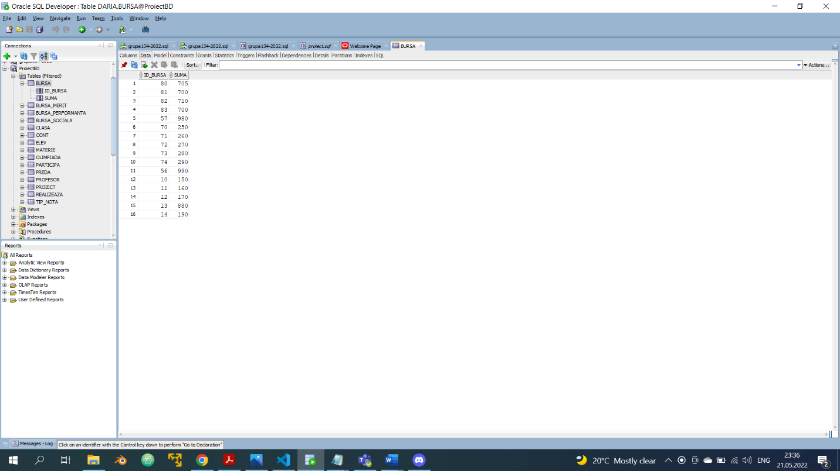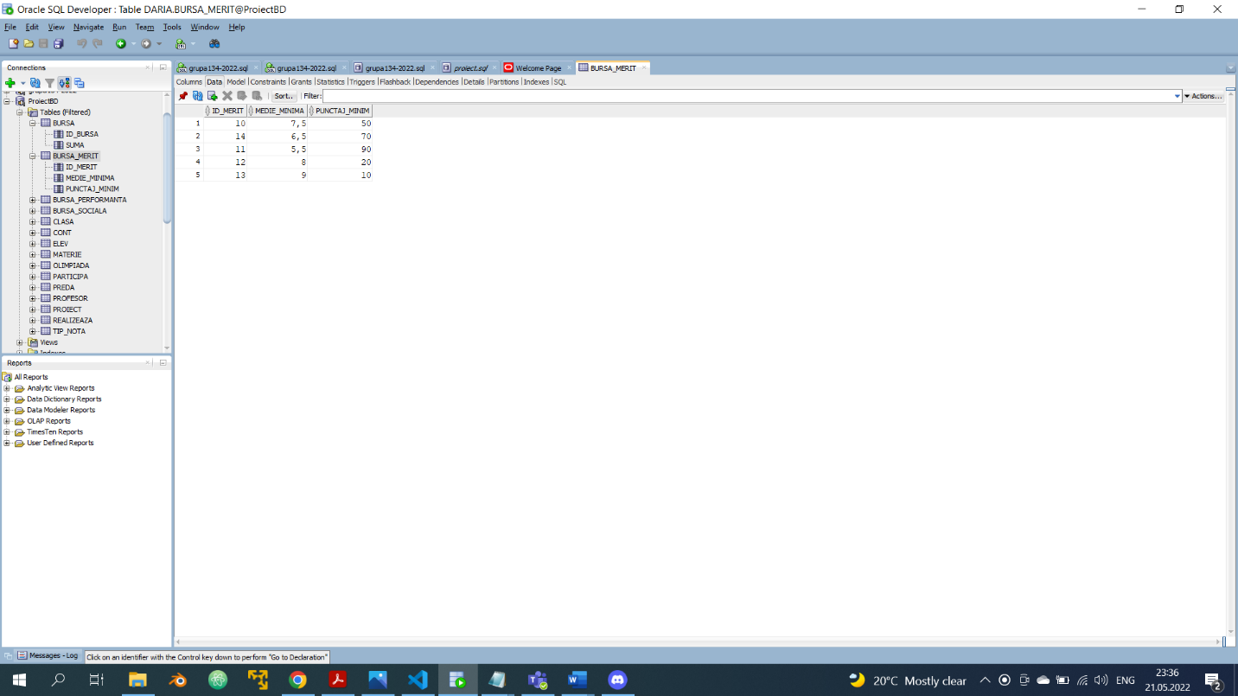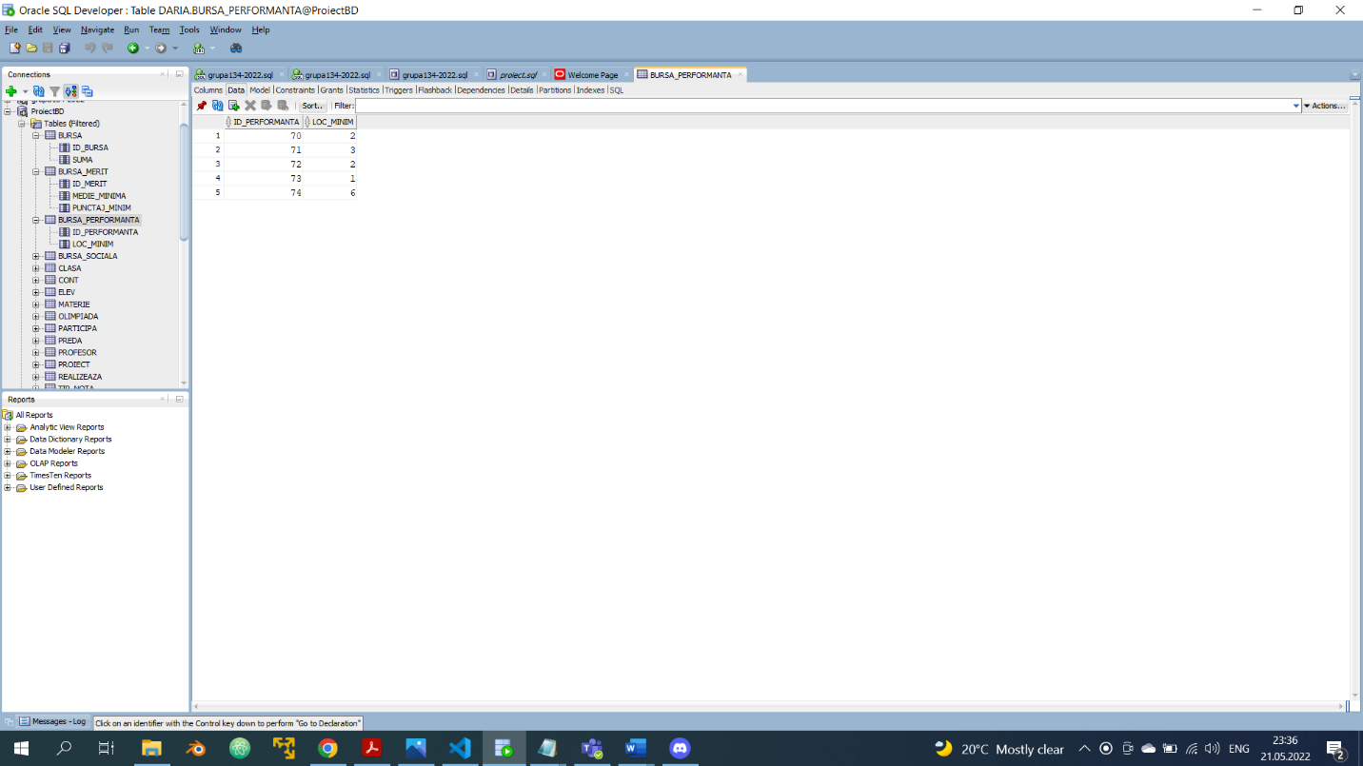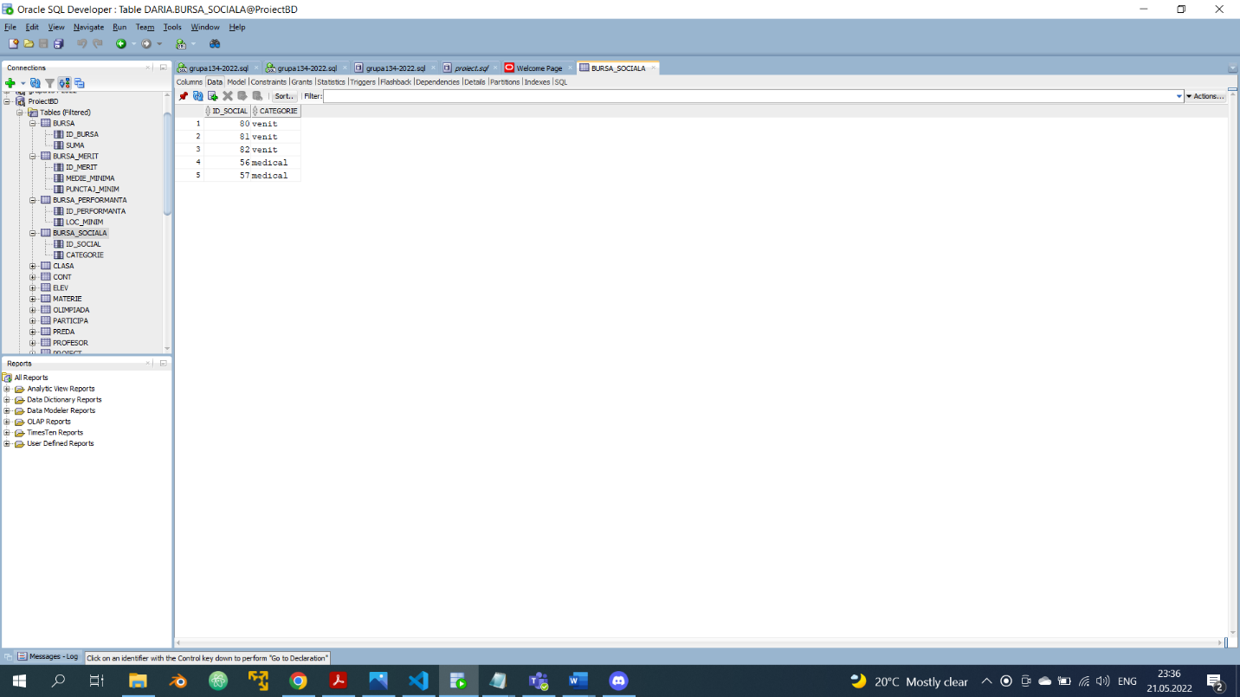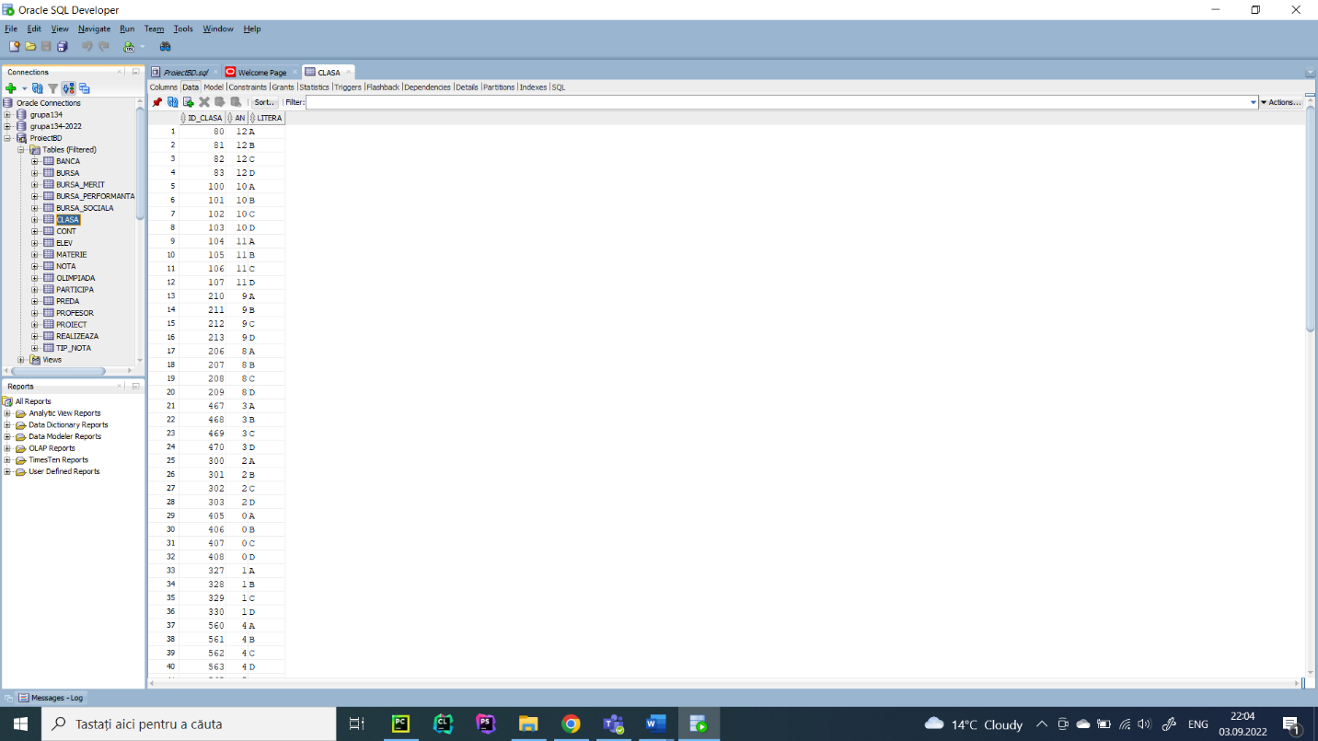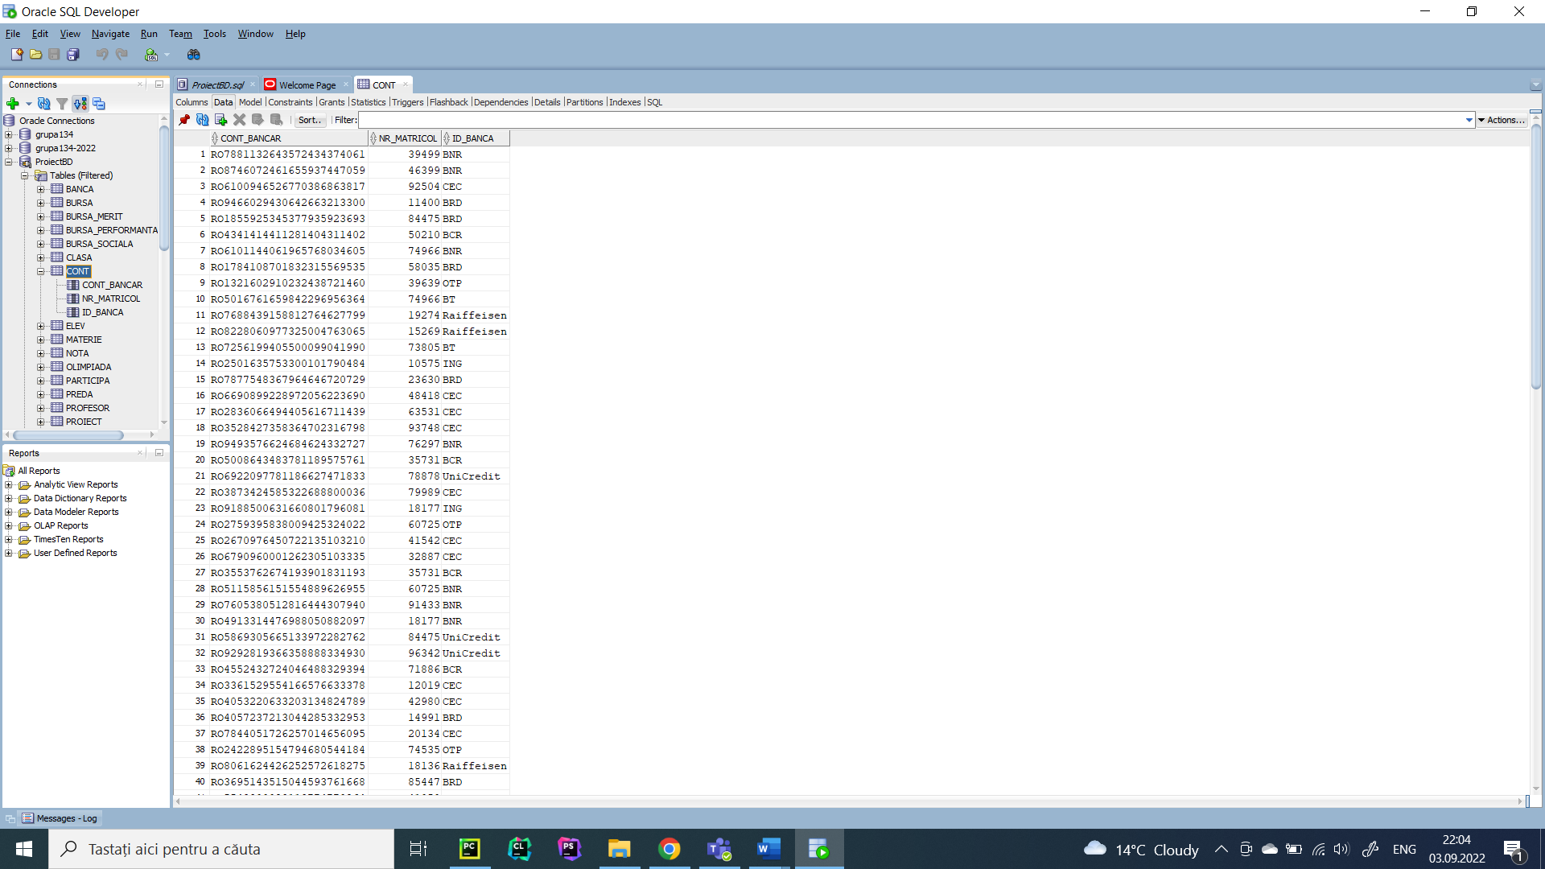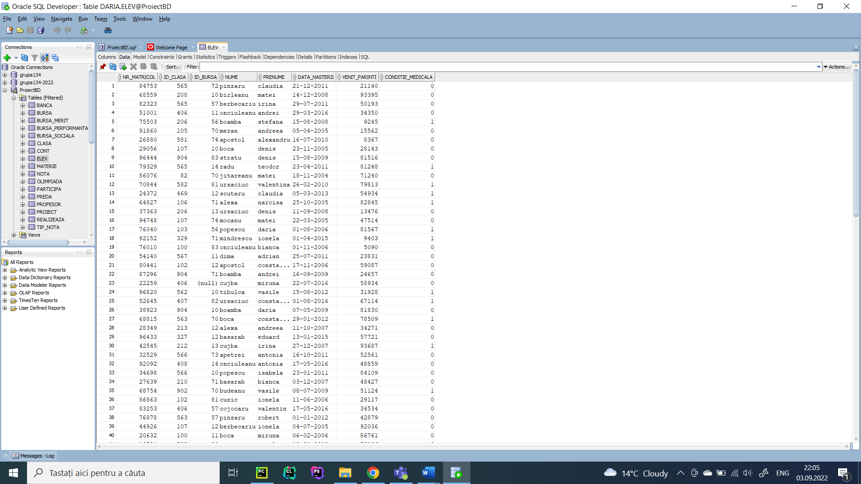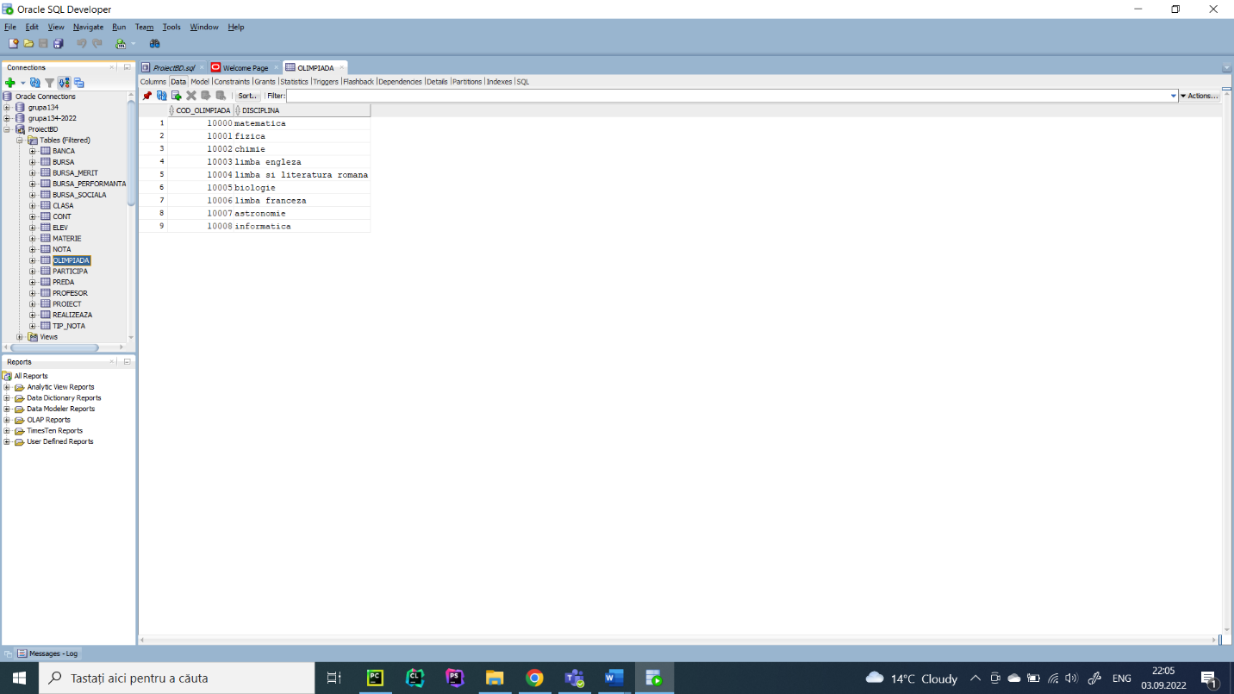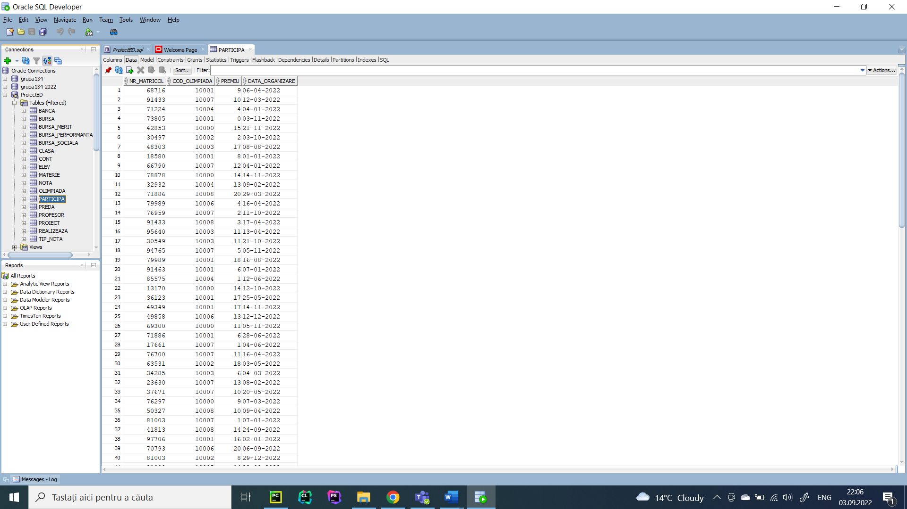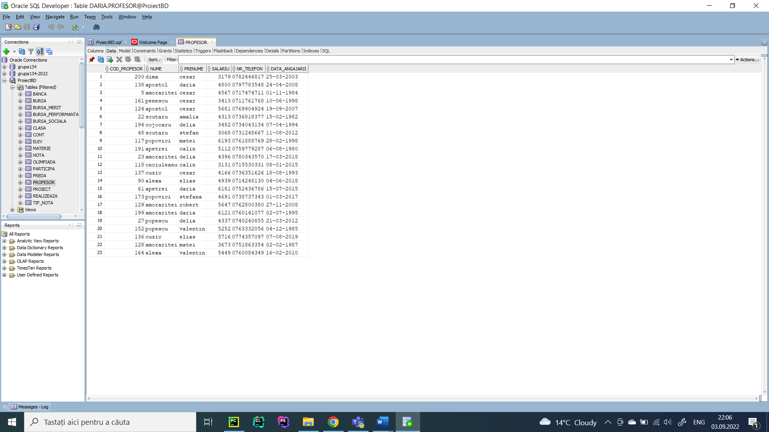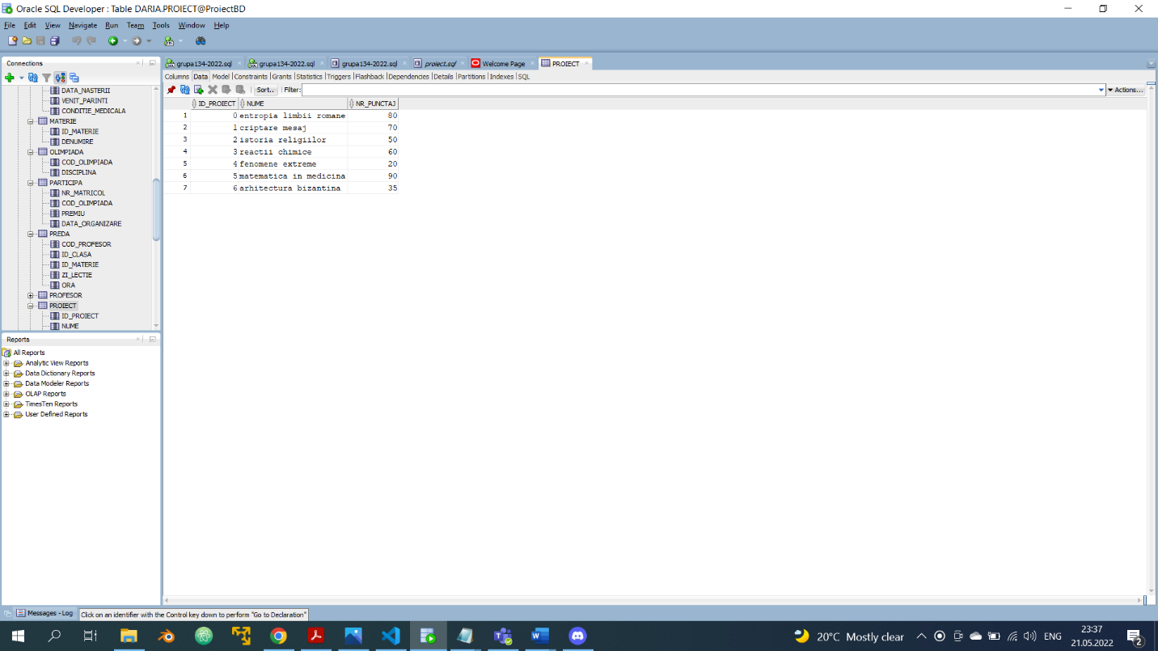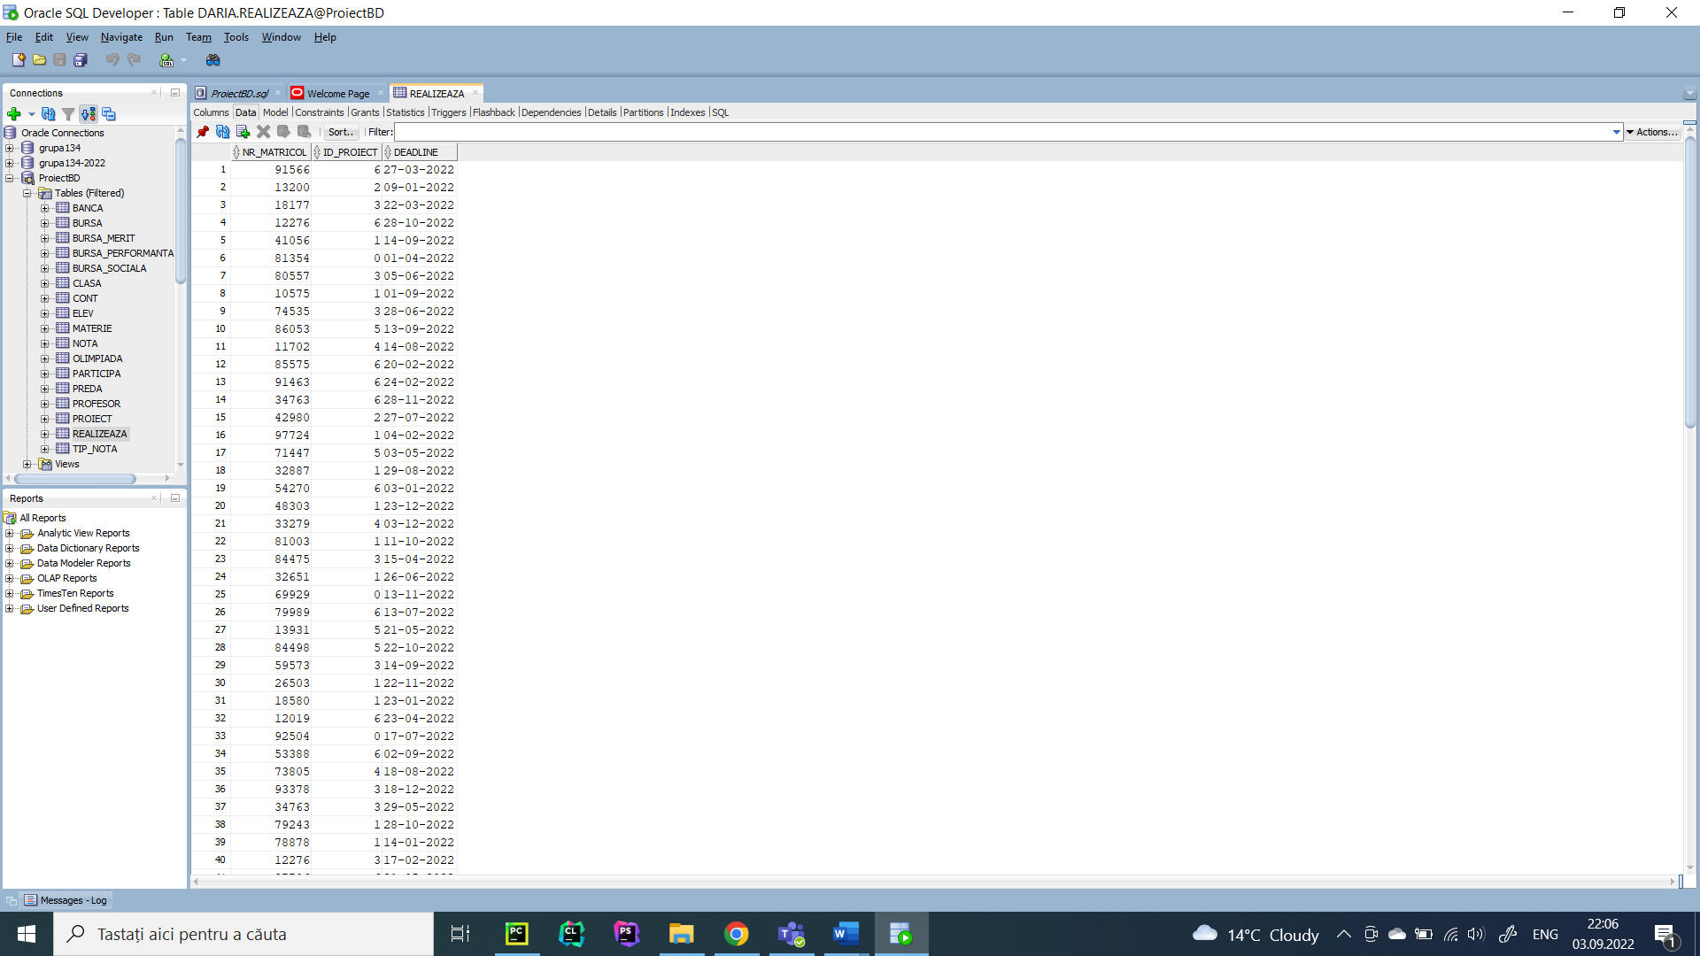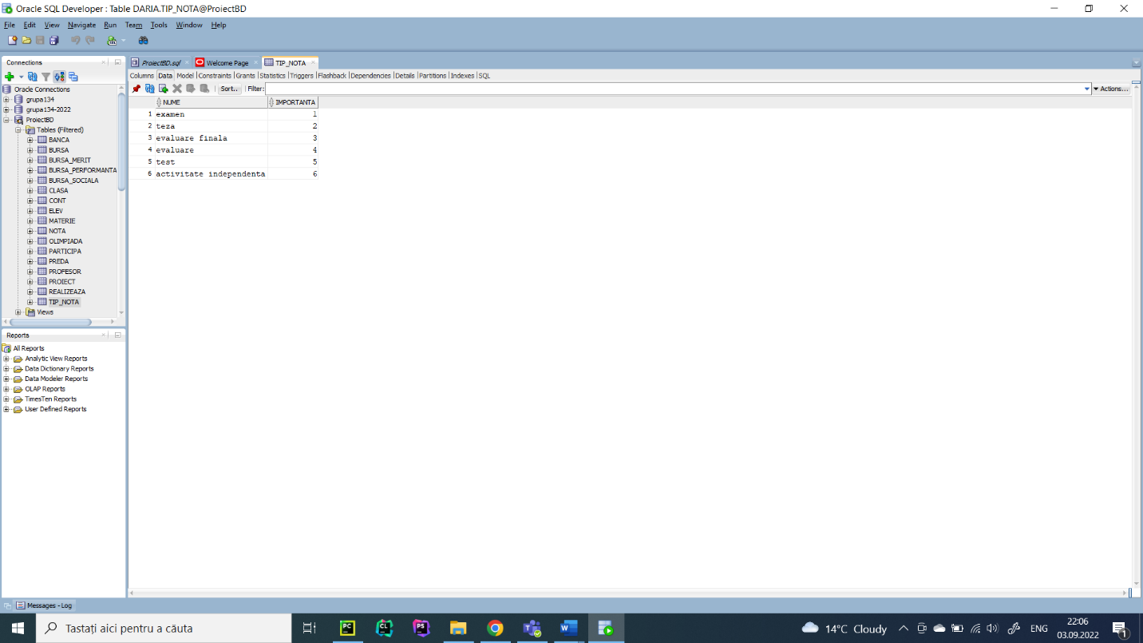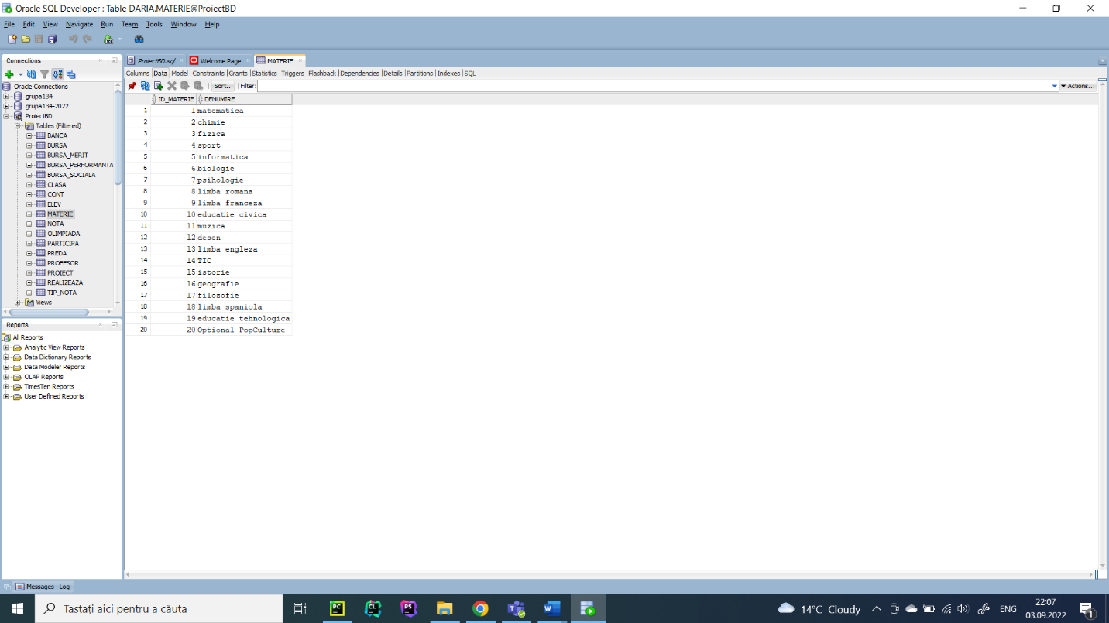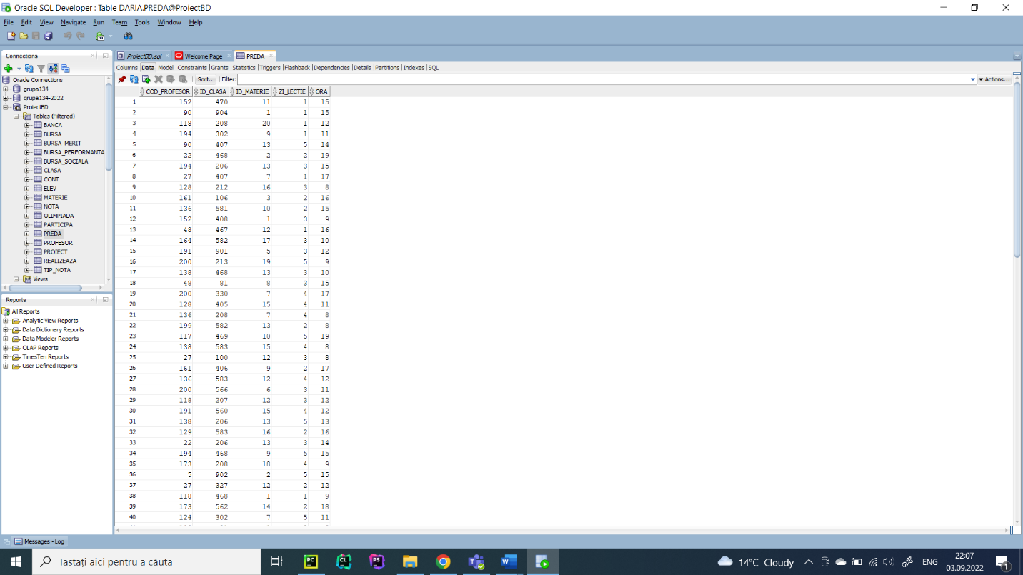

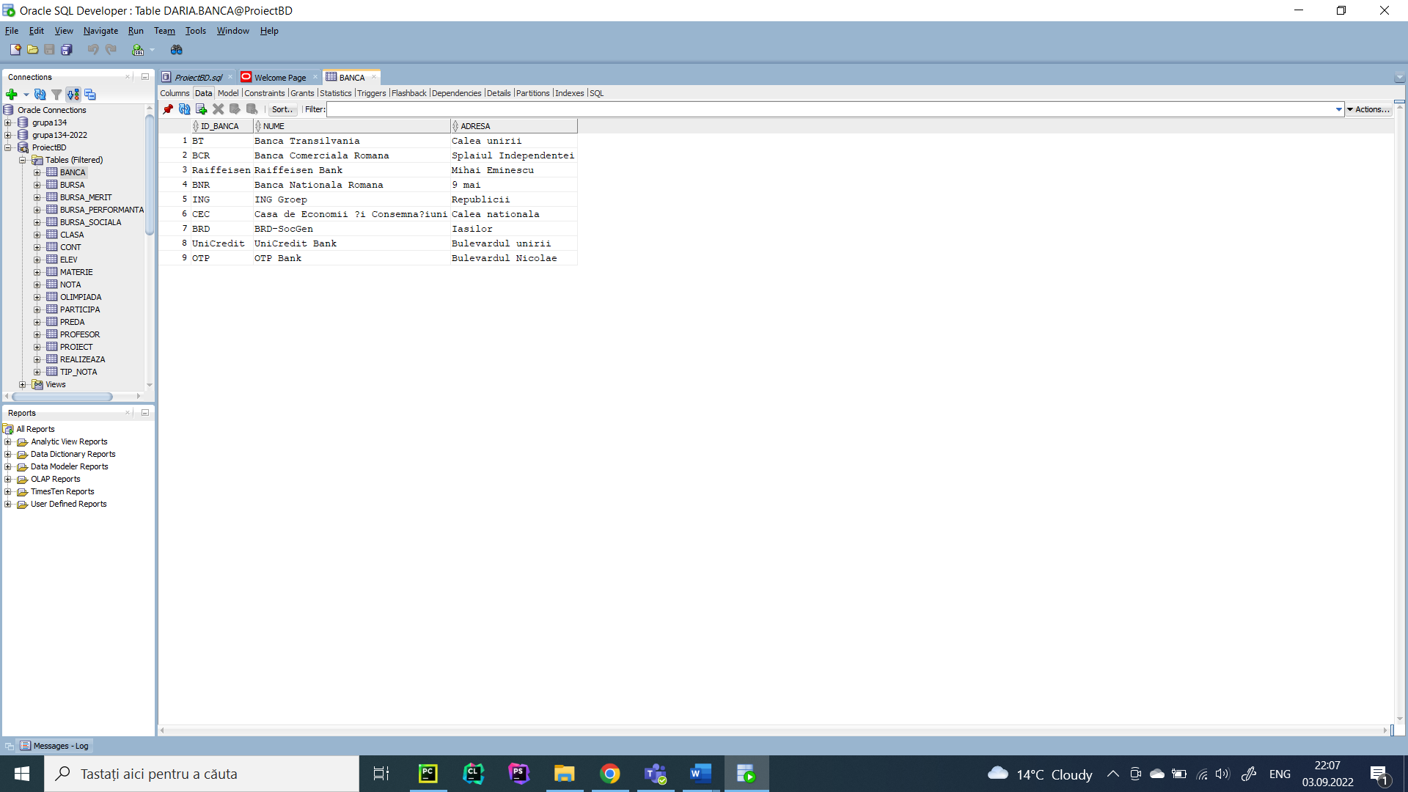

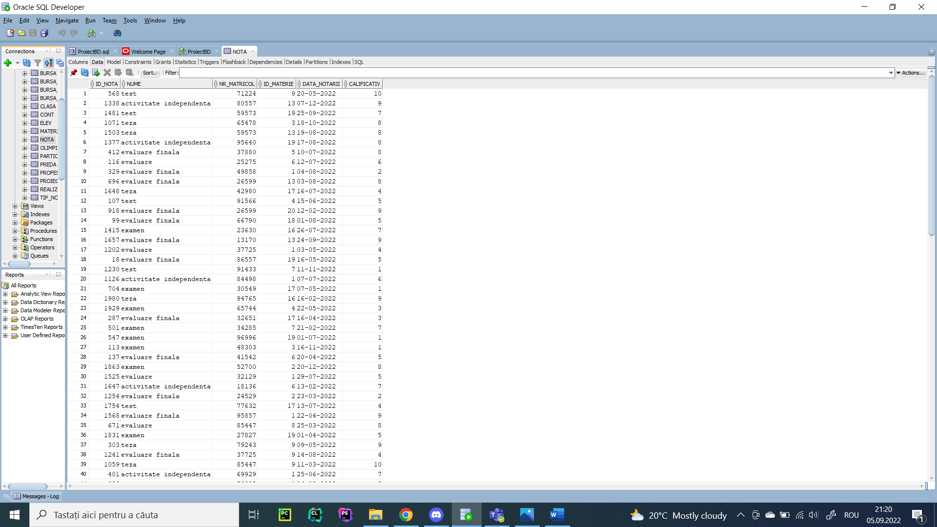

**12.** Formulați în limbaj natural și implementați 5 cereri SQL complexe

--Sa se afiseze in ordine descrescatoare mediile studentilor la teste care sunt inscrisi in clasa cu cei mai multi elevi din scoala.

with medii as

(select round(avg(calificativ), 2) medie, e.nr_matricol

from nota n, elev e

where n.nr_matricol = e.nr_matricol

and n.nume = 'evaluare'

group by e.nr_matricol)

select nume, prenume, medii.medie

from elev, medii

where medii.nr_matricol = elev.nr_matricol

and id_clasa in (select c.id_clasa

from elev e, clasa c

where e.id_clasa = c.id_clasa

group by c.id_clasa

having count(*) = (select max(count(*))

from elev e, clasa c

where e.id_clasa = c.id_clasa

group by c.id_clasa))

order by 3;

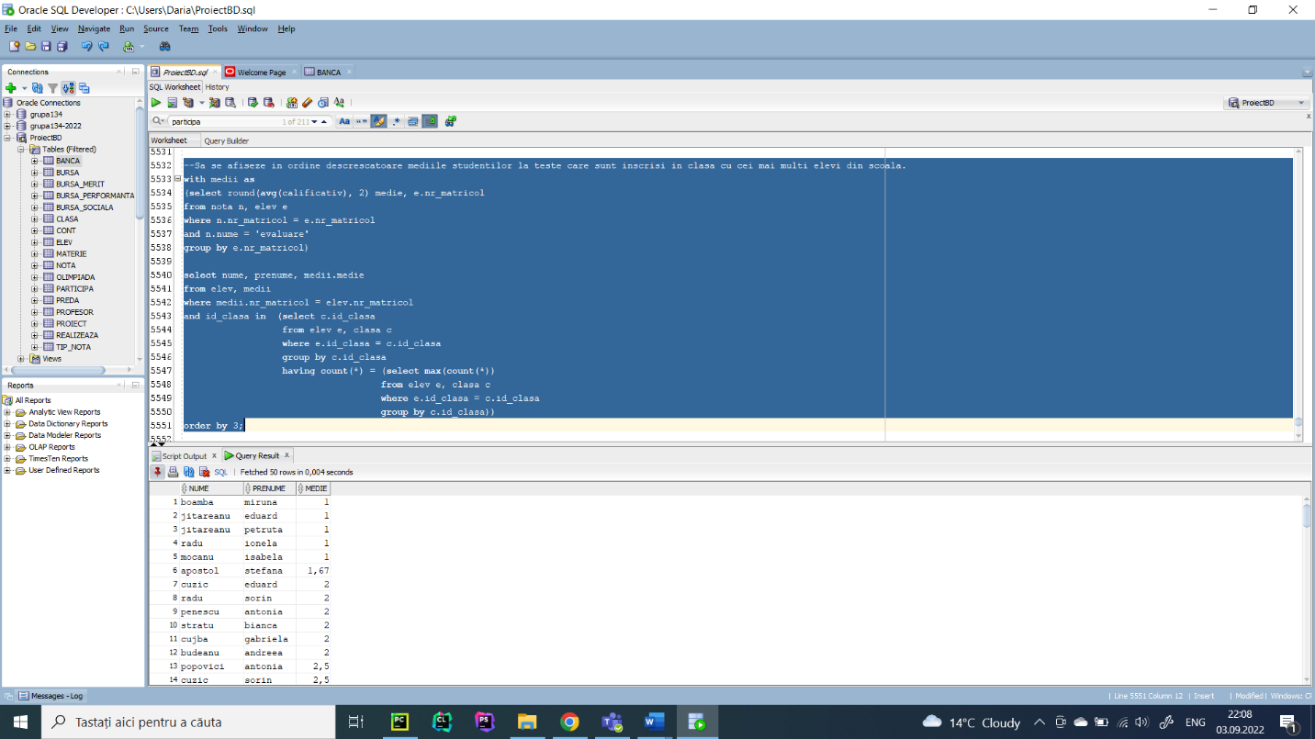

--Sa se afiseze pentru fiecare clasa olimpiadele la care au participat elevii inscrisi in clasa respectiva.

select o.disciplina, p.premiu, c.an, c.litera

from olimpiada o, clasa c, elev e, participa p

where o.cod_olimpiada = p.cod_olimpiada

and e.nr_matricol = p.nr_matricol

and c.id_clasa = e.id_clasa

order by 2,3, 4, 1;

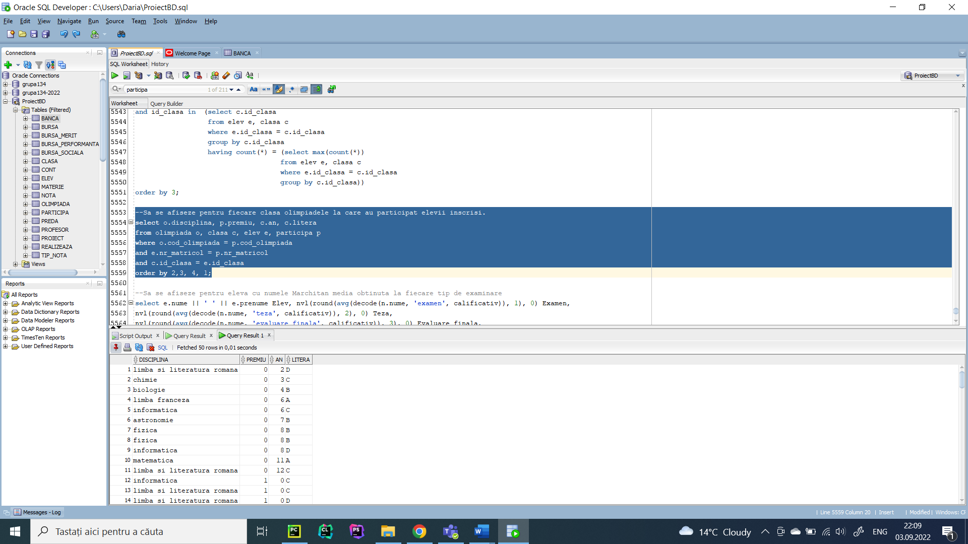

--Sa se afiseze pentru elevii cu numele Maftei media obtinuta la fiecare tip de examinare

select e.nume || ' ' || e.prenume Elev, nvl(round(avg(decode(n.nume, 'examen', calificativ)), 1), 0) Examen,

nvl(round(avg(decode(n.nume, 'teza', calificativ)), 2), 0) Teza,

nvl(round(avg(decode(n.nume, 'evaluare finala', calificativ)), 3), 0) Evaluare_finala,

nvl(round(avg(decode(n.nume, 'evaluare', calificativ)),4), 0) Evaluare,

nvl(round(avg(decode(n.nume, 'test', calificativ)), 5), 0) Test,

nvl(round(avg(decode(n.nume, 'activitate independenta', calificativ)), 6), 0) Activitate_independenta

from elev e, nota n

where e.nr_matricol = n.nr_matricol

and initcap(e.nume) = 'Maftei'

group by e.nume, e.prenume;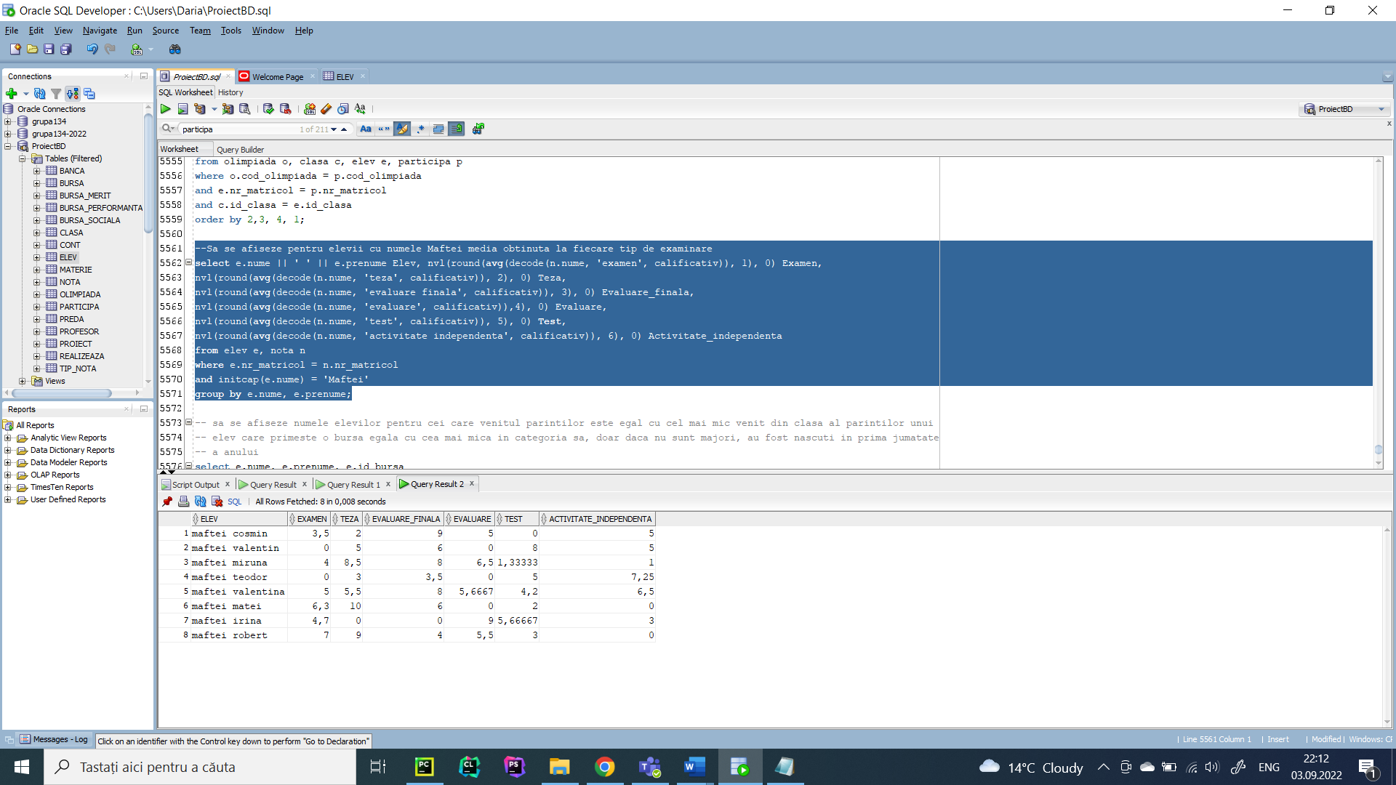

--Sa se determine pentru fiecare elev care sufera de o conditie medicala un alis format din prima litera a numelui, prima

--litera a prenumelui si 1, iar pentru cei care sunt sanatosi un alias format din prima litera a numelui, prima

--litera a prenumelui si 0.

select nume, prenume,

case (conditie_medicala)

when 1 then concat(substr(nume, 0, 1), concat(substr(prenume, 0, 1), '1'))

when 0 then concat(substr(nume, 0, 1), concat(substr(prenume, 0, 1), '0'))

end "alias"

from elev;

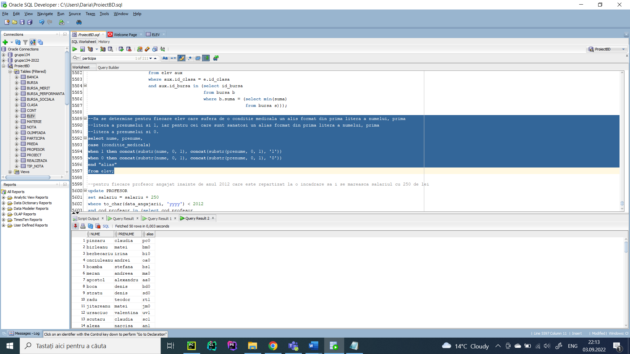

-- sa se afiseze numele elevilor pentru cei care venitul parintilor este egal cu cel mai mic venit din clasa al parintilor unui

-- elev care primeste o bursa egala cu cea mai mica in categoria sa, doar daca nu sunt majori, au fost nascuti in prima jumatate

-- a anului

select e.nume, e.prenume, e.id_bursa

from elev e, clasa c

where to_char(sysdate, 'yyyy') - to_char(e.data_nasterii, 'yyyy') < 18

and extract(month from e.data_nasterii) < 7

and e.id_clasa = c.id_clasa

and e.venit_parinti in (select min(venit_parinti)

from elev aux

where aux.id_clasa = e.id_clasa

and aux.id_bursa in (select id_bursa

from bursa b

where b.suma in (select min(suma)

from bursa s)));

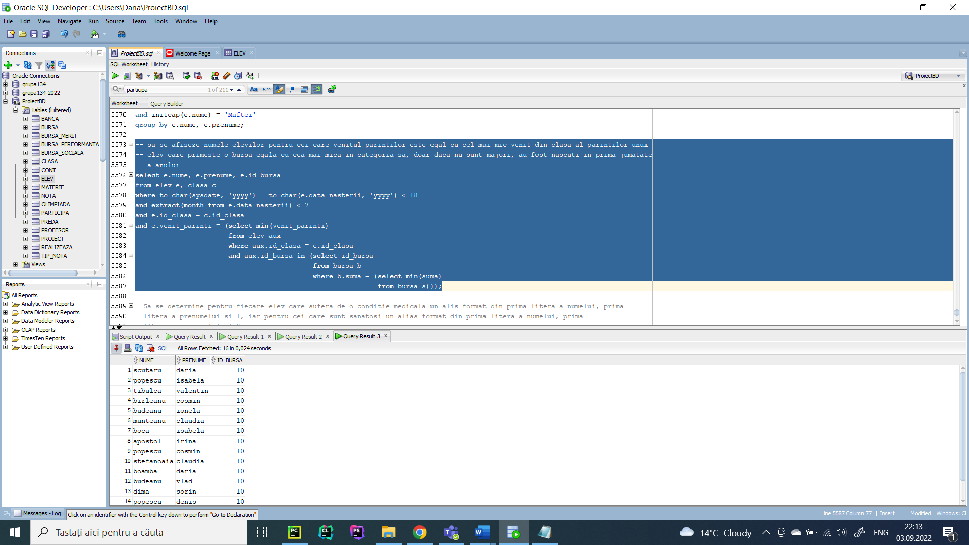

13. Implementarea a 3 operații de actualizare și de suprimare a datelor utilizând subcereri.

--pentru fiecare profesor angajat inainte de anul 2012 care este repartizat la o incadrare sa i se mareasca salariul cu 250 de lei

update PROFESOR

set salariu = salariu + 250

where to_char(data_angajarii, 'yyyy') < 2012

and cod_profesor in (select cod_profesor

from preda);

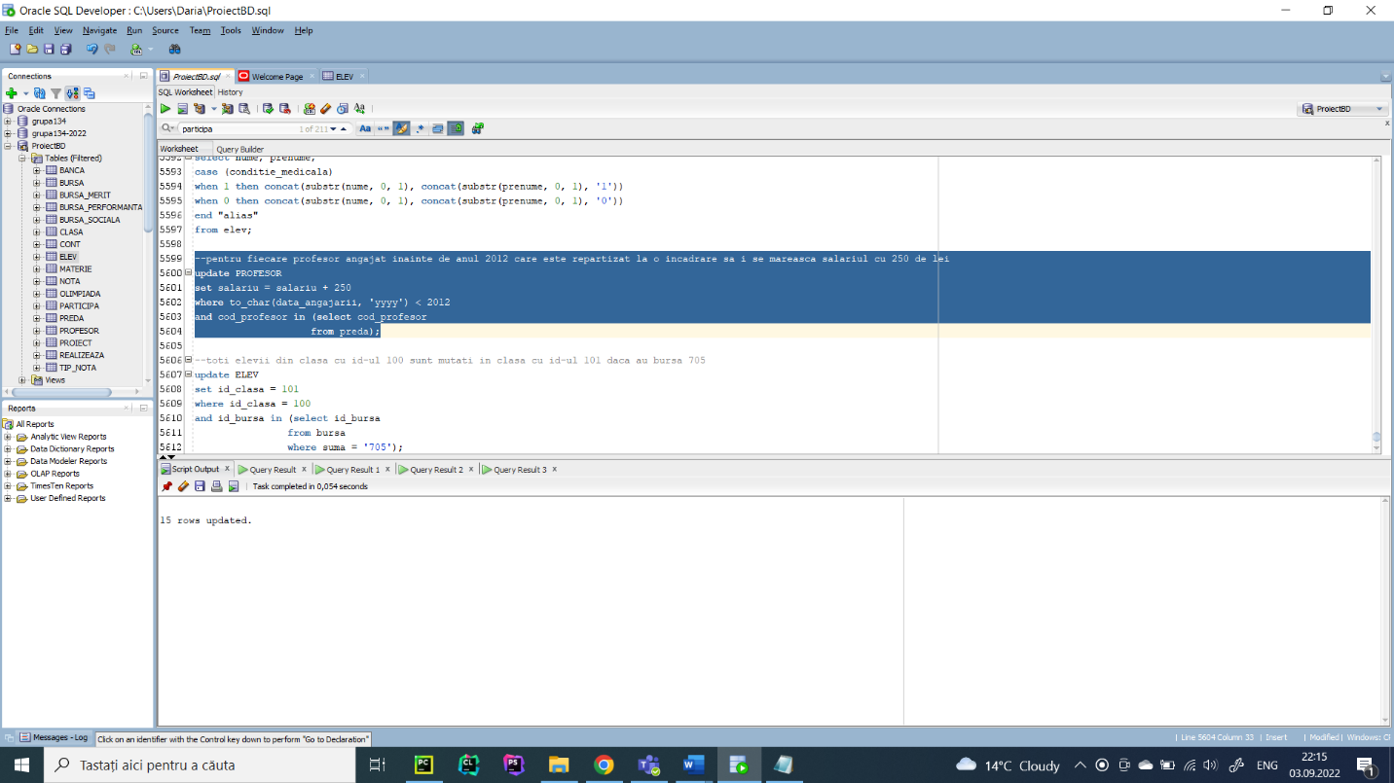

--toti elevii din clasa cu id-ul 100 sunt mutati in clasa cu id-ul 101 daca au bursa 705

update ELEV

set id_clasa = 101

where id_clasa = 100

and id_bursa in (select id_bursa

from bursa

where suma = '705');

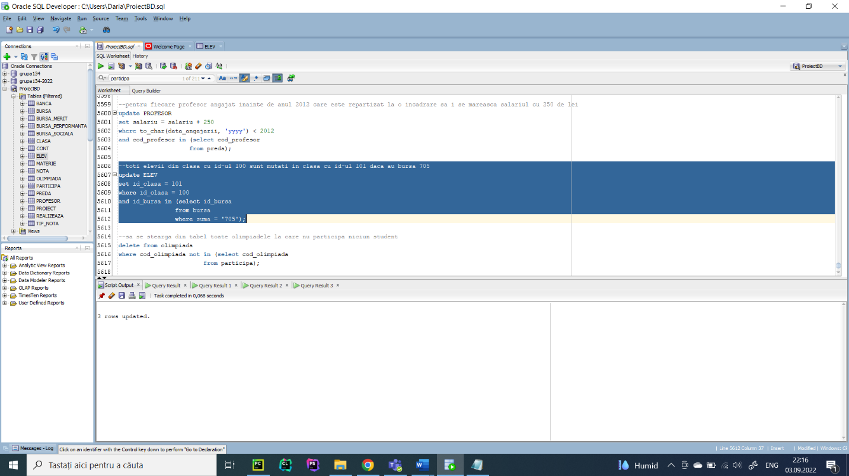

--sa se stearga din tabel toate olimpiadele la care nu participa niciun student

delete from olimpiada

where cod_olimpiada not in (select cod_olimpiada

from participa);

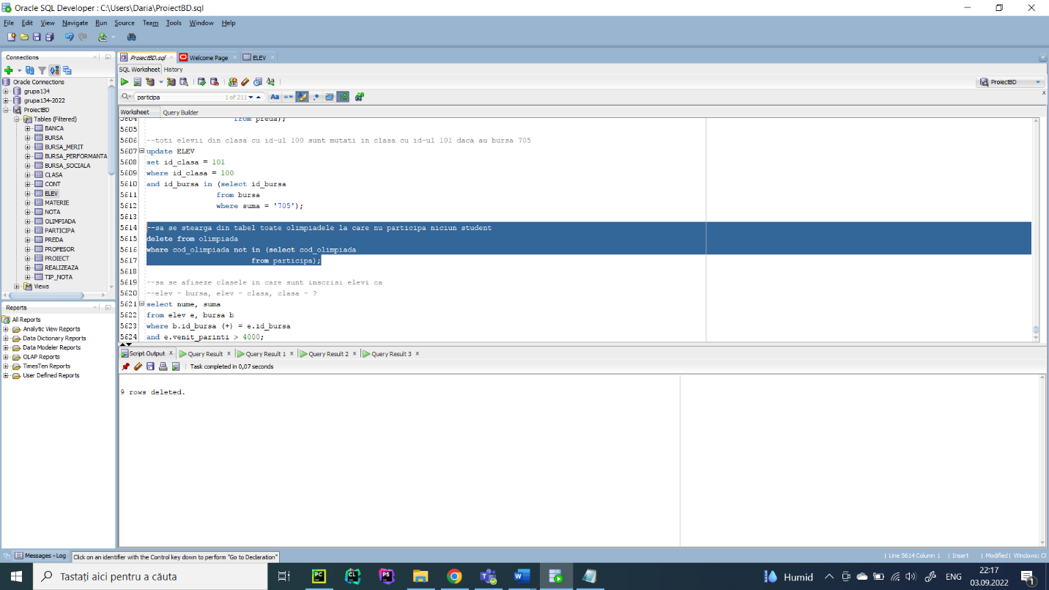

1. Formulați în limbaj natural și implementați în SQL: o cerere ce utilizează operația outer

Join pe minimum 4 tabele și două cereri ce utilizează operația division.

--Sa se afiseze numele elevilor, bursa pe care o primesc si banca la care au deschis un cont cu contul aferent (se vor afisa si

--cei care nu iau bursa sau care nu au un cont deschis) doar daca venitul parintilor este mai mare de 1000 de lei.

select e.nume, suma, cont_bancar, k.id_banca

from elev e, bursa b, cont c, banca k

where e.id_bursa = b.id_bursa (+)

and e.nr_matricol = c.nr_matricol (+)

and c.id_banca = k.id_banca (+)

and e.venit_parinti > 1000;

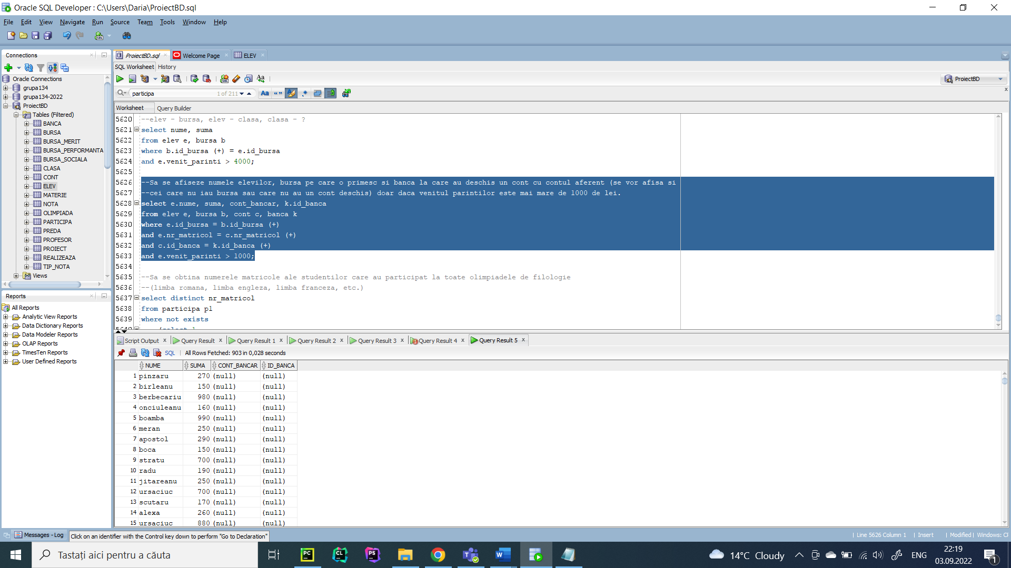

--Sa se obtina numerele matricole ale studentilor care au participat la toate olimpiadele de filologie

--(limba romana, limba engleza, limba franceza, etc.)

select distinct nr_matricol

from participa p1

where not exists

(select 1

from olimpiada o

where o.disciplina like 'limba%'

and not exists

(select 1

from participa p2

where o.cod_olimpiada = p2.cod_olimpiada

and p2.nr_matricol = p1.nr_matricol));

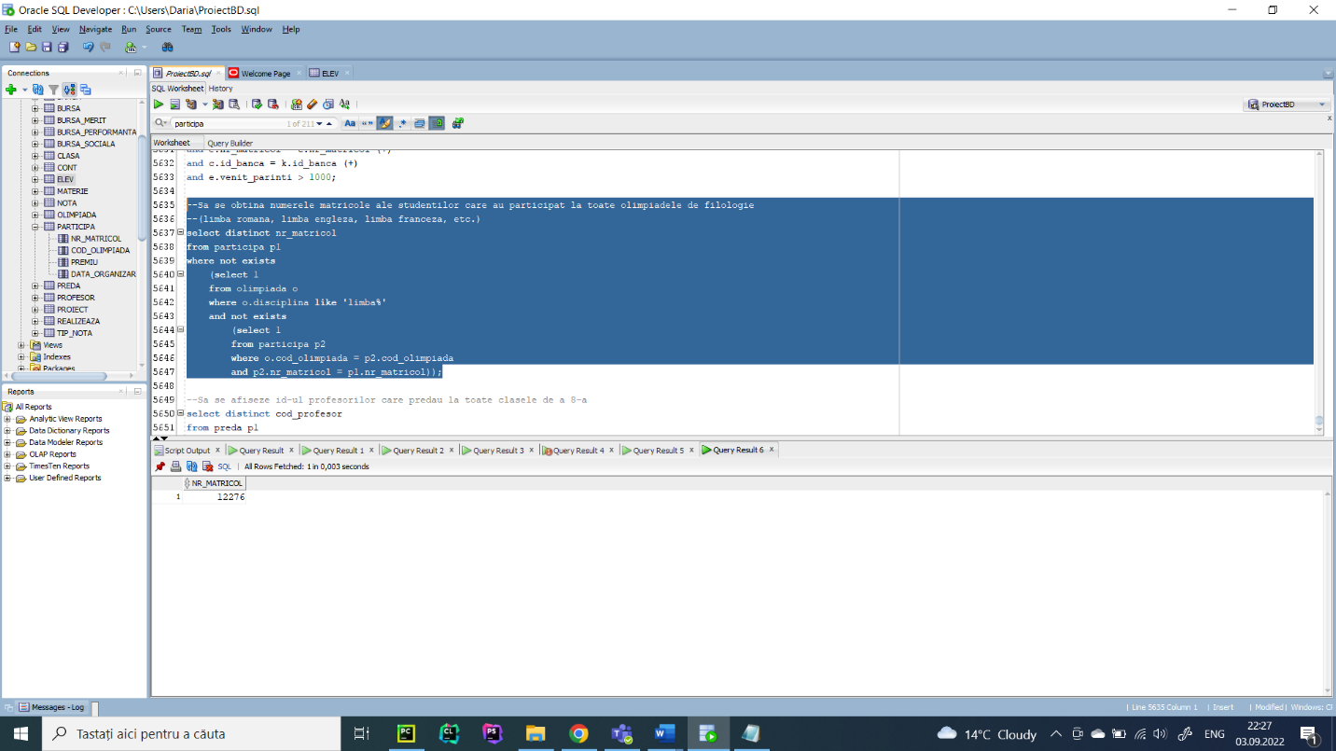

--Sa se afiseze id-ul profesorilor care predau la toate clasele de a 8-a

select distinct cod_profesor

from preda p1

where not exists

(select 1

from clasa c

where c.an = 8

and not exists

(select 1

from preda p2

where c.id_clasa = p2.id_clasa

and p2.cod_profesor = p1.cod_profesor));

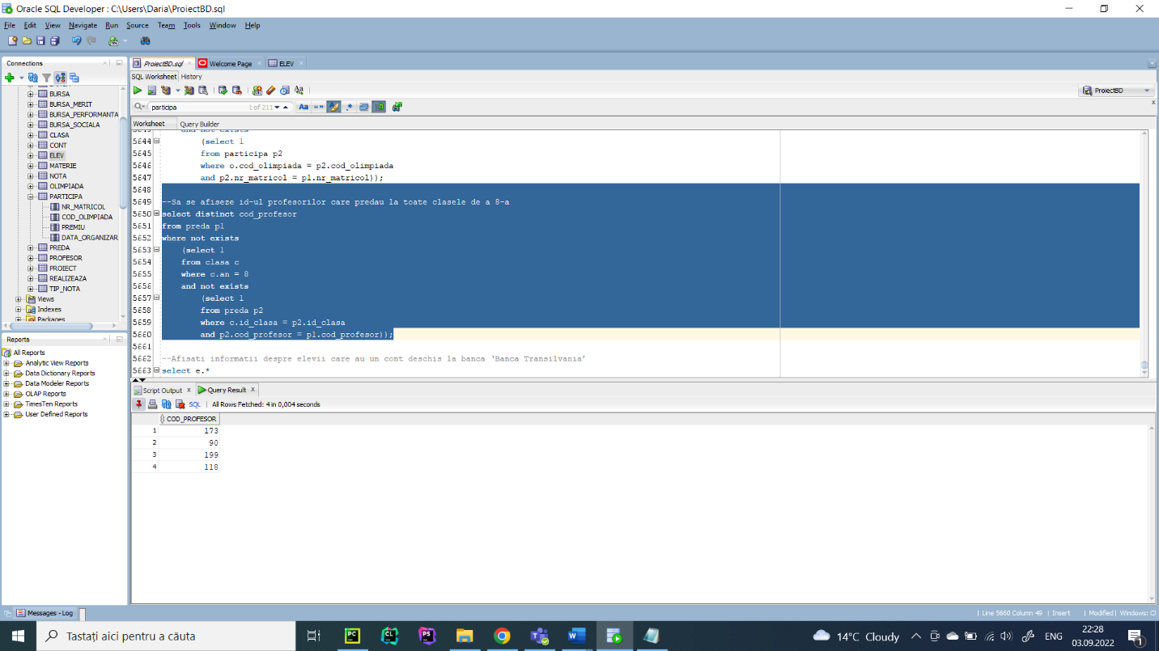

1. Optimizarea unei cereri, aplicând regulile de optimizare ce derivă din proprietățile

operatorilor algebrei relaționale. Cererea va fi exprimată prin expresie algebrică, arbore algebric și

limbaj (SQL), atât anterior cât și ulterior optimizării.

--Afișați informații despre elevii care au un cont deschis la banca ‘Banca Transilvania’

Neoptimizat:

select e.*

from elev e, cont c, banca b

where c.nr_matricol = e.nr_matricol

and c.id_banca = b.id_banca

and b.nume = 'Banca Transilvania';

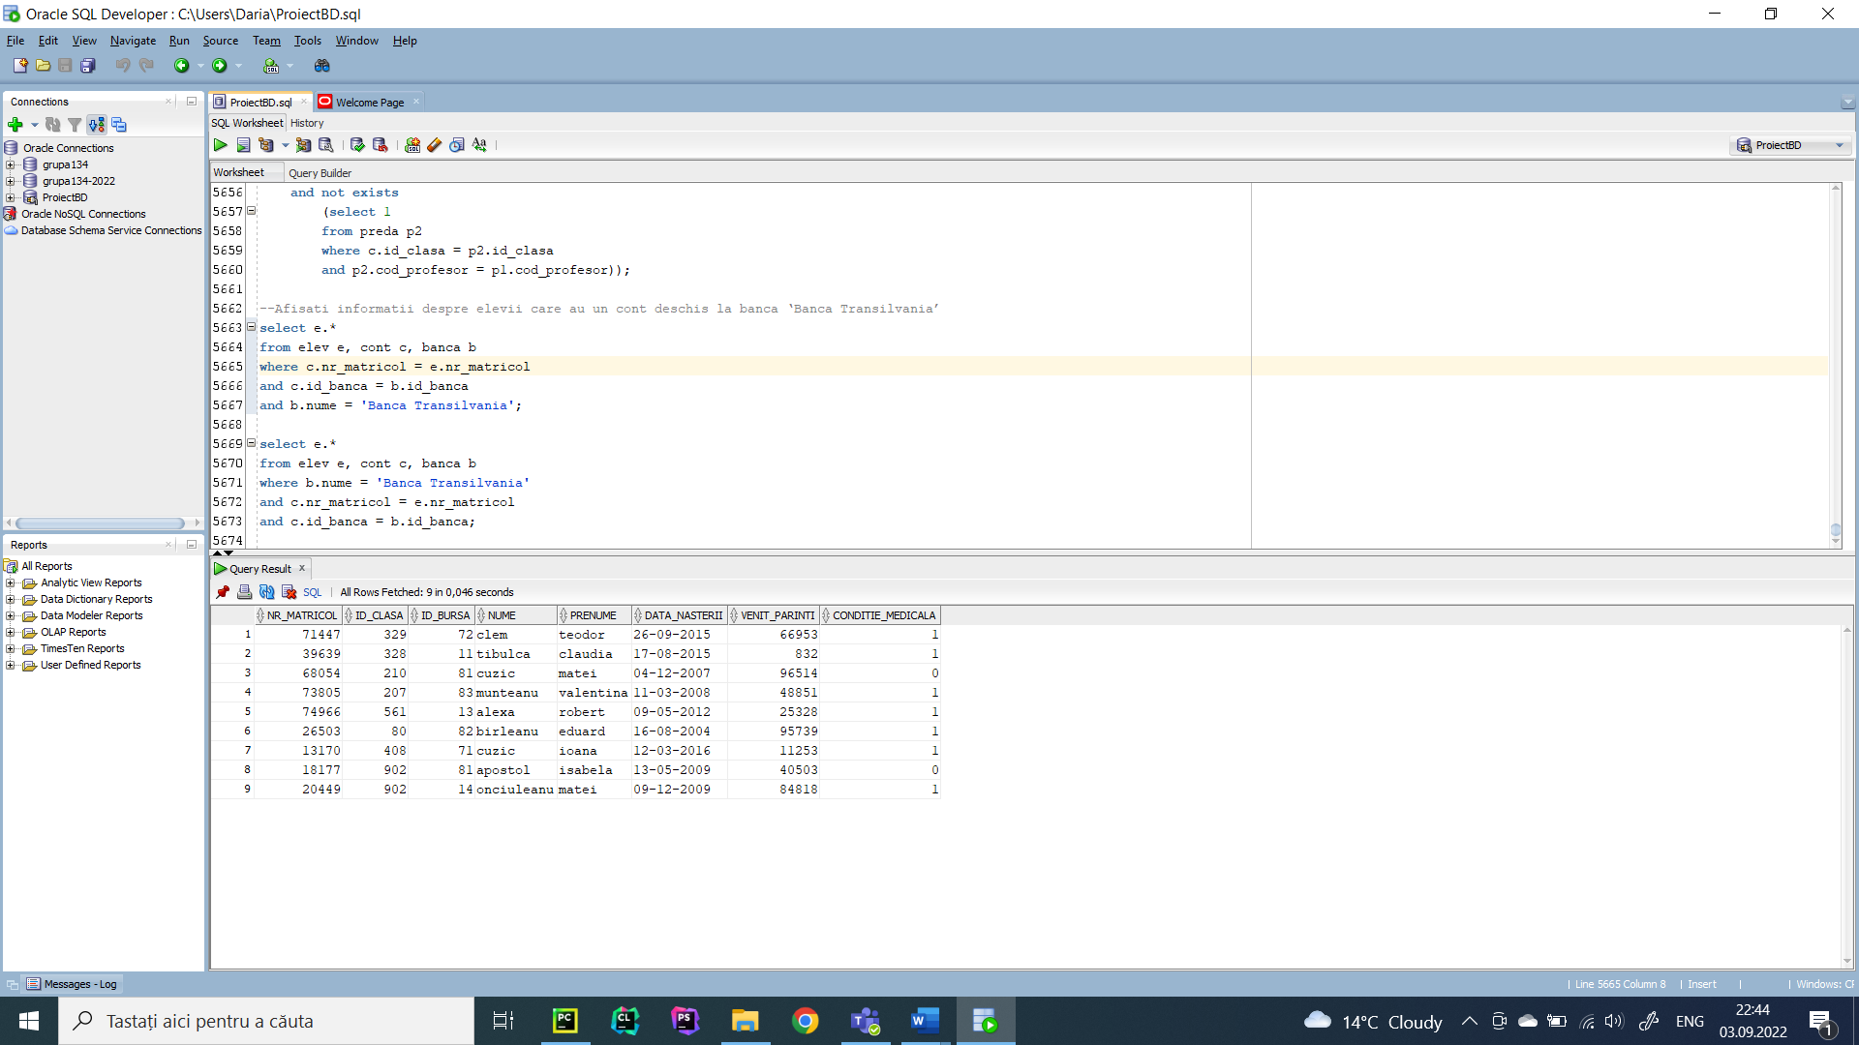

Optimizat:

select e.*

from elev e, cont c, banca b

where b.nume = 'Banca Transilvania'

and c.nr_matricol = e.nr_matricol

and c.id_banca = b.id_banca;

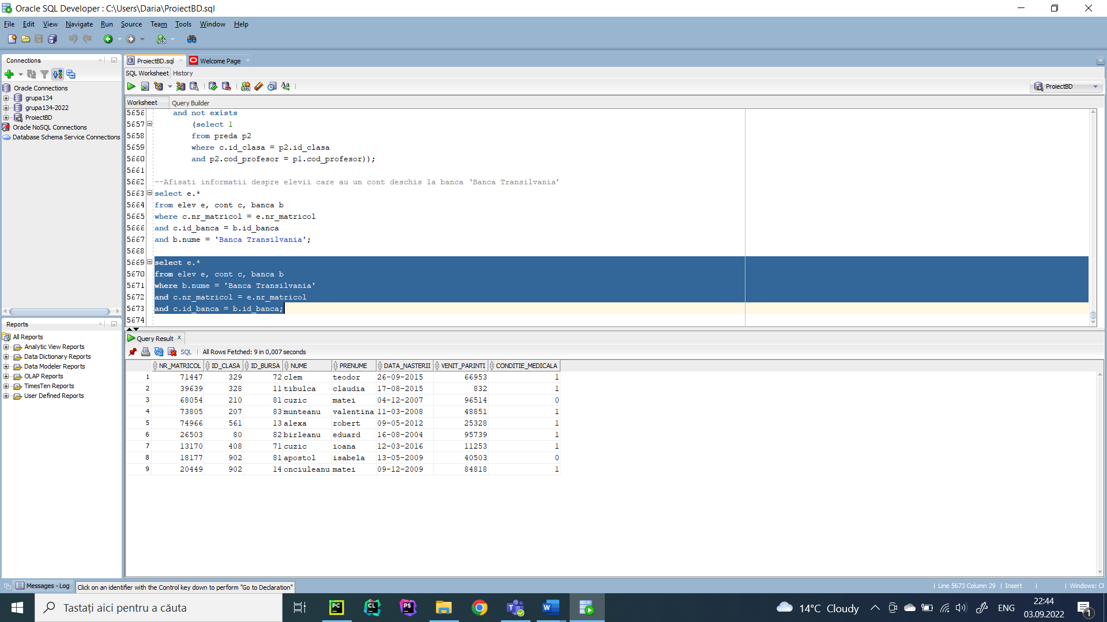

Cerere exprimată prin arbore algebric și prin expresii algebrice

Neoptimizat:

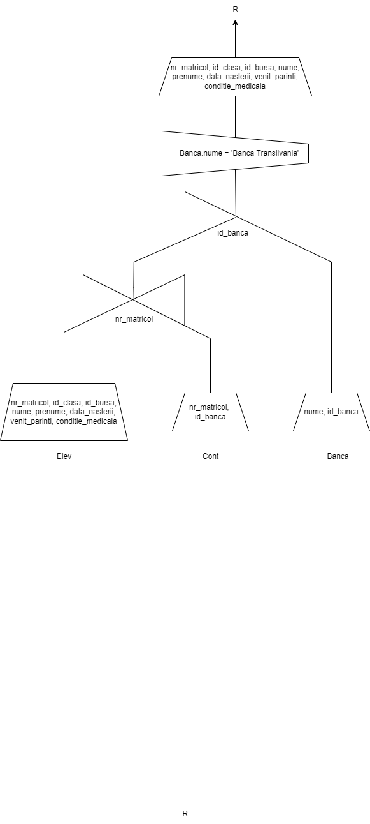

R1 = PROJECT (ELEV, nr_matricol, id_clasa, id_bursa, nume, prenume, data_nasterii, venit_parinti, conditie_medicala)

R2 = PROJECT (CONT, nr_matricol, id_banca)

R3 = JOIN (R1, R2, nr_matricol)

R4 = PROJECT (BANCA, nume, id_banca)

R5 = SEMIJOIN (R3, R4, id_banca)

R6 = SELECT (BANCA, nume = ‘Banca Transilvania’)

R = PROJECT (R5, R6, nr_matricol, id_clasa, id_bursa, nume, prenume, data_nasterii, venit_parinti, conditie_medicala)

Optimizat:

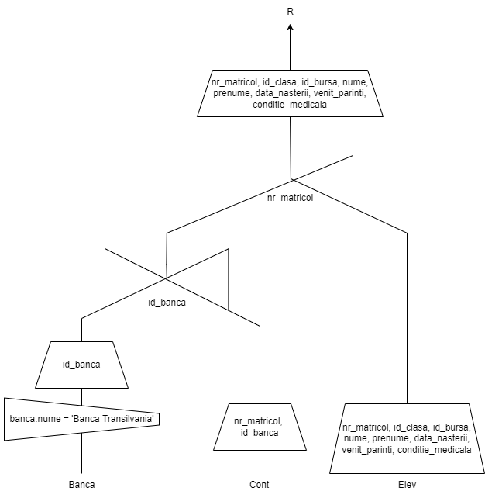

R1 = SELECT (BANCA, nume = ‘Banca Transilvania’)

R2 = PROJECT (R1, id_banca)

R3 = PROJECT (CONT, nr_matricol, id_banca)

R4 = JOIN (R2, R3, id_banca)

R5 = PROJECT (ELEV, nr_matricol, id_clasa, id_bursa, nume, prenume, data_nasterii, venit_parinti, conditie_medicala)

R6 = SEMIJOIN (R4, R5, nr_matricol)

R = PROJECT (R6, nr_matricol, id_clasa, id_bursa, nume, prenume, data_nasterii, venit_parinti, conditie_medicala)

Cererea este optimă, întrucât a fost realizată respectând următoarele reguli de optimizare:

* Selecţiile se execută cât mai devreme posibil.
* Produsele carteziene se înlocuiesc cu join-uri, ori de câte ori este posibil.
* Proiecţiile se execută la început pentru a îndepărta atributele nefolositoare.
  1. Realizarea normalizării BCNF, FN4, FN5.

BCNF

Un tabel este considerat în BCNF (Boyce-Codd) dacă este în FN3 și pentru fiecare dependență funcțională între A și B, A trebuie să fie o super cheie.

Pentru a exemplifica, considerăm următoarea situație. Această tabelă nu este în BCNF, întrucât îndependența funcțională între Id_materie și Titular, Id_materie nu este cheie primară.

**NON BCNF**

|  |  |  |  |
| --- | --- | --- | --- |
| Cod_profesor | Nume | Id_materie | Titular |
| 200 | Dima | 19 | Popescu |
| 200 | Dima | 19 | Cuzic |
| 200 | Dima | 20 | Clem |
| 128 | Amoraritei | 16 | Alexa |
| 128 | Amoraritei | 16 | Scutaru |

**BCNF**

Tabela Profesor

|  |  |
| --- | --- |
| Cod_profesor | Nume |
| 200 | Dima |
| 128 | Amoraritei |

Tabela Materie

|  |  |
| --- | --- |
| Id_materie | Titular |
| 19 | Popescu |
| 19 | Cuzic |
| 16 | Alexa |
| 16 | Scutaru |
| 20 | Clem |

Tabela Preda

|  |  |
| --- | --- |
| Cod_profesor | Id_materie |
| 200 | 19 |
| 200 | 20 |
| 128 | 16 |

FN4

Un tabel este considerat în FN4 dacă nu are două sau mai multe date independente care descriu entitatea relevantă.

Considerăm tabelul cu următoarea structură, ce nu respectă condițiile impuse celor din diagramă.

**NON FN4**

|  |  |  |
| --- | --- | --- |
| Nr_matricol | Suma | Cont_bancar |
| 84753 | 270 | RO7881132643572434374061 |
| 84753 | 300 | RO7881132643572434374061 |
| 84753 | 270 | RO4341414411281404311402 |
| 84753 | 300 | RO4341414411281404311402 |

**FN4**

|  |  |
| --- | --- |
| Nr_matricol | Suma |
| 84753 | 270 |
| 84753 | 300 |

|  |  |
| --- | --- |
| Nr_matricol | Cont_bancar |
| 84753 | RO7881132643572434374061 |
| 84753 | RO4341414411281404311402 |

Introducerea unui nou cont bancar ar fi însemnat în prima tabela suplimentarea cu încă 2 înregistrări, pe când după normalizare vom introduce o singură informație nouă.

FN5

Un tabel este considerat în FN5 dacă este în FN4 și poate fi împărțit în mai multe tabele fără pierderea datelor.

**NON FN5**

Considerăm tabelul următor, folosindu-se atributele nume profesor, id_clasa și materie pentru ilustrarea mai bună a normalizării.

|  |  |  |
| --- | --- | --- |
| Nume profesor | Id_clasă | Materie |
| Dima | 213 | educatie tehnologica |
| Dima | 213 | psihologie |
| Scutaru | 468 | chimie |
| Apetrei | 901 | informatica |

Presupunem că adăugăm o nouă clasă, dar nu știm despre materiile predate și cine va preda materia respectivă, așa că vom avea rubrici completate cu null. Dar toate cele trei coloane împreună acționează ca o cheie primară, așa că nu putem lăsa alte două coloane goale. Pentru a transforma tabelul de mai sus în 5NF, îl putem descompune în trei relații, reprezentate prin tabelele următoare.

**FN5**

|  |  |
| --- | --- |
| Nume profesor | Id_clasă |
| Dima | 213 |
| Scutaru | 468 |
| Apetrei | 901 |

|  |  |
| --- | --- |
| Id_clasă | Materie |
| 213 | educatie tehnologica |
| 213 | psihologie |
| 468 | chimie |
| 901 | informatica |

|  |  |
| --- | --- |
| Nume profesor | Materie |
| Dima | educatie tehnologica |
| Dima | psihologie |
| Scutaru | chimie |
| Apetrei | informatica |

* 1. Aplicarea denormalizării, justificând necesitatea acesteia.

Denormalizarea adaugă date redundante în baza de date, tehnica fiind folosită atunci când există

un număr foarte mare de date pentru care executarea unui Join este o operație costisitoare. În așa fel,

informațiile redundante sunt stocate în tabele pentru a evita operațiile de Join.

Astfel, pornind de la exemplul dat anterior la FN4 și aplicând denormalizarea, vom avea tabela

care conține atât sumele, cât și conturile. Justificarea acestei decizii constă în faptul că responsabilul

pentru acordarea burselor va putea astfel gestiona mai ușor acordarea banilor, pentru că va avea mereu

contul aferent alături de suma care trebuie plătită, fiind scutit de realizarea unor join-uri costisitoare.